[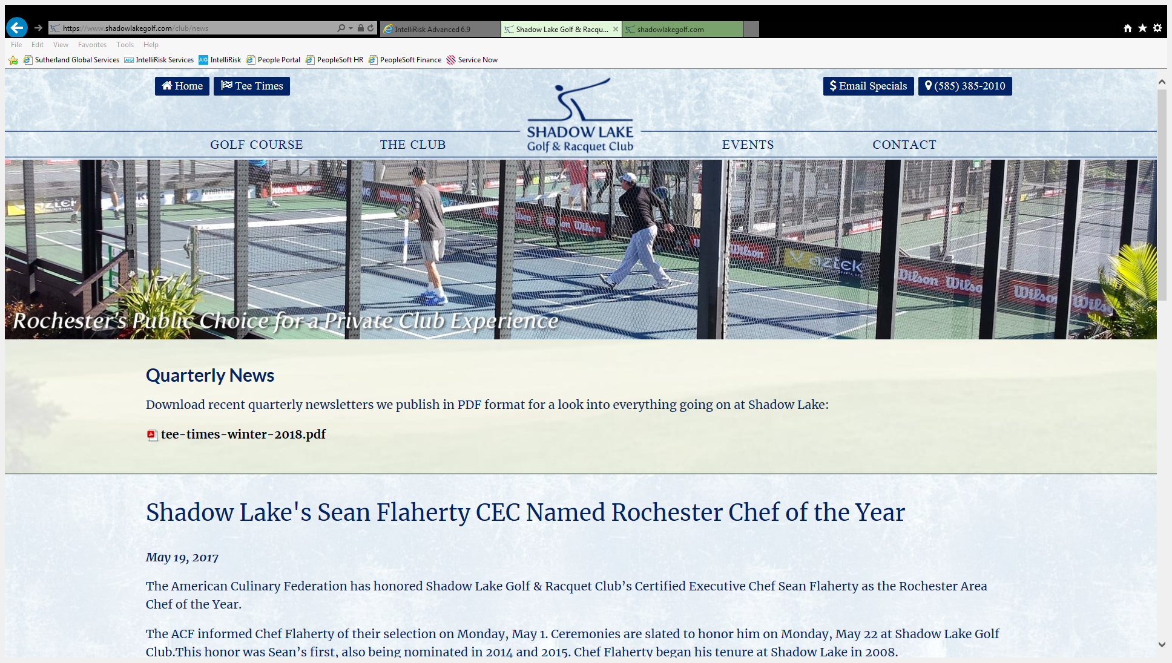](https://www.shadowlakegolf.com/club/news)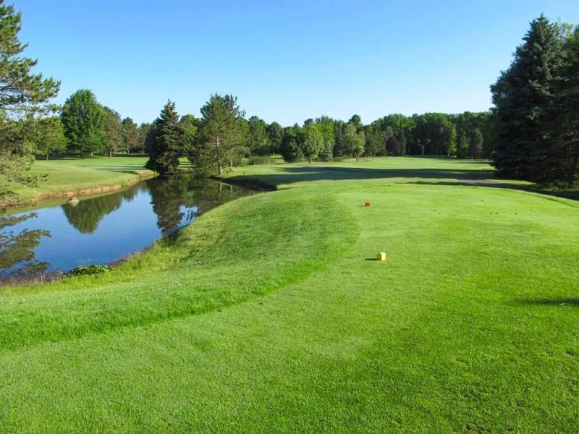

**Tuesday, june 18, 2019**

RIMS upstate ny 25th annual golf outing

**18 Holes, Lunch, Contests, Prizes, Networking, Dinner and More!**

Come join the fun at the RIMS Upstate NY Chapter Golf Outing at Shadow Lake! This annual event is a great opportunity to network with local Risk and Insurance Professionals. For non-golfers, please join us for dinner or consider a sponsorship for your organization.

A portion of the proceeds will benefit:

**Shadow Lake Golf &**

**Raquet Club**

**1850 Five Mile Line Road**

**Penfield, NY 14526**

**9:30a Registration**

**10:30a Tee Time**

**3:30p Drinks,**

**Hors d’oeurves,**

**Dinner & Awards**

**Entry Fees:**

**$160 Single Registration**

**$600 Foursome Registration**

**$60 Dinner Only**

**Registration Available Online At:**

[**http://upstatenewyork.rims.org**](http://upstatenewyork.rims.org)

**Highlights Include:**

* **Team Scramble Format**
* **Hole In One Prize**
* **Contests**
* **Basket Raffles & 50/50**
* **Other Great Prizes**
* **Sponsorship Opportunities**

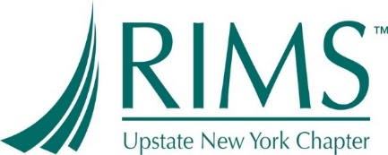

**Golf Committee:**

**• Sarah Gibson (M&T Bank)**

**• Anne Askloff (Sutherland)**

**• Annette Maldonado (Rich Products)**

**• Vicki Froman (Rich Products)**

**• Shanna Baritot (American National)**

**• Chris Hoch (Raymour & Flanigan)**

**For more information, please contact:** Viki Froman, RIMS Upstate NY Secretary

Phone: (716) 878-8894 or Email: [vfroman@rich.com](mailto:vfroman@rich.com)

**For more information, please contact:** Viki Froman, RIMS Upstate NY Secretary Phone: (716) 878-8894 or Email: [vfroman@rich.com](mailto:vfroman@rich.com)