GOLF REGISTRATION
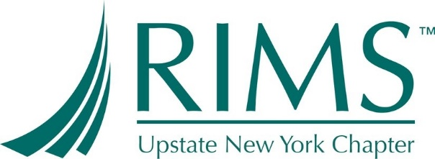

2019 RIMS upstate New york – golf fundraiser
25th ANNUAL GOLF EVENT
A portion of proceeds will benefit:
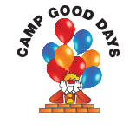

SHADOW LAKE GOLF CLUB
1850 Five Mile Line Road, Penfield, NY 14526
Event Date: Tuesday, June 18, 2019
Registration: 9:30 AM – 10:15 AM
Shotgun: 10:30 AM

- Register early-space available for the first 144 registrants
- Includes: round of golf, dinner, snack bar lunch, and beverages on the course
- Purchase raffle tickets throughout the day on great prizes
- Awards from contests and raffle prizes distributed during dinner
- Golf clubs may be rented by contacting the Pro Shop at Shadow Lake Golf Club
Sponsorship Opportunities Available! See Golf Sponsorship Form for details
REGISTRATION:
$160 Single Golfer  Single golfer will be place on foursome the morning of event |  |  |  | $600 Foursome  Save $10 per golfer by registering a foursome
$1,250 Gold Sponsorship  4 rounds of golf + tee sign |  | $750 Silver Sponsorship  2 rounds of golf + tee sign |  |  |  | $500 Bronze Sponsorship  Round of golf + tee sign
Please complete page 2

2019 RIMS upstate New york – golf Registration Form
GOLFERS: (Please complete electronically)
☐ Single | ☐ Foursome | ☐ Gold | ☐ Silver | ☐ Bronze | ☐ Dinner Only

Name |  | Company |  | Phone |  | Email |  | Dinner?
 |  |  |  |  |  |  |  | ☐ Yes ☐ No
 |  |  |  |  |  |  |  | ☐ Yes ☐ No
 |  |  |  |  |  |  |  | ☐ Yes ☐ No
 |  |  |  |  |  |  |  | ☐ Yes ☐ No
Note: Dinner Only = $60 per person (please be at the course by 3:30)
PAYMENT OPTIONS:
- Credit Card via PayPal, Check, and Cash
- Make checks payable to RIMS Upstate New York Chapter
- Note: We will not be able to accept credit cards for raffle tickets
Deadline & Refunds: Your Entry Fee must be received by June 16, 2018. No refunds will be provided after June 16, 2018.
Golf Committee: Sarah Gibson, Anne Askloff, Annette Maldonado, Vicki Froman, Shanna Baritot, Chris Hoch

Forward completed form to:
Annette Maldonado c/o Rich Products
1 Robert Rich Way, Buffalo, NY 14213
Phone: (716) 878-8404 amaldonado@rich.com

