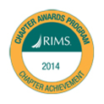
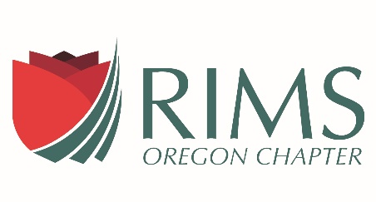

ARM Courses Offered by RIMS, Oregon Chapter
Fall Term 2018

ARM 54: RISK MANAGEMENT PRINCIPLES AND PRACTICES

Focuses on risk management programs and process; operational, financial and strategic risk management; and risk identification, analysis and treatment. 10 weeks. INSTRUCTOR: Eva LaBonte, MS, ARM, (503) 846-4476 Eva_LaBonte@co.washington.or.us TIME AND LOCATION: Live Online Course 5:00 – 6:30 PM, Tuesday, August 28 to October 30.

ARM 55: RISK ASSESSMENT AND TREATMENT

Focuses on root cause analysis, business continuity, property risk, legal and regulatory risk, management liability, HR risk, environmental risk, crime and cyber risk, and fleet risk. 11 weeks. INSTRUCTOR: Victoria Nolan, ARM, CSP, (503) 681-3626, nolanv@cleanwaterservices.org TIME AND LOCATION: Live Online Course 5:00 – 7:00 PM, Tuesdays, September 4–November 13.

Early Bird Registration by August 17, 2018. Registrations after that date may not be accepted. No refunds will be given after the first two weeks of the course. Please send checks or credit card information payable to “RIMS, Oregon Chapter” as requested below. RIMS, Oregon Chapter reserves the right to make alternative study plans or cancel a class if a minimum registration is not met.

Books need to be ordered on-line at www.aicpcu.org. Oregon RIMS does not provide books. An IIA/CPCU ID Number is required to register, if you do not have one please visit the above web site. Please ensure your AICPCU “My Profile” information is listed as NOT CONFIDENTIAL as OR-RIMS and your instructor would like access your contact information. The exam window is October 15-December 15.

--------------------------------------------------------------------------------------------------------------------------------------
Fall 2018 - ARM 54 & ARM 55 REGISTRATION FORM
Please be sure to note each class schedule.

Name

Email address or Phone number

AICPCU ID Number (must obtain to register)
Social Security Numbers are NOT accepted.

REGISTRATION FOR: (Check one)
ARM 54: Risk Management Principles
ARM 55: Risk Assessment and Treatment

TUITION (Excludes Books & Exam Fee):
Early Bird Registration:
RIMS Members …... $250.00
Non-Members …..… $275.00
After August 1, 2016 Registration:
RIMS Members …... $275.00
Non-Members ….. . $300.00

Please e-mail registration form to
Education Chair, RIMS, OR Chapter
educationorrims@gmail.com

Send Payment (Check/Credit Card) to:
Dale Lindstrom
c/o Oregon Chapter of RIMS
PO Box 2010, Portland, OR, 97208
treasureroregonrims@gmail.com

CEU Credits Requested - Students must attend ALL classes and pass the exam to receive CEU’s

