
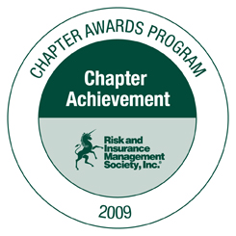

Piedmont Chapter

President
JORIE DICKERSON
SAS Institute Inc.
SAS Campus Drive, T0120
Cary, NC 27513
Jorie.Dickerson@sas.com
919.531.6129

Vice President
& Chairperson – Student Involvement
ED ADAMS
Progress Energy, Inc.
P.O. Box 1551, PEB 19A3
Raleigh, NC 27602
ed.adams@pgnmail.com
919.546.6003

Treasurer
LISA BALCERAK
Quintiles Transnational Corp.
4820 Emperor Boulevard
Durham, NC 27703
lisa.balcerak@quintiles.com
919.998.7481

Secretary

& Co-Chairperson Membership
JIM WATSON
General Parts, Inc.
2635 E. Millbrook Road
Raleigh, NC 27604
jim.watson@gpi.com
(919) 227-5240

Chairperson – 2011 Southeastern Educational Conference
MARI-JO HILL
SAS Institute Inc.
SAS Campus Drive, T0116
Cary, NC 27513
Mari-Jo.Hill@sas.com
919.531.7912

Chairperson – Events
ANN HUDOCK
Dex One
1001 Winstead Drive
Cary, NC 27513
Ann.Hudock@dexone.com
919.297.1260

Co-Chairperson Membership
CHARLOTTE PEEDIN
Golden Corral Corporation
P.O. Box 29502
Raleigh, NC 27626-0502
cpeedin@goldencorral.net
919.881.4606

Webmaster
CHARLIE WILDES
Talecris Biotherapeutics Inc.
79 TW Alexander Drive
Research Commons 4101
Research Triangle Park, NC 27709
charles.wildes@talecris.com
919.316.6483

