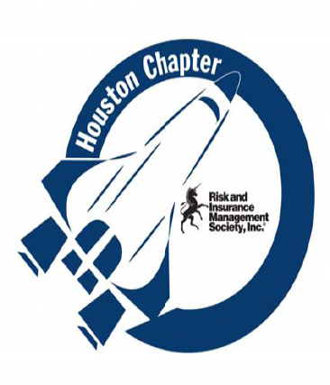
 | THE CHAPTER ACHEIVEMENT AWARD WINNING HOUSTON CHAPTER
March 2011
In This Edition:  - Chapter President Message  - Meeting Information  - Welcome New or Renewed Members  - Opportunity to Donate  - Texas RIMS on the Hill  - Professional Development – CPCU  - UHD Student at RIMS on the Hill  - Social Sponsor  - Educational Opportunity  - Facebook  - UHD Internship Program  - 2011 National RIMS Conference – Vancouver, BC  - Chapter Information  - Job Postings  - Meeting Place  2011 Houston Chapter Board Members and Advisors  President  Stephanie Degreve, CRM  Swift Energy  Stephanie.degreve@swiftenergy.com  First Vice President & Legislature  Nikolas G. Kapatos  Sterling Bancshares, Inc.  nick.kapatos@banksterline.com  Vice President & Treasurer  Michelle Wilkerson  Newfield Exploration Company  mwilkerson@newfield.com  Vice President & Secretary  Sondra K. Faul, CIC  The University of TX HSC-H  sondra.k.faul@uth.tmc.edu  Vice President & Assistant Secretary  Jo Anne Lancaster, ARM  Westlake Chemical Company  jalancaster@westlake.com  Membership & Attendance Director  Cynthia Vickers, CPCU, ARM  El Paso Corporation  Public Relations & Newsletter Director  John Lawson, ARM  Goodman Global, Inc.  john.lawson@goodmanmfg.com  Chapter Liaison &  Job Placement Director  Ginny Penzell, ARM, RF  El Paso Corporation  ginny.penzell@elpaso.com  Education Director  Sharon Guillory, ARM  sharonguillory@att.net  Associate Director of Education  Tiffany Barnes  Halliburton Company  tiffany.barnes@halliburton.com  RIMS Delegate  Ella Andrews  Friedkin Companies, Inc  eandrews@friedkin.com  Past President  Victor Pivetta, ARM  Vopak North American Inc.  Victor.pivetta@vopak.com  Advisors to the Board  Webmaster  Shawn Pickens  sppickens@earthlink.net  Webmaster  Julia Mercer  PSC, LLC  jmercer@pscnow.com  ARM Instructor  Jim Drew  Bowen Miclette and Britt, LLC  jdrew@bmbinc.com  National RIMS Board Liaison  Michael Phillipus  ATP Oil & Gas Corporation  mphillipus@atpog.com  Our February  Meeting Moments  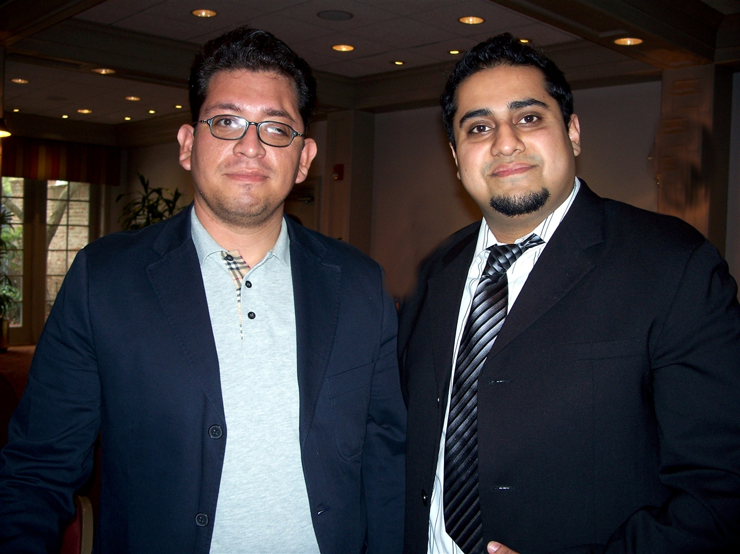  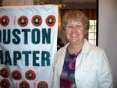  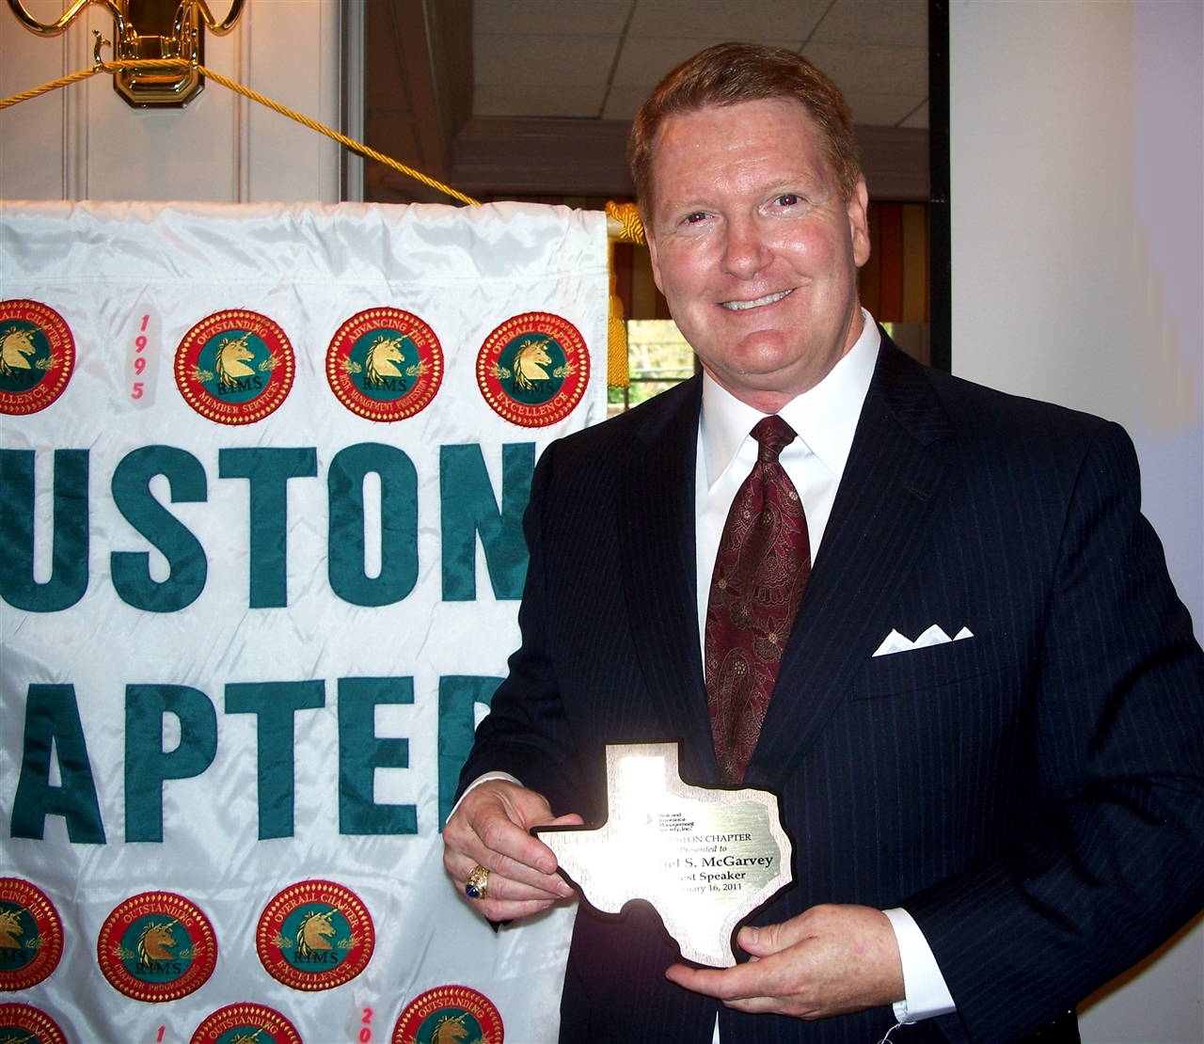    RIMS Chapter Meeting  Dates for 2011  March 15, 2011  Joint RIMS – CPCU Meeting  April 19, 2011  Evening Social  May 1 – 5, 2011  49th Annual RIMS Conference in  Vancouver, BC Canada  May 18, 2011  Staff Appreciation Meeting  June 15, 2011  July 20, 2011  Past Presidents Appreciation  August 16, 2011  September 21, 2011  Education Programs Meeting  October 14, 2011  Fall Conference and Golf Tournament  November 16, 2011  ARM Completers Recognition  December 14, 2011  Evening Meeting  The Houston Chapter RIMS mailing address is  5090 Richmond Ave. #86  Houston, TX 77056-7402  G-Mail Address is  RimsHou@gmail.com  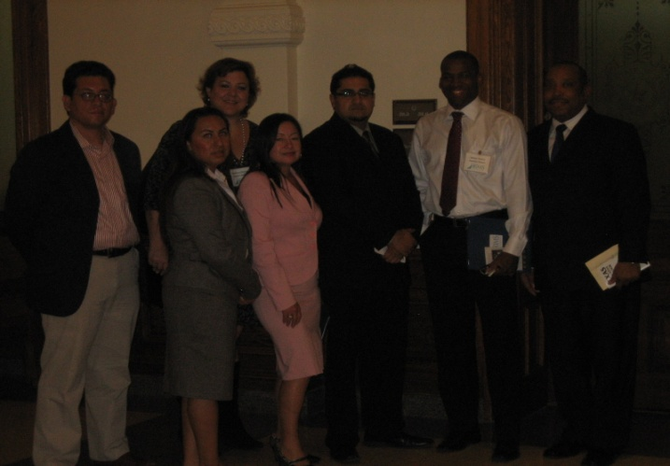  UHD IRM students (L-R) Eustulio Sanchez, Elizabeth Salgado, Isabel Jordan, Andy Trivedi, Adrian Hopkins and Rodney Singleton with UHD IRM faculty member and Houston RIMS President Stephanie Degreve (back).  Educational and Associations Websites:  American Institute for CPCU and Insurance Institute of America www.aicpcu.org  Charter Property Casualty Underwriters Society www.cpcusociety.org  Institutional Risk  Management Institute  www.irmi.org  The National Alliance www.scic.com  Construction Risk and  Insurance Specialist  www.cris-ce.com  For further Educational Opportunities Forms or Information, please visit the Chapter website at:  http://houston.rims.org/ChapterWebsite/RIMSChapter.cfm?CID=328  NOTICE:  Effective January 1, 2008, the RIMS Society changed their method of collecting Local Chapter Dues. In the past there were two deputies included with the membership, then a charge for each additional deputy added. Under the new structure they will begin collecting chapter dues on a per deputy member basis. The new structure for the Houston Chapter Dues is $55 per deputy member. The change will be reflected on the renewal invoice. The dues structure for associate membership has not changed.  Please see our Chapter Website for  additional information:  WWW.RIMS.ORG/HOUSTON  or  WWW.RIMS.ORG – Chapters – Houston  Please see the Local Chapter website and the RIMS.org Jobs Listing for details.  Published by the Houston Chapter of the Risk & Insurance Management Society |   FROM THE DESK OF THE CHAPTER PRESIDENT…  Hello to our RIMS community!  2011 is off to a great start and continually getting better. First and foremost, we are proud to announce that the Houston Chapter has been selected as a winner of a Chapter Achievement Award as part of the RIMS 2010 Chapter Award Program. Nick Kapatos will be accepting the Communication Achievement Award for our Newsletter on behalf of the Houston RIMS Chapter at the National Conference in Vancouver the first week of May. We take pride in our communications and hope that you appreciate what we deliver to you.  The second event I would like to touch on is the RIMS on the Mall event several of the Houston Board members attended last month. It was a fantastic experience and, along with several other Texas chapters, quite a bit was accomplished by RIMS. Further information regarding our experience can be found in Nick’s article within this newsletter. The next session is in 2013 and we encourage everyone who is available to join us.  Earlier in this letter, I mentioned the RIMS National Conference in Vancouver. The deadline for registration is April 1st. The RIMS conference is one of a kind and is a great opportunity for a meeting of risk minds on a national level. RIMS Houston has reserved two tables at the Awards Ceremony (Monday, May 2, 12:25), please come sit with your fellow members to show support for the Houston Chapter as we are presented with our award.  We’ve reserved the Woodlands Resort & Conference Center for our Fall Conference on October 14th. Please mark your calendars now – we’ll be communicating additional information to you in the coming weeks and months.  Finally, we hope to see you all at the RIMS Social at 5:30 on Tuesday, April 19th at Berryhill Baja Grill. We find our socials to be a great opportunity for networking among our members. A big thank you to Gardere Wynne Sewell LLP who has generously offered to sponsor this event.  Stephanie Degreve  Chapter President  March Meeting Topic and Speaker  Tuesday, March 15, 2011  11:30 AM – 1:00 PM  Joint Meeting with CPCU Houston Chapter  and RIMS Houston Chapter  Speaker: Loren Steffy  Loren Steffy is the business columnist for the Houston Chronicle. His column appears in on Wednesdays, Fridays and Sundays, and he writes a daily blog (http://blogs.chron.com/lorensteffy/) that discusses business topics. He has appeared on CNBC, Fox Business, the BBC and the NewsHour with Jim Lehrer.  Mr. Steffy is the author of Drowning in Oil: BP and the Reckless Pursuit of Profit published by McGraw-Hill in 2010 and The Man Who Thought Like a Ship, which is scheduled to be published by Texas A&M University Press in early 2012.  Welcome New and Renewed Members  Tony Braddock – International Risk Consultants  David Fox  Sharon Guillory  Alvaro Guzman - Exterran  Adrian Hopkins – University of Houston - Downtown  Bryan Leger – MEI Technologies, Inc.  Diana Morales – Stage Stores  Brittney McVay – Murphy Oil Corporation  Shawn Pickens  Michael Williams – Brown Sims, PC    Texas RIMS on the Hill – Austin 2011  Contributed By Nick Kapatos  On February 28, 2011 Houston Chapter members together with members from our other three Texas RIMS chapters met in Austin for our second biennial visit to the Capitol. This two day event included a day of training to prepare us for the discussions that would take place with elected officials and their staff the following day. On Tuesday March 1st we presented RIMS’ position on three pieces of legislation being considered during the 82nd Legislative Session.  There were over 30 risk professionals from around the state that attended the Monday training session. The workshops included speakers that addressed current legislation and regulatory issues in Texas as well as legislative advocacy. Houston attendees for our training on Monday included:  - Stephanie DeGreve, Risk Analyst, Swift Energy Operating, LLC  - Nick Kapatos, SVP & Enterprise Risk Manager, Sterling Bank  - John Lawson, Director of Risk Management, Goodman Global, Inc.  - Michele Wilkerson, Risk Analyst, Newfield Exploration Company  - Julia Mercer, Corporate Claims Analyst, PSC, LLC  - Rob Walters, Corporate Insurance/Risk Management, Conoco-Phillips  - Rebecca Rowland, Risk & Safety Manager, Link Staffing Services  - Dr. Wendall Braniff, Director, UHD Insurance & Risk Management Center  - Adrian Collins, student, UHD Insurance & Risk Management Center  On Tuesday, our Houston delegation split into two groups and met with a total of six legislators and staffers to discuss RIMS’ position on the following three bills:  1. HR 1535 - Relating to the participation of this state in the Surplus Lines Insurance Multi-State Compliance Compact.  2. SB 425 - Relating to property and casualty certificates of insurance and approval of property and casualty certificate of insurance forms by the Texas Department of insurance; providing penalties.  3. SB 511 - Relating to the designated doctor's examination under the workers' compensation system.  During our meetings we emphasized that risk managers are insurance consumers and not brokers or carriers, a distinction that is important to make to those who might not know exactly what we do.  We are also happy to report that one of the bills that we presented, SB 425, on certificates of insurance made it out of the State Affairs Committee on Monday March 7th with all members present voting for it. We also now have a companion bill, HB 1803, which has been referred to the House Insurance Committee.  Overall it was a fantastic two days. I encourage all of you who did not attend to consider attending two years from now. If you cannot wait two years, then RIMS on the Hill in Washington DC is only three months away and takes place from June 12th to June 14th. Both events are excellent opportunities to learn about the legislative process and to help shape pending legislation affecting the risk management and insurance industry. We can make a difference in our legislative process if we try!  CPCU Chapter Announcement  executive Risk liability: DIRECTORS & Officers, Employment practices and fiduciary liability  Tuesday – march 15, 2011  8:15 am – 11:15 am  Please return attached form by march 4, 2011  Where: Briar Club – 2063 Timmons @ Westheimer  Houston, TX 77027  713-622-3667  Attendance Fee: $85 per person (CPCU, RIMS members = $75)  10% disc: register by Feb 22  Includes: Coffee & rolls  Lunch after: East Room – Briar Club  Hosted by Houston Chapter of CPCU @ $20 per person  (Pre-paid Chapter members “free”)  This seminar discusses key components of Directors & Officers, Employment Practices and Fiduciary Liability – valuable information for organizations and the agent/brokers, underwriters and risk managers who serve those companies.  Speaker/panel: David Garrett, Managing Director Professional Indemnity/Bond Dept with John L. Wortham & son, L.P., will highlight director, officer and entity exposures as well as review policy language and applicable endorsements.  Corey Dunbar, AVP, Market Development Manager, Hartford Steam Boiler Inspection & Insurance Co. will highlight changes in workplace attitudes and behavior. He will also discuss employer coverage benefits and protection with an emphasis on “wrongful acts” and key features that most policies provide.  Jeff Barnes, Associate, Houston office of Jackson Lewis LLP will highlight current legislation and its potential impact on employer-related matters, including contractual disputes, class actions and claims of discrimination, harassment, retaliation and defamation.  Chapter Hosts UHD Insurance and Risk Management Student at Texas RIMS on the Hill Event  Contributed by Dr. Wendell Braniff  The Houston Chapter of Risk and Insurance Management Society hosted University of Houston Downtown insurance and risk management senior Adrian Hopkins at the 2011 Texas RIMS on the Hill legislative event. UHD Insurance and Risk Management Center Director Dr. Wendall Braniff, a Houston RIMS member, also attended the conference, which focused on pending health care, property and liability insurance and surplus lines legislation. They attended educational workshops on current legislation and regulatory issues in Texas with industry professionals at the Texas Association of Counties in Austin and met with legislators at the State Capitol to learn about the legislative process and pending legislation affecting the risk management industry.  In addition to the legislation discussions, Lee Ann Alexander, Assistant Vice President of Public Affairs and Senior Legislative Counsel for Liberty Mutual provided pointers on legislative advocacy. During the catered lunch, Mr. Hopkins and Dr, Braniff visited with Houston RIMS board members and advisor including Nikolas Kapatos, Senior VP and Enterprise Risk Manager for Sterling Bank, John Lawson, Director of Risk Management for Goodman Global, Inc., Julia Mercer, Corporate Claims Analyst for PSC, LLC, Michele Wilkerson, Risk Analyst for Newfield Exploration Company and Houston Chapter president, Stephanie DeGreve, Risk Analyst for Swift Energy Operating, LLC who is also an Adjunct Lecturer at UHD and teaches a risk management course in which stiudents can also earn credits toward a Certified Risk Manager professional designation.  At the Capitol, Hopkins accompanied Degreve, Mercer and national RIMS Government Affairs Manager Nathan Bacchus for a meeting with staff for Representative Senfronia Thompson. Dr. Wendall Braniff and UHD students Eustulio Sanchez, Elizabeth Salgado, Isabel Jordan, Andy Trivedi, and Rodney Singleton joined them for a meeting with Debra Gonzales, Legislative Director for Senator Mario Gallegos to discuss RIMS’ positions on SB 511 (Van de Putte), relating to medical exams by treating or referral doctors which RIMS opposes; HB 1535 (Eiland) relating to the surplus lines multi-state compliance compact which RIMS supports with amendments; and HB 1803/SB 425 (Hancock/Carona) relating to certificates of property and casualty insurance which RIMS supports.  Hopkins also attended a House Insurance committee meeting with UHD Guest Lecturer Dr. Tom Braniff, Texas Insurance Consulting President, where they listened to testimony by Texas Department of Insurance Commissioner Mike Geeslin on TDI’s recent action to place Texas Windstorm Insurance Administration, a state-created but privately-run insurer, under state administrative oversight. Representative John Zerwas, a physician and sponsor of HB 636 also laid out his bill related to the creation of the health benefits exchange, the Texas Health Insurance Connector to committee members.  “Participating in this event has been an illuminating experience, commented Hopkins, who will be the UHD IRM program’s first graduate in May. “The UHD IRM program is an outstanding way to make industry business connections that lead to great career opportunities in the insurance and risk management industry.”  Social Event - April 19th  The Chapter would like to the firm of Gardere Wynne Sewell LLP who has generously offered to sponsor this event at Berryhill Baja Grill. Please watch for your E-vite in the near future and RSVP if you would like to attend.  Opportunity to Donate  We are looking our members to potential donate door prizes for the meetings. If you would like to donate, please contact any Board member. We appreciate your consideration in this matter.  Educational Announcement  Presented by Marsh’s Academy of Risk  Risk Management 101  Managing Risk and Understanding the Insurance Marketplace  Event Overview  Risk Management today, now more than ever, is a crucial part of every organization’s business practices. With the definition of risk constantly evolving, the risk management process has become more of a strategic practice within the organization. Identifying, managing and monitoring risk requires discipline, organization and strategy. Marsh developed Risk Management 101 to help individuals responsible for their company's insurance plans to get a basic overview of risk management. We understand that corporate insurance may not be your only function, and this course will review the different policies available, what they insure, and how to manage the insurance responsibilities.  Part 1 of a 3 Course Series:  - RM201—May 17th  - RM301—September 15th  Agenda  - Overview of Risk Management  - Commercial Insurance Marketplace  - Understanding Insurance Contracts  - Risk Management Issues  Who Should Attend  Risk Managers and individuals with risk and insurance responsibilities  Chief Financial Officers, Treasurers, and Controllers  Senior Managers wanting baseline knowledge of risk management concepts  This course is provided to all clients and invited guests of Marsh, free of charge.  This course is approved for 6 hours of General Continuing Education Credit for Texas  Property & Casualty and Life & Health Insurance licenses. Please bring your appropriate license number with you to receive CE credit.  Date/Time  Thursday, March 24, 2011  8:30 am to 3:00 pm  Location  Marsh Houston Office  1000 Main Street  Suite 3000  Houston, TX 77002  Guests should come to the 30th Floor for reception to sign in.  Parking  Please park in the building parking garage using the Travis Street or McKinney Street entrances and bring your ticket to the receptionist for validation.  RSVP  Please register online at:  www.seeuthere.com/RM101/Houston  Should you have additional questions, please contact Krista Perry at 214.303.8553 or Krista.Perry@marsh.com  The Chapter is now on Facebook  While on you Facebook account search for Houston Chapter of the Risk and Insurance Management Society. Once on our page, click the "like" button on the right side of the page to follow the activity.  We are in need of content so please join.  UHD Recruiting Event  University of Houston Downtown (UHD) Career Center is hosting a Spring Recruiting event. The Insurance and Risk Management (IRM) center will be coordinating with the UHD Career Center to develop internships for their IRM majors and minors to fulfill their requirements for Field Experience this summer. All IRM internships must be arranged by April 15, 2011 for students to be eligible to use the internship to fulfill their Field Experience requirement. Students will be evaluated for the period of June 7 – July 27, 2011, so the internship needs to start by around June 7th.  Employers can register at www.uhd.edu/jobs4gators  National RIMS Conference 2011  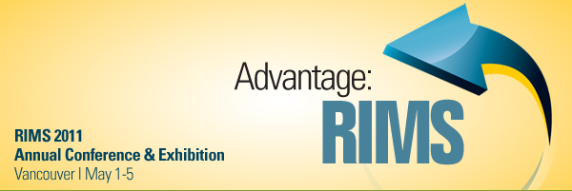  Monthly Drawings for Evaluation Completion  Please remember to complete the speaker evaluation at each meeting and be placed in the drawing for the next meeting to win cash.  Names Badges  Please be advised that the colors of the badges have meaning.  Green – Board Members  Blue – Deputy Members  Yellow – Associate Members  Light Purple – Committee Members and Volunteers  Please contact Cynthia Vickers (cynthia.vickers@elpaso.com) if you need any changes to your badge.  Houston Chapter Membership Directories  The 2010 Houston Chapter Membership Directories are available. The directory may be picked up at the monthly meetings.  Job Postings  National RIMS Website – Texas  Manager of Risk Management – Dallas Area  Risk Management Analyst – Dallas Area  Insurance Manager – Dallas Area  Houston Area – Local Chapter Posting:  Underwriting Account Executive  Customer Service Representative  Senior Risk Analyst  Loss Control Manager  Assistant Director for Campus and Occupational Safety  Austin Area – Local Chapter Postings:  Property & Casualty Underwriter  Dallas Area – Local Chapter Postings:  Risk Manager  Workers’ Compensation Claims/Leave of Absence Program Coordinator  Property, General Liability, Auto Coordinator  Loss Control Coordinator  Risk and Insurance Staff Consultant  San Antonio Area – Local Chapter Postings:  Assistant Risk and Safety Manager  Memberships - National  Please be advised that with the economic conditions and the number of layoffs that has occurred, RIMS National has announced that the Deputy memberships will not be automatically terminated for up to six months for those members that have been laid off. Please notify the National Membership office if a layoff has occurred.  Luncheon Meeting Place  The Briar Club  2603 Timmons Lane  Houston, Texas 77027  Telephone: (713) 622-3667  Wednesday, January 19,2011  11:30 AM – 1:00 PM
   |  | General Session  Apolo Anton Ohno  Olympic Gold Medalist  Far and away the biggest name in American speed skating, Apolo Ohno has won five Gold medals at the Winter Olympics and is one of only four Americans to win three medals in a single Olympics. Ohno will share his story of overcoming obstacles and triumphing in the face of adversity.
   |  | Risk Leadership Keynote Luncheon  Stephen Dubner  Author, FREAKONOMICS and SUPERFREAKONOMICS  Award-winning author Stephen J. Dubner will show how economics is, at root, the study of incentives—that is, how people get what they want, or need, especially when other people want or need the same thing. He uses humor and first-rate storytelling to discuss topics that are on every businessperson’s mind.
   |  | Keynote Speaker Breakfast  Ron Holton  Vancouver Organizing Committee for the 2010 Olympic and Paralympic Winter Games  Hear first-hand how the Vancouver Organizing Committee implemented a fully integrated ERM program and how the program assisted with the management of risks that manifested during the 2010 Winter Games.
  View the online conference program and sessions guide for complete details.
  We have lots more information to share with you. Join us online for Vancouver travel tips, conference updates, details on what our speakers are up to, timely articles and fun contests. (Shh…our first contest starts next week on Twitter). We’re listening, so tell us what you’d like to learn or see at RIMS 2011!
  The Early Bird discount expires on Friday, March 4. Register today!

