Presentation title in sentence case (Arial, 12 pt, bold, centred)

Lucia A. Wangª, Jack N. Bloggs^{a,b}, Jane Jones^{c}

ªDepartment Name, Organisation, City, State, Country;
^{b}Department Name, Organisation, City, State, Country;
^{C}Department Name, Organisation, City, State, Country.
LAW: lawang@insta.edu.au, JNB: j.bloggs@insta.edu.au, JJ: j.jones@instc.edu.au

All text should be in Arial, 11 pt except the abstract title which is 12 pt bold.
Underline the presenting author’s name only.
The body of the abstract should be fully left-and right-justified. Line spacing must be single. The abstract must not exceed one A4 page. An abstract submission file must be 10 MB or smaller. Do not use bold in the abstract text, only the title should be in bold.
The text should be as informative as possible.

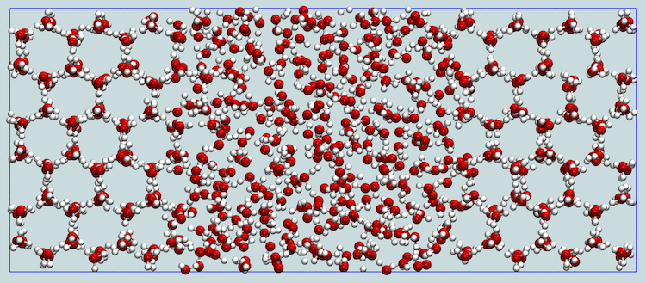
Figures should be centred. Figure caption is optional.

Please pay particular attention to these instructions as abstracts that do not conform will be returned to the authors for reformatting.

Please submit your abstract before 20 October 2025 abstract submission deadline.

References
- T. Omura and R.Sato, “A new cytochrome in liver microsomes” J. Biol. Chem., 237, 1375,
(1962).

