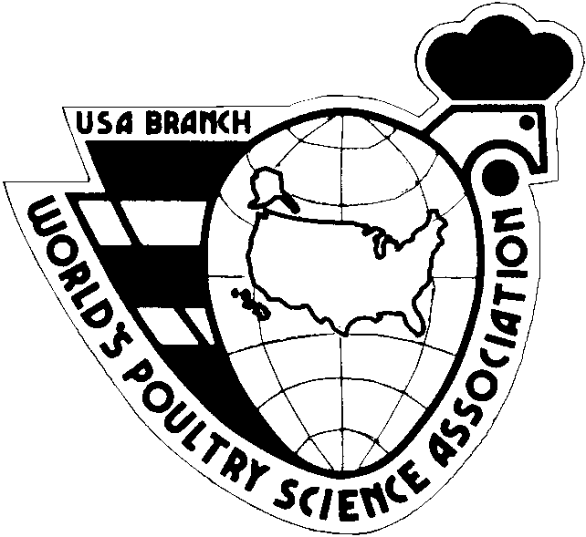

WORLD’S POULTRY SCIENCE ASSOCIATION – USA BRANCH

2026 CLIFF D. CARPENTER STUDENT ESSAY CONTEST
Three travel awards ($1,000 each to be matched by the student’s institution for a total award of $2,000) will be made on a competitive basis to poultry science students (see criteria listed below) for attendance at the XXVII World’s Poultry Congress, to be held July 13-17, 2026 in Toronto, Canada. Awardees will be selected based on an essay submitted by the applicant and evaluated according to guidelines established by the WPSA-USA Branch Carpenter Essay Committee.

•Eligibility Requirements

1. Birthday between October 15, 1995 and October 15, 2007 (i.e., age 18-30 on October 15, 2025)

2. Full-time undergraduate or graduate student majoring in Poultry Science or a related discipline with a poultry emphasis at a U.S. institution of higher education. For clarification, students in a D.V.M., Ph.D., M.S., or B.S. program are eligible for this competition.
3. WPSA-USA membership in 2025

•Application Procedure and Essay Guidelines
1. The entire essay (including preface) will not exceed 1000 words.
2. The typewritten manuscript will be written in English. The document should include a Preface page (see below), a Title page, and the essay.
3. Each application MUST be accompanied by:
a) The official application form (below);
b) One brief letter of recommendation (no more than 1 page) from a person in authority at the applicant’s institution (e.g., Department Head, Undergraduate Program Director, or the applicant's academic advisor), that includes statements that indicate:
•In what capacity, and for how long, the person writing the letter of recommendation has known the applicant
•The applicant is within the age limitations;
•The applicant is a full-time student in good standing, and meets all the other selection criteria;
•Other brief statements of support
4. Submit all documents to the email address listed below, NO LATER THAN October 15, 2025.
5. The Essay Committee will determine the winning entries based on the scoring criteria outlined below. Please follow directions, as this will affect the final decision.
6. Keep a copy of your essay and application form for your records.
7. If you have not received an e-mail of receipt within 5 days of emailing, please direct inquiries by phone or email to the contact listed below.

Essay Topic – What are the main effects of climate change on poultry health and productivity?

Winning applicants will be determined according to the highest point score. Alternate applicants will be determined in the same manner. Scores will be kept confidential. The scoring criteria and point value for the essay are as follows:

Criteria | Points
Neatness | 5
Clarity of writing | 5
Grammar | 10
Spelling | 10
Length | 10
References cited | 10
Preface | 10
Insight | 20
Accuracy of statements | 20
Total | 100

The Preface, containing no more than 200 words, will be used in addition to the essay to determine the award recipients, and will include a brief description of the applicant’s:

•Educational and personal background

•Experience in, and contributions to, the poultry field or industry

•Current and future poultry interests

•Future career plans

AWARD

Each award recipient will be reimbursed for $2,000 in travel and registration expenses ($1,000 from WPSA-USA Branch and $1,000 matching from their institution [e.g., department, college, or university]). The WPSA-USA Branch Travel Grant is intended to be used for registration fees, airfare, and other expenses directly related to attending the WPC2026 in Toronto.

Contact information for application forms and details for participants:
Dr. Bob Buresh (WPSA-USA Branch Secretary)
Email: wpsausa@gmail.com
Phone: (864) 633-8633
WORLD’S POULTRY SCIENCE ASSOCIATION – USA BRANCH

2020 CLIFF D. CARPENTER STUDENT ESSAY CONTEST APPLICATION FORM

XXVII World’s Poultry Congress, Toronto, Canada, July 13-17, 2026
(Applicant’s information can be typed directly into this Word document)

Date:

- Name of Applicant:
- Home Address:
- Phone Number:
- E-mail address:
- Date of Birth:
- University, College, or Institutional Information:
Name:
Address:
Phone Number:
Academic degree you are currently pursuing:
Major field of study:
- Current Poultry Activities:
- Information regarding the person providing a letter of recommendation:
Name and Title:
Institution:
Address:
Phone Number:
E-mail address:
- Signature of Applicant:

