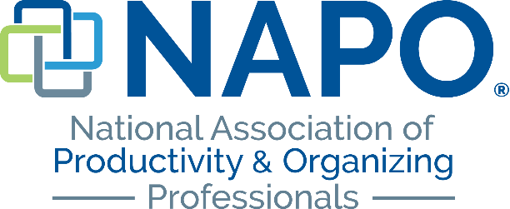

Possible Questions for an Effective Intake Assessment
When you are contacted by a potential client, you will want to gather information that will help you work well with your client. Below are possible questions to ask when conducting an intake assessment.
Contact information
Name
Address
Email address
Home/Work phone
Cell phone
Preferred contact method (email, cell, home, text)
Residential intake
Tell me about what prompted you to contact me.
Have you felt disorganized for a while? What situations have occurred in your home?
Do you live with others?
How long have you lived in your home?
What areas of your home require assistance?
Has your struggle with clutter been throughout your life or has a recent situation or medical condition created more clutter?
What organizing tools do you currently use?
Do your children struggle with organization?
Do you struggle with time management issues?
Do you have a home office? What is it used for?

Business intake
Tell me about what prompted you to contact me.
What type of work do you do?
How long have you been in this position and with this company?
What type of time management system and planner do you use?
How are your paper management skills?
Do you keep a list? What kind?
What are your goals in hiring a productivity consultant/ professional organizer?
What challenges has your disorganization created?
What are some of the negative outcomes that you have experienced from being disorganized?
How does this affect people you work with?
What are your challenges with technology?
Are you able to work on your desk?
What is it you want that you don’t have?
General
Do you prefer to work virtually or on-site?
If on-site, where are you located?
What are your best hours to work? (Weekdays, weekends, business hours, etc.)
How frequently do you want to work?
Do you have a budget?

