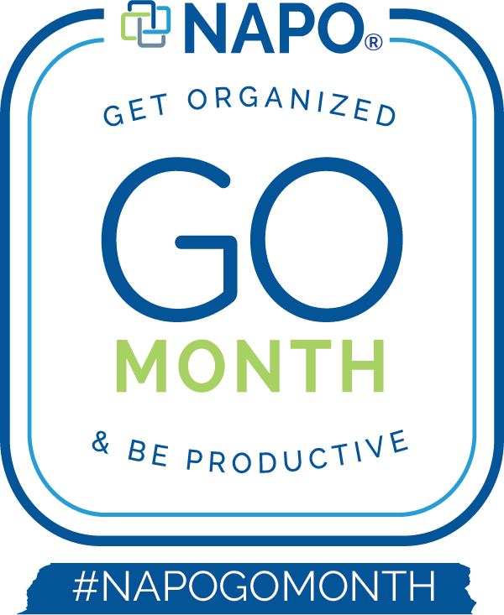

What is GO Month?
January is Get Organized & Be Productive (GO) Month, an annual initiative sponsored by the National Association of Productivity & Organizing Professionals (NAPO). This month-long event increases general public awareness of what NAPO is and how our members are drivers of change by providing unique services tailored to meet their individual client needs.
January is the ideal time for GO Month since “change” is a popular New Year’s resolution. During GO Month, NAPO professional organizers and productivity consultants across the country host events in their communities to empower individuals, families, businesses, and organizations to regain control over their surroundings, time and possessions.

How You Can Promote GO Month
As a valued NAPO member, we need your help to spread the word to your local community! There are many ways you can help share the word about this initiative to your colleagues, neighbors and potential clients. We have created a toolkit with images and logos created specifically for GO Month. We encourage you to share via social media posts, blogs, email blasts to your subscribers, and to use the assets in your collateral.

We suggest changing your Facebook cover or any of your social media profile images with the GoMonth2020 Facebook cover image in the toolkit on dropbox or add any version of the 2020 logo to your social, email signature, website or blog header. The options are endless!

Recommended hashtags
#NAPOGoMonth
#GoMonth2020
#GONAPO
#NAPOPro

Tips, contests, stats, polls and more
NAPO HQ will be posting on Facebook, Twitter, LinkedIn and Instagram - if you haven’t yet followed NAPO take the time to do so from your chapter account and your business account.

Share from HQ!
We encourage you and your chapter to "share" the posts from NAPO HQ - the intention behind this is to make GO Month a national event while we help each other share!

How to Share from FB
Simply click on the NAPO HQ posts and select "share" to post on your personal news feed or "share to a page" to post on your chapter page (if you are an admin for your chapter page).

How to Create an Event on Facebook
How to Invite People to Your Event

Local Chapter Events
If your local chapter is holding an event make sure to tag or add “National Association of Productivity & Organizing Professionals” as your co-host so HQ can share it and create it as a PUBLIC event on Facebook and invite your followers to attend.

Viewing a Story on the Instagram app
If someone has shared a story you haven't seen yet, you will see a colorful ring around their profile picture.
To view someone's story, tap their profile picture at the top of your feed, on their profile or next to a post they've shared on your feed.
Stories you have already viewed will automatically move to the right of the line.
You can tap the screen to skip to the next photo or video, or swipe right or left to skip between people's stories.
Swipe down on the screen or tap x in the top right to exit someone's story and return to Feed.

Viewing a Story on the web at Instagram.com
Stories appear at the top of Feed on mobile, and to the right of Feed from your desktop.
Tap or click on any story to view it, or use the arrows to get to the next screen or story.
Select x in the top right to exit someone's story and return to Feed.

How to share an Instagram post
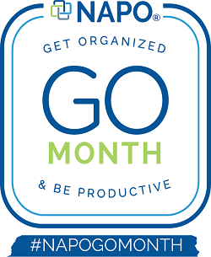
As a NAPO member and/or NAPO chapter member you have our permission to share our posts but here is a helpful article from HubSpot on how to share Instagram posts: https://blog.hubspot.com/marketing/how-to-repost-on-instagram

How Do I Reply to Someone’s Story with a Message?
You can reply to someone’s story with a message by following the steps below:
Open the story you'd like to reply to.
Tap Send Message at the bottom of the screen.
Type your message and then tap Send.

Direct People to the NAPO Site
You can link to the GO Month website we have created - https://www.napo.net/page/NAPOGOMonth2020

Encourage others to join during the month of January as a first-time Provisional Member and save $25 off the application fee with code GOMonth2020!

Click here to access the GOMonth 2020 Toolkit and download:
GoMonth logos in multiple sizes and formats (JPEG, PNG)
NAPO PR Kit
Facebook cover images
Twitter cover image
NAPO Men vs. Women (Member version) Press Release
Chapter Press Release

