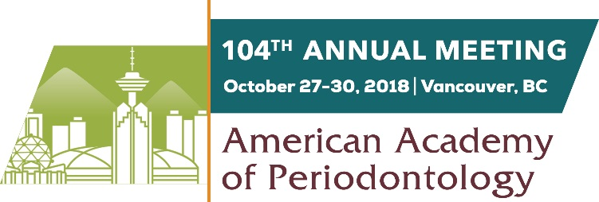

Social Media Posts

Facebook: Join me (or insert practice/company name) by attending the AAP’s 104th Annual Meeting Oct. 27-30 in Vancouver, British Columbia! #PerioAM18 https://members.perio.org/am2018
Twitter: Join @AmerAcadPerio at #PerioAM18, Oct. 27-30. Register today! http://ow.ly/j0jD30jXrCa

Facebook: Expand your knowledge and earn CE by attending the AAP’s 104th Annual Meeting in Vancouver, British Columbia. This year’s program will feature more than 45 courses and 30 new speakers! #PerioAM18 https://members.perio.org/am2018
Twitter: Expand your knowledge and earn CE at #PerioAM18. This year’s program will feature over 45 courses & 30 new speakers! http://ow.ly/j0jD30jXrCa

Facebook: #PerioAM18 has many exciting new offerings, including a live-streaming surgery during a general session, keynote speaker Astronaut Captain Mark Kelly, redesigned program tracks, a speaker studio, and more! https://members.perio.org/am2018
Twitter: #PerioAM18 has many exciting new offerings this year, including redesigned program tracks, a live-streaming surgery, a speaker studio, and much more! Register now at http://ow.ly/j0jD30jXrCa

Facebook: Attend the 2018 AAP Annual Meeting to learn, share, and network with the best and the brightest in the field of periodontology. #PerioAM18 https://members.perio.org/am2018
Twitter: Attend the 2018 AAP Annual Meeting to learn, share, and network with the best and the brightest in the field of periodontology. #PerioAM18 http://ow.ly/j0jD30jXrCa

Facebook: Join @AmerAcadPerio for its 2018 Annual Meeting, to be held Oct. 27-30 in Vancouver. The cosmopolitan city has something to offer everyone, from the five-star cuisine to the dazzling nightlife to the outdoor adventures. Register today! https://members.perio.org/am2018
Twitter: Join @AmerAcadPerio for its 2018 Annual Meeting, to be held Oct. 27-30 in Vancouver. The cosmopolitan city has something to offer everyone, from the five-star cuisine to the dazzling nightlife to the outdoor adventures. Register at http://ow.ly/j0jD30jXrCa #PerioAM18

