PDMA Doctoral Consortium
July 30-August 2 2024
Snyder Innovation Management Center
Whitman School of Management
Syracuse University


When students do, they understand by Professor Barry Bayus, Roy O. Rodwell Distinguished Professor of Marketing, Kenan-Flagler Business School, The University of North Carolina at Chapel Hill

https://snyder.syracuse.edu/barry-bayus-pdma-doctoral-consortium-session-teaching-excellence-in-innovation/ (3:40 minutes)
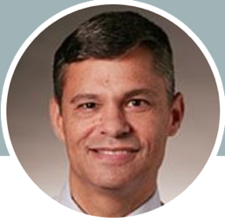
Professor Bayus from the University of North Carolina has learned after many years of teaching that students learn best when experiential learning is part of their education.

His mantra is:

- What I hear, I forget
- What I see, I remember
- What I do, I understand

