PDMA Doctoral Consortium
July 30-August 2 2024
Snyder Innovation Management Center
Whitman School of Management
Syracuse University

Summary of the Talk “Don’t Throw Away ‘Non-Working’ Data” by Ravi Mehta
https://snyder.syracuse.edu/ravi-mehta-pdma-doctoral-consortium-session-data-and-new-research-ideas/ (14:07)
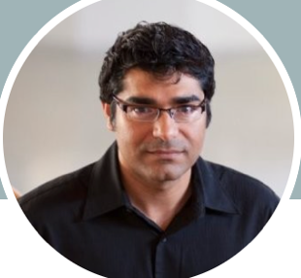

This talk builds on the findings presented in the article “Technology devalues luxury? Exploring consumer responses to AI-designed luxury products” by Lidan Xu and Ravi Mehta (available at: https://bit.ly/3ZSuJmt ).
In his presentation, Ravi Mehta emphasizes the value of continuing to use and analyze data that does not yield the expected results. Dr. Mehta asserts: “Data from a non-working study is equally or even more important than data with useful results. It is unnecessary to manipulate the data because understanding why something did not work can inspire more creative ideas and uncover new opportunities. This principle can also be applied to the development of new products.”

