Join Us for a Vista Cruise on Lake Superior

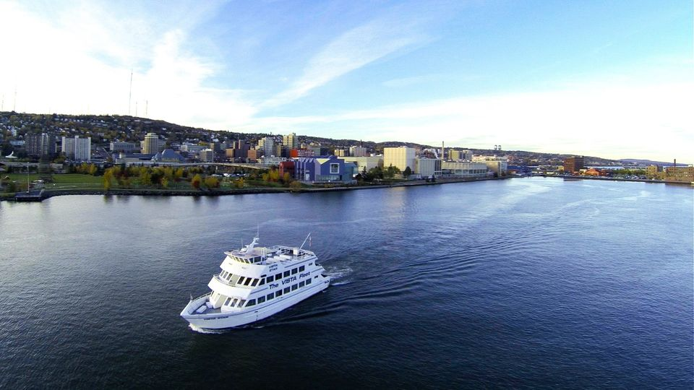

|  |
| --- |
| What: 90 Minute Cruise  When: Tuesday, August 12, 2025  Time: Departure PROMPTLY at 5:55pm. Boarding begins at 5:30pm.  Where: 323 Harbor Drive, Duluth, MN  Food will be provided and there will be a cash bar.  Attendees must have either attended the annual Vendor Fair or two ONS dinner programs in 2025.  Members may bring one guest to join.  Questions and RSVP to Adrienne at Adrienner17@gmail.com |