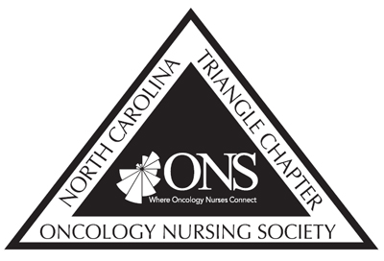
North Carolina Triangle Chapter of Oncology Nursing Society
Box 61682
Durham, NC 27705

NCTONS Application for ONS Congress Scholarship Award

The Triangle Chapter of the Oncology Nursing Society is committed to providing members opportunities to develop professionally and contribute to improving care for our patients. Attending the ONS Annual Congress provides this kind of opportunity. NC TONS is offering scholarships, in the amount of up to $250, for up to 20 active NC TONS members to attend 2021 Virtual ONS Congress. Funding will also be considered for other oncology related conferences. Priority will be given to those who have no funding available to them, and/or have not been previously funded through NC TONS, and/or who are planning to attend ONS Congress. This is a reimbursement award, and therefore monies will not be provided prior to the event. All recipients will be required to “pay it forward” by volunteering for a NC TONS community event or sharing by your experience with members, at a chapter meeting.

Eligibility:
- ONS and NCTONS membership in good standing for the past 12 months or longer.
- Completed application with brief statement of goals of no more than 250 words.
- Must commit to “pay it forward” to TONS.
- Plans to attend ONS Congress (or funding for other oncology related conferences will be considered).

Brief Statement of Goals should include:
- Why do you want to attend the meeting?
- Do you have a special interest/area of focus that will be addressed at Congress? If so, please explain this area of focus/specialty.
- How will you “pay it forward” to NC TONS. Pay it forward options include:
- Participating in a NC TONS community event
- Share your experience at NC TONS Posters of Parade or virtual meeting
- Share your Congress experience at another TONS program or virtual meeting (5-10 minute presentation); you could discuss:
- The session(s) that you found most beneficial and why
- Suggestions that could help someone else attending the conferences (first-timer, networking opportunities, planning your time at the meeting)
- You may contact TONS community outreach chair to learn about possible volunteer activities.

Your responsibilities if awarded:
- Submission of original receipts to the NCTONS treasurer within 30 days of attendance at the meeting (put email address here)
- Submission of “pay it forward” plans to NCTONS Scholarship Chair within 30 days of attendance at the meeting. (email to ejabern@aol.com)
- Completion of “pay it forward” activity and documentation of activity by Dec 31, 2021 (email to ejabern@aol.com) Recipients who fail to “pay it forward” will not be considered for future TONS scholarships or awards.

NCTONS Application for 2021 ONS Virtual Congress Meeting

Name: _______________________________ ONS Member #_________________

Address: _________________________________________________________________

E-mail address: ___________________________

Work Phone: ___________________Cell Phone: __________________Preferred: work/cell (circle)

Have you ever received a TONS educational stiped to attended Congress before?
☐ Yes ☐ No

Are you receiving any other financial support for this meeting? If yes, please describe
☐ Yes ☐ No

___________________________________________________________________________________
___________________________________________________________________________________
___________________________________________________________________________________

How much funding are you requesting (up to $500)? ______________

Indicate what the funds will be used for: __________________________________________________

__________________________________________________________________________________

Brief Statement of Goals (250 word maximum)

Signature: _______________________________ Date: ____________________________

Email this application to: ejabern@aol.com by March 1, 2021

