MDONS Wellness Weekend Agenda
Grand Traverse Resort
100 Grand Traverse Village Blvd., Acme, MI 49610

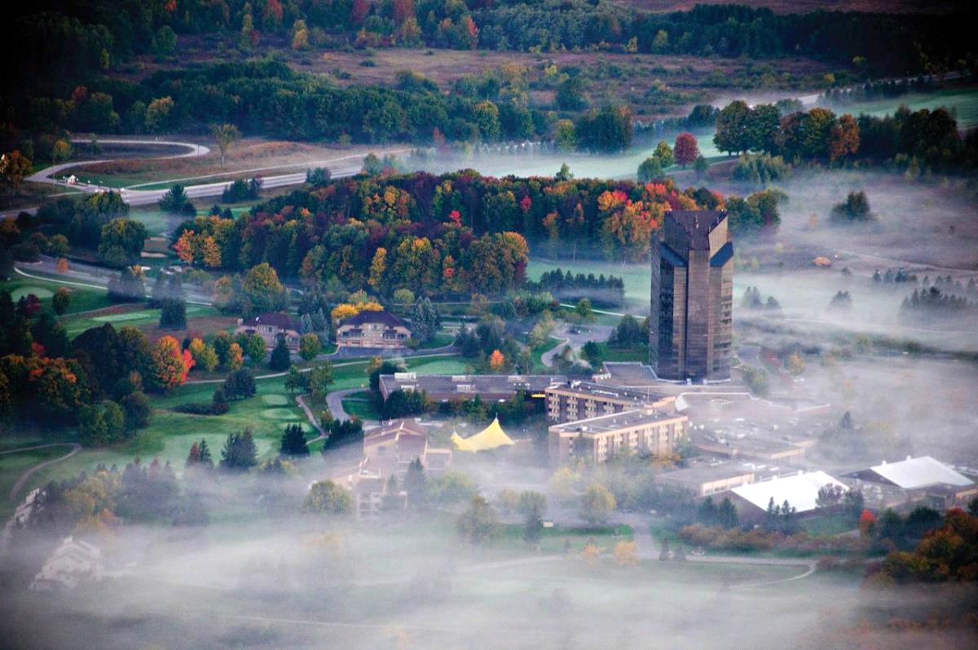

- Guest speakers with 2 CEUs
- Wine tasting
- Friends & Networking
- Shopping
- Good food
- Laughs, fun, relaxation…….you owe it to yourself!!

Friday October 14th, 2022
4:30 P.M. Registration

6:00 P.M. Welcome and Announcements
Dinner
Speaker: Dr. Grace Cullen, DNP PMGT-BC, FNP-BC, AOCNP, ACHPN,
Aroma Therapy

7:30 P.M. Social hour/Games

Saturday October 15th, 2022
7:30 A.M. Wellness walk

8:00 A.M. Breakfast

9:00 A.M. Speaker: Kay Wagner DHA, MSN, RN
Resiliency…A process for healing

10-1030 A.M. Break with Exhibits

10:30 A.M. Free time to get ready

11:00 A.M. Board bus

11:30-1 P.M. Chateau Chantel

1:00 P.M. Board bus

1:30 P.M. Lunch at Grand Traverse Resort

2:30 P.M. Board bus

3:00 P.M. Shopping in Traverse City

4:30 P.M. Board bus

5:00 P.M. Bowers Harbor

6:30 P.M. Board bus

7:00 P.M. Dinner

8:00 P.M. Social time/Games

Sunday October 16th, 2022
8-9:00 A.M. Breakfast

9-10:00 A.M. Yoga

10-11:00 A.M. Closing

“When you’re a nurse, you know that every day you will touch a life or a life will touch yours.” —Unknown

