MDONS Newsletter Spring 2026
MDONS 34th Annual Conference Updates in Oncology
February 18, 2026
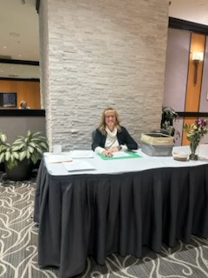
Somerset Inn, Troy Michigan

Registration started at 7:30 AM. It was nice to see fellow oncology nurses that were last seen in October after what feels like a long, cold winter. A delicious warm breakfast was waiting along with a bottomless pot of coffee. Vendors from 33 different companies were there to greet us and sponsor our event. The first of 5 lectures started with Dr. Hotaling, head and neck surgeon at Karmanos Cancer Center. We started with a historical perspective on oral surgery, in particular Transoral Laser Microsurgery (TLM). Through the decades TLM lead the way to Transoral Robotic Surgery (TORS). TORS allows for 3D view with 10X magnification. TORS along with neck dissection for HPV positive unknown primary tumors has provided long-term disease-free survival. TORS also allows for potentially reduced dose of adjuvant chemotherapy, radiation or in some cases elimination of post-operative treatment. We spent time reviewing HPV associated head and neck cancers. We learned that HPV positive skin cancer may present with a neck mass and requires further screening to detect the primary lesion. While HPV is considered a sexually transmitted disease, non-sexually active individuals can acquire HPV through other routes: direct skin to skin contact, autoinoculation (spreading virus form a wart to another body part), vertical transmission (childbirth), fomite transmission (contact with contaminated surfaces-less common low risk type). HPV DNA has been detected in breast cancer tissue although a causal relationship has not been established.

Our next fabulous speaker was Dr. Lisa Chism to review the art and science of genitourinary syndrome of menopause. Symptoms of genitourinary syndrome of menopause include decreased vaginal rugae, erythematous vaginal tissue, decreased size of labia minora, decreased clitoral hood, loss of labial fullness, pale tissue, pH>5 and cellular changes. Subjective findings include decreased arousal affecting orgasms, pain with penetration, irritation and itching. The first line of defense, if you will, are moisturizers and lubricants. Moisturizers are considered maintenance and provide symptomatic relief of vaginal dryness, improves elasticity, reduces irritation and discomfort and supports pH balance. Moisturizers are to be used every 2-3 days. Example of moisturizers are Revaree® by Bonafide. Unlike a moisturizer, a lubricant is to be used at times of friction. Lubricants come water or silicone based. Avoid using a silicone dilator together with silicone lubricant which will result in a gummy-like reaction. Some lubricants come with lidocaine, check out Good Clean Love. We discussed vaginal estrogen use in the breast cancer patient population. Major societies are endorsing use of localized estrogen for women with a history of breast cancer. Start vaginal estrogen nightly for two weeks followed by every 3 day maintenance therapy. Vaginal stretching may be required; options include dilators and pelvic floor physical therapy. Use dilators two weeks after starting vaginal estrogen/moisturizers.

After a break and visiting with vendors we moved to identifying and treating psychiatric symptoms in oncology patients with Dr. Morreale, psychiatrist at Karmanos Cancer Center. We started with the impact that depression and anxiety have on quality of life, compliance with treatment regimen and the relationship with health care team. Common normal reactions to a cancer diagnosis include anxiety and fear about their prognosis; sadness and grief of anticipated losses; changes in identity, functioning and relationships. Oncology nurses are in prime position to observe behavioral and mood changes, notice treatment refusal or disengagement. Normal mood and behavioral changes noted with diagnosis are intermittent sadness, worry that fluctuates, sleep difficulties, preserved functioning, responds to support. Pathologic coping is when there are persistent symptoms, hopelessness and suicidal ideation, worsens over time, impairment in functioning, not alleviated with support, interferes with treatment adherence. Depression risks are chronic pain, steroid use, uncontrolled symptoms, prior psychiatric history and specific diagnosis i.e. head and neck cancer, pancreas cancer. Symptoms of depression include persistent depressed mood, anhedonia, hopelessness, guilt, appetite and sleep changes not explained solely by treatment, fatigue out of proportion, suicidal ideation. Objective findings in depression are flat or tearful affect, irritability, withdrawal from staff or family, decline in selfcare or engagement, stopping medications. May hear statements from depressed patients that indicate loss of meaning, “I don’t care anymore”; “What is the point?” Risks for suicide, patients may make statements about wanting to die, feeling like a burden to others, refusing life sustaining treatment for psychological/psychiatric reasons.
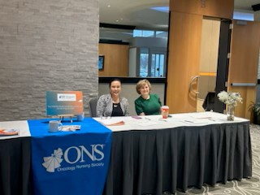
Pathologic anxiety may be manifested with excessive worry not aligned with findings, catastrophic thinking, restlessness or pacing. Anxiety can amplify physical symptoms and worsen pain perception. May lead to more PRN medications, escalation of workups with normal findings, more emergency department visits or admissions. If left untreated anxiety can disrupt relationship with care team and worsen quality of life.
Delirium, described by Dr. Morreale, is fluctuating consciousness and alertness. Onset is sudden, duration is temporary. Manifests as disorientation, inattention, hallucinations. Two specific types of delirium are hyperactive and hypoactive. Hyperactive delirium manifests agitation
and restlessness. Hypoactive delirium, patients present lethargic, not engaged. Nurses will see neuro changes such as new onsets of confusion, disorientation, hallucinations or agitation. Risk factors include infection, dehydration, electrolyte imbalance, opioids, steroids, benzodiazepines, structural brain changes or severe illness. Management of delirium includes treating the underlying medical cause, reorient as needed, have family provide a presence, minimize use of restraints, light and dark cues, protected sleep. Light and dark cues are interventions aimed at restoring circadian rhythms, reducing hallucinations and agitation. Light cues include opening windows or blinds, use of lights, participating in daytime activities. Dark cues aim for sleep; decrease light levels, employ eye masks, and earplugs.

After a nice lunch, our next speaker Dr. Carrolyn Sledz, spoke on Multi Modal Cancer Related Pain Management: A Palliative Approach. Dr. Sledz started defining palliative care as the relief of suffering. The goal is to improve quality of life to patients and their families. Referral to palliative dare is appropriate at any age, stage of treatment. Applicable for patients receiving curative treatment. Palliative care is not hospice. Hospice is end of life care, and the provision of symptom management. We reviewed the assessment for pain; PQRST: provoke, quality, region/radiation, severity, temporal factors/timing. Look for nonverbal cues: breathing pattern, negative vocalization, facial expression, body language, consolability. Pharmacologic pain relievers include acetaminophen, NSAIDS, opioids, antiepileptics, antidepressants, corticosteroids, nerve blocks, pain pumps, radiation therapy. Non-pharmacologic interventions are application of heat/ice, compression, activity/PT, repositioning, massage, acupuncture, TENS, music, art, yoga, relaxation, meditation, guided imagery, and cognitive behavioral therapy.
Our final speaker was Dr. Izabela Mazur on Bites, ADCs and CAR-T. Immunotherapy was defined as cancer treatment assisting the immune system to find and attack cancer cells. We spent time discussing the tumor microenvironment (TME). TME is the environment and community of cells surrounding a tumor. Tumors release signals to control their interaction with the body’s blood vessels, immune cells, tissues and organs. Tumor niches are individual sub-microenvironment within the TME. There are 6 niches within the TME:
Hypoxic niche Growth of a cancer cell leads to hypoxia, ultimately stimulates vascular endothelial cells
Acidic niche Lactic acid buildup is initially toxic, but cancer cells quickly adapt and utilize glycolysis (anaerobic metabolic pathway, cellular respiration that feeds into anaerobic fermentation)
Innervated niche When cancer invades the nervous system, develops perineural invasion, which leads to a grim prognosis
Metabolic niche With hypoxia and glycolysis the TME is very inhospitable. Incoming immune cells, including targeted therapies, find abundant reactive oxygen molecules damaging their DNA
Mechanical niche Intracellular components such as actin fibers, extracellular matrix, stromal cells can remodel the TME and promote invasion
Cancer research and treatment have switched from a cancer-centric model to a TME-centric approach. Notable approvals are monoclonal antibodies, bispecific antibodies (BITES), CAR-T, and antibody drug conjugates (ADCs).

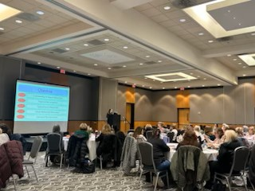
On April 11, 2026, MDONS held a Spring Mini Conference at The Henry Autograph Collection, Dearborn. Our vendors/supporters of the conference were introduced and visited by participants. After an enjoyable breakfast we started with Update in Cancer Genetics and Precision Oncology by Dr. Zakalik. The BRACA gene has paved the way for precision oncology medicine. According to the New England Journal of Medicine, oncology leaders in precision medicine tailor medical treatment to individual tumor characteristics including genetic makeup. Somatic tumors are caused by an acquired genetic mutation. Germline tumors are formed from reproductive cells, most seen in ovaries or testicles. NCCN guidelines suggest offering genetic testing to ALL breast cancer patients 65 years old or younger; a select group for those older than 65. Genetics has played an important factor on cancer treatment as it can identify high risk individuals.
Which cancer warrants germline testing?
- Early onset cancer or multiple tumors
- Ovarian cancer
- Breast and ovarian in the same patient
- Ashkenazi Jewish ancestry
- Male breast cancer
- Pancreas cancer (10% have germline mutation)
- Triple negative breast cancer
- Metastatic prostate cancer
We then heard from Rita DiBiase, MSN, ACNP-BC, CHPCN(C) on Nurses’ Grief: Riding the Waves to Shore, Giving Meaning to Dark Periods of Life. We discussed disenfranchised grief, which is surviving a loss generally not acknowledged. Examples include perinatal death, abortions, pets, same sex partners. There are populations that are excluded from socially sanctioned grieving such as persons with cognitive disabilities, mental illness, dementia, elderly and the very young. People grieve differently from one another. The Intuitive Griever demonstrates a strong affective reaction to the situation; The expression mirrors the feelings. Adapting to the loss involves expression and exploration of feelings. The Instrumental Griever experiences grief as a cognitive experience; generally, involves thinking and action.
I hope you enjoyed reading the MDONS Annual Conference and Spring Mini updates. Our next newsletter will focus on Congress, held this year in San Antonio.
Please email me with work you would like to publish at weissd@karmanos.org
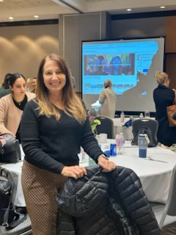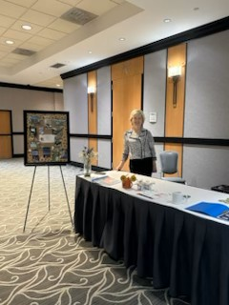

MDONS Chapter Leadership
OFFICERS:
President: Pam Laszewski, BSN, RN, OCN
President Elect: Agnes Pilecki, MSN, AGNP-C
Past President-Nominating Chair: Pam Laszewski, BSN, RN, OCN
Secretary: Kathy Pastoria, BSN, RN, OCN
Treasurer: Anne Marie Campbell BSN, RN, OCN ,TCTCN
Co-treasurer: Jarrad Mitchell, DNP, RN, TCTCN
Membership Chair: Anne Marie Campbell BSN, RN, OCN ,TCTCN
Director at Large: Grace Cullen, DNP, AOCNP, PMGT-BC, FPCN
Director at Large: Susan Wozniak, MSHS, RN, OCN-Emeritus
Committee Chairpersons
Vendor Liaison: Angela Shukwit BSN, RN, OCN
angelashukwit@gmail.com
Newsletter Editor: Denise Weiss, PhD, FNP, BC, AOCNP
Program Chair: Melissa Mitchell, MSN, RN, TCTCN , OCN
Program Co-Chair: Agnes Pilecki, MSN, AGNP-C
Patient Advocate and Health Policy Chair: Sabrina Mayhew, PhD, RN, CN-BN
Social Media: Maryann Sparks, BSN, RN, OCN
Chapter Email address: metrodetroitons@gmail.com

