MDONS DECEMBER 2025 NEWSLETTER
Letter from the Editor
Denise Weiss, PhD, FNP, BC, AOCNP

Let’s jump right into the Fall Mini Conference, which was held on September 27 at the Detroit Zoo. Three of the 2025 Congress Scholarship recipients presented a brief update on a Congress topic of their choice. Rose Ermete updated us on genomic testing; Emily Wise discussed ‘Investigating the Past, Present and Future of Oncology Nursing’; and Rana Allawnha spoke on advancing oncology nursing.
The first presenter was Dhaval Patel, PharmD from Karmanos. Dr. Patel focused on the immune system and how cancer inhibits the normal immune response thereby enabling growth of malignant cells. A normal immune system can inhibit cancer. We went over the difference between immunotherapy and chemotherapy. Immunotherapy targets tumors over time, best with small tumor burden.
Next was Lauren Fryzel. Ms. Fryzel is from Blood Cancer United, formerly known as Leukemia and Lymphoma Society. The mission remained unchanged; Cure blood cancer and improve quality of life for all patients and their families. They boost a bold goal that by 2040 one million more lives will be saved. Services provided include clinical trial support, free nutrition consults, family support groups, free educational material, financial support, and resources for healthcare professionals. To refer patients or for more information contact Blood Cancer United at 1-800-955-4572 or infocenter@lls.org.
Lecture summarized by Susan Daron.
Blood Cancer Support for Patients, Families, and Health Professionals presented by Lauren Frazel (Senior Manager, Patient and Community Outreach of Blood Cancer United)
Lauren’s Phone - 248-581-3891
Email - lauren.fryzel@bloodcancerunited.org
The Leukemia and Lymphoma Society has been renamed Blood Cancer United to include other cancers such as Myeloma. The mission has remained the same for 75 years, and is accomplished through 3 pillars: 1) Patient Support, 2) Research, and 3) Policy Advocacy
Every three minutes a person is diagnosed with blood cancer. 187,740 people are expected to be diagnosed with blood cancers in 2024 (9.4% of new cancer cases)
Their goal is to engage blood cancer patients to have more than 1 million more years of life by 2040
There is no screening test for blood cancer yet, however The Dana Farber Institute is working on one for myeloma
Clinical trials are an option for almost all stages of cancer, including survivorship
Blood cancer patients have unique needs including: medical treatment (can cause isolation due to decreased immunity) , physical and daily living (fatigue, weakness, access to high quality meals) , emotional/psychosocial (fear, anxiety, “scan-anxiety”, fear of relapse), family/caregiver (childcare, elder care) , financial (number one question is navigating costs of care, job loss) and survivorship and long-term care (chronic and long term side effects)
Anyone can reach out to Blood Cancer United Information Specialists, by calling 800-955-4572 or through email infocenter@lls.org . Information Specialists are trained to provide individual clinical trials searches, financial resources, and one-one-one support
Food Insecurity Resources include:
Free nutrition consults (offered for any cancer diagnosis - i.e. breast, colon, lung)
Supplemental Nutrition Assistance Program (SNAP)
Women, Infant and Children (WIC)
Meals on Wheels
Commodity Supplemental Food Program
Food Pantries www.foodpantries.org
National Hunger Hotline (1-866-3-HUNGRY)
Patients can request to be paired with a First Connection Volunteer. This is a 1 to 1 peer match with another patient who has their diagnosis, has been there and can share experiences
There are a variety of Support Groups offered including:
Family Support Groups - hybrid style and based out of Lansing, they meet monthly
Online Chats – live weekly online chats, done in chatroom style, each chat is moderated by an oncology social worker
Caregiver Support – resources can include a caregiver workbook, online chat just for caregivers, family calendar, and medication reminders
Blood Cancer United Community – an online community where patients can join various groups (young adults, LGTBQ, etc)
There is a variety of free print educational booklets and fact sheets (popular topics include new therapies, side effect management, diagnosis tools, and stress management) available which can be ordered to stock in clinic offices, or can be downloaded from the website
Various Financial Support Resources include:
Patient Aid Program - includes a one-time $100 stipend to help offset non-medical expenses
Urgent Need Program -helps resolve medical debt, address financial concerns, identify resources, assist with insurance plan evaluations, navigate insurance benefits, denials of care, and out-of-pocket costs
Co-Pay Assistance Program – Provides assistance toward the cost of Private, Medicare, Medicaid, and TRICARE insurance premiums, and treatment-related co-pays and co-insurance for prescription drugs, labs, scans, tests, etc.
Travel Assistance – includes a $500 grant for travel related costs
CART-T travel Assistance -includes a $2500 grant for any travel related costs involving CART-T therapy
Medical Debt Case Management – (cannot help once debt has gone to collections) – patient/caregiver can call 833-507-8036, or apply online at bloodcancerunited.org/medical debt
There are virtual webinars or In-Person Rounds for healthcare providers which offer free CEUs
There is a Podcast called “Treating Blood Cancer” for healthcare providers by healthcare providers
Lauren asked we please share these resources with as many fellow providers, patients, families, friends, and caregivers as possible.

In closing were heard from MDONS president Rosily Gborogen. Dr. Gborogen went to ONS Capitol Hill Conference 2025. She discussed key legislative priorities:
- Palliative Care and Hospice Education and Training Act
- Cancer Drug Parity Act
- National Institute of Nursing Research and National Cancer Institute Funding

Once again, the MDONS’ Wellness Weekend was a success! I drove myself to St. Joseph as there were many yarn shops along the route. To my surprise the fall colors made a beautiful display, mother nature’s reminder that the season was not over. The air was cool and crisp which made wearing a sweater comfortable. Checked in to the hotel and was greeted with a complimentary margarita, the weekend was off to a great start. Dinner was served at 6 PM and our guest speaker was spot on for welcoming us to our weekend of self-care. Pastor Brown discussed different therapies for better mental health. He compared new age coping methods to that of the older version of Cognitive Behavioral Therapy (CBT). The alternative method I found intriguing is Acceptance and Commitment Therapy (ACT). In CBT, we change negative thought into positive to reduce symptoms and improve coping. ACT has emphasis on acceptance, mindfulness and behavior; to change our relationship with thoughts rather than changing the thought.
After a wonderful dinner and lecture we played Pictionary. This was my first time playing and if I may speak for the entire group, we had a blast. Try this clue that stumped both teams ‘study.’ Admittedly, that is a hard word to describe in a picture.
The next day, Saturday, we started with a healthy breakfast and a visit from Gilda’s Club. We met two program managers, Tiffany Chenault and Wendi Henning. Tiffany discussed ‘How Personal Experience Wendi talked with us about ‘Beyond the White Coat: Rethinking Work-Life Balance in Medicine.’ Please refer to Susan Daron’s summary. We then took a break from lecture, I went for a walk, others went to their room or relaxed in the beautiful lobby. A delicious Mediterranean lunch awaited our return. Our final speaker was nutritionist Emily Haller, who discussed plant based nutrition. This was very informative.


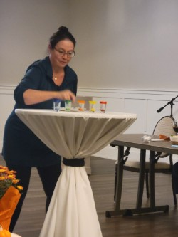

Work Life Balance- A presentation about the stressors of working in the medical field, the importance of finding that balance, the false narrative that's a true balance, and some calming techniques presented by Wendi Henning MSW, LMSW, OSW-C

Wendi started her presentation by defining burnout which is now an official diagnosis in the ICD-11 Manual. It is characterized by the following features : 1) A feeling of energy depletion or exhaustion, 2) Increased mental distance from one's job or feelings of negativism or cynicism related to the job, and 3) Reduced personal accomplishment/efficacy

She shared some statistics from the Centers for Disease Control and Prevention from 2022 which reported 46% of healthcare workers often feel burned out (this is up from 32% in 2018). Nearly half of all health care workers intend to look for a new job and this too is elevated from 33% in 2018.

Burnout is a symptom not a destination. It is not linear and does not have to be a final destination.

Our lives feel more well balanced and rounded when we recognize that our work life is integrated into our non-work lives. Work life balance is dividing our time and energy evenly between work and everything else in our lives. It's important to keep in mind that everyone's balance does not look the same.

Some tips Wendi shared to help with burnout prevention at work:
#1 Set manageable goals each day
#2 Be efficient with your time
#3 Ask for flexibility
#4 Take small breaks throughout the day – short scheduled breaks make you more productive so make sure to schedule those with intention and purpose
#6 Tune into music
#5 Communicate effectively
#6 Give yourself a break – no one is perfect and most people judge themselves much harsher than others do

Some tips Wendi shared to help with burnout prevention at home:
#1 Unplug – physically step away from the laptop, phone, or tablet
#2 Divide and conquer – break large projects into smaller ones which do not seem as daunting
#3 Don't overcommit - learn to say no and mean it and set boundaries
#4 Get support - From friends, coworkers, family, church, or professional organizations
#5 Take advantage of Employee Assistance Programs
#6 Stay active - physical activity has been shown to be beneficial in reducing stress and cortisol levels
#7 Treat your body right - eat healthy, get enough rest, manage stress levels
#8 Get help if you need it – enlisting professional help from a psychiatrist/ psychologist/ medical doctor/social worker
#9 Pause and de-normalize – make time to think and feel
#10 Pay attention to emotions - learn to feel the discomfort and be with it without wishing it away
#11 Reprioritize - consider your alternatives and find ones which better align with your priorities
#12 Implement changes

The next area Wendi covered was something called Box Breathing which is where you inhale for a count of four seconds, hold your breath for a count of four seconds, and then breathe out for a count of four seconds. It can be helpful to think of the shape of a box when doing the breathing to keep track of your time.
Benefits of Box Breathing include lowering blood pressure, decreasing cortisol (both of which can improve your mood). It also helps refocus attention, aid in sleep, and eases panic and worry
Navy SEALS use box breathing as a way to stay focused and precise during missions.

Wendi closed her presentation by speaking about Gilda’s Club. Gilda's Club was founded by Gilda Radner from Saturday Night Live. The Metro Detroit location was the second Gilda’s Club in the nation. Not only do they offer programs for patients and families affected by cancer but also for health professionals. Wendi reiterated that professionals such as nurses are encouraged to attend Gilda’s Club events. Also included in the population served are cancer survivors who are always welcome at any Gilda’s Club event.
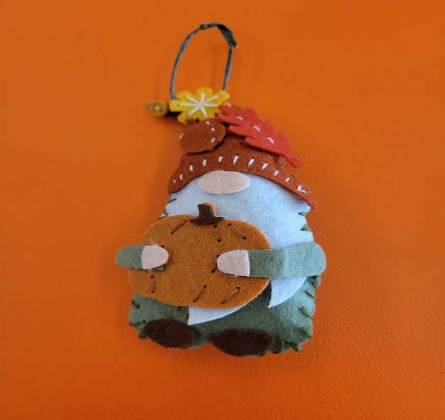 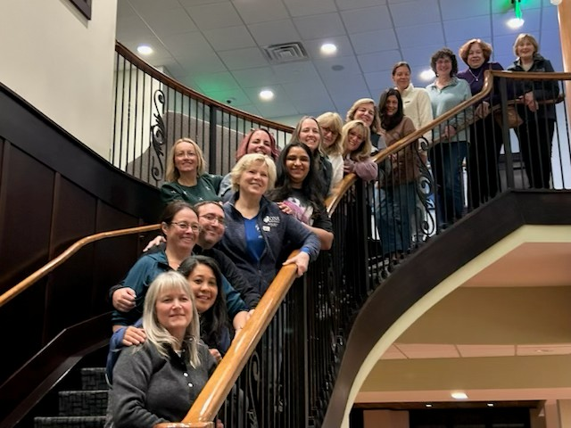Here we are, enjoying the Wellness Weekend!
Did I mention we did arts and crafts?


Beautiful St. Joseph

The agenda incorporated time to explore the town of St. Joseph and explore we did. There were some that shopped until they nearly dropped, so much fun! We met up at The Lazy Ballerina winery, see photos. Back at the Inn for our final dinner followed by games and laughs.
We faced Sunday morning bright and early with Yoga. I learned that sitting in the Lotus position has become uncomfortable, when did that happen?? Time to incorporate more stretching into the routine. A nice hearty breakfast then ready to head home.
Over 4 CEUs were obtained, loads of information, rest and fun all wrapped up in a serene environment.

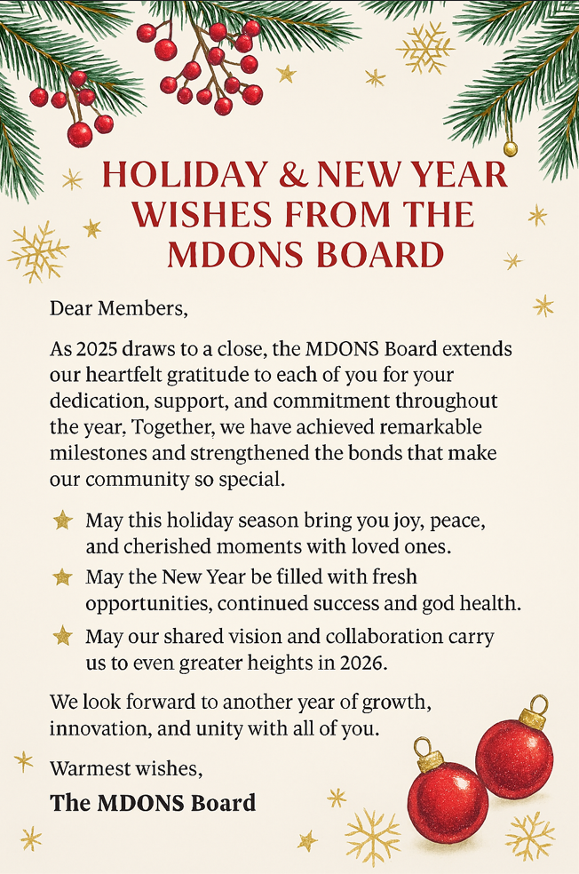 OFFICERS:
President: Pam Laszewski, BSN, RN, OCN®
President Elect: Agnes Pilecki, MSN, AGNP-C
Past President-Nominating Chair: Pam Laszewski, BSN, RN, OCN®
Secretary: Kathy Pastoria, BSN, RN, OCN®
Treasurer: Ann Marie Campbell, BSN, RN, OCN®
Co-treasurer: Jarrad Mitchell, MSN, RN, BMTCN
Membership Chair: Ann Marie Campbell, BSN, RN, OCN®
Director at Large: Dr. Grace Cullen, DNP, FNP-BC, ACHPN, RN-BC
Director at Large: Pam Laszewski, BSN, RN, OCN®

Committee Chairpersons
Vendor Liaison: Angela Shukwit BSN, RN, OCN®
angelashukwit@gmail.com
Newsletter Editor: Denise Weiss, PhD, FNP, BC, AOCNP®
Program Chair: Melissa Mitchell, MSN, RN, BMTCN , OCN®
Program Co-Chair: Agnes Pilecki, BSN, RN
Patient Advocate and Health Policy Chair: Susan Wozniak MS, RN
Social Media: Stacy Simons NP, AGPC-BC, ACHPN, AOCNP
Chapter Email address: metrodetroitons@gmail.com
