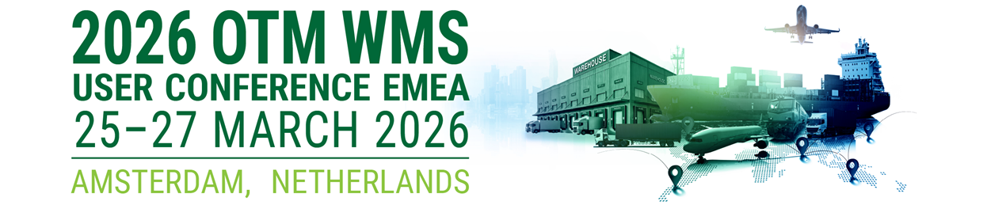

Dear ,

I’m confident that attending the 2026 OTM WMS User Conference EMEA, the premier gathering for logistics and supply chain professionals, where industry leaders explore the forefront of Oracle Transportation Management (OTM), Warehouse Management Systems (WMS), and Global Trade Management (GTM) solutions. 2026 OTM WMS User Conference EMEA, 25-27 March 2026, in the historic heart of Amsterdam, Netherlands. This conference is the place for OTM/WMS/GTM users, Oracle representatives, and other industry parties to connect and share. Current and prospective users will gain valuable insight into current features and future enhancements while also taking advantage of great networking opportunities.

I anticipate gathering actionable information that’s directly relevant to my work on <insert name of initiative or project>.

Education sessions include product development updates and roadmaps from Oracle, as well as user case studies highlighting upgrades, demonstrations of new features and performance-boosting techniques that have been tested in the real world. The event offers \ keynote presentations and demonstrations, plus valuable networking opportunities each day. At the regular registration rate of $795 USD, we offer live, interactive training where I can pursue immediate answers to our most pressing questions and challenges.

I’m requesting approval to attend, plus sponsorship of the conference registration fee and travel expenses.

Here is the detailed cost breakdown:

- Registration $
  - Visit https://www.oatug.org/otmwmsconference/register
  - to find your conference registration rate ($795-$995).
  - Groups of three or more registered from the same organization save $100 after the first two register at the going rate.

- Airfare: $
- Hotel: $
  - Visit https://www.oatug.org/otmwmsconference/hotel-travel
  - and reserve early for lowest rates

- Meals: $

The total travel costs are $
There is a total conference cost of $

Pending your approval, there are a number of presentations that I would attend, including:
<insert titles of presentations you plan on attending; view sessions at https://www.oatug.org/otmconference/agenda>

I have chosen these sessions because they are pertinent to my job function, and I think they will offer a new and greater understanding of what I’m working on.

I sincerely hope that I’m given the opportunity to attend the 2026 OTM WMS User Conference EMEA and reap the wealth of benefits that this conference has to offer. Because I would like to make sure that I register in time for the discounted Early Bird Registration, I would greatly appreciate a response by <insert date; the early bird registration deadline is 4, February 2026 >.

Thank you in advance for your consideration of this opportunity.

Regards,

Your Name

