OATUG Regional Summit
In partnership with NCOUAG
Tuesday, December 9 | Location: Westin Chicago Lombard

Join us at the Oracle Applications and Technology Users Group Regional Summit in partnership with the NCOUAG. This one-day event is an opportunity to connect with fellow Oracle users and industry partners, sharing practical solutions and strategies for everyday business challenges. Take advantage of in-depth sessions on AI, as well as breakouts for EBS and Cloud Fusion users to discover best practices, new features, and innovative approaches that can help your organization thrive. Engage in discussions with attendees who face similar challenges and learn from their real-world experiences. Whether you're looking to optimize your current systems or explore emerging trends, you'll gain valuable insights and actionable ideas to bring back to your team.
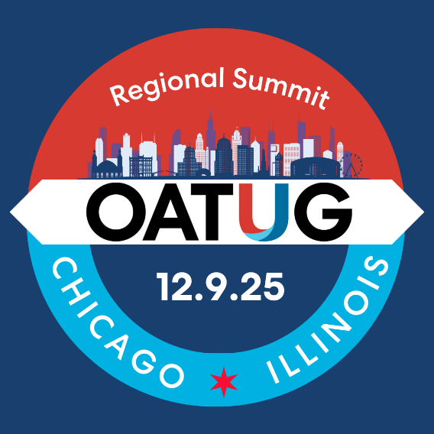
9:30 – 10:00 am | Coffee
10:00 -10:10 am | Opening and Welcome
10:10 - 11:10 am | Oracle GenAI, VectorDB & Agentic AI  Richard Niemiec, Chief Innovation Officer, Viscosity North
11:20 am - 12:10 pm | Panel: Navigating Business and People in the Age of AI: Realities and Readiness
12:20 - 1:15 pm | Lunch with Roundtable Hot Topics
1:30 - 2:20 pm | Breakout 1 EBS  Maximize Your EBS HorsePower  Speakers: Brett Barnhart, Videojet and Fred Tingle, ennVee TechnoGroup Inc | Breakout 2 Cloud Fusion:  Cloud Introducing AI Agents: The Gateway to Smarter Business Automation  Speaker: Ramesh Kumar, eAlliance Corporation
2:30 – 3:15 pm | Breakout 2 EBS:  To be announced | Breakout 2 Cloud Fusion:  To be announced
3:30 - 4:30 pm | Closing Keynote  Gil Traverse, Oracle Center of Excellence
4:30 – 5:30 pm | Reception

AGENDA

