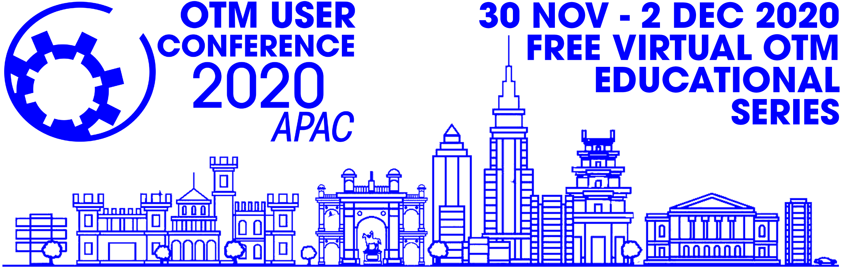

SPONSORSHIP OPPORTUNITIES

2020 OTM User Conference APAC
Virtual Education Series
30thNovember to 2nd December 2020

Organiser: OATUG OTM SIG
Oracle Applications User Group (OAUG)
Oracle Transportation Management (OTM)
Special Interest Group (SIG)

https://www.oatug.org/otmsig/home
* * * * * * * * * * * * * * * * * *

.

Sponsorship contracts are accepted from 4 Sept 2020

2020 OTM User Conference APAC - Virtual Education Series

You’re Invited

It is our pleasure to invite you to participate in the 2020 OTM User Conference APAC - Virtual Education Series, which will be held on 30th Nov to 2nd Dec. This conference is designed for people to learn and share knowledge, ideas and experiences about Oracle’s Logistics products: OTM, GTM and OCWMS.

With an anticipated attendance of 200 people, this conference is the perfect event for organizations to:

• Be part of a valuable conference designed to address key aspects of Oracle Logistics products
• Gain exposure to conference attendees
• Maximize your presence in the industry
• Strengthen your brand identity
• Receive recognition as a sponsor on the conference website and in the on-site program guide

Sponsorship opportunities are limited and contracts will be accepted from 4th Sept 2020. Mark your calendar and plan to submit your contract by this date to ensure your participation in this important conference. We look forward to seeing you there!

Please visit https://www.oatug.org/otmsig/home or contact the OTM SIG Board Administrator for additional information at boardadmin@otmsig.com

OTM SIG Board of Directors

Contact Details:

ORGANISER

OTM SIG – Oracle OTM Special Interest Group

Board Administrator
Email: boardadmin@otmsig.com
Website: http://www.otmsig.com

MEETING PLANNER

Meeting Expectations Inc.
Attn: James Hobbs/ OTM SIG
Building 5, Suite 300
3525 Piedmont Rd.
Atlanta, GA 30305
United States of America

Telephone: +1 (404) 477-5829
E-Mail: otmsig@meetingexpectations.com

2020 OTM User Conference APAC
Sponsorship Opportunities

Platinum Sponsor USD 600

- Recognition as a Platinum Sponsor on conference marketing material, signage, and website.

Terms and Guidelines:

Payment Terms: Sponsorship payment is made to Meeting Expectations. Sponsorship must be paid in full.

Cancellations and Refunds: Sponsorship/Advertising cancellations are subject to a 50% cancellation fee if received by 30th October 2020. Cancellations received after this date are subject to a full payment cancellation fee.

Additional Guidelines: The Organiser (OTM SIG) manages the fulfillment of sponsorship benefits, which are tied to a first come, first-served base. All advertising benefits are based on materials being received by deadlines as communicated to the sponsors by the Organiser.

Exhibitor Rules and Guidelines

Exhibitors will be limited to the tabletop exhibits defined by the following rules and regulations:

- Display Sponsor Logos before each presentation.
- Usage of Sponsor logos in all Communications email/website etc.
2020 OTM User Conference APAC
Sponsorship Contract

Contact Information:

Company:

Company Web-Site:

Primary Contact Name: Title:

Mailing Address:

City: State: Postal Code: Country:

Telephone: Mobile:

E-Mail Address:

Payment Information:
Checks Payable to: OTM SIG

Mail Address: OTM SIG
C/O Meeting Expectations
3525 Piedmont Rd. NE, STE 300
Atlanta GA 30305

For Questions, please contact:
Paritosh Mangrulkar
Email: paritosh.mangrulkar@geappliances.com
E-Mail: board-regional@otmsig.com

Amount: USD 600

Online Payment - paypal
https://www.paypal.com/paypalme/meetingexpectations

Other modes/options for Payment

Please select the appropriate payment options:
□ Check or Money Order enclosed (Payable to OTM)
□ Visa □ MasterCard □ American Express

Name (as it appears on credit card):

Billing Address:

Credit Card Number: Security Code:

Expiration Date: Card Holder’s Signature:

Instructions:

Sponsorship Contracts are accepted from 4th Sept 2020

Please send your completed contract by email to OTM SIG (boardadmin@otmsig.com)

After receipt of the contract and acceptance of the OTM SIG Board of Directors, you will receive instructions to pay the sponsorship fees.

Sponsorship fees are collected by the MeetingExpectations on behalf of the OTM SIG (Organiser), who will send you instructions to pay for the fees.

Main point of contact for all sponsorship queries is the OTM SIG (boardadmin@otmsig.com)

