SIGMA THETA TAU INTERNATIONAL
KAPPA CHAPTER MEETING MINUTES

Meeting Date: October 21, 2025
Location: Virtual Zoom
Start Time: 6:45 P.M. (EST)
Meeting: 7:00 P.M. (EST)

Attendance: Kathleen Noel, Deborah Jolissaint, Marysanta Bigony, Heidi Maloni, Dean Marie Nolan, Eileen Caulfield, Barbara Gillman Lamping, Agnes Burkhard, Susan Macyko, and Lorraine Huber

- MEETING CALL to ORDER: 7:00 P.M. by Kathleen Noel, President
- MEDITATION: Saint Mother Teresa Meditation
Barbara Gillman Lamping (has friend who is a member of the MC order)

- MINUTES Meeting September 16, 2025: Motion to approve by Agnes Burkhard; second by Heidi Maloni

NEW BUSINESS
- State of the Conway School of Nursing (CSON): Marie Nolan, Dean (deferred until 8:00pm)
  - In previous meeting Dean Nolan recognized the largest incoming class at CSON. Currently at 164. Thanked were Dr. Caulfield, Dr. Macyko, Dr. Bigony (in meeting) and all faculty for their work.
  - Had CSON Board of Visitors Meeting in October 10, 2025.
  - CSON Parents’ Weekend was on October 10, 2025 with Simulation Center demonstrations. Advisors Board members were in attendance.
  - Had Open House in October with good attendance. The faculty presented well.
  - On October 18th, Mr. Bill Conway and (in memoriam) Mrs. Joann Barkett Conway were inducted into American Academy of Nursing.
  - On October 19th, Brother Ignatius Perkins was recognized as a “Living Legend” by the American Academy of Nursing.
  - BSN Program is now #28 in the nation, placing us in the top 4% of programs nationally.
  - First time NCLEX pass rates at 98.6% with 20% of our students are Hispanic. All of our students are talking about giving back and serving the underserved.
  - Credits to Dr. Mary Dixon for bringing together an excellent panel for the upcoming Conway Seminar on November 17, 2025 on palliative care and End-of-Life.

- Sigma Nurse Learning Exchange (New) – President Noel
    - Grow. Lead. Thrive. The Nurse Learning Exchange is here to help you unlock your potential, boost your confidence, and earn contact hours—all with FREE, high-quality courses that meet you where you are in your career. Thanks to support from Johnson & Johnson, you now have access to a powerful collection of learning designed just for nurses like you.
    - This is a new offering, different from the webinars available. Appears to be divided up by specialties and other things.
    - Will find it in the lower left corner of the banner page for Sigma.
    - President Noel through the Leadership Committee will share with students access the Sigma site which is free to students.

OLD BUSINESS
- 2025 Tri-State Conference
    - Held In-Person at University of Delaware on Sunday October 19, 2025 from 9:15 A.M.-2:15 P.M. with 3 CE’s; will be there next year also.
    - Topic: Empowering Nurses: Cultivating Resilience and Self-Care
    - Speakers: Athena Fernandez (Resilience) DNP, MSN, RN-BC, FACHE and Christina Gomez (Self-Care) MSN, RN, NI-BC, EBP, HTCP
      - Speakers will very, very good and had a lot of things to share.
      - Noted importance of self-care before all else
    - CSON Student Attendance: Megan Stake, Hannah Daisomont, Aracely Juica and Elizabeth Webb; two students opted not to attend. Kappa paid registration for 2 juniors and 2 freshmen to attend. Kappa did not pay for the non-attendees.
    - Following last meeting on September 16, 2025 a motion went to members via email to support funding additional students, amending budget to provide for this change. Results were:
        - Voting Results to increase the Kappa Budget to support additional students
I agree for the Kappa Chapter to support three additional Conway School of Nursing Students to attend the 2025 Sigma Tri-State Distinguished Lectureship on October 19, 2025 and to amend the Budget for an additional $165.00. 16

I am not in favor of the Kappa Chapter supporting three additional Conway School of Nursing Students to attend the 2025 Sigma Tri-State Distinguished Lectureship on October 19, 2025 and amending the Budget for an additional $165.00. Zero
Three members had not voted. E-mail sent out September 24, 2025.
MOTION: Approved September 28, 2025
  - Check forwarded to Tri-State by Heidi Malone for Students and Kappa Leadership Attendees.
    - Discussion of asking the student to share their experiences in class: freshmen in N151, juniors next year in one of their senior courses.
    - Susan Macyko attended the conference; had conversations with CSON students about their future plans; topic was timely for the stress students are experiencing with their academic workload. She also thanked Kappa for their support of her attendance at the conference.

- Past Events
    - The 2025 CSON Blessing of the Hands and White Coat Ceremony occurred on Friday October 3, 2025 at 3:00 P.M. in the Basilica of the Immaculate Conception Crypt Church. Kappa members participating in the ceremony were Kathleen Noel, Deborah Jolissaint, Sandra O’Brien, Donna Gunella, Dean Marie Nolan, Eileen Caulfield and Maura Wenzel.
    - CSON Reception with Dean Marie Nolan during Cardinal Weekend was on Friday October 17, 2025 from 3:30-5:00 P.M. in the Conway School of Nursing. Alumni and Kappa members were in attendance.

- Upcoming Events
1. 2025 Conway Leadership Seminar on November 12, 2025 in the Conway School of Nursing from 4:30-6:30 P.M. Topic: Palliative and End-of-Life Care. https://advance.catholic.edu/go/csonseminar. This is an in person only event. The panel will include:
Sister Diane Marie, O.P., vocations director and hospice nurse at Dominican Sisters of Hawthorne
Professor Elizabeth Kirk, J.D., co-director of the Center for Law and the Human Person & assistant professor at the Columbus School of Law
Michelle Churchill, MSN, CRNP, ACHPN, director of clinical programs, palliative care at Johns Hopkins Hospital
Rina Moore, LICSW, palliative care social worker at MedStar Georgetown University Hospital
Professor David Jobes, Ph.D., associate director of clinical training, and director of the Suicide Prevention Laboratory at The Catholic University of America.
  - President Noel will ask Dr. Mary Dixon if it is possible to record the seminar to be shared online with Kappa members and students.
  - President Noel would like students with classes and other activities to be able to see the recording so they can get extra credit for attendance.

- 48th Biennial Convention
    - 2025-2027 Biennial Candidates and Proposed By-Laws review by Kathleen Noel and Deborah Jolissaint (Delegates); Sandra O’Brien will also be attending the Biennium.
    - Date changes: November 8-11, 2025.
    - Changes proposed to the International By-laws:
      - Article IV. Officers: Add position of a Vice President who will perform duties of the president in the absence of the president and president-elect. Change proposed by House of Delegates
          - Request delegates ask why there is a proposal to bring back position that was eliminated in last by-law changes
      - Article IV. Officers. Section 2. Add that elections may be held during an in-person or electronic meeting of the house of delegates or by written ballot vote (which may be in electronic form and electronically transmitted and executed) of the delegates without a meeting. Nominations and elections shall be conducted in accordance with the policies and procedures adopted by the board...Terms of office shall begin at the close of the meeting following elections.
          - Adds electronic voting – no discussion questions from Kappa Board
      - Article VII, Section 2: the house shall have the authority to elect officers, directors, and other positions as allowed by these bylaws…..
          - No questions from Kappa Board
      - Article VII Section 3: add, decisions may be made by the delegates by written ballot (which may be in electronic form and electronically transmitted and executed) without a meeting to the fullest extent permitted by law
          - No questions from Kappa Board
      - Article IX Section 1: add: in the distraction of the Board and to the fullest extent permitted by law, such elections may be held during an in-person or electronic meeting of the house of delegates or by …
          - No questions from Kappa Board
      - Article IX Section 3: Change ballot sent to the board at least two months prior to any election and to the chapters at least one month prior to any election
          - No questions from Kappa Board

- 2026 Annual Meeting (deferred to November Board Meeting)
    - Committee: Sandra O’Brien, Kathleen Noel, Eileen Caulfield. Will develop a plan to present to Board either by electronic vote or at the November Meeting.
    - Explore date (Easter Break April 2-6, 2025; HESI)

- Nurse Leader Challenge Continues
1. The Leadership Team is again encouraged to contribute to the Challenge with new Potential Candidates for Nurse Leaders. An area that needs work for the future 2025-2027 Key Award Submission.

- Policies and Procedures Agnes Burkhard
    - The only outstanding item is the job description for the President-elect position. Discussion deferred until next meeting

- 2025-2026 Strategic Plans (Discussion deferred until next meeting)
    - Governance
    - Leadership
    - Research

PLANNING AGENDA
- Vice-President: Deborah Jolissaint
  - Future Planning
  - Received an inquiry from an Alzheimer’s group to provide educational programs to be offered to Kappa membership and/or students. Deborah Jolissaint will meet with them next week to discuss further.
  - Received an inquiry for a fundraiser from a bone marrow related organization. They were advised we may be interested next year. Await new Sigma President’s Organizational Call to Action which will be provided at the House of Delegates at the Biennium.

- Ad-Hoc Programs: President Noel to solicit volunteer
  - Request for volunteer will be noted in the November Sigma Update.

- Governance Committee: Angela Cooper, Zachary Brotzman, Victoria Lowe and Sandra O’Brien – No report submitted.
  - Per President Noel, Strategic Plan is in a draft format.
  - Per Agnes Burkhard, they are looking at an event for the Little Sisters of the Poor. The Sisters have a significant need for assistance. Awaiting word from the committee.

- Leadership Committee: Eileen Caulfield, Abby Villarroya, and Barbara Gillman Lamping
  - Met on October 16, 2025.
  - Reviewed Sigma Global Leadership Framework and will structure our work around it. Will look at the 10 sub-competencies and use them to develop our organizing framework.
  - Meetings will be the 2nd Thursday of each month.
  - Committee members completed global leadership self-assessment (https://www.sigmanursing.org/global-nursing-leadership-competencyframework?utm_campaign=&amp;utm_content=Global%20Nursing%20Leadership%20Competency%20Framework&amp;utm_term=&amp;utm_medium=email&amp;utm_source=newsletter_
  - Suggestion by Agnes Burkhard to share this survey with members. Committee will discuss this at next meeting.
  - Recognize the call to identify nurse leaders and to develop a ballot later in the year.
  - Barbara Gillman Lamping will also attend the Biennial.
  - Reviewed the Kappa Chapter Report for 2024-2025; immediate priorities: increase diversity; begin to work with freshmen; begin each meeting with a reflection to help center.
  - Current Membership: 234 (4 Inactive as of October 1, 2025 (72.17% Retention in 2025)
  - See Attachment

- Treasurer’s Report: Heidi Maloni
  - Will prepare and distribute report.

- Finance Committee: Anna Alt-White (not present)
  - Committee will meet again in February

H. Faculty Counselor: Kathleen Noel presented the Report for Sandra O’Brien
1. 2025 Founders’ Day Recipients’:
Junior: Keira Johnston
Senior: Megan Williams
MCHA (Masters Complex Healthcare Administration): Theresa Arlinghaus
DNP: Delaney Foster
PhD: Lai Wong
  - See Attachment

- Ad-Hoc Health and Climate: Susan Macyko, Mackenzie Costello
- Shared upcoming seminars available through Sigma on Nursing on the Frontiers of the Climate Change. Susan and Mackenzie will obtain additional information to share with members.

J. Research Committee: Agnes Burkhard
- Fall Applicants
  - Received only 1 application (PhD) and it is under review.
  - Two DNP were interested, but did not submit.
  - Will bring recommendation to November Meeting.
- Working on Spring cycle for applicants.
- Discussing eligibility, IRB, and the Research Practice Improvement Grant available to members in the spring at next committee meeting.
- Propose date of February 19, 2026 from 7-8:30 P.M. on zoom with recording, with 1.5 CEs ($175): Kappa Adventures in Science.
  - Would have two speakers and highlight grant awardees. Have secured Nick Comeau, DNP who will present his DNP project: Pediatric Patient Decompensation. Working on a PhD compensation.
- President Noel noted that University of Maryland has an upcoming educator conference Future Proofing Nursing Education: Agility, Leadership, Transformation in a Changing World on April 24, 2026, requesting abstracts. She will send to Dr. Martha Scheckel.

- Ad-Hoc Communications: Report Provided by Kathleen Noel for Sudin Thomas
- Emails sent out for flyer for 2025 Tri-State Consortium Distinguished Lectureship
- Notice for Volunteer Service for Founders’ Day October 5, 2025 sent out.

- Interactions Kappa Chapter and the Conway School of Nursing
- President Noel reached out to Magie Maline, NSNA President and Jamie Mersel, NSNA Vice-President.

- Student Intern 2025-2026: Representative Needed

ADJOURMENT: 8:37 P.M.

NEXT MEETING: The next Kappa monthly zoom meeting will be on Tuesday November 18, 2025 with conversation at 6:45 P.M. and meeting from 7:00 – 8:30 P.M.

Respectfully submitted, October 21, 2025

Marysanta D Bigony, PhD, MSN, MA, RN, CCM, PHCNS-BC

Kappa Chapter Transition Meeting
2025 – 2026 Leadership Committee Proposed Plan
Activities:
- Schedule Monthly Zoom Meetings
  - Will the second Thursday at 9:00 am work with everyone’s schedule?
- Organize Monthly Committee Work Activities
  - Monthly Coffee Hour
  - AT CSON Monthly Town Hall
    - Put Kappa Chapter Update on Agenda
- Ballot 2026
  - Confirm with Kathleen openings
- Collaborate with Sudin Thomas – Social Media
Goals:
- Recruit 5 new Kappa members representing our multicultural communities and increase diversity.
  - Strengthen international footprint
- Recruit 2 students to sit on Leadership Committee
  - One CUA student
  - Second student from another university
- Survey current student members
  - What is necessary for them to renew? Expectations and Needs
  - NCLEX Prep Resources?
  - Professional Development Support?
  - Continuing Education
- Mentorship
- Leadership Development
- Student Ambassadors
  - What would that look like?
- Networking & Community
  - Community Service Events
  - Professional/Local Events
  - Sigma Opportunities
- Professional Development
  - Resume writing

Leadership Report
October 21, 2025
- Committee met on Thursday, October 16 from 7:30 pm – 8:30 pm.
- Abby Villarroya
- Barbara Gillman Lamping
- Eileen Caulfield
Decision made to hold meetings on the 2nd Thursday of every month.

- Discussed 2025 – 2026 Leadership Committee Plan presented on July 26 at the Kappa Transition Meeting.

- Reviewed Sigma’s Global Leadership Competency Framework
- https://www.sigmanursing.org/global-nursing-leadership-competency-framework?utm_campaign=&utm_content=Global%20Nursing%20Leadership%20Competency%20Framework&utm_term=&utm_medium=email&utm_source=newsletter
- 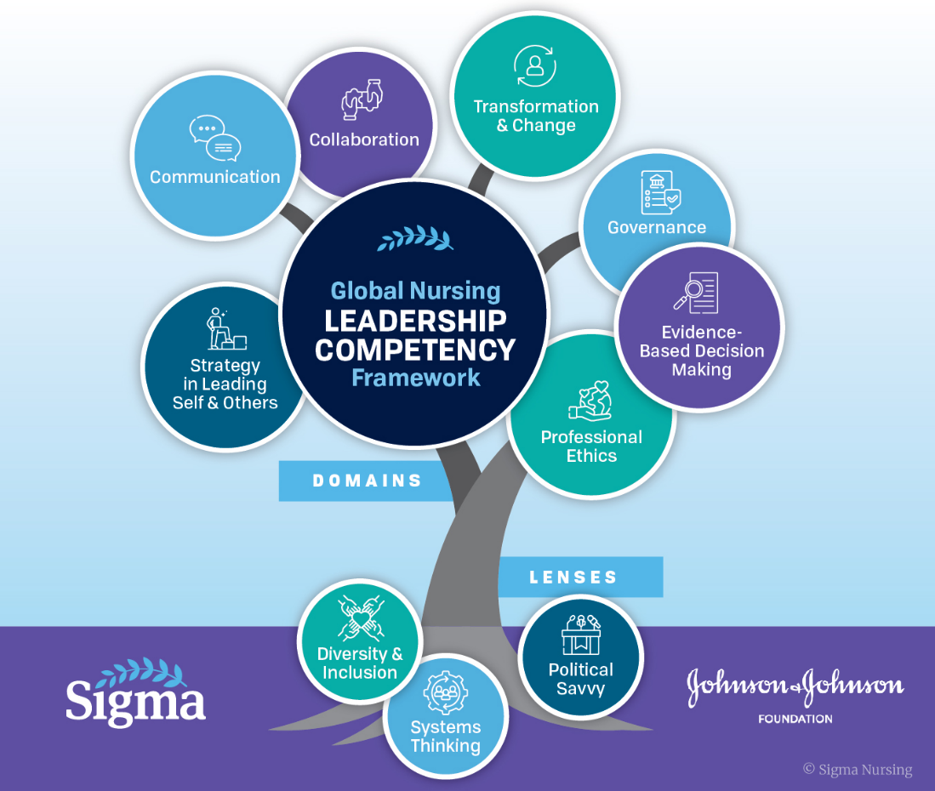
- Decided to use model as the organizing framework for the Leadership Committee.
- Committee members will take the self-assessment prior to Kappa Tuesday meeting and provide report.
  - Three Spider charts
  - Invite all do the survey
- Barbara will attend the 48th Biennial Conference and will check for information about the Global Nursing Leadership Competency Framework (GNLCF).

- Reviewed Kappa Chapter 2024 -2025 Report

- Priorities:
- Increase diversity
- Focus on freshman
- Begin our meetings with a Reflection

- Next meeting November 13th at 7:30 pm

SIGMA KAPPA CHAPTER
FACULTY COUNSELOR’s REPORT October 21, 2025

Founders' Day
Junior Keira Johnston
Senior Megan Williams
Masters Complex Healthcare Administration: Theresa Arlinghaus
DNP Delaney Foster
PhD Lai Wong

Student Intern
Kathleen and I will meet soon to discuss how we'd like to pursue recruiting and vetting a new student intern

Kappa Table
We plan to set up a Kappa on display table in October and December

HURST Review
It is time to determine what snacks we want to provide during the first week of November

Supply Drive for Little Sisters of the Poor- identified by Governance Committee
I can help advertise the supply drive and provide a drop off area for supplies.
During this meeting, my request is that members tonight could discuss
- how we identify the items needed by the LSOP
- how we can engage our distant members in this endeavor
- how to collect items from distance members

Sandra O'Brien, PhD, RN, CNE, CRNP-F, PHCNS-BC
Director, Family Nurse Practitioner Program
Director, International Nurse Exchange Programs
Faculty Counselor. Sigma Global Nursing Excellence
Scholar, Sigma Nurse Faculty Leadership Academy
Clinical Assistant Professor
Conway School of Nursing

