SIGMA THETA TAU INTERNATIONAL
KAPPA CHAPTER MEETING MINUTES
LEAD TOGETHER – Our Voice, Our Value, Our Impact

Meeting Date: November 18, 2025
Location: Virtual Zoom
Start Time: 6:45 P.M. (EST)
Meeting: 7:00 P.M. (EST)

Attendees: President Kathleen Noel, VP Deborah Jolissaint, Treasurer Heidi Maloni, Secretary Dr. Marysanta Bigony, Faculty Counselor Dr. Sandra O’Brien, Dean Marie Nolan, Zachary Brotzman, Dr. Abigail Villarroya, Dr. Agnes Burkhard, Dr. Susan Macyko and Lorraine Huber

- MEETING CALL to ORDER: 7:03 P.M. by Kathleen Noel, President
- MEDITATION: Prayer of Thanksgiving Abby Villarroya
- President Noel shared CUA notification to the community today of the passing of Fr. Jude DeAngelo, OFM Conv, past chaplain at CUA and Board offered a prayer for him.

- MINUTES MEETING OCTOBER 21, 2025:
- A discussion occurred as to where submitted reports should be included in minutes. They will be added after secretary’s signature as an attachment.
- Agnes Burkhard noted Research Committee Report missing from minutes, she will resend.
- Motion to approve (Heidi Maloni), seconded (Marysanta Bigony), one abstention – approved with addition of the October Research Committee Report.

NEW BUSINESS
- State of the Conway School of Nursing (CSON): Marie Nolan, Dean
    - Dr. Sandra O’Brien accepted the appointment of Associate Dean of MSN and DNP Programs. Grateful for her leadership.
    - Starting January 8, 2026, Lauren Aragoni will join as Assistant Dean of MSN and DNP Programs. She has been leading a management team at National Children’s Hospital in Washington, D.C.
    - Dr. Nicholas Comeau, DNP will be Coordinator of PNP Program for both Pediatric Primary and Pediatric Dual.
    - Dr. Marysanta Bigony was inducted into the Prince George’s County Volunteer Fire and Rescue Association Hall of Fame for 40+ years of service to the citizens of Prince George’s County.
    - President Peter Kilpatrick is close to finalizing the University Strategic Plan.
  - CSON held off on our Strategic Plan until the CUA plan is completed.
  - Will be having listening sessions with stakeholders, including Kappa, to assist CSON in develop our plan.
  - CUA plan includes 6 core strategic pillars: Catholic mission, academic excellence, formation of church leadership, unique student experience, premier outcomes, and institutional strengths and partnerships.
    - Dean Nolan is open to welcoming nurse leaders to visit/tour the new building and going out to speak to nursing leaders.
    - The Fall 2026 Conway Leadership Seminar was on November 12, 2025. Thank you to Kappa for funding the reception. Seminar addressed Interdisciplinary Palliative Care and End-of-Life Care. Dr. Mary Dixon led the planning and did a great job.

- Wreaths Across America
    - Volunteers (members and family) are needed for Saturday December 13, 2025.
    - Itinerary:
• 10 a.m. | Gather at the U.S. Soldiers' and Airmen's Home National Cemetery 21 at Harewood Road, N.W. Washington, DC 20011 to unload wreaths
• 11:30 a.m. | Group photo
• Noon | Short ceremony followed by wreath laying
    - Register through CUA Calendar Events site. Note: there are Wreaths Across America events in several locations in the country (https://engage.catholic.edu/events)
    - President Noel will ask Ms. Sudin Thomas to add information to our website.

- Resume Writing Marysanta Bigony
    - Seeking Kappa Members who will volunteer to assist CSON students (grad and undergrad) with their resumes.
    - Will survey Kappa members to ask for volunteers with responses by January 1, 2026.
a. Marysanta Bigony will develop a form for members to sign-up and follow-up with Leadership Committee and/or President Noel for distribution to Kappa members.
b. Plan is a list will be given to CSON faculty to share with students.
c. A student would then independently reach out to Kappa. members.

- Sigma Nurse Learning Exchange (New)
    - Grow. Lead. Thrive. The Nurse Learning Exchange is here to help you unlock your potential, boost your confidence, and earn contact hours—all with FREE, high-quality courses that meet you where you are in your career. Thanks to support from Johnson & Johnson, you now have access to a powerful collection of learning designed just for nurses like you.
    - Students can have access to NCLEX prep information through the Sigma website. They will need to create an account, even if they are not members (may need to call Sigma for assistance). President Kathleen Noel sent information to Dean Eileen Caulfield and will send to board members.

OLD BUSINESS
- 2025 Tri-State Conference
    - Held In-Person at University of Delaware on Sunday October 19, 2025 from 9:15 A.M.-2:15 P.M. with 3 CE’s
    - Topic: Empowering Nurses: Cultivating Resilience and Self-Care
    - Speakers: Athena Fernandez (Resilience) DNP, MSN, RN-BC, FACHE and Christina Gomez (Self-Care) MSN, RN, NI-BC, EBP, HTCP
    - CSON Student Attendance: Megan Stake, Hannah Daisomont, Aracely Juica and Elizabeth Webb. Statements to date …
Elizabeth Webb: At the conference I learned about what exactly resilience was in relation to thriving. Thriving is the ability to flourish in difficult circumstances, and resilience is the adaptation to those difficult circumstances that allows for an individual to thrive. I also learned about how the brain reacts to threats; it cannot tell the difference between physical, social, and perceived threats. Meaning I have to put more effort into controlling my responses to issues that may come up in the future as my brain will not think critically through a problem when it senses danger.

I thank you again so much for this opportunity to participate in the Tri-State Consortium. It was a pleasure to attend and it has given me a lot to consider in my time here as a student.
Aracely Juica: The keynote lecture Empowering Nurses through Cultivating Resilience and Self-Care was both inspiring and heartfelt. The speakers shared powerful stories from their own lives and careers, showing how resilience, compassion, and balance are essential in nursing and beyond. Their message emphasized that caring for ourselves allows us to better care for others turning challenges in the workplace into opportunities for growth, connection, and renewed purpose.
Item will remain on Old Business Discussion awaiting response from remaining 2 students, Megan Stake and Hannah Daisomont.
- 2025 Conway Leadership Seminar
    - Held on November 12, 2025 in the Conway School of Nursing from 4:30-6:30 P.M.
Topic: Palliative and End-of-Life Care.
The panel included:
Sister Diane Marie, O.P., vocations director and hospice nurse at Dominican Sisters of Hawthorne
Professor Elizabeth Kirk, J.D., co-director of the Center for Law and the Human Person & assistant professor at the Columbus School of Law
Michelle Churchill, MSN, CRNP, ACHPN, director of clinical programs, palliative care at Johns Hopkins Hospital
Rina Moore, LICSW, palliative care social worker at MedStar Georgetown University Hospital
Professor David Jobes, Ph.D., associate director of clinical training, and director of the Suicide Prevention Laboratory at The Catholic University of America.
    - Zoom viewing for CE to be provided by Dr. Mary Dixon at a later date. Email will be sent out with instructions by Kathleen Noel. President Noel will be following up with Dr. Dixon on the CEUs for remote viewing.
    - Dean Nolan sent information to regional nurse executives and Dr. Dixon reached out to many also.
    - Strong attendance (>100). Awaiting final numbers.

- 48th Biennial Convention November 8-11, 2025 Indianapolis, Indiana
    - Kappa Members in attendance: Kathleen Noel and Deborah Jolissaint (Delegates); Sandra O’Brien, Janice Agazio and Barbara Gillman Lamping.
    - By-Laws reviewed by the Kappa Leadership Team were approved at the House of Delegates on November 11, 2025. Theses By-Laws changes will go back to Sigma Governance for final approval.
    - Current Sigma President, Sandra Garmon Bibbs, installed the 36th Sigma President, Liz Westcott (from United Kingdom), on November 11, 2025.
Call to Action: Lead Together – Our Voice, Our Value, Our Impact
    - Election Results: President-Elect, Karen Gorton; Vice-President, Elizabeth Rosser; Secretary, Janice Hawkins and Regional 12 Coordinator (re-elected), Tami Jakubowski. President Noel can share the full election results with anyone who would like them.
    - There was a Region 12 Meeting where the coordinator “went through everything” for each chapter. Each chapter could receive up to 5 recognitions. Kappa received all five: mentorship, communication, respecting, responding, and reflections. Some chapters did not receive any recognitions. Kappa, also, received the eleventh Chapter Key Award.

- 2026 Annual Meeting
    - Explored dates recognizing Easter Break April 2-6, 2025; HESI dates are not finalized. Board considered Wednesday April 22, Thursday April 23 and Wednesday April 29. Would have it in Maloney Hall from 5:30 – 8:00 P.M.
    - Discussion of student availability on Thursdays due to possibility of exams on Fridays.
      - All in attendance supported Wednesday as the preferred date.
      - Later in the meeting, Dr. O’Brien reported when she tried to book April 22, the space in Maloney wasn’t available. Discussion of other dates: April 8 (week after Easter); April 29 (week before finals). She was able to request 4/29 for the event.

- Nurse Leader Challenge Continues
    - The Leadership Team is again encouraged to contribute to the Challenge with new Potential Candidates for Nurse Leaders. An area that needs work for the future 2025-2027 Key Award Submission.
    - Criteria for leadership membership is
      - BSN or more
      - Area of clinical expertise
      - Resume
      - Statement of interest
      - Kappa Chapter votes on the application then it goes to Sigma for review.

PLANNING AGENDA
- Vice-President: Deborah Jolissaint
  - Future Planning
  - Reviewed possible speakers, three were identified; possible topics:
        - How nurses can affect climate change
  - Best schedules for nurse retention
          - A Question of whether this would be a compelling or inspiring topic for attendees
  - Concept of/partner with another chapter for a presentation

- Ad-Hoc Programs: Member Needed
  - Request for volunteer was noted in the November Sigma Update. No response to date.

- Governance Committee (Report by Zachary Brotzman): Angela Cooper, Zachary Brotzman, Victoria Lowe and Sandra O’Brien
  - Request prayers for Angela Cooper.
  - Have been in contact with Lorraine Huber regarding Little Sisters of the Poor. They are in need of donations, prefer cash/check/gift cards.
      - Mr. Brotzman is working on a flyer for Thanksgiving.
      - Noted donations could be used at any time and would be much appreciated.
      - President Noel noted donations need to go directly to Little Sisters of the Poor and not through Kappa.
      - Zachary will also check to see if they have an Amazon wish list through which people could donate.
      - Kappa is a 501c3 but would be better for donations to go directly to Little Sisters of the Poor.

D. Leadership Committee (Report by Abby Villarroya): Eileen Caulfield, Abby Villarroya, and Barbara Gillman Lamping (See attachment A)
1. The Committee met on November 13, 2025.
2. They are looking at continued development of student leadership ambassador program and collaborating with another chapter. Will discuss further at December Meeting.
3. Planning to meet with President Noel in December to reach out to Sigma leadership for consultation on how to develop mentorship program in Kappa. Plan to implement in January 2026, a time when people make resolutions and changes.
4. Discussed Global Leadership Competency Framework. Leadership Committee members took the 45-minute assessment. Found it very enlightening.
5. Discussed 2026 ballot. They will meet with President Noel to discuss openings.
6. Contacting 2025 Inductees and 2024 Inductees Inactive
a. Per President Noel, it’s been over 6 months since any contact with new inductees. Priority: need to reach out to them.
7. Current Membership: 231 (4 Inactive as of October 1, 2025 (72.17% Retention in 2025)
8. Next Committee Meeting is December 4, 2025 at 7:30 P.M.

E. Treasurer’s Report: Heidi Maloni
1. N990 has been filed to Sigma.
2. Sigma made a deposit into our account for new members. In the past was received in August, this year received in October.
3. Majority of funds in a TRUIST Money Market, accruing about $50.00/month.
4. Bills are paid.

- Finance Committee: Anna Alt-White – not present, no report submitted

- Faculty Counselor: Sandra O’Brien
- No HURST Review and awaiting date from Dr. Caulfield.
- Kappa Tables for Students planning possibly for a week between January 11-24, 2026.
- Have not begun search for Student Interns. Dr. O’Brien and President Noel to discuss how to go about this.

- Ad-Hoc Health and Climate: Susan Macyko, Mackenzie Costello
- Last week’s seminar on Cancer and the Environment.
- This week on Emergency Preparedness
- Alliance Series from current to December 2, 2025 is coordinated by Columbia University and speakers are global.

- Research Committee: Agnes Burkhard (See attachment B)
- Finished the Fall 2025 Applicants for the grant. One applied and decision was made not to fund applicant based on her application. Over the years, approximately 25% of applications are denied.
- $2,000 for this semester will roll into the spring.
- Plans for Kappa showcase on Thursday February 19, 2026 at 7:30pm via Zoom.
      - Have 2 speakers: Abby Villarroya (Nurse’s Cultural Competence in the Emergency Department) and Nick Comeau, DNP (Education Program to Enhance Recognition of Deterioration in the Pediatric Setting).
      - Decided not to apply to Wisconsin due to the cost ($175) and need to submit materials 60 days in advance. Georgia is still only $100 and submission is 100 days prior.
- Discussion of zoom accounts. Have three accounts – discussion tabled until the next meeting.

- Ad-Hoc Communications (Report by President Noel): Sudin Thomas
- Flyer for Conway Seminar sent out.
- Notice for Volunteer Service for Founders’ Day October 5, 2025 sent out.

- Interactions Kappa Chapter and the Conway School of Nursing
- Magie Maline, NSNA President and Jamie Mersel, NSNA Vice-President; President Noel sent information to them, but has not received a reply.

- Student Intern2025-2026: Representatives Needed

NEXT MEETING: The next Kappa zoom meeting will be January 20, 2026 with conversation at 6:45 P.M. and meeting at 7:00 P.M.

ADJOURMENT: 8:36 P.M.

Respectfully submitted,
Marysanta D Bigony, PhD, MSN, MA, RN, CCM, PHCNS-BC

Attachment A

Leadership Report
November 18, 2025
- Committee met on Thursday, November 13 from 7:30 pm – 8:15 pm via Zoom.
- Abby Villarroya
- Barbara Gillman Lamping
- Eileen Caulfield

- Barbara discussed the Sigma Biannual Conference.
- Strategies to create student chapter engagement:
  - Develop a student leadership ambassador program.
  - Draw students into the chapter before graduation.
  - Increases likelihood students following graduation will remain involved and stay on the board.
  - Target freshman and sophomore nursing students.
  - Chapter would pay for Sigma membership.
- Barbara established a contact with another Sigma member who will share information from her chapter.
- Eileen requested the CSON BCC student representative to informally survey students to gage interest.
- Work to establish a Kappa mentorship program.
  - Reviewed the Sigma Mentorship Model
https://thecircle.sigmanursing.org/mentoring/aboutmentormatch

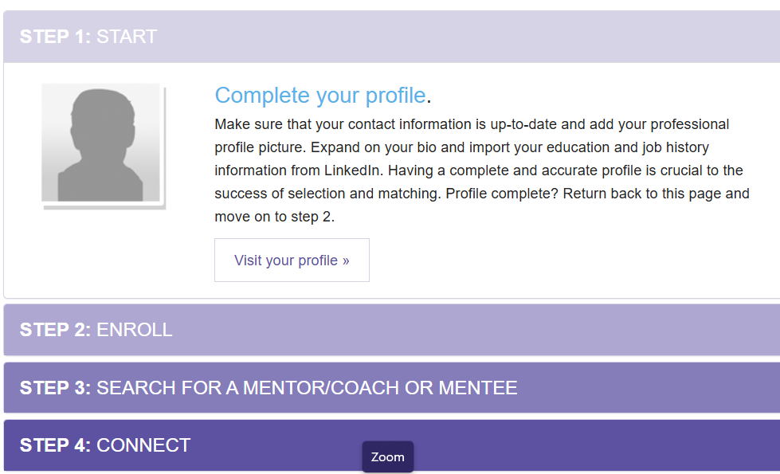

  - Let’s not “reinvent the wheel”, determine how to make this work for Kappa.
  - Plan a meeting with Kathleen in early December to discuss contacting Sigma Headquarters to determine how the Leadership Committee can utilize the Sigma framework and website.
  - Based on the Sigma consultation, plan how to implement the Kappa mentorship program.

- Timeline
Committee Work – Nov/Dec
- Communication Plan
Implementation – January 2026
- During the new year, people reflect upon the upcoming year and make changes/resolutions.
Measure Effectiveness
- Mentor/Mentee share experience
- Survey

- Global Nursing Leadership Competency Framework (GNLCF).
- Follow-Up to Invitation Board members: take the self-assessment ?

- Kappa Ballot
- Verify open positions with Kathleen
- Focus on freshman
- Begin our meetings with a Reflection

- Next Leadership meeting December 4th at 7:30 pm.

- Abby will give Committee Leadership Report at the Nov 18th Kappa Board Meeting.

Attachment B

Kappa Research Award Committee Report
November 18, 2025
(Revised)
- The Fall 2025 grant application reviews have been completed. There was one applicant for the grant. The applicant’s materials were reviewed by three PhD reviewers. Based on the review scores, the committee’s recommendation is not to fund this applicant.
- Planning is underway for the Kappa Showcase: Adventures in Nursing Science 2026. We have two past grant awardees as confirmed speakers: Abby Villarroya PhD (2019) and Nick Comeau DNP (2025). Abby’s research focused on nurses’ cultural competence in the ED and Nick’s project evaluated an education program for nurses to enhance recognition of deterioration in the pediatric setting. Terri Kapetanovic and I are working on the CE application. We anticipate submitting an Individual Education Activity application to the Georgia Nurses Association. The cost will be $100 and the deadline is 30 days before the program. The program date will be Thursday, February 19, 2026, 7-8:30 pm. The lie program will be recorded and available for later viewing. Publicity for the program will begin in December with a “save the date”.
Respectfully submitted,
Agnes Burkhard PhD, RN
Research Award Committee, Chair

