Fall/Winter Newsletter 2022
As we move into the holiday season, I reflect on the magic it creates with my young children. The excitement they have on their faces when they see Christmas lights going up, Santa starting to show his face, and of course, the Christmas tree their presents will lay underneath. However, it isn’t always the same for us as adults. Sometimes the holiday season can create even more stress and depression. Although many of us may feel this way, it is important to find and reflect on things we are grateful for. I have been blessed with wonderful friends, colleagues, family, healthy children, a roof over my head, to take care of others during times of illness, help develop the new nurses of the future, and so much more. My wish for each of you during this holiday season is to feel the magic of the holiday season by reflecting on the good in your life by spending time with family or friends, eating all the holiday food, shopping, getting a little bit more rest, or just what makes your heart happy. Even with all the bad in this world, there is much more good. We just need to look a little harder for it.
Merry Christmas and a Happy New Year!

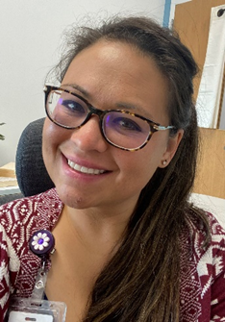
This Photo by Unknown Author is licensed under CC BY
Nu Rho Chapter at Large- President
Krystal Davis Ed.D, RN
_________________________________________________________________________________
Put these chapter activities on your calendar:
Monday, January 30th – Nu Rho Education and Board Meeting at 6 p.m. at Nebraska Wesleyan, Callen Conference Room, Lower Level of the Smith Curtis Building
Monday March 27th, Induction of New Members at Heartland Hall, College View Seventh Day Adventist Church at 7:00 p.m.
In Memory of Dr. Marilyn McArthur,
founding member of Nu Rho Chapter-at Large

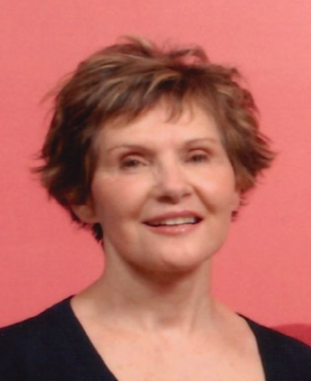

Dr. McArthur taught at Union College from 1981 until her retirement in 2004, becoming chair of the Division of Nursing in 1990. While teaching at Union, she earned a Ph.D. in Human Resources and Family Science at the University of Nebraska-Lincoln.
Under her leadership, the Nursing Program launched a series of foot clinics for the homeless and near-homeless of Lincoln, a service Union College nursing and PA students have continued for 29 years. Perhaps less known, was her research related to the experiences of widows living in China resulting in her invitation as an honored speaker at a conference sponsored by the Chinese government.
After her retirement, she taught Transcultural Nursing in the M.S.N. Program at Nebraska Wesleyan and worked with graduate student research projects. She was a treasured mentor, both at Union College and Nebraska Wesleyan University. She is fondly remembered by faculty and students at both universities.
_______________________________________________________________________

Induction of New Members
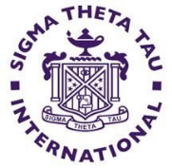
Our in-person induction will take place Monday, March 27th at 7:00 p.m. at the Heartland Hall (East upper entrance) of College View Seventh Day Adventist Church. If you know of a nurse who is interested in joining, please contact any of the board members and they can help you find the nomination page on the Sigma Website. There are many worthy nurses who should belong!
______________________________________________________________________
Education Program Monday, January 30, 2023
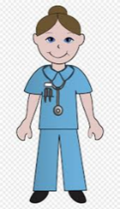
Assessment of Knowledge and Confidence of the
Respiratory System in the Novice Nurse
Presented by
Peggy Behrens, DNP, APRN-CNS, RNC-OB
Assistant Professor of Nursing, Nebrwesleyan University
Business meeting at 6:00, refreshments and program begin at 7:00 p.m.
Callen Conference Room, Smith Curtis Hall, Lower Level
Nebraska Wesleyan University
You may park any where on campus or 50th St. or Madison Street
Non-peer reviewed continuing education credit
_________________________________________________________________

Board Vacancies
Want to work with amazing people? We need 2 people. If you want to meet other nurses and like to organize events, we would love to have you as our Membership Involvement Chair. If you like to update Facebook or social media, and learn about the Sigma Facebook social media, we would love to have you involved! Contact any board member if you are interested.

President: Dr. Krystal Davis (2022-2024)
Leadership Succession Committee Members: Lynne Heithoff (2021-2023) & Kristi McGuire (2022-2024)
Governance Chair: Jenny Eilts (2021-2023)
Newsletter/Publicity: Jeri Brandt
Secretary: Dr. Sue Gabriel (2021-2023)
Research: Dr. Linda Hardy (2022-2024)
Treasurer: Carey Deeds (2022-2024)
Awards/Recognition: Dr. Kristine Follett (2020-2022)
Vice-Presidents: Dr. Charlotte Liggett (NWU 2021-2022) & Dr. Larinda Fandrich (Union 2022-2024)
Webmaster: Vacant
Faculty Counselors: Dr. Becke Voight (NWU 2022-2024) & Dr. Rebecca Randa (Union 2020-2022)
Membership Involvement- vacant
Leadership Succession Chair: Dr. Peggy Behrens (2022-2024)
Governance Committee Members: Dr. Becke Voight (2021-2023) & Kathy Feagler (2022-2024)

_____________________________________________________________________________

Nu Rho Sigma Chapter Exceeds its Goal for Virtual Food Fund Raising!
Our chapter exceeded its goal for raising food!

