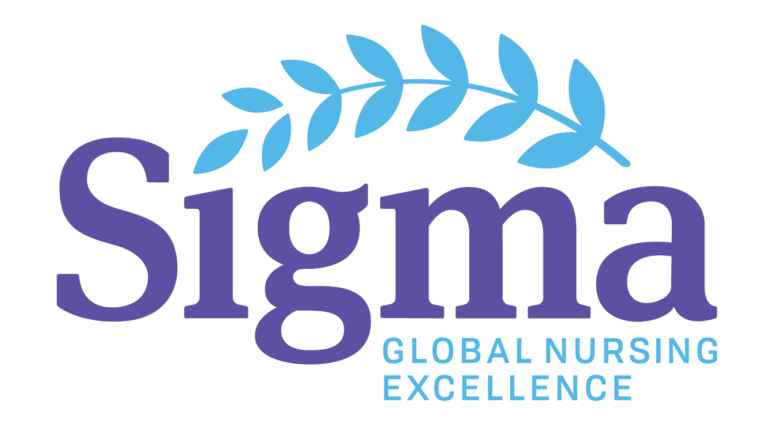
Sigma Theta Tau International, Sonoma State University
LAMBDA GAMMA CHAPTER
2021 RESEARCH GRANT
APPLICATION FORM
Due April 15, 2021

- Date:
- Name:
- Email:
- Home Address:
- City: State: Zip:
- Phone:
- Registered Nurse in State(s) of: License #(s):
- Sigma Theta Tau Member: Lambda Gamma Member:
- Previous Sigma Theta Tau Research Funding
None Regional Chapter International
Preference for Lambda Gamma Active Members or those invited to the Lambda Gamma Chapter. Disbursement of grants based upon available budgeted funds. Funds unused in one category may be allocated to another at Board Discretion.
The deadline for Scholarships & Grants applications for 2021 must be received by April 15, 2021 to Mary Ellen Wilkosz, PhD, RN, MSN, Chair, Scholarship, Awards and Grants Committee wilkosz@sonoma.edu

Please prepare grant to contain each of these issues; May address each briefly

TITLE:

Abstract:
Background:

Problem Statement:

Study Aims:

Hypothesis:

Theoretical Framework:

Literature Review:

Human Subjects/Institutional Review Board:

Population/Sample:

Instruments-Reliability and Validity:

Procedure -- The study plan is as follows:
Methodology –
Study Design:
Steps to Study:
Data Collection:
Data Analysis:
Timeline:
Budget Requested: (Up to $1800 has been awarded per applicant according to budget available, dependent upon number of qualified applicants)

Biographical Sketch of Applicant:

The deadline for Scholarships & Grants applications for 2021 must be received by April 15, 2021 to Mary Ellen Wilkosz, PhD, RN, MSN, Chair, Scholarship, Awards and Grants Committee wilkosz@sonoma.edu

