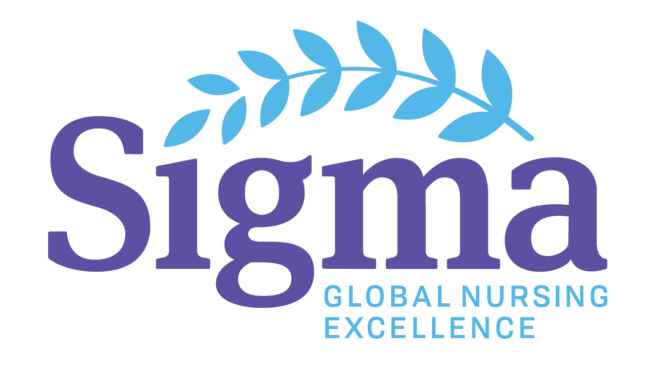
ALPHA PSI CHAPTER

Research/Scholarship & Project Grants and

The Alpha Psi Chapter of Sigma Theta Tau International is committed to promoting nursing scholarship and is pleased to invite you to apply for one of the two following awards that focus on nursing knowledge generation, dissemination, and application:

- Alpha Psi Research/Scholarly Project Grant (up to $1,000)
- Alpha Psi Professional Development Award (up to $500)

Purpose: The Alpha Psi Research/Scholarship and Professional Development grants support scholarly activities that foster high professional standards, strengthen nursing ideals, and promote the science of nursing. Proposals/applications that are encouraged are those in which:

- Participants will disseminate information that advances nursing education, research, and practice.
- Involve innovative collaborative research, education, and/or practice efforts between academic and clinical arenas.
- Increase personal and professional development that will contribute to the advancement of nursing science and practice.
- Applicants request assistance to present papers or posters that are accepted or submitted for presentation at a professional conference.
- Contribute to future research endeavors or scholarly activities that advance nursing science.

Eligibility Criteria: All active members of the Alpha Psi Chapter are eligible. Applicants must agree to spend the monies in accordance to the budget submitted. Once the proposed project is completed, the applicant must provide a project summary and submit a brief report that may be published in the Chapter newsletter.

Application Procedures:
- The current deadline for submission is: Feb. 16th, 2020
- Submit a completed Research/Scholarship or Professional Development grant application to the chairperson of the scholarship committee.
- If permission to complete the proposed project is required, submit a letter of support from the appropriate personnel.
- List additional funding sources that are anticipated
- Members of the Alpha Psi Scholarship Committee will review and rank complete applications submitted by the due date.
- The committee will complete its review within 1 month.
- Applicants will receive written notice on the outcome of their proposal at the conclusion of the review process.

Guidelines:
- All Alpha Psi Chapter members can submit an application for a grant.
- The amount and number of grants and awards will depend, in part, on the amount of funding allocated and the numbers of grant and award proposals. The committee reserves the right to allocate partial funding and to solicit additional information.
- The committee reviews all complete applications received on time.
- The review process is a blind review.
- Applications are not to exceed 5 pages.
- Applicants are eligible to receive only one grant award annually. Grant summaries must be received before applicants are eligible to apply for additional awards.
- Members of the Scholarship committee are eligible to submit a grant proposal or award application for consideration but must remove themselves from the grant review process.
- Complete and Submit either: 1) Research/Scholarship Grant; or 2) Professional Award Application Form:
- Research/Scholarship Grant Proposal Review Criteria (see 1 below for further description): Applications will be reviewed and rated on: a) Significance; b) Approach; c) Innovation; d) Investigator; e) Environment; and f) Translation.
- Professional Development Award Application Review Criteria (see 2 below for further description): Applications will be reviewed and rated on: a) Significance; b) Approach; c) Investigator; d) Award Goals.

1. Research/Scholarship Grant Criteria (not to exceed 5 pages):

Significance: Does this study address an important nursing problem? How will this advance the science of nursing?

Approach: Is the proposal well developed (Nursing framework, design, methods, analyses) and appropriate to the aims of the proposed project or study?

Innovation: How is the study or proposed project original and innovative?

Investigators: Is/are the investigator(s) appropriately trained and well suited to conduct or complete the proposed project or study?

Environment: Does the nursing environment in which the study will be conducted contribute to the probability of success?

Translation: Does the proposed research have translational significance?

2. Professional Development Award Criteria (not to exceed 5 pages):

Significance: Does the proposed professional development activity address an important nursing problem? How will scientific nursing knowledge or clinical practice be advanced by the professional development activity?

Approach: If requesting funds are being used to present at a conference, does the proposed abstract include a conceptual or clinical nursing framework, and an appropriate design, methods, and analyses discussion that are well integrated, well reasoned, and appropriate to the purpose statement?

Researcher/scholar: Is/are the researcher/scholar(s) appropriately trained and well suited to complete the proposed professional development activity?

Award goals: Are the goal statements clear, coherent, and measurable to achieve the desired ends of the professional development activity?

ALPHA PSI CHAPTER

1. Research/Scholarship Grant Application
Application Deadline for Submission: Feb. 16, 2020

Name of Applicant
Date
Contact Information
Phone Number
Address
E-mail address
Current Position
Agency Employed
Grant Proposal Overview
A concise descriptive statement of the proposed project (Project summary)
Grant Proposal
Briefly describe proposed project: a) specific aims; b) significance; c) innovation; d) approach; e) investigator; and f) environment.
A time schedule for completion
A proposed budget with justification (may attach completed budget form if necessary; Not to exceed $1,000.00)
Indicate additional sources of funding including source and amount of grant(s).
Provide a summary of the translational impact of the proposed project and description of how the findings will be disseminated
Supportive Narrative
Describe how this research project will contribute to your personal professional development.
Describe how the completion of the research project will contribute to the mission and goals of the Alpha Psi Chapter and advance the profession of nursing.
Grant Proposal Agreement
I am a current member of the Alpha Psi Chapter and am eligible to receive grant monies
I agree to spend allocated funds according to the budget submitted
I agree to complete a grant summary (or update) within one year
I agree to submit a report to be published within the Chapter newsletter
Signature:
Date:

Please email submission to Crista Reaves at: mitch350@msu.edu

ALPHA PSI CHAPTER

2. Professional Development Award Application
Application Deadline for Submission: Feb. 16, 2020

Name of Applicant
Date
Contact Information
Phone Number
Address
E-mail address
Current Position
Agency Employed
Professional Development Award Overview
A concise descriptive statement of the proposed professional development activity.
Professional Development Activity Description
Goals and evaluation plan for the professional development activity
The time schedule for professional development activity completion
A proposed budget with justification (may attach completed budget form if necessary; Not to exceed $500.00)
Provide a brief summary of your background & relevance/suitability to this professional development award application
Conference Information (if applicable)
Sponsoring Organization
Conference Name
Conference Web Address
Conference Location
Purpose of attending conference | Personal Professional Development_____  Present at the conference:  Paper:__________  Poster:__________  Panel or Workshop: __________  Individual Presentation:___________  Other: (please describe):
Title of Presentation:
Insert abstract of proposed presentation if applicable:

Have you received confirmation of acceptance to present at the conference | Yes: Please provide relevant documentation  No: Anticipated date of notification
Supportive Narrative
Describe how this professional development activity will contribute to your personal professional development.
Describe how your completion of the professional development activity will contribute to the mission and goals of the Alpha Psi Chapter and advance the profession of nursing.
Professional Development Award Agreement
I am a current member of the Alpha Psi Chapter and am eligible to receive professional development award monies
I agree to spend allocated funds according to the budget submitted
I agree to complete a professional development summary (or update) within one year
I agree to submit a report about the professional development activity to be published within the Chapter newsletter
Signature:
Date:

Please email submission to Crista Reaves at: mitch350@msu.edu

