Minutes from the Sigma Xi Iota Board/Executive Meeting
Agenda for Mon, September 8, 2025, at 1200
Centennial Hall Nursing Conference Room
Current Membership is: 69 Members
Meeting Attendees:
Alicia Cure, Stacey Machado, Jeanette Sanders, Robin Lockhart, Morgan Holcomb, Sandra Groth, Melissa Witherspoon, Michelle Hall
On - Zoom - Keelin Cromar, Carol Stiltner
- Leadership Positions Needed (14)
President - Michelle Hall
Vice President - Sandra Groth
Treasurer - Stacey Machado
Secretary - Morgan Holcomb
Chapter Delegate 1 - Robin Lockhart
Chapter Delegate 2 - Michelle Hall
Governance Chair - Robin Lockhart
Governance Chair Member 1 - Alicia Cure
Governance Chair Member 2 - Carol Stiltner
Leadership Succession Chair - Melissa Witherspoon
Leadership Succession Chair 1 - Morgan Holcomb
Leadership Succession Chair 2 - Jeanette Sanders
Counselor - Nicholas Hubbert

2. Spring 2026 Induction Ceremony Date
- Tuesday, April 14th or 21st from 6 pm to 8 pm - Reserve the CH Lobby - Will decide depending on the clinical week
- Do we want to buy the students their cords?
- Speaker

3. Sigma Budget
- Balance Amount _$5, 602.43 ________
- Money Market Account - wait on this
- Donation for Alzheimer’s Walk with SNA -
  - Proposal: Approve funding to donate $250 to the Alzheimer’s Walk on Sept 27th, 2025
  - Motion: Robin Lockhartmade a motion to approve the proposal
  - Second: Melissa Witherspoon seconded the motion
  - Discussion: Members discussed the budget and the past two years donations
  - Vote: Motion carried unanimously (9-0)
- Biennial Conference
  - Proposal: Approve funding of $345 for Registration to the Virtual Conference Attendance by One Sigma Member (Robin Lockhart) on Nov 10th and 11th, 2025
  - Motion: Michelle Hall made a motion to approve the proposal
  - Second: Alicia Cure seconded the motion
  - Discussion: Members discussed the budget and the attendees
  - Vote: Motion carried unanimously (9-0)

4. Conferences
- Biennial Conference - 48th Biennial Convention - Nov 8-11, 2025 - Indianapolis, IN - Need one or two Zoom Attendees - Monday, Nov 10th and Tuesday, Nov 11th - Virtual Conference Attendees - $345 (Xi Iota - CHP 343, North America 6 Region) - See proposal above

5. General Meeting Dates this Semester -
- Zoom Meeting - Tuesday, Oct 14th, 7 - 8 pm
- Lunch Meeting - Wednesday, Nov 12th, Noon - Reserve Room (Pizza Lunch)

6. Volunteer Events
- Alzheimer’s Walk with SNA, Date is Saturday, Sept 27th - 0830 (see proposal above)
The Team is under Zoe Shoemaker name: https://linkprotect.cudasvc.com/url?a=https%3a%2f%2fact.alz.org%2fsite%2fTR%3ffr_id%3d18931%26pg%3dpersonal%26px%3d25602096&c=E,1,m5u1Xgyz9BLHlkVUgMKRKedqC4-TFRw-Bj3SxPww9rtUAeuSL1w9OARyNrpRm1VHiwgx4LM7aUU3cU4XRY_r_wh1OoWJ8A9LaV1r6adIMtxCb-fYxqz0kw,,&typo=1

- Day at the Food Bank - will look into a day, talk with SNA
- Day with Hospice - will email the staff

7. Sigma Xi Iota Website - Survey - Will send out the Form Link

https://docs.google.com/forms/d/e/1FAIpQLScrVNh646tcmqzEYpS-GUc8Rd8cDwJNPn4QDRUc_ymZbkp0xw/viewform?usp=sharing&ouid=112560833508905301356

8. New Initiatives
- Nurses Climate Challenge - Will talk with Betty and Marty, Jeanette is going to send the AF initiatives
- Mentorship Program - Robin and Jeanette are setting up a Luncheon, Talking about a CE event at the Country Club
- Key Chapter Award - Will begin to work on this
- Flu Clinic with Sheppard Air Force Base - Will have 4th and 5th-semester students participate

9. Book Club -
We picked Endurance for the Book of the Semester, would like to discuss it at the Wed, Nov 12th, Noon Lunch Meeting
- Endurance Shackleton’s Last Expedition 1914-1917 - Ernest Shackleton - Book for this Fall 2025 semester, would like to discuss the book at the Wed, Nov 12th Luncheon
- When Breath Becomes Air- Paul Kalanithi
- The Epidemic - David Bekok

10. Next Meeting Date – Monday, Oct 13th at Noon

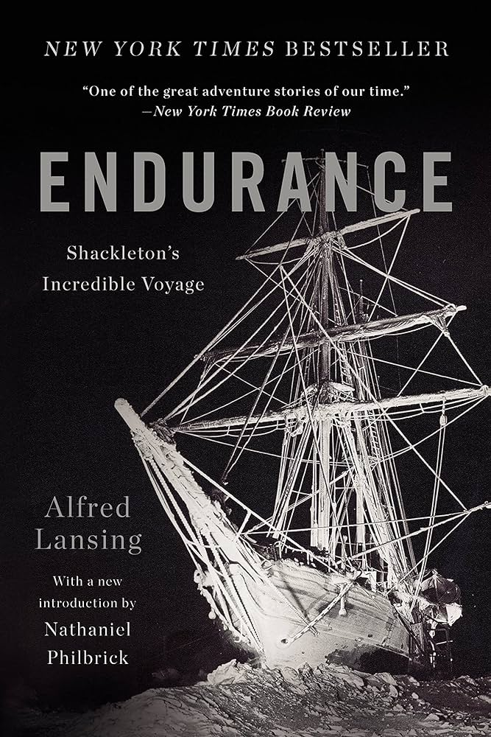

Endurance Shackleton’s Incredible Voyage by Alfred Lansing
This is a new reading of the thrilling account of one of the most astonishing feats of exploration and human courage ever recorded.
In August of 1914, the British ship Endurance set sail for the South Atlantic. In October 1915, still half a continent away from its intended base, the ship was trapped, then crushed in the ice. For five months, Sir Ernest Shackleton and his men, drifting on ice packs, were castaways in one of the most savage regions of the world.
Lansing describes how the men survived a 1,000-mile voyage in an open boat across the stormiest ocean on the globe and an overland trek through forbidding glaciers and mountains. The book recounts a harrowing adventure, but ultimately it is the nobility of these men and their indefatigable will that shines through.

