July 10, 2020 – Friday – 11:00 AM – 12:30 PM (fee based)
Sports and Performance Programs: Support for the Social Emotional Wellness of Students

Speaker Biographies
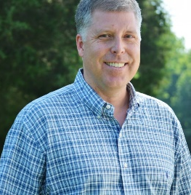

Dr. David Wyrick
Director of the Institute to Promote Athlete Health & Wellness
Associate Professor of Public Health Education and Faculty Athletics Representative
University of North Carolina at Greensboro

Dr. Wyrick is the Director of the Institute to Promote Athlete Health & Wellness, Associate Professor of Public Health Education and Faculty Athletics Representative at the University of North Carolina at Greensboro. As a prevention scientist, Dr. Wyrick has extensive experience in innovative research methods, program evaluation, and intervention development. He has served as a Principal Investigator/Co-Investigator for more than 20 National Institutes of Health (NIH) funded projects and has published extensively in academic peer reviewed journals. He is currently Co-Investigator on a 5-year project funded by the National Institute on Alcohol Abuse and Alcoholism (NIAAA) that is developing and optimizing an online behavioral intervention targeting the intersection of alcohol and sexual risk behaviors among college students.

Dr. Wyrick is also a former NCAA dual sport student-athlete (Basketball & Track and Field; Elon University) which is the primary source for his passion to conduct research aimed at promoting the health and wellness of athletes. Dr. Wyrick has received multiple awards from the National Institute on Drug Abuse (NIDA) to develop myPlaybook, an online health and wellness resource for college student-athletes. myPlaybook is being implemented by hundreds of college and university athletic departments around the country.

Dr. Wyrick has served as a member of the Board of Directors for the Society for Prevention Research, the Early Career Preventionist Network, the North Carolina Entrepreneurship Center, and the UNCG Entrepreneurship Cross-Disciplinary Program. He has also served as the Chair of the UNCG Faculty Athletics Advisory Committee, the Chair of the UNCG Chancellor’s Advisory Committee for Intercollegiate Athletics, a member of the UNCG School of Health and Human Sciences Research Advisory Council, and multiple NIH grant review committees.

He has partnered with organizations such as the National Collegiate Athletic Association (NCAA), the National Association for Intercollegiate Athletics (NAIA), the National Football League (NFL), the North Carolina School of Science and Mathematics, Nebraska Educational Telecommunications, the Carnegie Foundation for the Advancement of Teaching and Learning, the Pacific Institute for Research and Evaluation, Coach for America, the Denver Broncos, the Dallas Cowboys, and the National Center for Drug Free Sport. David loves traveling with his wife Cheryl and three daughters Katherine, Caroline and Elizabeth.

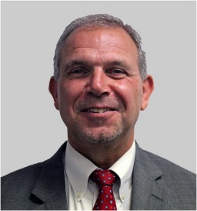
Dr. John “Billy” Haun, Ed.D.
Executive Director
Virginia High School League

Billy Haun currently serves as executive director of the Virginia High School League, an alliance of Virginia’s public and approved non-boarding, non-public high schools that promotes education, leadership, sportsmanship, character and citizenship for students by establishing and maintaining high standards for school activities and competitions.

Haun served as the Chief Academic Office and Assistant Superintendent for Instruction of the Virginia Department of Education, which allowed him to work with all areas of the Commonwealth.

He also has previous experience as an assistant superintendent, middle and high school principal, assistant high school principal, teacher, athletic director and coach.
Haun earned a bachelor’s degree in education from Virginia Tech, a master’s degree in education administration and supervision from Shenandoah University and a doctorate in administration and supervision from the University of Virginia.

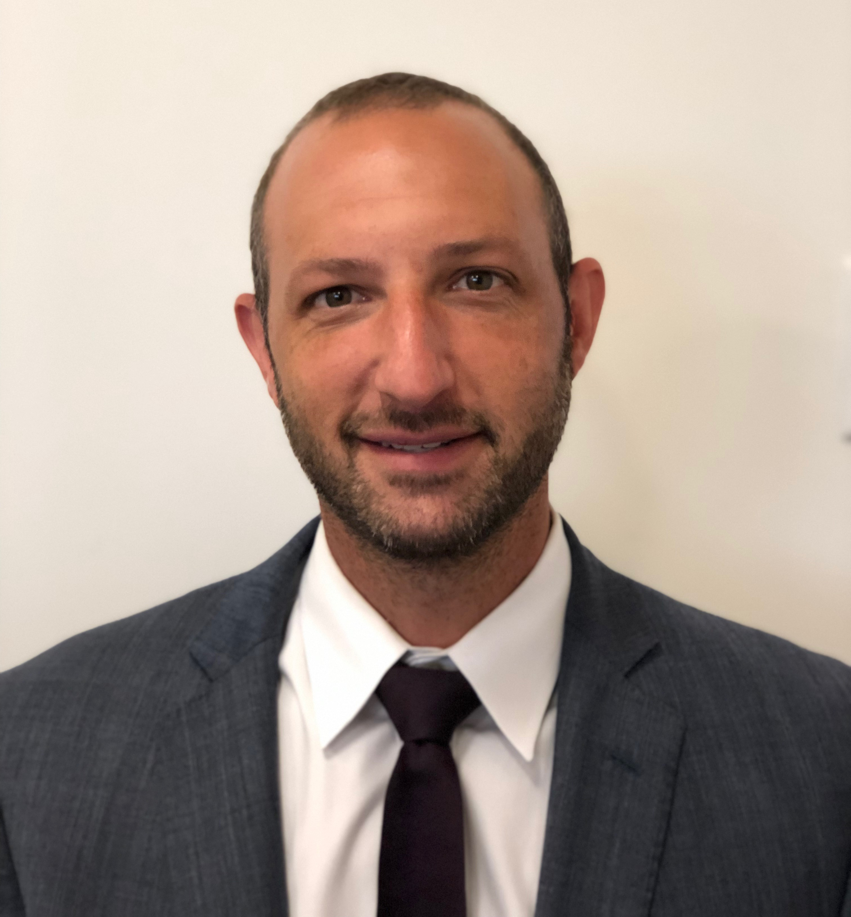

Adam Lustig
Director
NSBA Center for Safe Schools

Adam Lustig is currently the Director for the National School Boards Association's Center for Safe Schools, an NSBA initiative to support and ensure a safe and secure environment for students, staff and community members. Adam has spent his career working in public education as first a teacher and varsity coach before becoming a school administrator responsible for Safety, Security and School Climate in New York City Public Schools. He then worked in Washington DC Public schools managing the areas of social-emotional learning, student behavior, bullying prevention and restorative justice for all DCPS schools. Through these experiences he has formed the belief that school safety goes far beyond just focusing only on security measures or individual programs, but rather with a shift from reactive to preventative measures, focusing on supporting the whole child, while also engaging schools, families and communities. Adam has also served as a professional development trainer at the state, district and school levels.
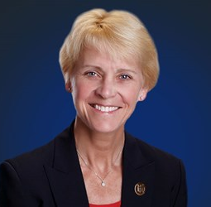

Dr. Karissa Niehoff
Executive Director
National Federation of State High School Associations

Dr. Karissa L. Niehoff is in her second year as executive director of the National Federation of State High School Associations (NFHS) in Indianapolis, Indiana. She is the first female to head the national leadership organization for high school athletics and performing arts activities and the sixth full-time executive director of the NFHS, which celebrated its 100th year of service during the 2018-19 school year.

She previously was executive director of the Connecticut Association of Schools-Connecticut Interscholastic Athletic Conference for seven years.

