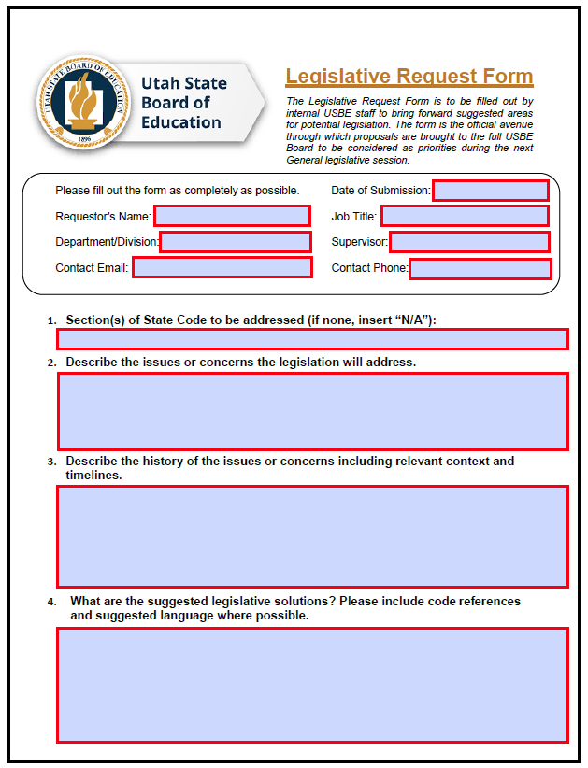
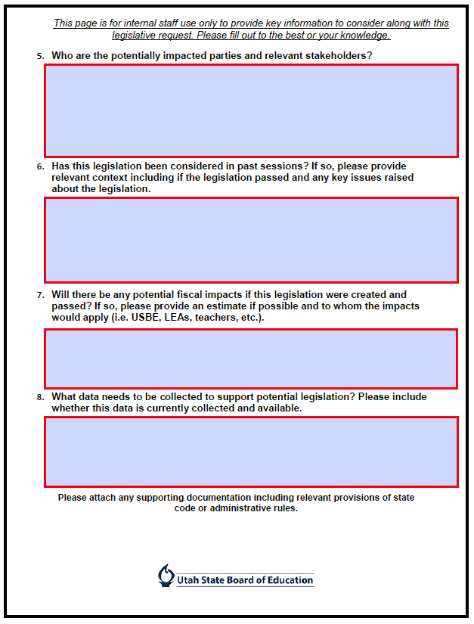
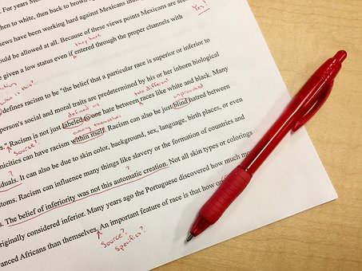
Drafting Manuals:
Link to states manuals-- http://www.ncsl.org/legislators-staff/legislative-staff/research-editorial-legal-and-committee-staff/bill-drafting-manuals.aspx
Utah Drafting Manual- https://le.utah.gov/documents/LDM/draftingManual.html

Laws:
Model Procurement Code: https://www.americanbar.org/content/dam/aba/administrative/public_contract_law/pcl-model-02-2000-code-procurement.pdf
Model Procurement Code Regulations: https://www.americanbar.org/content/dam/aba/administrative/public_contract_law/pcl-model-03-2000-model-procurement-regulations.pdf

FAR: https://www.acquisition.gov/browse/index/far

Other Resources:
JAG Contract Attorney Deskbook: https://tjaglcspublic.army.mil/documents/27431/37168/Contract+Attorney+Deskbook+2017.pdf/e0f6f388-6a39-4f09-b553-8d991d67e7a3?version=1.0
NASPO State and Local Government Procurement: A Practical Guide
State bar associations (government and admin sections can provide assistance)

Questions?
Please feel free to reach out to Zac Christensen at zac.christensen@schools.utah.gov or Fay Tan at fay.tan@schools.utah.gov

