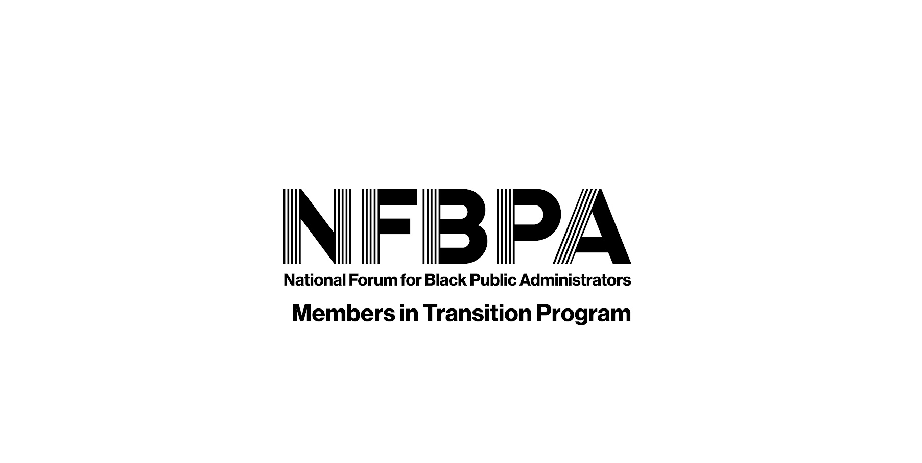
Ambassador Application Form

Thank you for sharing your time and talents with NFBPA’s MIT Program (MIT)! We appreciate that volunteerism comes in different components and environments and require a time commitment to serve as an MIT Program Ambassador. Your participation is key for NFBPA’s ongoing support and retention of a member in transition during a highly stressful time in a professional career. Once submitted, your information will serve as a skills and resources inventory and remain active until you decide to update or withdraw the application. NFBPA’s MIT Team will strive to match you with the best opportunity to assist a MIT consistent with your talents and experiences that is located in your area. Volunteer service as an MIT Ambassador has a one-year term and is renewable after one year as you desire. Participation is a key component to the overall success of MIT. Ambassadors must initially participate in an informational webinar designed to fully introduce MIT and its goals. Ambassadors will have networking calls every quarter in order to share best practices, experiences, and suggestions to improve MIT. Ambassadors will conduct their communications with an MIT electronically, conference call, or Zoom meetings, and these calls vary in frequency depending on the needs of the MIT participant. Please submit your application to MIT@nfbpa.org.
Date ________________________
General Information
Name ______________________________________________________ Telephone No ____________________________________
NFBPA Member Chapter Location(s) ______________________________ Email Address ____________________________________
No. of Years NFBPA Member ________ Male _________ Female __________
Education
College _______________________________________________ Degree Completed ____________________________
College _______________________________________________ Degree Completed_____________________________
Professional Information
Years in Public Service/Nonprofit Sectors ____________________
Current Employer _______________________________________ Years in Position ______________________________
Position Title ___________________________________________
Please Attach Copy of Resume
Professional Certifications: Key Professional Affiliations:
______________________________________________________ ____________________________________________
______________________________________________________ ____________________________________________
Please provide a brief statement of your interest in serving as an MIT Program Ambassador

