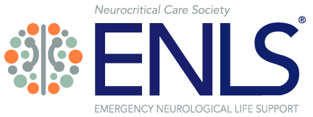

Sample ENLS Live Course Agenda

Course Time: 8:00am-5:15pm
Actual Training Time: 7.5 hours (Does not include two 15-minute breaks and one hour for lunch and 15 minutes for Trainer Evaluation Survey)
Module Start Time Topic
Introduction | 8:00 AM | ENLS Introduction
1 | 8:10 AM | Acute Non-Traumatic Weakness
2 | 8:40 AM | Intracranial Hypertension and Herniation
3 | 9:10 AM | Meningitis and Encephalitis
Break | 9:45 AM | Pharmacotherapy
4 | 10:00 AM | Break
5 | 10:30 AM | Resuscitation Following Cardiac Arrest
6 | 11:00 AM | Airway, Ventilation and Sedation
7 | 11:30 AM | Subarachnoid Hemorrhage
Lunch | 12:00 AM | Lunch
8 | 1:00 PM | Traumatic Brain Injury
9 | 1:30 PM | Intracerebral Hemorrhage
10 | 2:00 PM | Status Epilepticus
11 | 2:30 PM | Acute Ischemic Stroke
Break | 3:10 PM | Break
12 | 3:25 PM | Approach to the Comatose Patient
13 | 4:00 PM | Traumatic Spinal Cord Injury
14 | 4:30 PM | Spinal Cord Compression
Course Wrap-Up | 5:00 PM | Trainer Survey

(Faculty information inserted here)

