Supplementary Materials (Figures reflecting correlations in Table 4).

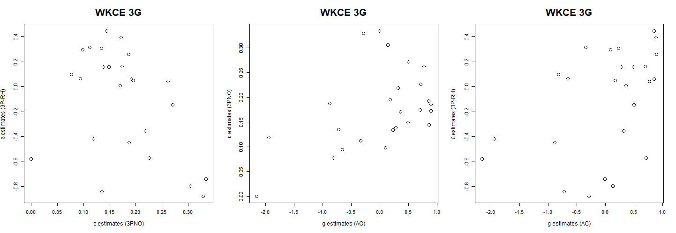
Figure S-1. Scatterplots of item-level guessing and asymmetry parameter estimates for the 3P-RH, 3PNO and AG models within WKCE 3th grade math test

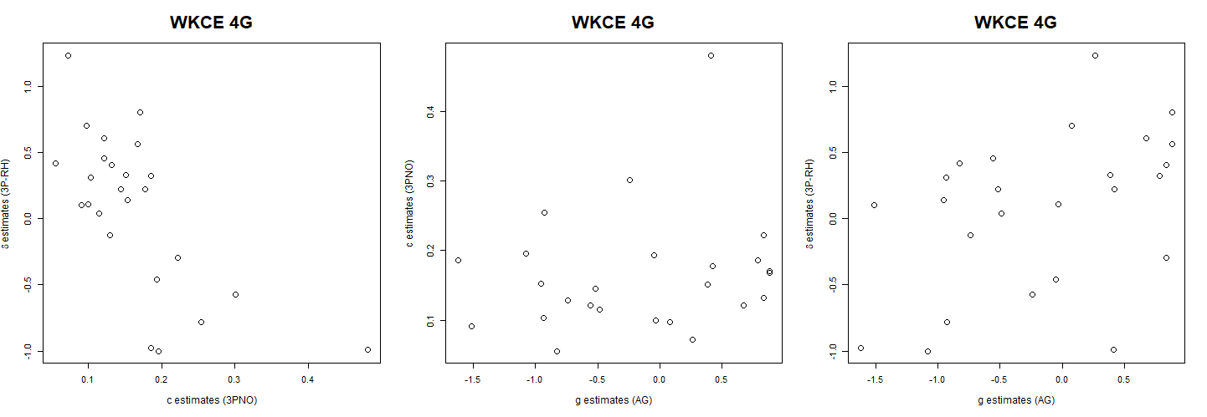
Figure S-2. Scatterplots of item-level guessing and asymmetry parameter estimates for the 3P-RH, 3PNO and AG models within WKCE 4th grade math test

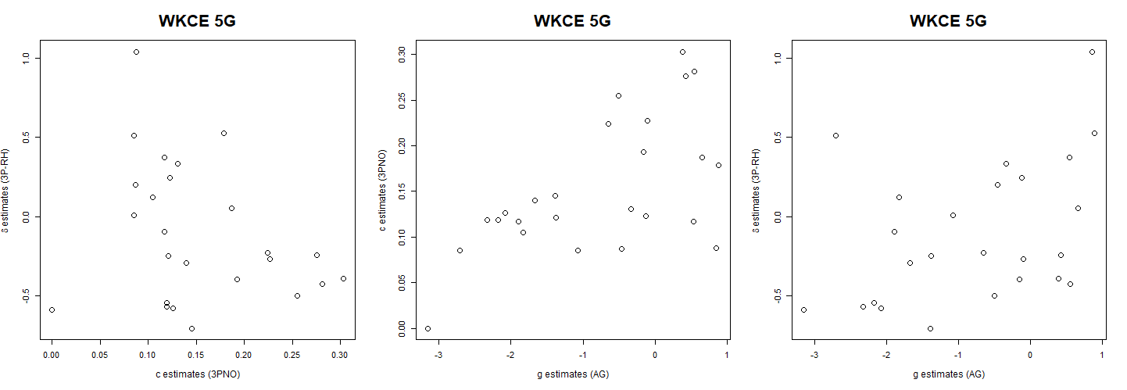
Figure S-3. Scatterplots of item-level guessing and asymmetry parameter estimates for the 3P-RH, 3PNO and AG models within WKCE 5th grade math test

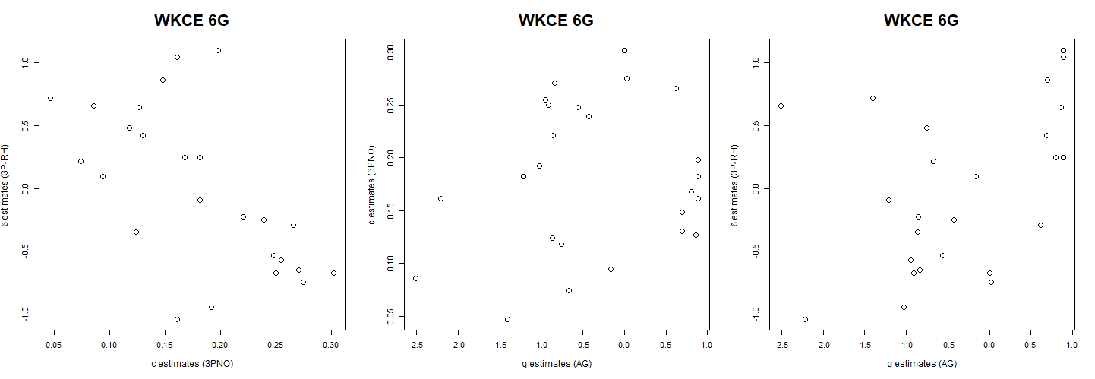
Figure S-4. Scatterplots of item-level guessing and asymmetry parameter estimates for the 3P-RH, 3PNO and AG models within WKCE 6th grade math test

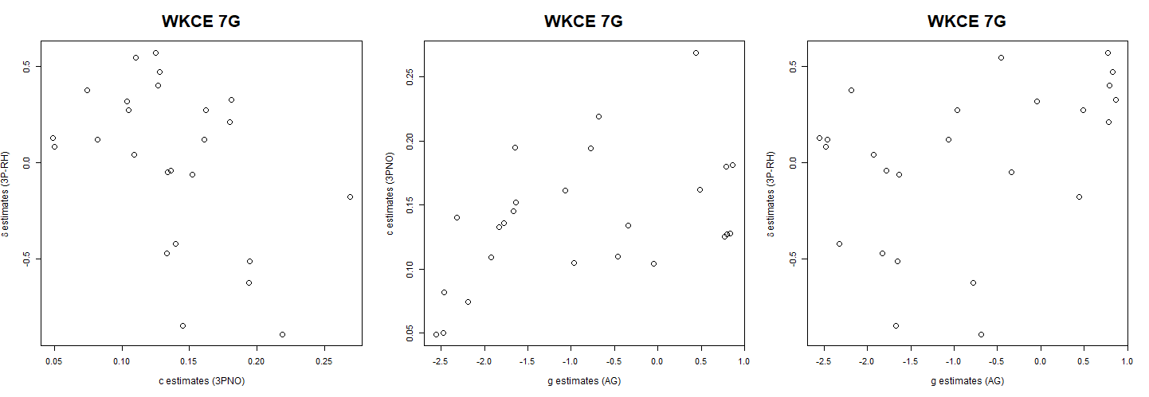
Figure S-5. Scatterplots of item-level guessing and asymmetry parameter estimates for the 3P-RH, 3PNO and AG models within WKCE 7th grade math test

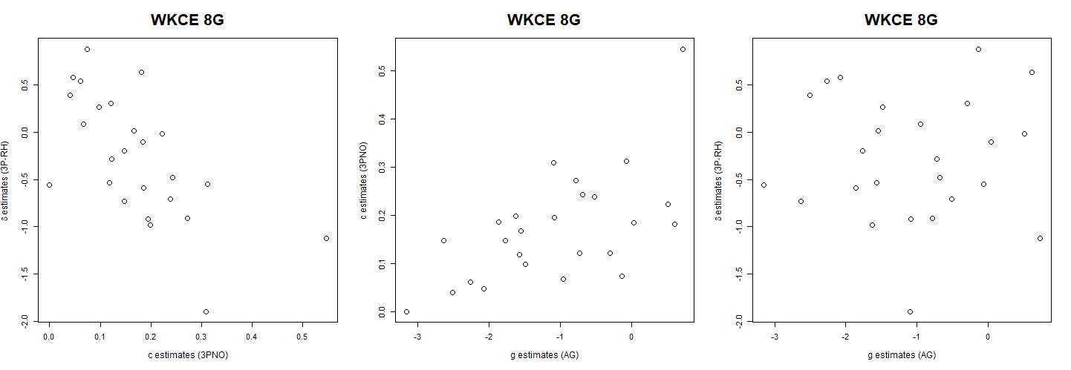
Figure S-6. Scatterplots of item-level guessing and asymmetry parameter estimates for the 3P-RH, 3PNO and AG models within WKCE 8th grade math test

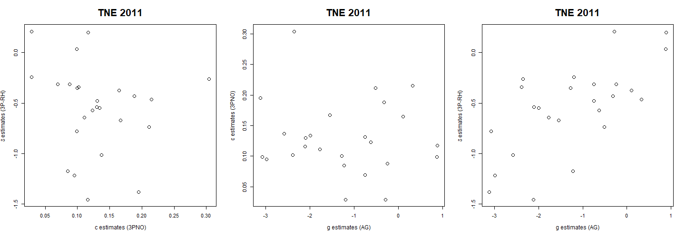
Figure S-7. Scatterplots of item-level guessing and asymmetry parameter estimates for the 3P-RH, 3PNO and AG models within T&E math placement test in 2011

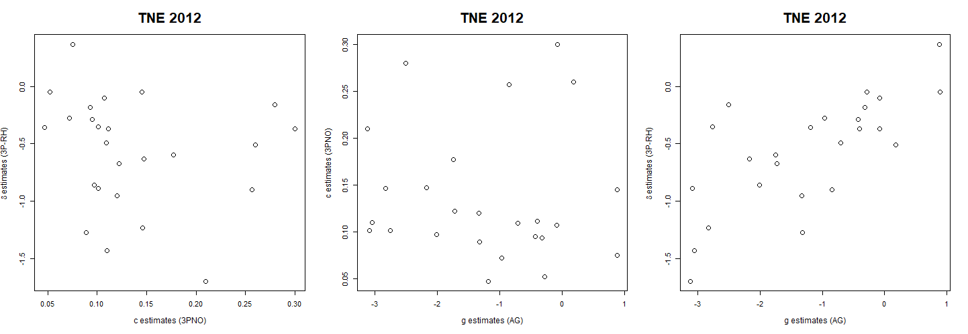
Figure S-8. Scatterplots of item-level guessing and asymmetry parameter estimates for the 3P-RH, 3PNO and AG models within T&E math placement test in 2012

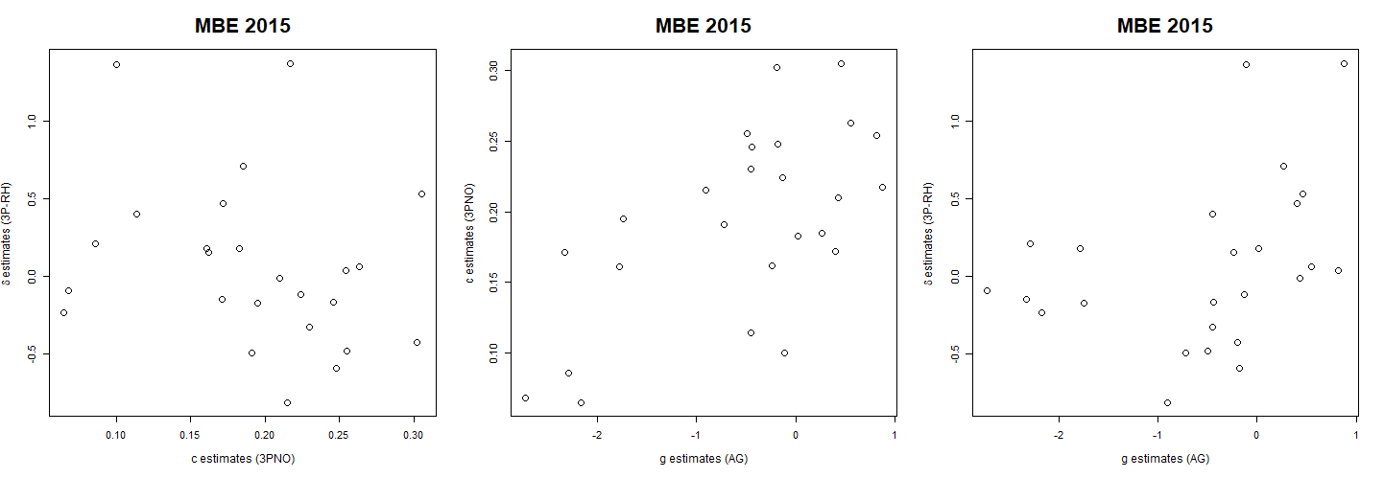
Figure S-9. Scatterplots of item-level guessing and asymmetry parameter estimates for the 3P-RH, 3PNO and AG models within Multi-state Bar Exam in 2015

