Table S1
Average SE of Human- and Machine-Coded New Science Item Parameter Estimates
 | Human-Coded New Science Items |  |  |  | Machine-Coded New Science Items
n | FIPC-P | FIPC-S | CC-S |  | FIPC-P | FIPC-S | CC-S
SE of Slope Parameter Estimates
125 | 0.225 | 0.207 | 0.200 |  | 0.218 | 0.190 | 0.184
250 | 0.158 | 0.145 | 0.141 |  | 0.151 | 0.134 | 0.130
500 | 0.110 | 0.100 | 0.100 |  | 0.105 | 0.095 | 0.089
1,000 | 0.077 | 0.071 | 0.071 |  | 0.077 | 0.063 | 0.063
SE of Difficulty Parameter Estimates
125 | 0.202 | 0.202 | 0.202 |  | 0.195 | 0.195 | 0.195
250 | 0.141 | 0.141 | 0.145 |  | 0.138 | 0.138 | 0.138
500 | 0.100 | 0.100 | 0.100 |  | 0.095 | 0.095 | 0.095
1,000 | 0.071 | 0.071 | 0.071 |  | 0.071 | 0.071 | 0.071
SE of Step Parameter Estimates
125 | 0.230 | 0.230 | 0.232 |  | 0.249 | 0.249 | 0.249
250 | 0.161 | 0.161 | 0.161 |  | 0.160 | 0.160 | 0.173
500 | 0.114 | 0.114 | 0.114 |  | 0.118 | 0.118 | 0.118
1,000 | 0.077 | 0.077 | 0.077 |  | 0.083 | 0.083 | 0.083
Note. $\overline{n}$ = country-specific sample size; SE = standard error; standard errors in parentheses.

Table S2
Average MD of Science items across calibration methods and subsamples
 | New Science Items |  |  |  | Trend Science Items
n | FIPC-P | FIPC-S | CC-S |  | FIPC-P | FIPC-S | CC-S
125 | 0.000  (0.0002) | 0.000  (0.0002) | 0.000  (0.0002) |  | 0.001  (0.002) | 0.000  (0.0004) | 0.000  (0.0003)
250 | 0.000  (0.0002) | 0.000  (0.0002) | 0.000  (0.0002) |  | 0.001  (0.002) | 0.000  (0.0003) | 0.000  (0.0002)
500 | 0.000  (0.0002) | 0.000  (0.0002) | 0.000  (0.0002) |  | 0.000  (0.002) | 0.000  (0.0003) | 0.000  (0.0002)
1,000 | 0.000  (0.0002) | 0.000  (0.0002) | 0.000  (0.0002) |  | 0.000  (0.002) | 0.000  (0.0002) | 0.000  (0.0002)
Note. $\overline{n}$ = country-specific sample size; MD = mean deviation; standard errors in parentheses.

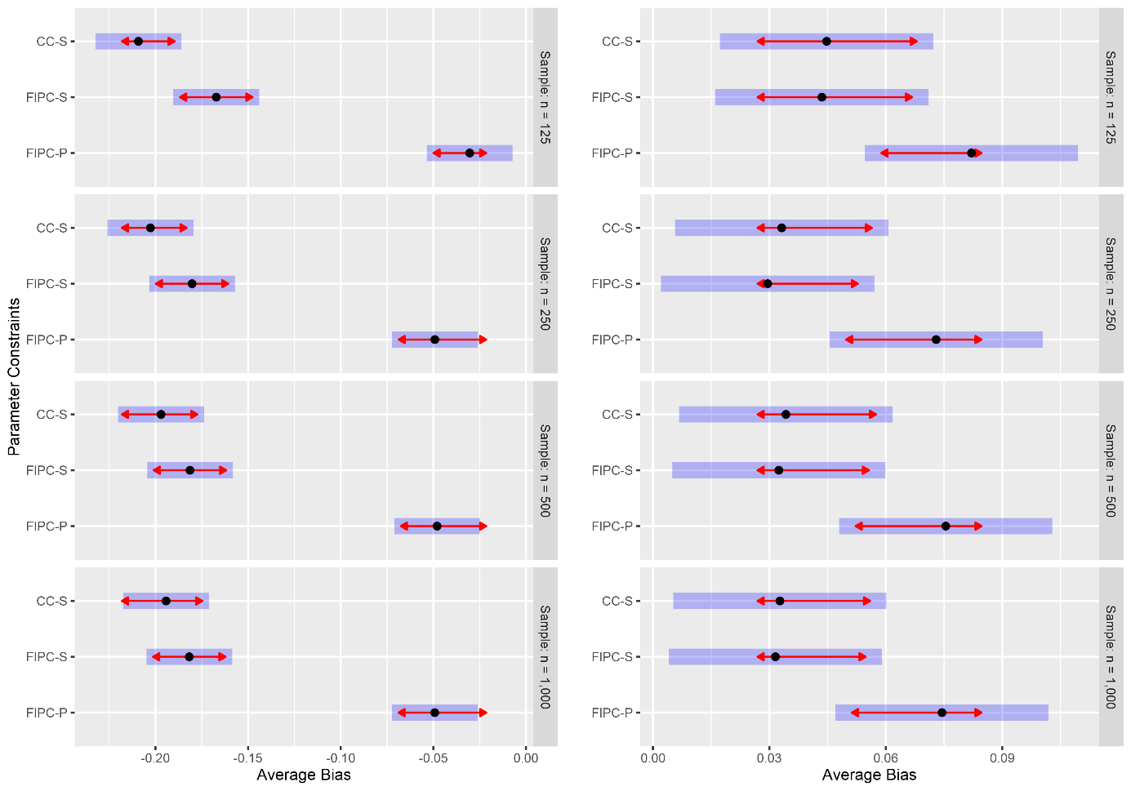
Figure S1. Pairwise contrasts of parameter constraints (different amount of information introduced into the calibration) in terms of their estimated marginal mean bias for each sample size (overall new Science items). Note: Left column: item discriminations. Right column: item difficulties. The blue bars represent the 95% CIs of the means. Non-overlapping red arrows within the blue bars indicate substantial differences between parameter constraints. Contrasts conducted with Tukey multiplicity adjustment.$α=0.05$.

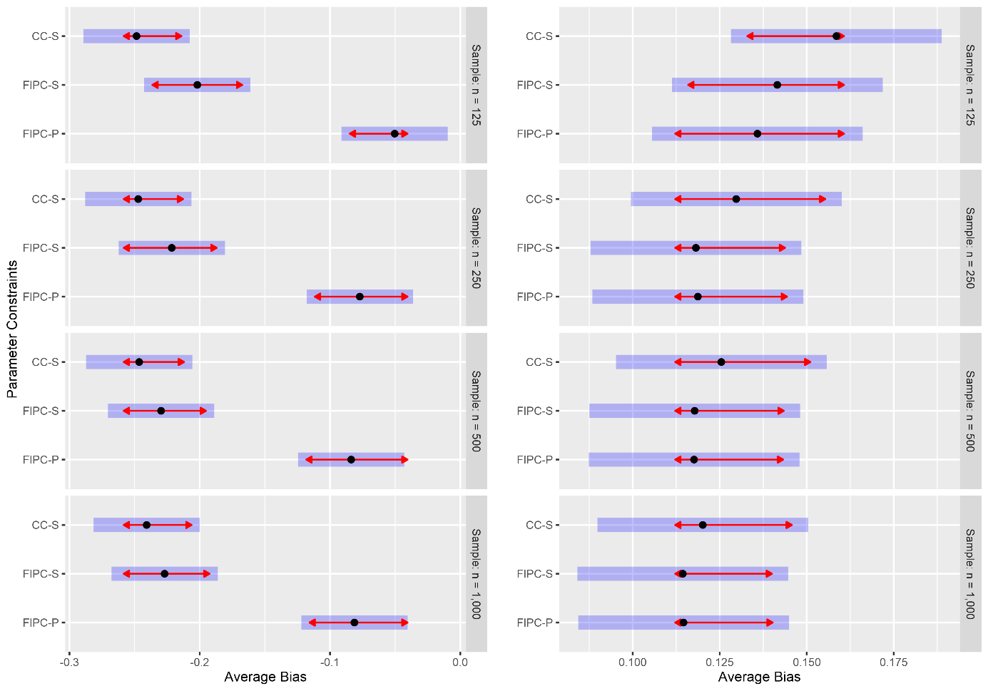
Figure S2. Pairwise contrasts of parameter constraints (different amount of information introduced into the calibration) in terms of their estimated marginal mean bias for each sample size (human-coded new Science items). Note: Left column: item discriminations. Right column: item difficulties. The blue bars represent the 95% CIs of the means. Non-overlapping red arrows within the blue bars indicate substantial differences between parameter constraints. Contrasts conducted with Tukey multiplicity adjustment.$α=0.05$.

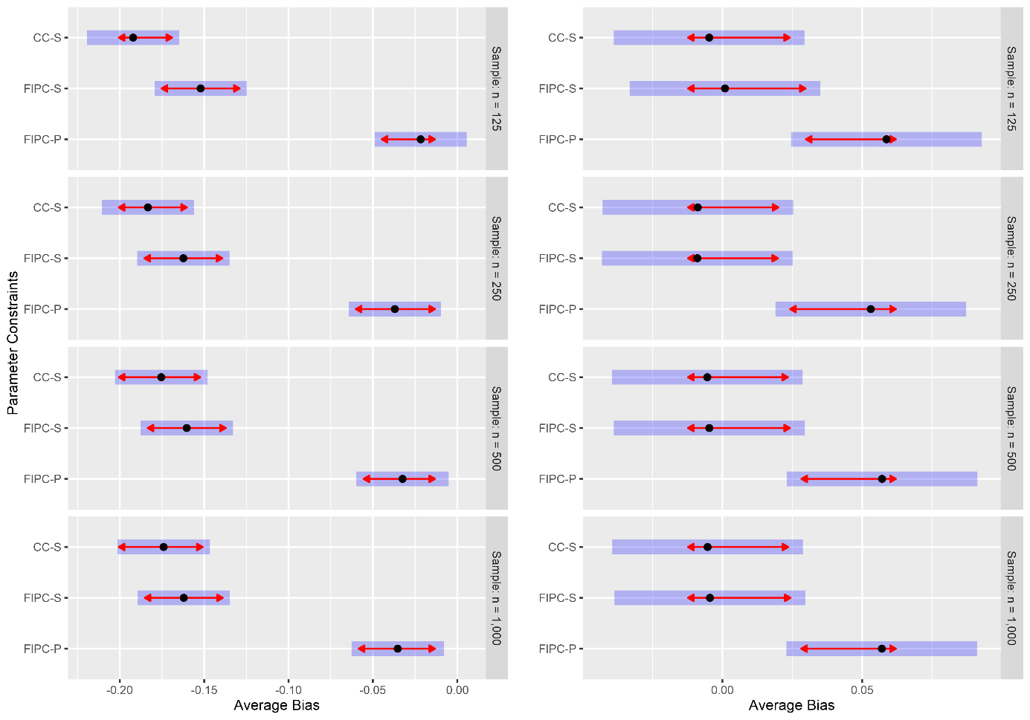

Figure S3. Pairwise contrasts of parameter constraints (different amount of information introduced into the calibration) in terms of their estimated marginal mean bias for each sample size (machine-coded new Science items). Note: Left column: item discriminations. Right column: item difficulties. The blue bars represent the 95% Cis of the means. Non-overlapping red arrows within the blue bars indicate substantial differences between parameter constraints. Contrasts conducted with Tukey multiplicity adjustment.$α=0.05$.

