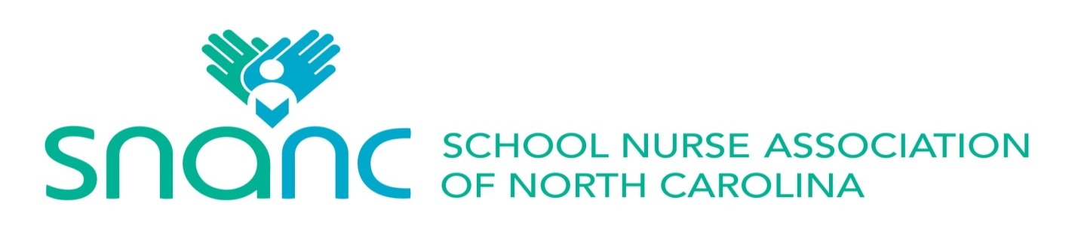
2023 School Nurse Administrator of the Year Award
Guidelines and Criteria

PURPOSE:
The purpose of this award is to publicly recognize school nurse administrators statewide
by annually honoring one administrator who administers and coordinates quality school
nursing services and health programs.

ELIGIBILITY:
- The nominee must be a registered nurse with a minimum of a bachelor’s degree in nursing.
- The nominee must be a member of the School Nurse Association of North
Carolina for the current year and for the preceding five years.
- The nominee must be currently practicing full time and have as their main
responsibility the supervision, administration, and coordination of school nursing
services and health programs in North Carolina. Main responsibility means
working more than 50% in an administrative capacity. Full time means working
the full position that is available. If the only school nurse administrator position in
that community involves fewer hours than usual full time, it will be considered
full time for the purposes of eligibility.
- Evidence of excellence in school nursing administration must be presented.
- Nomination may be made by a school nurse, administrator, supervisor, teacher, parent, student, or others affected by the school nurse administrator.
administrator’s scope of practice.
- Nomination materials must be received on or before the specified date indicated on the
nomination form (May 15th ) .

PROCEDURE:
- Nomination form may be downloaded from the SNANC website or requested from the Nomination Chair.
- Submit one copy of the completed nomination materials to the Nomination Chair. The submission should be electronic as an attachment.
- In order to promote an unbiased selection, the application should be written in a “blind format.” The applicant’s name should only appear on the cover sheet. In the narrative portion or in recommendation letters, refer to the applicant as “he/she” and “this nurse.”

MATERIALS FOR A NOMINATION MUST INCLUDE:
- The School Nurse Administrator of the Year Award Nomination Form with required signature.
- Resume or Curriculum Vitae
- A brief narrative by the nominator summarizing the nominee’s accomplishments using the following categories below as a guide:
1. Quality of Practice (demonstrates clinical knowledge,
communication, planning, and performance assessment skills)
2. Administrative leadership and collaboration(program planning, implementation,management; policy and procedure development)
3. Professional development and collegiality(participates in administrative continuing education, provides continuing education for staff, membership and
service in professional organizations.)
4. Community involvement and advocacy(participation in community organizations, initiator of projects, award recipient)
5. Research (actively involved in research, applies research for evidence based practice, research project published)
- Supporting letter(s) of recommendation (may be from school nurses, principals, supervisors, teachers, parents, students, or others)
- Headshot photo to be used on the website and other forms of recognition. This should be sent digitally to the Nomination Chair.

Nomination materials must be submitted to the School Nurse Association Nomination Chair. The Nomination Chair shall convene the School Nurse Administrator of the Year Selection Committee to review the nomination materials and select the recipient using the above selection criteria.

The Nomination Chair shall notify the SNANC President and Executive Board members of the School Nurse Administrator of the Year selection.

The President of the School Nurse Association of North Carolina shall telephone the selected person and send a follow-up letter of confirmation. The person who nominated the selected person and their immediate supervisor shall be notified by email of their nominee being selected, and will be invited to attend the award ceremony. The nominator will be asked to introduce the award winner.

The Nomination Chair shall notify the other nominees by email and thank them for their participation.

Presentation of the Award shall be made at SNANC’s Annual Meeting. The chosen School Nurse Administrator of the Year will be given a choice between:

A one-year membership to SNANC and payment of the registration fee for the annual North Carolina School Nurse Conference
OR

Payment of their registration fee to the upcoming NASN Annual Conference.

2023 School Nurse Administrator of the Year Award
Nomination Form

Complete and return this form, together with the other nomination materials to the Nomination Chair: Amy McAteer-Jones @ parteeofsix@msn.com .
The completed nomination packet must be received no later than May 15th .

Name of Nominee: _____________________________________________________________

Nominee’s Home Address: _______________________________________________________

Nominee’s Phone Number: H: ___________________ W: ____________________

Cell: _________________

Nominee’s Email Address: _______________________________________________________

Employer’s Name: ______________________________________________________________

Immediate Supervisor’s Name: ____________________________________________________

Supervisor’s Email Address: ______________________________________________________

Present Position: _______________________________________________________________

Number of Years in Present Position: _______________________________________________

Number of Years in School Nursing: ________________________________________________

Grade levels covered in present position: ___________ Number of students served: __________

Nominated by: ________________________ Email Address: _______________________

Relationship to Nominee: _______________________________________________________

I affirm that I meet eligibility criteria for the School Nurse Administrator of the Year Award.

______________________________________________________________________________
Signature of Nominee Date

