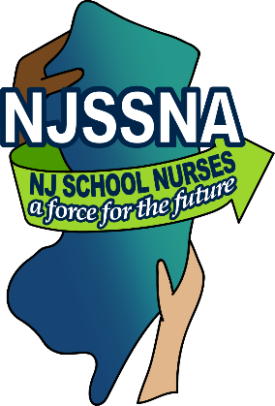
Invitation to Present Posters:
NJSSNA Spring Conference 2020:
NJ School Nurses A Force for the Future
March 27 and March 28, 2020

Whether you are an experienced school nurse or a novice, we can all learn from each other. Present a Poster to share your ideas and programs at NJSSNA’s annual conference.
Poster topics can include:

- Your original research
- A community based health initiative
- A health education program you presented for students, staff, or parents
- An in-service session for other school nurses
- An innovative way to address school health challenges

Participation is simple:

- Submit your poster ideas to our Education Committee members via educationchair@njssna.org by March 1, 2020.
- Using a standard 48" x 36" presentation size, create a poster featuring some facet of your practice.
- Develop a handout (approximately 300 copies) conveying the important concepts of your poster.
- Bring your paper poster and handouts to the NJSSNA conference March 27 and March 28, 2020. The poster will be displayed on an easel, so please attach it to a foam core poster board.

All contributors will be given a Certificate of Participation to include in your professional portfolio. In addition, the names of all participants will be included in a special drawing for a $100.00 gift certificate towards the 2021 NJSSNA Conference registration!

Complete this registration form and return via email to educationchair@njssna.org by March 1, 2020

