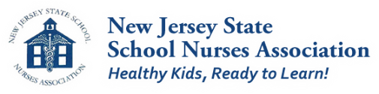

WANTED

Wanted -Millennials-born after 1980. NJSSNA has an
amazing offer for you. Do you have leadership skills? Would like to learn how to be a leader? Are you ready to help support leadership for the NJSSNA of the future? Then you are the person we are looking for!

NJSSNA Millennial Scholarship

NASN/NJSSNA is actively seeking to foster leadership for those who consider themselves Millennials - born after 1980. NASN is hosting a Leadership (Pre) Conference, June 29th, 2018 in Baltimore, MD, prior to NASN 2018 Conference. NJSSNA is offering a scholarship covering the cost of the Leadership Pre-conference, the NASN 2018 Conference and lodging.
NASN 2018 Conference will be held June 30th to July 3rd.
Criteria for eligibility include:
(1) birth date 1980 or after
(2) working as a certified school nurse in NJ
(3) living in NJ
(4) NJSSNA/NASN member
(5) agreement to attend the pre-conference and entire NASN 2018 conference
(6) submission of completed Millennial Scholarship application prior to deadline, March 31st, 2018.
Submit completed application form to Gina Emge, NASN Director at
NASNDirector@gmail.com
Dear NJSSNA members,
If you are not a millennial, please help us to identify colleagues who could qualify and urge them to apply.

