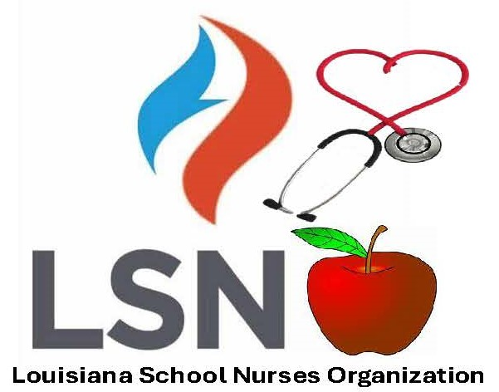  TUESDAY, APRIL 21, 2026  8:30 AM- 4:30 PM  The American Red Cross  Instructor Training  Natchitoches Event Center  4:30 PM - 5:30 PM  Stop the Bleed Training  Natchitoches Event Center  6:00 PM - 9:00 PM  Welcome  Social and Registration  Hors d’oeuvres served  Merci Beaucoup  Registration and breakfast start daily at  7:30am  Lunch on your own daily | WEDNESDAY, APRIL 22, 2026  OCHSNER DAY  8:30 AM – 8:40 AM  Opening Pledge  8:40 AM - 8: 50 AM  Mayor's Welcome  8:50 AM - 9:00 AM  President's Welcome  9:00 AM - 10:00 AM  Diabetes  Dr. Cielo Alleyn  10:00 AM - 10:30 AM  Break  10:30 AM - 11:30 AM  Concussions  Dr. Aaron Karlin  11:30 AM- 1:30 PM  Lunch  1:30 PM - 2:30 PM  Anxiety Presentation and  Management in the School Setting  Dr. Erin Reuther  2:30 PM - 3:00 PM  Break  3:00 PM – 4:00 PM  Orthopedics- Management  of Playground Injuries  Dr. Ryan Farmer  4:00 PM - 4:30 PM  Gift Drawings  5:00 PM - 8:00 PM  Party with a Purpose | THURSDAY, APRIL 23, 2026  8:30 AM – 8:45 AM  Welcome & Announcements  8:45 AM – 9:30 AM  Break  9:30 AM – 11:00 AM  LSNO Business Meeting  11:00 AM - 11:15 AM  Break  11:15 AM - 12:45 PM  Steel Magnolias in Motion: Leading with Strength, Advocacy and Sustainable  Impact  Shantrice M. Winston  12:45 PM - 2:30 PM  Lunch  2:30 PM - 4:00 PM  Legal Issues in School Setting  Courtney Joiner  4:00 PM - 4:30 PM  Gift Drawings  Awards  6:00 PM – 10:00 PM  Social  DJ, Dinner Buffet  Cash bar  Riverside Reserve | FRIDAY, APRIL 24, 2026  8:30 AM – 8:45 AM  Welcome & Announcements  8:45 AM – 9:45 AM  Tobacco, Asthma Control, and Oral Health  Tanya Cobb  9:45 AM – 10:45 AM  Developing and Writing an Individualized HealthCare  Plan in the School Setting Andrea Ferguson  10:45 AM - 11:15 AM  Break  11:15 AM – 12:15 PM  Let Them Be Little:  The Impact of Childhood Trauma on Student Health and Behavior  Dr. Monica Frazier  12:15 PM - 1:00 PM  Thank you and Closing Remarks  Available Contact Hours  Day 1 = 4  Day 2 = 3  Day 3 = 3  Total = 10  This continuing nursing education conference will provide school nurses with information on issues pertaining to school health to perform best practice and for professional growth.  *Topics may be subject to change.  **Please bring 2 door prizes and 1 Auction Themed Gift Basket per Parish.

