 | This continuing nursing education conference will provide school nurses with information on issues pertaining to school health to perform best practice and professional growth.
Hotel Information:  Paragon Casino/Resort  711 Paragon Place  Marksville, LA 71351  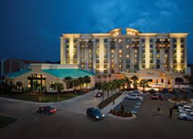  $109- Standard Room South Tower  $119- Deluxe Atrium  $108.35- Cabins  $20.21- RV  -------------------------------------------------------------  To Book rooms:  Cal 318-253-1946 Or  toll free 1-800-642-7777  CODE: LSNM18G  Reservation Deadline:  February 25, 2019  (This is the absolute deadline for hotel)  -------------------------------------------------------------  Bring your School Board’s Tax Exemption Form and your Employee ID to avoid paying State room tax!  School board checks will be accepted. | 2nd One Mile Fun Run!  Wednesday, March 20, 2019  4:30 PM – Warm Up  5:00 PM – Start Time  $20 Registration  Serving students and schools while advancing practice of School Nursing | LSNO 50th Annual Professional Growth Seminar  March 19 – 22, 2019  KEEP CALM AND SUIT UP!  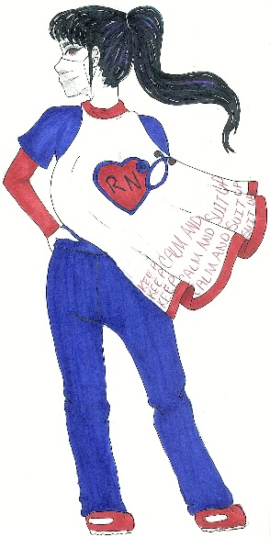
**Please bring 2 door prizes and 1 Auction Themed Gift Basket per Parish ** |  | www.lsno.org
Tuesday, March 19, 2019  6:00 PM – 8:00 PM  Welcome Social and Registration  Snacks and Drinks Provided  Club Me Zazz  Wednesday, March 20, 2019  7 AM  Full Breakfast Buffet / Registration  8 AM  Welcome  Nina Ferkaris, NASN President  8:30 AM – 3:30 PM  Best Current Practice  For Medical Emergencies  Sandra Moritz, M.Ed, BS, RN, NCSN  5 Contact Hours  HOT lunch will be provided  Courtesy of LSNO  5 PM – 6 PM  Fun Run/Walk  7 PM- 11 PM  Private Indoor Pool Party  DJ and Hors D'oeuvres Provided | Thursday, March 21, 2019  7 AM  Full Breakfast Buffet / Registration  8:30 AM – 10:30 AM  Business Meeting /Installation of Officers & Awards  10:30 AM – 10:45 AM - Break  11:00 AM – 12:00 PM  EIS- Medicaid Billing Lunch and Learn  Greg Bergeron  1 Contact Hour  12:00 PM – 12:15 PM - Break  12:15 PM – 1:15 PM  Headache Hygiene  Jessica Gauthreaux, MD  1 Contact Hour  1:15 PM – 1:30 PM - Break  1:30 PM – 3:30 PM  Vision: Academic Challenges,  Classroom Behaviors, and Evidence-Based Vision Screening  P. Kay Nottingham Chaplin, EdD  0 Contact Hours  7 PM – 10 PM Social  DJ and Hors D'oeuvres Provided  Club Me Zazz  FEES: See registration form.  DISCLOSURES: There are no identified conflicts of interest with the faculty or planners for this continuing education activity.  DISABLED PARTICIPANTS: Accommodations will be made for participants who notify us in advance of their special needs. Please include a written statement on your registration.  Subject to Change! | Friday, March 22, 2019  6:30 AM – 7:30 AM  Full Breakfast Buffet / Registration  7:30 AM – 9:30 AM  “Nurse FUNshine”  Cheryl Fell, RN  2 Contact Hours  9:30 AM – 9:45 AM - Break  9:45 AM – 10:45 AM  Some Legal Issues regarding Students with Disabilities and Health Services in Schools  Wayne T Stewart, Attorney at Law  1 Contact Hour  10:45 AM – 11:45 AM  Opioids  Dr David J Holcombe, MD, MSA, FACP  1 Contact Hour  11:45 AM – 12:00 PM  Closing  CONTACT HOURS: A total of 11 contact hours will be awarded to participants who attend the entire conference. Bureau of Education and Research will provide 5 contact hours on Day 1. LSNO has applied for 6 contact hours for Day 2 & 3. Daily contact hours are available. Refer to Written Disclosure form for more information.  