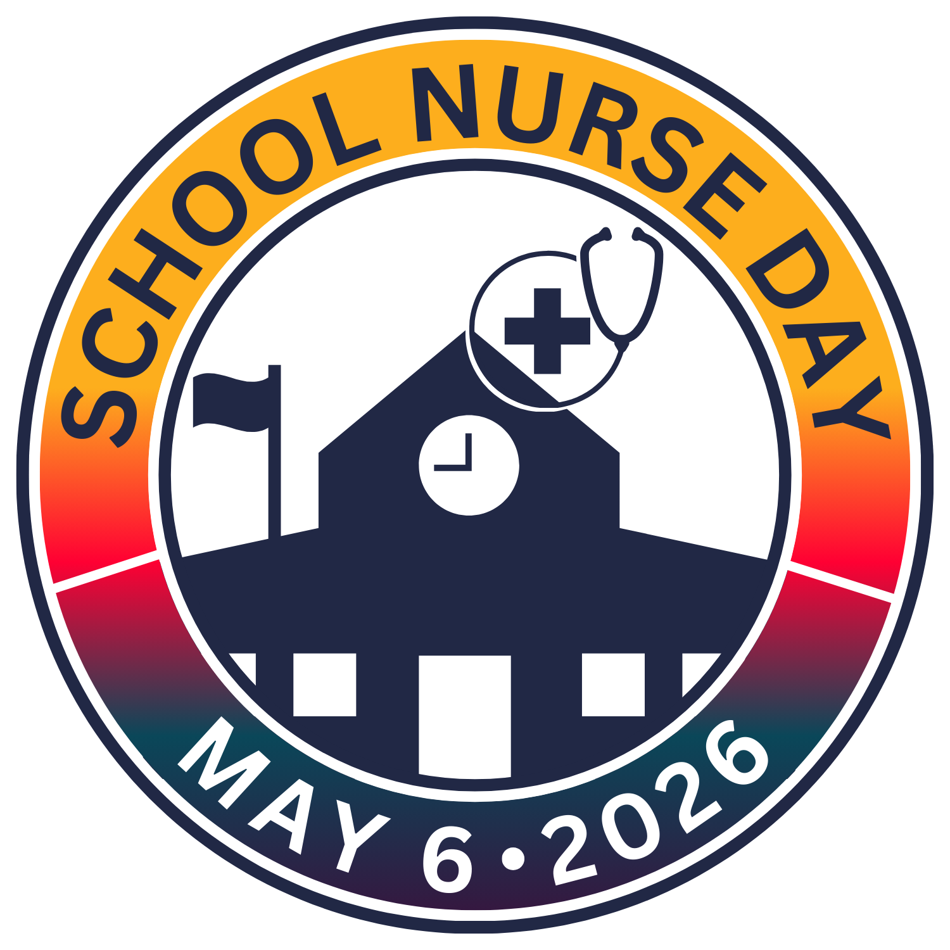
Amplify Awareness: School Nurse Day 2026!
NASN has put together the following suggested social media messages and images, available here, for you to share across your channels.
Recommended Hashtags: #SND2026 #SND #SchoolNurses #NASNStrong #NurseinEverySchool #StudentHealth #SchoolHealth
Handles for tagging:
Instagram: @nasnschoolnurses
Facebook: @National Association of School Nurses
LinkedIn: @National Association of School Nurses

Social Media Messages for Facebook/LinkedIn/Instagram:
(For IG, please add the www.schoolnurseday.org website link to the bio and add 'link in bio' to the caption)

#Schoolnurses play a critical role in supporting the health, wellness, and academic success of students nationwide. I stand with NASN in advocating for policies that ensure every child has access to a school nurse every day. www.schoolnurseday.org #SND2026 #NASNStrong #NurseinEverySchool

With over 40% of school-aged children affected by chronic or mental health conditions, #schoolnurses play a vital role in improving attendance, reducing health disparities, and supporting student success. Celebrate National School Nurse Day on May 6! #SND2026 #StudentHealth www.schoolnurseday.org
#Schoolnurses positively impact students, families, and schools by providing direct care, managing chronic conditions, promoting mental health and school attendance, connecting families to community resources, and coordinating care to break down barriers to healthcare access. #SND2026 www.schoolnurseday.org #StudentHealth

School nurses make a difference every day, but they need sustainable support to keep doing it.
This #SchoolNurseDay, let's advocate for:
✔️ Stable funding for school health services
✔️ Expanded Medicaid support
✔️ Policies that invest in student health
When we fund school nursing, we invest in stronger schools and healthier communities.
#SND2026 #NurseinEverySchool #SchoolHealth #NASNAdvocacy

#SchoolNurses are critical to all aspects of #studenthealth! National School Nurse Day is May 6. Celebrate and advocate for a #NurseinEverySchool #SND2026 www.schoolnurseday.org

Join us in advocating for healthier, safer learning environments, celebrate #SND2026 on May 6! www.schoolnurseday.org #NASNStrong #School Nurses #SchoolHealth

Every child deserves access to healthcare in school to thrive academically and personally. To optimize student health, safety, and learning, a school nurse must be present in every school all day, every day. Amplify the critical role of and need for #SchoolNurses #SND2026! www.schoolnurseday.org #nurseineveryschool #StudentHealth #SchoolHealth

#SchoolNurses are more than caregivers. We are advocates, leaders, and essential members of the education team. #SND2026 #AdvocacyInAction #NASNStrong #SchoolHealth
#Schoolnurses, recognized for their vital role in schools and student well-being, are essential in every school, and so is the funding to do so. With increased awareness and policy advocacy, we can safeguard the critical contributions of school nurses for future generations. #SND2026 is May 6: celebrate and advocate for school nurses! www.schoolnurseday.org #NurseinEverySchool #StudentHealth #SchoolHealth
Today is National School Nurse Day! Let's unite to celebrate and champion these dedicated healthcare leaders today and every day of the year! #SND2026 #SchoolNurses www.schoolnurseday.org.

Today, we celebrate National School Nurse Day! Let's unite our voices to champion increased funding and access to #schoolnursing services at the local, state, and national levels. Together, we can pave the way for a healthier, more equitable future for all students. #SND2026 www.schoolnurseday.org #NASNStrong #NurseinEverySchool
Today on #SchoolNurseDay, we celebrate the professionals who keep students healthy, safe, and ready to learn. 💙 But celebration isn't enough. Every student deserves access to a full-time registered school nurse.
One-third of schools still don't have one. Let's change that.
📣 Advocate for policies that ensure a school nurse in every school—because student health is essential to student success.
#SND2026 #SchoolNurses #NurseinEverySchool #StudentHealth #SchoolHealth #AdvocateForStudents
School nurses are at the center of student well-being, supporting physical health, mental health, and safety every day.
This #SchoolNurseDay, we recognize their role in:
🩺 Providing evidence-based care
🧠 Supporting mental health
🏫 Creating safe, inclusive school environments
Every student deserves equitable access to care at school.
#SND2026 #SchoolNurses #NurseinEverySchool #StudentHealth #SchoolHealth

