2022-2023 Issue 43 www.snoa.org April/May 2022

Upcoming Events

May 4
School Nurses, Students and COVID: What Do We Know Now?
May 5th
Youth Mental Health First Aid Training
June 6th
Trauma Sensitive Schools
Symposium
June 2023
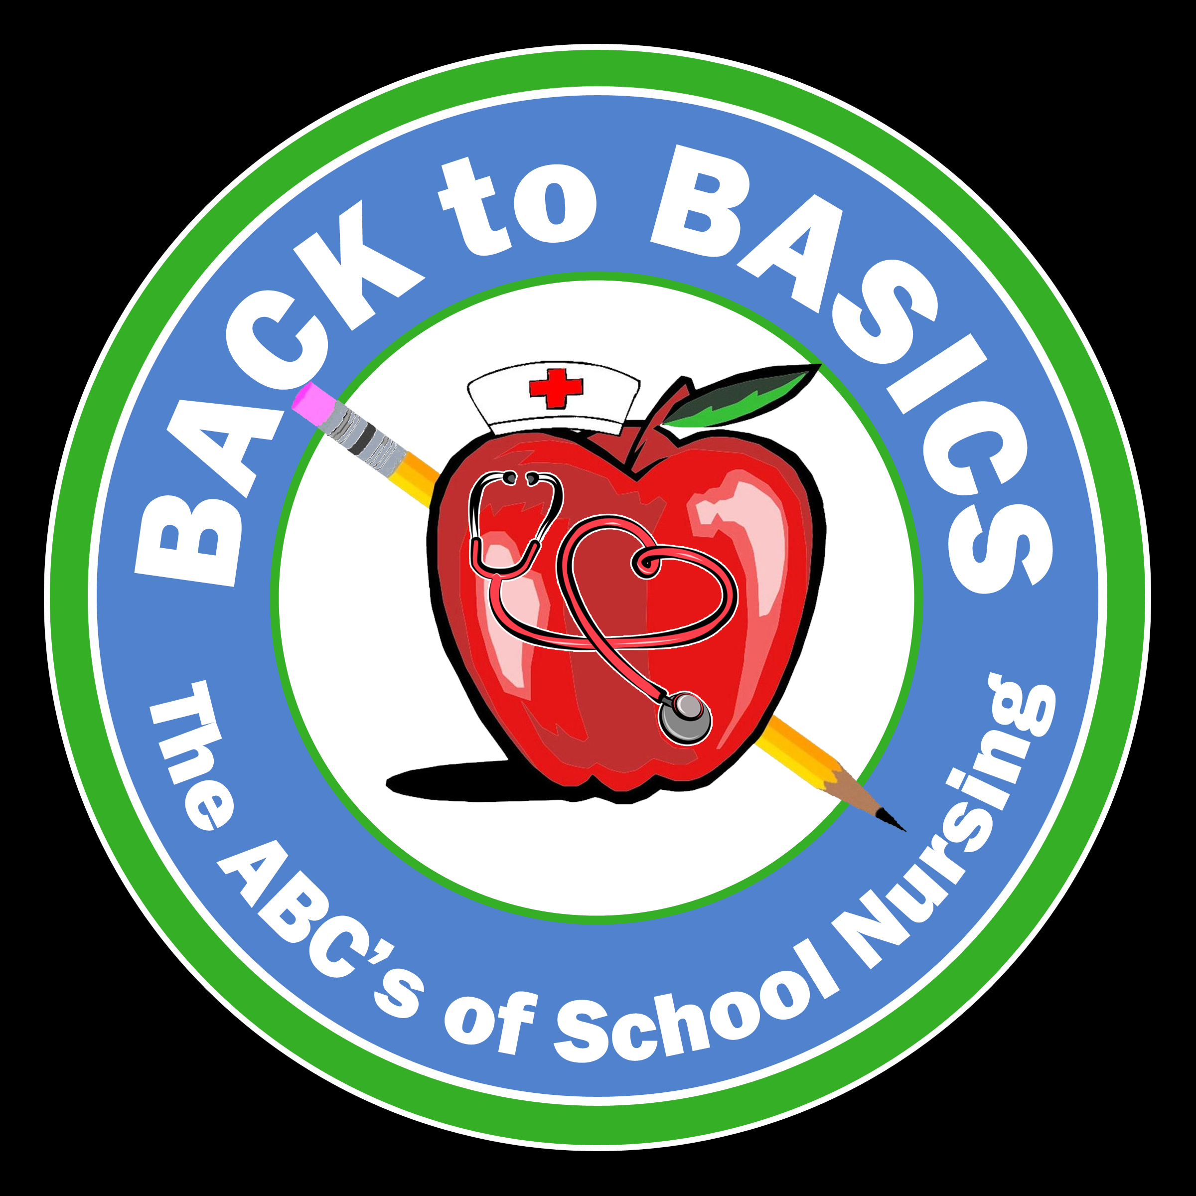
June 12 & 13th 2023, School Nurses Organization of Arizona (SNOA) Conference
School Nurses Organization of Arizona
http://www.snoa.org/index.php
SNOA Board
Nadine Miller, RN, MS, President
namiller@mpsaz.org
Lisa Alexander, RN, Vice President
LiAlexander@pusd11.net
Sandra Brown, RN, Treasurer
skbrown@mpsaz.org

Christine Mahoney, MSN-Ed, RN, Secretary
cmmahoney@mpsaz.org

Sarah Portle, M.ed, RN, NCSN
NASN Delegate at Large
sarah@azffn.org

Important Information
The Arizona Department of Health Services and the Arizona Chapter of the American Academy of Pediatrics are excited to collaborate with The School Nurses Organization of Arizona to provide an opportunity for conference attendees to complete hearing screener training as part of the 34th Annual School Health Conference.
The purpose of this training is to certify participants as Hearing Screeners for children enrolled in public, charter, accommodation, or private schools, including children and youth with special health care needs, in line with the requirements in the Hearing Screening Rules.
There will be no fee for participation in the training.
Attendees will be asked to complete the self-paced, online coursework prior to attending the conference and will have the opportunity to complete the hands-on competency requirement during the conference.
Access to the online training will be provided in the coming weeks.
Please note:
*This is a modified training course for conference attendees only, you cannot sign up separately.
*There is no need to bring equipment as they will supply all needed equipment
*Be patient as the information with more detail and links will be coming soon

 Legislative updates
Vision Screening Statutes and Rules: Senate Bill 1456 Linked in Children and Youth with Special Healthcare Needs through ADHS

President’s Note
Dear SNOA Members and health staff,
After 10 years as president of the School Nurses Organization of Arizona, I want to take the time to thank you for allowing me to serve and learn from so many of you and what we are doing to support the health and safety of our students. During my tenure as your president, I have seen enormous growth in our desire to do what is best for our students. We have seen support from many of our state organizations, Arizona Nurses Association, Arizona Department of Education, and Arizona Department of Health Services, as well as all my SNOA Board over the years who have brought their expertise and hard work to make Arizona a safer place for students and families.
I have been blessed to get to know many of you personally, and I thank you for your friendship and the opportunities I have had to learn from you and your work.

I am excited to introduce our new SNOA board members:
Lisa Alexander-President
Rachel Muth-President Elect
Rachel Howard-Secretary
Sandra Brown-Treasurer (continued)
I am looking forward to supporting our new board and wishing them success in continuing to move SNOA forward in supporting families, staff, and schools.
I am excited about seeing you at the 34th Annual School Health Services Conference, Back to Basics, The ABCs of School Nursing-June 12, 2023, at the Desert Willow Conference Center in Phoenix, Arizona. See SNOA.org

Nadine Miller
SNOA President

Partners in Health and Education

School Nurse Day is Wednesday,
May 10th, 2023.
Since 1972, National School Nurse Day has been set aside to recognize school nurses. National School Nurse Day was established to foster a better understanding of the role of school nurses in the educational setting. School Nurse Day is celebrated on Wednesday during National Nurses Week. National Nurses Week is May 6-12 each year.
The Comprehensive School Wellness Program at the Arizona Department of Education invites you to celebrate ………
School Nurse Day on Wednesday, May 10th from 3:00 pm – 4:00 pm
Register here


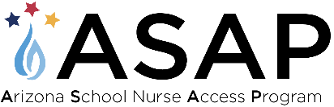

Programs to Explore
AzFFN, Arizona Foundation for The Future of Nursing
Fallen Nurses Tribute
RNconnect
Arizona School Nurse Program (ASAP)
Arizona School Nurse Lifetime Service Award
Mentorship
National Certified School Nurse (NCSN)

Arizona School Nurse Access Program (ASAP)
The Arizona Department of Education with funding support from the Arizona Department of Health Services will be implementing the Arizona School Nurse Access Program (ASAP) , an aptly named program to expediently increase the number of school nurses in Arizona.
The ASAP will support professional growth and development of both new to practiced school nurses as well as the incumbent workforce. The goal of the ASAP is to foster a highly educated workforce that functions to the full extent of their license and education. The COVID-19 funding through the Centers for the Disease Control and Prevention (CDC) Workforce Development Crisis Emergency Cooperative Agreement makes the ASAP possible.
Please reach out to sarah@azffn.org with any questions

EMS and Prehospital Care Conference 2023, Monday, Oct. 30th, 2023 @ Wild Horse Pass Resort and Casinos. The conference is designed to provide the most up-to-date pediatric emergency and trauma care education for pre-hospital and emergency providers. This year’s conference is expected to draw over 1,000 participants from around the country. Attendees can choose to participate in an in-person experience, a virtual-only experience. Register by August 15 to get the Early Bird discount: https://ems.phoenixchildrens.org/

Frequently asked questions/topics

Licensing, Certification, Delegation:
Arizona Board of Nursing School Nurse FAQ’s
Arizona Board of Nursing Nurse Practice Act
Guidelines for the Delivery of Specialized Health Care in the School Setting

Summer Camps for kids
Camp Not-A-Wheeze
Camp Not-A-Wheeze is the premiere camp for children.
with asthma in the state of Arizona.
June 4-10, 2023
Summer Employment:

Lions Camp Tatiyee
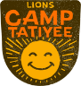
Girls Scout Summer Camp : We are hiring Health Supervisors!
Manage and implement the residential health care plan for
campers aged 5-17 and camp staff.
For more information: girlscoutsaz.org/work-at-camp
__________________________________________
As I close out this last newsletter and turn the keyboard over to our next secretary, Rachel Howard, I want to say a heartfelt Thank you. Being in this role for the last seven years has allowed me to grow both personally and professionally in working with so many of you and the collaborative groups we have partnered with over the years. To say that this group is resilient would be an understatement; school health is many times an undervalued, underfunded, and underappreciated necessity to a student’s educational success, and the contribution to that success from each of your health offices is directly due to the passion, commitment, love, and expertise you all bring to your role everyday. Our Arizona kids are lucky to have such dedicated champions in their corner. I look forward to continuing to support the efforts of SNOA, school health, and all of you.
- Christine (Tina) Mahoney



