2021-2022 Issue 39 www.snoa.org Jan/Feb 2022
Dear SNOA Members,
Happy New Year! SNOA is collaborating with the Arizona Nurses Association (AzNA) in the new Arizona Foundation for the Future of Nursing (AzFFN) which includes the Arizona School Nurse Access Project (ASAP); an aptly named program to expediently increase the number of school nurses in Arizona. https://www.aznurse.org/mpage/ASAP1
The ASAP will support professional growth and development of both new to practiced school nurses as well as the incumbent workforce. The goal of the ASAP is to foster a highly educated workforce that functions to the full extent of their license and education. The COVID-19 funding through the Centers for the Disease Control and Prevention (CDC) Workforce Development Crisis Emergency Cooperative Agreement makes the ASAP possible.
The Goals of ASAP:
- Add up to 60 new school nurses in school health offices throughout Arizona, primarily in rural and underserved communities
- Establish an Arizona School Nurse Advisory Council (AzSNAC) consisting of school nurse and health stakeholders who will guide and advance the efforts of the ASAP while establishing steps to sustain the ASAP
- Enhance professional development opportunities by bringing key partners, the School Nurses Organization of Arizona (SNOA) and the Arizona Foundation for the Future of Nursing (AzFFN) to the ASAP to establish a newly developed School Nurse Residency and Fellowship Program inclusive of competency-based education, mentorship, and completion of national certification.
- Recognize baccalaureate preparation and national school nurse certification as a minimum requirement to practice
- Augment and improve the nurse graduate pipeline to school nursing through partnerships with nursing education programs
Nadine Miller
SNOA President
Partners in Health and Education

with COVID-19 and watch for symptoms of COVID-19. They should also get tested at least 5 days after having close contact with someone with COVID-19. If they test positive or develop COVID-19 symptoms, they should follow recommendations for isolation.
-Students, teachers, and staff who have presumed or confirmed COVID-19 or are showing symptoms of COVID-19 should isolate regardless of vaccination status. Isolation is used to separate people with confirmed or suspected COVID-19 from those without COVID-19. People who are in isolation should stay home until it’s safe for them to be around others.
-Students, teachers, and staff should continue to wear a mask around others at home and in public for 5 additional days (day 6 through day 10) after the end of their 5-day isolation.
-If they continue to have fever or their other symptoms have not improved after 5 days of isolation, they should stay in isolation until they are fever-free for 24 hours without the use of fever-reducing medication and their other symptoms have improved. Contact a healthcare provider with questions.
-Day 0 is the day symptoms began or the day the person took a test that had a positive result. Day 1 is the day after symptoms began or, if a person does not have symptoms, the day after the person tested positive-use the date the test was collected
CDC Partner Alert 1/6/22
Today, CDC updated guidance for K-12 schools to align with the updated quarantine and isolation guidance. Isolation is used to separate people with confirmed or suspected COVID-19 from those without COVID-19. Quarantine is a strategy used to prevent transmission of COVID-19 by keeping people who have been in close contact with someone with COVID-19 apart from others. CDC continues to recommend universal indoor masking by all students (ages 2 years and older), staff, teachers, and visitors to K-12 schools, regardless of vaccination status. Students, teachers, and staff who come into close contact with someone with COVID-19 should quarantine for at least 5 days after their last close contact with someone with COVID-19 if they are in one of the following groups:
-Ages 18 years or older and completed the primary series of recommended vaccine more than 6 months ago but have not received a recommended booster shot.
-Those who have received the single-dose Johnson & Johnson vaccine (completing the primary series) over 2 months ago and have not received a recommended booster shot.
-Those who are not fully vaccinated or have not completed a primary vaccine series.
All students, teachers, and staff who have been exposed to someone with COVID-19 should wear
a well-fitting mask around others for 10 days from
the date of the last close contact with someone

Exciting Volunteer Opportunity for School Nurses to Help Students with Anxiety
Due to the pandemic, we expect more students than ever before to visit their school nurse with symptoms of excessive anxiety (including stomach aches, headaches, dizziness) that impair their academic, social, and emotional functioning. To address this critical student mental health problem (and with funding from the US Department of Education), a research project called CALM (Child Anxiety Learning Modules) has been offering free training to school nurses (we actually pay them!) to enhance their capacity to identify and help manage anxiety in their students. The study is completely voluntary and all nurses are compensated for their participation (all school training is done virtually and not during the school day). The COVID-19 pandemic has highlighted mental health challenges for many, and resources to support students struggling with anxiety are needed now more than ever. To set up a time to learn more about this study- you can email CALM@uchc.edu
This opportunity is coming from:
Professor, Golda S. Ginsburg, Ph.D. (she/her)
Department of Psychiatry
University of Connecticut School of Medicine
Adjunct Professor of Psychiatry The Johns Hopkins University School of Medicine

SNOA Results
We would like to welcome Lisa Alexander BSN, RN, District Lead Nurse from PUSD as our new SNOA Vice President.

There were no other nominees at this time for outgoing positions but if you have an interest in getting involved let us know/contact us!
CONT’d: CDC also recommends that students, teachers, and staff who are asked to quarantine should not go to school or school events in-person during their quarantine period unless they are participating in a school sponsored “test-to-stay” program.
-Students, teachers, and staff who have presumed or confirmed COVID-19 or are showing symptoms of COVID-19 should stay home and isolate away from other people for at least 5 full days. People with COVID-19 who have symptoms can end isolation after 5 full days only if they are fever-free for 24 hours without the use of fever-reducing medication and if other symptoms have improved. Students, teachers, and staff with COVID-19 should wear a well-fitting mask when around others at home and in public for an additional 5 days after the end of their isolation.
Updated web content: Guidance for COVID-19 Prevention in K-12 Schools, Overview of COVID-19 Isolation for K-12 Schools, Overview of COVID-19 Quarantine for K-12 Schools, What you should know about COVID-19 Testing in Schools

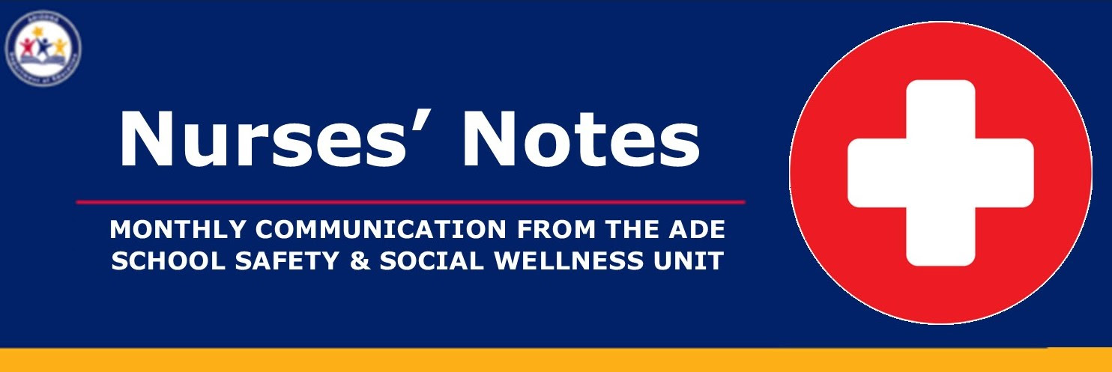
NEWS & ANNOUNCEMENTS
ADE School Nursing & Health Services

-Speakers announced for the next Professional Development Webinar on Feb 2nd: Lynn Gerald, PhD, MSPH and Wayne Morgan, MD from the University of Arizona Pediatric Pulmonary Center will be presenting
-The Arizona School Nurse Access Program (ASAP) has new staff hired! Please join us for the SN Huddle (sign up below) to meet Sarah Portle, MEd, BSN, RN, NCSN and Melinda Weible
UPCOMING VIRTUAL EVENTS
Jan 19th: School Nurse (SN) HUDDLE Join us to meet the new ASAP staff and hear more about the ASAP Mentor Program and the ASAP National Certified School Nurse (NCSN) Program Register Here
Feb 2nd: Managing Student Asthma in School During COVID-19 Register Here
Feb 12th: The University of Arizona PediatricPulmonary Center (UAPPC) 13th Annual School Healthcare Training Event Register Here
NASN Webinar
COVID-19 Prevention for K-12 Schools Part 3: Focusing School Located Vaccination on Health Equity
-1/12/22 at 3pm to 4:15pm ET
This webinar will promote school-located vaccination (SLV) as a measure to improve and maintain a safe and healthy environment for students and the community. CDC will provide an overview of COVID-19 cases in pediatrics, guidance for school-located vaccination clinics (SLVs) in schools, and Test to Stay Guidelines. School nurse leaders will provide insight on their SLV experiences, including successes and challenges and their roles in championing SLVs. Register today!

