

SAMPLE

Sample School District Communicable Disease Management Plan

Revised December 2025

TABLE OF CONTENTS
SAMPLE
Introduction 2
Authors and Acknowledgements 2
Important Links and Resources 2
School Board Policies 2
Oregon Legislation 2
OHA and ODE 3
Roles and Responsibilities 3
Communicable Diseases in Schools 4
Levels of Prevention 5
Primary Prevention: Everyday Prevention Strategies 5
Clean and Healthy Environments 6
Hand Hygiene 6
Respiratory Etiquette 7
Vaccination 8
Health Education 8
Secondary Prevention: Response to Ill Students and Staff 9
Staying Home When Ill 9
Exclusion and Isolation of Ill Individuals 10
Restrictable Diseases 13
Tertiary Prevention: Outbreaks, Epidemics and Pandemics 14
Outbreaks and Clusters 17
Mask-wearing 18
Physical Distancing and Cohorting 18
Symptom Surveillance and Testing 18
Additional Considerations 19
Uncommon Circumstances: Animals and Food Safety 19

Animals in School 19
SAMPLE
Food Safety 20
Glossary of Terms 21
References 23

INTRODUCTION
Students’ and staff health and safety are a priority of the [INSERT DISTRICT NAME] School District. One area of health and wellness in the school setting includes the prevention and control of communicable diseases.
Providing a safe, comfortable, and healthy environment facilitates the educational process, encourages social development, and allows children to acquire healthy attitudes toward school (NRC, 2020).
Illness and injury are not uncommon in the school setting; therefore, policies, procedures, and guidance related to infection control are of the utmost importance. When children are injured or feel unwell, it can create difficulties in the school setting related to both the risk to others and the child’s ability to fully participate in class and educational activities. Consistent with the Whole School, Whole Community, Whole Child model, staff collaborate to achieve the best outcomes for both the student population and individual students. In this regard, staff must be prepared and have access to appropriate resources and materials to identify and implement effective measures and interventions for child health issues, including communicable diseases (ASCD, 2020).

AUTHORS AND ACKNOWLEDGEMENTS
Alanna Russell, MN, RN, NCSN Wendy Niskanen MEd, RN
This document was adapted from the Colton School District Communicable Disease Management Plan developed by Jan Olson, DNP.

IMPORTANT LINKS AND RESOURCES

[Insert District Name ] School District Board Policies
- Communicable Diseases JHCC-AR
- Communicable Diseases JHCC
- Student Health Services JHC
- Animals in district

Oregon Legislation
SAMPLE
- OAR 581-022-2220 Communicable Disease Management Plan/Isolation Space/Standards for Public Elementary and Secondary Schools: Health Services
- OAR 333-019-0010 Exclusion Measures
- OAR 581-022-2225 Emergency Plan and Safety Programs
- OAR 166-400-0010 Educational Service Districts, School Districts, And Individual School Records
- ORS 433.255¹ Persons with or exposed to restrictable disease excluded from school
- ORS 336.201¹ Nursing services provided by district.
- OAR 437-001-0744 Oregon Occupational Safety and Health Division
- OAR 333-019-0015 Investigation and Control of Diseases: General Powers and Responsibilities
- OAR 333-003-0050 Impending Public Health Crisis: Access to Individually Identifiable Health

Oregon Health Authority & Oregon Department of Education
- Oregon Communicable Disease Guidelines for School

ROLES AND RESPONSIBILITIES
Development and implementation of a district communicable disease plan involves an interdisciplinary approach and should include input from multiple stakeholders and field experts.

The District Communicable Disease Management Team includes:

Title | Responsibilities | Name/Contact Information
District-level Administrator
Building-level Administrator
School Nurse
Facilities and Maintenance
LPHA Contact
Other

COMMUNICABLE DISEASES IN SCHOOLS

SAMPLE

Communicable disease control and prevention are of significant importance in creating a safe and healthy environment for students and staff. A communicable disease is an infectious disease transmissible by contact with infected individuals or their bodily secretions or fluids; by contact with contaminated surfaces or objects; by ingestion of contaminated food or water; or by direct or indirect contact with disease vectors. Although the terms infectious disease, communicable disease, and contagious disease are often used interchangeably, it is important to note that not all infectious diseases spread by disease vectors are considered “contagious,” since they cannot be transmitted through direct contact from one person to another (ACPHD, 2013).
Communicable diseases may be categorized in a variety of ways when considering population settings. When categorizing communicable diseases for response-oriented processes, one method includes acuity and frequency (Augello, 2005). This allows those operationalizing communicable disease prevention and response to identify the potential severity of a condition.
Low acuity, low frequency: Communicable diseases that are not uncommon but typically occur sporadically and pose low risk to the general school population in terms of morbidity and mortality (e.g., fifth disease, impetigo).
Low acuity, high frequency: Communicable diseases that are very common in pediatric populations and pose little risk of significant morbidity and mortality to the general school population (e.g., common cold, norovirus, hand-foot-and-mouth disease).
Medium acuity, medium frequency: Communicable diseases that pose a slightly heightened risk of morbidity and mortality on an infrequent or seasonal basis in subsets of the school population (e.g., influenza, parainfluenza).
High acuity, low frequency: Communicable diseases that have greater potential severity, less predictable trends, or unestablished seasonality, and that pose increased risk of morbidity and mortality to the school population or subsets of the school population (e.g., meningococcal disease, E. coli).
Determining the acuity and frequency of a condition requires clinical understanding of communicable diseases and their potential epidemiological variability, underscoring the importance of placing the nurse at the forefront of communicable disease decision-making. Additionally, responses to low-acuity conditions may require modification if morbidity is atypical, reiterating the importance of clinical consultation.
In addition to understanding the frequency and potential severity of a communicable disease, understanding how communicable diseases are spread is a critical component of prevention and mitigation. Modes of transmission depend on the specific infectious agent. Common ways communicable diseases spread include:

Direct contact: Physical contact with an infected person, such as through touch (staphylococcus), sexual contact (gonorrhea, HIV), fecal–oral transmission (hepatitis A), or droplets (influenza, pertussis, TB).
SAMPLE
Indirect contact: Contact with contaminated surfaces or objects (norovirus), food (salmonella, E. coli), blood (HIV, hepatitis B, hepatitis C), or water (cholera, listeria).
Vector-borne transmission: Bites from insects or animals capable of transmitting disease (e.g., mosquito: malaria, yellow fever; flea: plague).
Airborne transmission: Aerosolized spread through the air (e.g., measles).

In the school setting, the most frequent risks are associated with direct contact with ill individuals, contamination of surfaces or through airborne transmission. Primary sources of prevention-oriented measures include hand and surface hygiene, respiratory etiquette, isolation, exclusion, and standard precautions.

Prevention oriented measures are those which seek to prevent, reduce and control transmission of communicable diseases based on the actual and perceived risk relative to the circumstances that surround transmission and exposure potential. Prevention can be described and applied in a variety of ways. This plan will focus on Levels of Prevention translated to address communicable disease in the school setting.

Levels of Prevention

Levels of Prevention are regarded as essential public health operations to protect and improve overall health of populations and communities (WHO, 2022). Endorsing a leveled approach to communicable disease management creates a framework of embedding prevention at every level of management and response
[ i.e. preventing disease, preventing spread, preventing complications, preventing sequelae].
Levels of Prevention are categorized by primordial, primary, secondary, tertiary and quaternary. This plan will focus on those applicable to the school environment, which include primary, secondary, and tertiary.
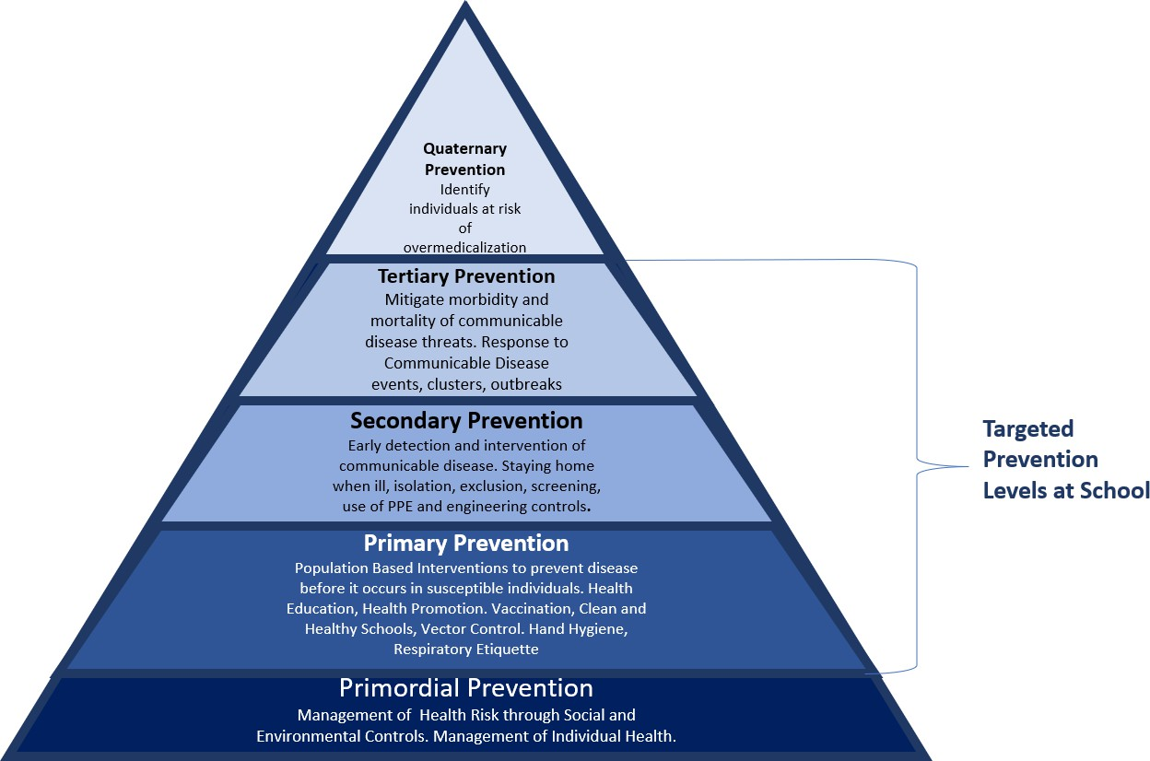

PRIMARY PREVENTION: Everyday Prevention Strategies
SAMPLE
Primary prevention should include a layered approach, or multicomponent intervention (MCIs), to provide the most effective protection from respiratory and gastrointestinal illnesses (CDC, 2024b). MCIs include simultaneous implementation of:

- Clean and Healthy Environments
- Hand hygiene
- Respiratory Etiquette
- Vaccination
- Health Education

Clean and Healthy Environments

Ventilation
Ensuring proper air ventilation within school buildings reduces risk of illness transmission to students and staff by reducing the number of viral particles in the air (CDC, 2024c). Ventilation strategies include:
- Natural Ventilation: Opening windows and doors
- Mechanical Ventilation: Fans, HVAC systems, and air purification devices Schools can promote air ventilation through a variety of strategies, including:
- Ensure existing HVAC systems are working in accordance with ventilation design codes.
- Open classroom windows when safe to do so.
- Use fans to enhance ventilation and increase effectiveness of opening or cracking windows.
- Use portable air cleaners in spaces with low ventilation.
- Consider holding school activities outdoors when it is safe to do so, such as lunch/recess, assemblies, and social activities.
- Open bus windows, even just 1-2 inches, when it is safe to do so.

Cleaning, Sanitizing and Disinfecting
Clean schools contribute to healthy environments and minimize the risk of communicable disease transmission. Schools should implement a process for daily cleaning and disinfection of high-touch surfaces and objects including desks, doorknobs, shared classroom materials, keyboards, and phones. Surfaces or objects that are contaminated with blood or other body fluids must be immediately disinfected. Staff should follow all district protocols developed by facilities management and custodial services when cleaning body fluids, including use of proper protective equipment and proper disposal. Enhanced cleaning protocols may be indicated during times of higher illness transmission (see Outbreaks, Epidemics and Pandemics section).

Hand Hygiene

Hygiene and sanitation are among the most important methods of disease prevention. Handwashing is one of the single most effective ways to reduce the spread of germs, particularly in the school setting. Appropriate handwashing practices will be taught, role-modeled, and regularly practiced.
SAMPLE
Hand sanitizer, while not effective against all pathogens or on visibly soiled hands, will be made available for situations in which handwashing is not immediately accessible. Hand sanitizer will be easily accessible throughout school buildings, particularly in high-contact areas and at entrances and exits, as feasible. Hand sanitizer will also be accessible in each classroom (CDC, 2024b).

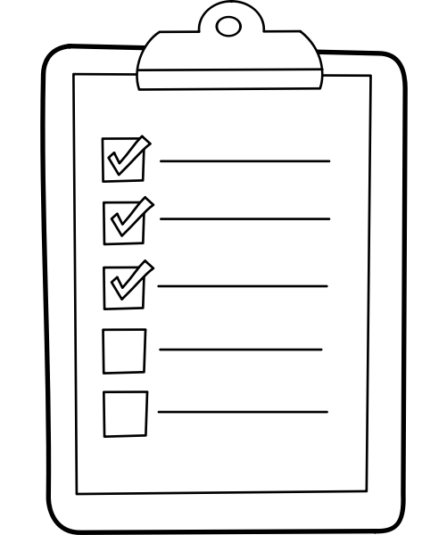
Students and staff will wash their hands with soap and water for at least 20 seconds:
- Before, during, and after preparing food.
- Before eating food
- Before and after caring for someone at home who is sick with vomiting or diarrhea
- Before and after treating a cut or wound
- After using the toilet, helping another person use the toilet, or changing a diaper
- After blowing one’s nose, coughing, or sneezing
- After touching an animal, animal feed, or animal waste
- After touching garbage
- ANY time hands are visibly soiled or have come in contact with body fluids (CDC, 2024a)

Respiratory Etiquette
Respiratory hygiene and cough etiquette are terms used to describe infection prevention measures that decrease the transmission of respiratory illnesses (e.g., influenza and common cold viruses). Respiratory infections can spread when an infected person coughs or sneezes. The droplets released from an ill person’s cough or sneeze can travel several feet, reaching the nose or mouth of others and causing illness. Viruses can also spread easily from person to person through direct contact, such as touching or shaking hands. In addition, droplets can survive for short periods on surfaces and objects, particularly high-touch areas such as doorknobs or desks.
Because some individuals cough without having a respiratory infection (e.g., people with chronic obstructive lung disease), it is not always possible to know who is infectious. Therefore, respiratory hygiene and cough etiquette are essential components of protecting oneself from illness and preventing others from becoming ill. Like hand hygiene, respiratory hygiene is part of standard precautions and will be taught, practiced, and role-modeled to prevent the spread of disease.

Vaccination
SAMPLE
In the school setting, vaccines are an important component of communicable disease control. Vaccinations are required for school attendance in Oregon; however, it is important to note that some individuals may not be vaccinated due to medical contraindications or non-medical exemptions. Each school maintains records of students who are and are not vaccinated with routine childhood immunizations, which serve as a primary control measure during outbreaks of vaccine-preventable diseases. For the purposes of communicable disease mitigation, it is essential to ensure that immunization records are accurate, up to date, and accessible when needed.
The vaccination process is covered in detail on the Oregon Health Authority’s Vaccine webpage.

Vaccination Resources:
- Vaccination information for parents and caregivers
- School-based vaccination clinics

Health Education

Prevention oriented measures are grounded in education of how diseases are transmitted, as well as practice application and role modeling related to appropriate measures and precautions.
Communicable Disease Related Health Promotion
- Age-appropriate hand hygiene curriculum can be found from a variety of resources and will be provided annually in the fall and as needed during peak illness season or specific increases of disease in the school setting.
- Cleanliness, germ transmission, and cough etiquette will be taught as age appropriate, and signage will be endorsed during peak illness seasons.
- Age-appropriate physical and sexual health education will be delivered per ODE Health Education Standards.
- Reminders will be provided to families about keeping children home when ill and reinforcing health and safety measures as a matter of practice.
- Vaccination reminders will be provided each year to students and families. Students who are not current with vaccinations will be addressed through Immunization exclusion day each year in February. Vaccines clinic advertisements will be forwarded to families in English and Spanish.
- Illness, isolation and exclusion policies will be taught to applicable staff and endorsed by building administration and School Health Services staff.
- Provision of food safety and hygiene measures will be followed and endorsed with mealtimes.
- Provision of hygiene and safety information around recess and physical education will be endorsed.

SAMPLE
- Coordination with counseling services to minimize fear when illness is present in the school setting will occur to maximize student understanding and build a safe environment.
- Communication will be made to families of immunocompromised children when illness is present in the school setting or specific classroom environment.
- Health promotion for staff including education, reinforcement of guidelines and recognition of illness will be done at least annually.
- Families will receive communications each school year related when children should remain home related to illness.
Health Promotion Resources:
- Minnesota Department of Health Hand Hygiene Lesson

Equity Considerations
Health Promotion materials and content should be effectively disseminated at an appropriate literacy level and provision of materials should be representative of the demographic and languages in the school setting.

SECONDARY PREVENTION: Response to Ill Students and Staff
Secondary prevention measures are those used to detect and minimize effects of illness related to early identification. Communicable diseases are transmitted from person to person by various routes. While some conditions are restrictable based on diagnosis, more often early identification of signs and symptoms of communicable disease is of paramount importance to increase the health of the school population and decrease school absenteeism. In the school environment, many communicable diseases are easily transmitted from one individual to another. Secondary prevention measures include:
- Staying home when ill
- Symptom based Isolation and Exclusion
- Specific Disease Exclusion/Restrictable Diseases

Staying Home When Ill

An important element of prevention is the policy and practice of staying home when ill with symptoms or conditions that are excludable. Information on when to stay home should be easily accessible to families and embedded in communications throughout the year. Annual reminders to students and staff regarding when to stay home is an important element of prevention. As well, additional communication can be endorsed during peak illness seasons.
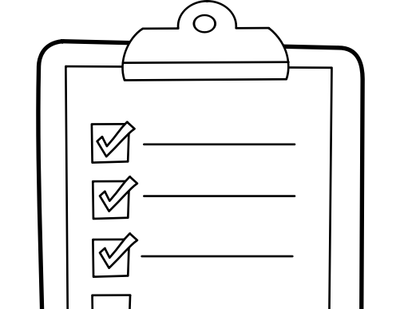
Communication of When to Stay Home:
- Provide annual reminders of when to stay home as it related to illness policy.

SAMPLE
- Additional communications shall be considered during peak illness seasons.
- Targeted communication may need to be endorsed during uncommon communicable disease occurrences or trends.

Exclusion and Isolation of Ill Individuals

Exclusion
Oregon public health law mandates that persons who work in or attend school who are diagnosed with certain diseases or conditions be excluded from school until no longer contagious. However, diagnosis often presumes evaluation by a licensed healthcare provider and specific testing, and schools must often make decisions regarding exclusion based on non-diagnostic but readily identifiable signs or symptoms. The Oregon Department of Education Communicable Disease Guidance Document details both symptom based and disease specific exclusion guidelines. Students and staff must be excluded if they meet one or more of the following criteria:
- Are in the communicable stage of an illness as evidenced by symptoms as outlined by the Symptom-Based Exclusion Chart (Table 1) below.
- Have been diagnosed with a school-restrictable disease as defined by [OAR 333-019-0010].
- Have been exposed to measles, mumps, rubella, diphtheria, pertussis, hepatitis A or hepatitis B. Additionally, students and staff with signs of illness should be excluded per the symptom chart below. Table 1. Symptom-Based Exclusion Chart
Exclusion Criteria | Exclusion Action
FEVER: a measured temperature equal to or greater than 100.4°F orally. | MAY RETURN AFTER fever-free for 24 hours without taking fever-reducing medicine.
COUGH: persistent cough that is not yet diagnosed and cleared by a licensed healthcare provider OR any acute  (non-chronic) cough illness that is frequent or severe enough to interfere with participation in usual school activities. | MAY RETURN AFTER symptoms improving for 24 hours (no cough or cough well-controlled.)
DIFFICULTY BREATHING OR SHORTNESS OF  BREATH not explained by situation such as exercise: feeling unable to catch their breath, gasping for air, breathing rapidly or shallowly, breathing with extra effort such as using muscles of the stomach, chest, or neck | MAY RETURN AFTER symptoms improving for 24 hours.  *This symptom is likely to require immediate medical attention.

SAMPLE
HEADACHE WITH STIFF NECK AND FEVER. | MAY RETURN AFTER fever-free for 24 hours without taking fever-reducing medicine AND symptoms resolve.  *This combination of symptoms may indicate a serious condition. Advise student’s guardian to seek medical attention.
DIARRHEA: three or more watery or loose stools in 24 hours OR sudden onset of loose or bloody stools OR student unable to control bowel function when previously able. | MAY RETURN AFTER diarrhea has improved (no more than two bowel movements more than normal in 24 hours) and the child is no longer having accidents.  Bloody diarrhea should be evaluated by a healthcare provider prior to return.
VOMITING: two or more unexplained episodes in 24 hours . | MAY RETURN AFTER 24 hours after last episode of vomiting OR after seen and cleared by a licensed healthcare provider.
SKIN RASH OR SORES: new rash not previously diagnosed by a health care provider OR rash increasing in size OR new unexplained sores or wounds OR draining rash, sores, or wounds which cannot be completely covered with a bandage and clothing. | MAY RETURN AFTER rash is resolved OR until draining rash, sores or wounds are dry or can be completely covered OR after seen and cleared by a licensed healthcare provider
EYE REDNESS AND DRAINAGE: unexplained redness of one or both eyes AND colored drainage from the eyes OR eye irritation accompanied by vision changes OR symptoms such as eye irritation, pain, redness, swelling or excessive tear production that prevent active participation in usual school activities. | MAY RETURN AFTER symptoms resolve OR after seen and cleared by a licensed healthcare provider. Eye redness alone, without colored drainage, may be considered for attendance per CDC guidelines and school nurse assessment.
JAUNDICE: yellowing of the eyes or skin that is new or uncharacteristic. | MAY RETURN AFTER seen and cleared by a licensed healthcare provider.
BEHAVIOR CHANGE: may include uncharacteristic lethargy, decreased alertness, confusion, or a behavior change that prevents active participation in usual school activities. | MAY RETURN AFTER symptoms resolve; return to normal behavior OR after seen and cleared by a licensed healthcare provider. *These symptoms may indicate a serious condition. Advise student’s guardian to seek medical attention.
MAJOR HEALTH EVENT or STUDENT | MAY RETURN AFTER health and safety are addressed.

SAMPLE
REQUIRING MORE CARE THAN SCHOOL  STAFF CAN SAFELY PROVIDE. May include a significant illness lasting more than two weeks, emergency room treatment or hospital stay, a surgical procedure with potential to affect active participation in school activities, loss of a caregiver or family member, or a new or changed health condition for which school staff is not adequately informed, trained, or licensed to provide care. | - Written instructions from a licensed healthcare provider are likely to be required.  - Schools must comply with state and federal regulations such as the Americans with Disabilities Act ensuring free and appropriate public education (FAPE). School staff should follow appropriate process to address reasonable accommodations and school health service provision in accordance with applicable laws.
Table developed per ODE/OHA Communicable Disease Guidelines
Illness and Exclusion Resources:
- ODE Parent Letters and Exclusion Charts

Equity Considerations
All students must be given the equitable measures related to health and safety in the school setting regardless of race, ethnicity, nation or origin, gender, orientation, ability, or socioeconomic status. Communicable disease mitigation measures should be imposed based on identifiers of the disease, symptoms, circumstances and potential outcomes, not relative to student identifiers.

Isolation
As per OAR 581-022-2220, The school district is required to maintain a prevention-oriented health services program which includes a health care space that is appropriately supervised and adequately equipped for first aid and isolation of ill or injured children from the student body.
Isolation Steps:
- When students are identified with restrictable diseases or excludable symptoms, students will be separated in a designated healthcare isolation space until they can be discharged to home.
- Students with respiratory illness should be offered a mask to limit airborne transmission.
- The isolation space should be in close proximity to adult supervision, and ill students should not be left unattended.
- The isolation space must be sanitized regularly. The space will be cleaned in between ill students.
- Appropriate PPE should be accessible for both students and staff. (i.e., gloves for first aid, masks for respiratory illness).

Restrictable Diseases
Restrictable diseases are specific infectious disease diagnoses that require students or staff to remain at home for a specified period of time to limit transmission. Restriction is typically based on the communicability and/or potential severity of the disease. Restrictable diseases are reportable to the local public health authority (LPHA), which typically notifies schools when a diagnosis occurs in a student or staff member.
However, there are occasions when a parent or guardian notifies the school first; in such cases, the registered nurse (RN) should promptly notify the LPHA.
Students diagnosed with diseases that are restrictable by the local public health authority under Oregon Administrative Rule (OAR) 333-019-0010 may return to school only when documentation is obtained from the local health department (LHD) indicating that the student is no longer communicable, including:

- Diphtheria,
- Measles,
- Salmonella
- Typhi infection,
- Shigellosis,
- Shiga-toxigenic Escherichia coli (STEC) infection,
- Hepatitis A,
- Tuberculosis,
- Pertussis,
- Rubella
- Acute Hepatitis B
- COVID-19

SAMPLE
Restrictable Disease Steps
- If a report is made to the school office, administration, or other school staff regarding a communicable disease diagnosis in a student or staff member, it must be immediately referred to the District Registered Nurse (RN).
- Reports of restrictable diseases are considered urgent referrals to the RN.
- The District RN, in collaboration with school administrators, will determine the need for communication, surveillance, and/or control measures. Response actions will vary depending on the specific condition and the circumstances surrounding the case.
- Interventions and communications are guided by multiple factors, including the diagnosis, the individual’s health status, risk of exposure, number of individuals affected, and risk to a cohort or specific students.
- School staff who receive reports must not inform other students, staff, or parents of the report, as doing so constitutes a violation of privacy. This information is to be communicated only to the District RN.

Vaccine-preventable Diseases
A vaccine-preventable disease (VPD) is an infectious disease for which an effective preventive vaccine exists. Vaccine-preventable diseases that are routinely immunized against in the United States include:
1. Diphtheria* 2. Tetanus*

- Measles*
- Mumps*
- Rubella*
- Haemophilus influenzae type b infections (Hib)*
- Pneumococcal infections*
- Meningococcal disease*
- Pertussis (whooping cough) *
- Poliomyelitis (polio)*
- Hepatitis A*
- Hepatitis B*
- Varicella
- Influenza
- COVID-19

SAMPLE

Most vaccine-preventable diseases (VPDs)* are also notifiable diseases, meaning they are reportable to the local health department and are subject to ongoing surveillance. When these diseases are diagnosed in a population setting, specific public health actions and control measures may be required.
Other VPDs that are not routinely vaccinated against in the United States may arise in particular individuals or groups under specific circumstances, such as cholera, plague, rabies, bat lyssavirus, yellow fever, Japanese encephalitis, Q fever, tuberculosis, and typhoid. While these conditions are uncommon locally, any diagnosed case should be referred to the District RN immediately.

TERTIARY PREVENTION: Outbreaks, Epidemics, and Pandemics
Tertiary prevention measures are those implemented when a disease has already occurred, in the context of communicable disease the school setting this may be relative to identification of outbreaks, clusters or specific response to a high acuity low frequency disease/vaccine preventable disease/ restrictable disease and the specific mitigation measures used to prevent additional morbidity, mortality and associated communication measures.
Standard Response Guidance for Notifiable or Restrictable Disease, Clusters or Outbreaks
- Verify symptom compatibility with a communicable disease or report of disease or outbreak.
  - This may require coordination with LPHA
  - This may require syndrome or symptoms surveillance
- Identify type of transmission associated with the syndrome of condition
  - Respiratory (aerosol, airborne, droplet, etc.)
  - Fecal Oral
  - Contact
- Determine the Response Required in collaboration with LPHA:
  - Identify infectious period for the specific disease, including maximum incubation period.
  - Identify exposure risk in the school setting or school sponsored activities (Was the infectious person(s) at school or a school sponsored event while contagious?)

SAMPLE
- Identify susceptible individuals
  - For example, unvaccinated for a vaccine preventable disease exposure.
- Identify individuals who would be candidates for prophylaxis, if applicable
  - For example, close contacts of a case of meningococcal meningitis.
- Coordinate imposition of restrictions with LPHA and Administration, if applicable
- Coordinate appropriate communication, health promotion materials and actions relative to the specific event.
- Identify additional measures that may be required:
  - School Closure
  - Communication
  - Legal consultation

Outbreaks and Clusters
Outbreaks are most often defined as compatible diagnoses or syndromes in individuals from 2 or more households in the same time period. Because of the nature of the ongoing congregate setting of school, this definition is insufficient for the purposes of seasonal illness, rather an increase in morbidity or severity will be indicators to report to the district RN for consideration of outbreak reports or control measure implementation. The attention to outbreaks, interventions, and resources are highly dependent on the severity or communicability of the syndrome or pathogen identified. Outbreak response including surveillance, infection control measures, and potentially exclusion are also diagnosing specific and may be indicated when:
  - A single significant infectious diagnosis is confirmed in the school setting.
  - Clusters of compatible syndromes or diagnoses associated with an infectious condition are identified within the school setting.
  - Significant absenteeism is identified to be associated with compatible syndromes.
  - Community transmission of an infectious disease is significant in the community and the Local Public Health Authority (LPHA) or the RN has deemed increased surveillance or response to outbreak a necessary measure.
  - Illness-specific examples are outlined in Table 2

Table 2. Examples of when to notify LPHA
Type of Illness/Exposure | Indicators to Notify LPHA
GASTROINTESTINAL ILLNESSES | - Multiple children with compatible gastrointestinal symptoms in 48 hours within the same cohort, but separate households.  - More than 2 cases of diarrhea with bloody stool in the school setting.

SAMPLE
- Sudden onset of vomiting in multiple persons in the same cohort.
- Any unusual combination of gastrointestinal symptoms, severity, duration, or incidence.
RESPIRATORY ILLNESSES | - Respiratory illness resulting in hospitalization or death of a student or staff member.  - Diagnosed pneumonia in 3 or more individuals in the same cohort.  - Identification of 2 or more cases of a vaccine preventable respiratory illness in the same cohort.  - When respiratory disease activity meets illness thresholds:  - School/facility level: ≥30% absenteeism among students/staff due to respiratory illness (with at least 10 individuals affected).  - Classroom/cohort level: ≥20% absenteeism due to respiratory illness (with at least 3 individuals affected).  - Prolonged illness, lasting longer than three days on average, among ten or more persons of the same cohort.  - Any uncommon incidence of illness in more than two students.
VACCINE-PREVENTABLE DISEASES | - A single case of a vaccine-preventable disease that is also a notifiable disease* or uncommon locally.  - More than 2 cases of chickenpox (varicella) from separate households in the same classroom or more than 5 cases in a school.  - More than 3 cases of diagnosed influenza from separate households in the same school setting.
SKIN LESIONS AND RASHES | - More than two students from separate households with reported compatible skin infections in the same school setting or athletic team.  - Students in the same athletic or academic environment with repeated skin infections by the same pathogen.
UNCOMMON EVENTS OR EXPOSURES | - Any student or staff member coming into contact with blood, saliva, or feces from a non-domestic animal in the school setting.

SAMPLE
- Any student or staff coming into contact with blood that is not their own.
- Any combination of illness, symptoms, severity, duration, or frequency that seems unusual as compared to routine seasonal illness.
- Any major event caused by violence or natural disaster that results in a large number of body fluid or blood spills.

Communication with the Public Health Authority

Outbreak investigations will be facilitated through the district RN in collaboration with administration and the local health department with the use of Oregon Health Authority Outbreak Toolkits for Schools. It is of significant importance to note that response of communicable diseases is not universal, and is highly dependent on the disease, conditions or exposure and potential risk. Schools should consult with the LPHA to determine appropriate interventions. In addition to continuation of existing MCI’s, interventions during times of increased illness may include:
  - Mask-wearing
  - Physical Distancing and Cohorting
  - Symptom Surveillance and Testing
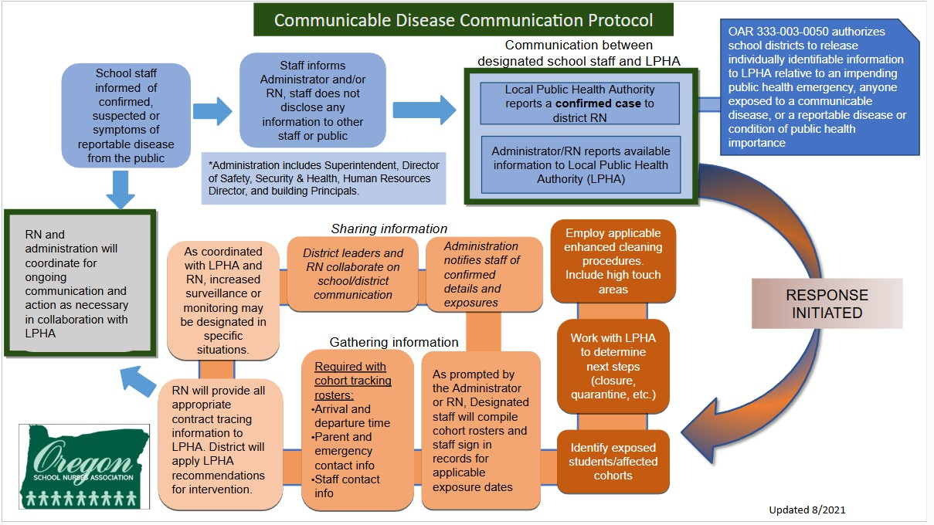

Mask-wearing

When worn properly, masks can reduce transmission of illness within the school setting during illness outbreaks. Mask effectiveness is based on a number of factors including the type of mask, fit of the mask, and proper use. Staff and students who wish to wear masks should be supported in doing so. During outbreaks, schools should consider increased support for mask-wearing for individuals who are at increased risk due to underlying conditions, who do not have access to clean or appropriate masks, or who may have difficulty wearing a mask. In collaboration with the LPHA, mask-wearing may also be considered when making decisions regarding quarantine of exposed individuals (CDC, 2024c).
SAMPLE

Physical Distancing and Cohorting

During periods of increased illness, schools can consider measures that increase physical distance between staff and students. This can involve limiting large gatherings, use of assigned seating, and holding activities outdoors whenever possible and safe to do so.
Because space in schools can be limited, schools can also utilize cohorting to reduce the number of individuals students and staff are exposed to in the school setting. Cohorting involves putting students and staff into small, consistent groups and limiting their interactions with other groups during the school day. When developing cohorts, students and staff with underlying medical conditions should not be separated into their own cohort or segregated from peers.

Symptom Surveillance and Testing

Symptom Surveillance
In response to an outbreak or increased community prevalence of an illness, schools may, in collaboration with the LPHA, implement symptom surveillance measures. This may involve distributing information to families and staff regarding symptoms to monitor for at home. Additionally, the LPHA may direct schools to monitor and track symptoms reported by students and staff during outbreaks.

Testing
During an outbreak, schools may consider testing programs in collaboration with the LPHA. Depending on the specific illness and availability of tests, a testing program may be used to increase illness screening. Schools can also consider distributing testing supplies and information to families.

Additional Considerations

Specialty Medical Procedures
During times of increased community prevalence of an illness, individuals providing specialized healthcare services in the school setting should consider modifying practices per the Oregon Department of Education Special Considerations for Clinical Procedures in Schools. (This document is in process of ODE updates as on 1/2026)

Modified Operations
SAMPLE
Changes in school operational status (i.e., virtual, hybrid, closure) are generally not indicated in response to outbreaks of communicable illness in the school setting (CDC, 2024b) . Any changes in school operational status should be made in coordination with local health authorities and should include discussions with a variety of stakeholders to ensure equitable consideration of impacts to students, staff and family wellbeing.

UNCOMMON CIRCUMSTANCES: Animals and Food Safety

Animals in School

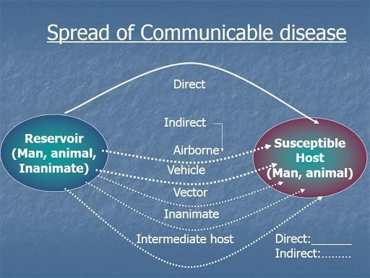
Animals in schools can have a positive effect in the school environment, but also may cause infectious disease issues for staff and students. School District policies and procedures need to address the educational benefits vs risks that animals present. Other considerations will be made in regard to controlling spread on infectious disease from animals:
  - Wild mammals, alive or recently dead, will not be allowed in school. Bats and skunks have a significant risk of being rabid, and other wild animals may be more prone to causing injury through bites and scratches.
  - Dogs, cats, and ferrets allowed in school will have a current rabies vaccine under circumstances that are consistent with board policies and building guidelines.
  - Any animal bites on school premises will be reported to the local health department for follow-up. [Image: Science Direct]
(Oregon Revised Statutes (ORS) 433.345)
  - Animals who are ill will not be allowed into the school setting.
  - Class pets will be removed if they become ill.
  - Handwashing must occur before and after handling animals to prevent the transmission of diseases. Animals will not be present or handled in areas where food and drink are consumed or prepared.
  - Children will not kiss animals such as chicks, ducks, turtles, and other reptiles.
  - Children will always be monitored with animal interactions.
  - Consider the medical needs of students who may be immunosuppressed or who may have allergies, as they may become severely ill when exposed to certain pathogens.

  - Service animals fall under specific guidelines and district policies which include protection of the animal to the extent that signage and education may be provided to prevent interaction with a service animal while it is working.
SAMPLE
In the event of an animal bite:
- Ensure standard first aid is rendered, and the student/staff is deferred to medical care.
- Unprovoked bites sustained from canines are reportable to the local health department.
(503) 655-8411
- Any animal bite to a person that causes a break in the skin must be reported immediately to the local health officer by any person having direct knowledge (Oregon Revised Statutes (ORS) 433.345).
- In the event that a student in a classroom is diagnosed with a disease known to be carried by animals (campylobacteriosis or salmonellosis, for example), the animal will be removed from the classroom setting until the risk is determined to be resolved.
- If an animal in the school setting becomes ill, it should be removed from the environment until a licensed vet has deemed it healthy.

Food Safety
Food safety for kitchen staff is supervised by nutrition services and the Environmental Health Division of the Local Health Department. For the purpose of population-based health and food preparation and consumption within the classroom, general food safety standards and disease prevention principles will be endorsed.

For elementary school classrooms:
    - Hand hygiene is practiced prior to eating,
    - General principles of food safety can be taught that are age appropriate.
    - Food sharing will be avoided.
    - For classroom and school-sponsored events, only commercially prepared products are permitted. No homemade goods from non-licensed kitchens are permitted.
    - Consideration must be given to allergies in addition to potential for food contamination or food borne illness.

For middle school or high school culinary classrooms:
    - Hand hygiene will always be encouraged.
    - Age-appropriate food safety principles are taught.
    - Appropriate food handling processes must be taught, role-modeled, and endorsed when food is being prepared in the academic setting. This includes overview of:
      - Hand hygiene and appropriate use of gloves.
      - Clean surfaces and appropriate use of sanitizers.
      - Separating raw and ready to eat foods/ avoidance of cross-contamination.
      - Cooking food to appropriate temperatures.

      - Appropriate storage and refrigeration.
SAMPLE
      - Measures to prevent allergic reactions
      - Abstaining from food preparation when specific symptoms or specific illnesses have been identified.

Other considerations:
Additional considerations related to food safety include diagnosed gastrointestinal illness among food prep workers or in classrooms where food is being prepared. Refer to gastroenteritis outbreaks above.

Glossary of Terms
Airborne precautions: Precautions that are required to protect against airborne transmission of infectious agents. Diseases requiring airborne precautions include, but are not limited to: Measles, Severe Acute Respiratory Syndrome (SARS), Varicella (chickenpox), and Mycobacterium tuberculosis
Antibody: A protein produced as an immune response against a specific antigen.
Antigen: A substance that produces an immune response.
Bacteria: Microscopic living organisms. Some bacteria are beneficial, and some are harmless, but some can pathogenic (cause disease).
Bloodborne pathogens: Microorganisms which are spread through contact with infected blood, that can cause diseases such as human immunodeficiency virus (HIV) and hepatitis B (HBV).
Communicable Disease: Illness that spreads from one person to another through contact with the infected person or their bodily fluids, or through contaminated food/water or disease vectors, such as mosquitos or mice.
Contact Tracing: Working with an infected person to determine who they have had contact with and potentially exposed, to an illness.
Disinfection: High level cleaning intended to kill germs on surfaces
Droplet precautions: Safety measures used for diseases or germs that are spread in tiny droplets caused by coughing and sneezing (examples: pneumonia, influenza, whooping cough, bacterial meningitis).
Epidemic: A disease affecting a large number of people in a community or region.
Exclusion: Preventing someone from entering a place or participating in an activity Immunocompromised: Having a weakened immune system that cannot respond normally to an infectious agent. This limits the body’s ability to fight disease.
Isolation: Being kept separate from others. A method of controlling the spread of a disease.
Novel: New—in medical terms, previously unidentified, as in, novel coronavirus
Pandemic: An epidemic that spreads over countries or continents.
Pathogen: A microorganism that can cause disease.
Personal Protective Equipment (PPE): Physical barriers used when exposure to hazards cannot be engineered completely out of normal operations and when safe work practices and administrative controls cannot provide sufficient protection from exposure to infectious or hazardous conditions. PPE includes such items as gloves, gowns, and masks.

Restrictable Diseases: Diseases that require exclusion from work, school, childcare facilities, for the protection of public health. According to the Oregon Health Authority, restrictable disease include diphtheria, measles, Salmonella enterica serotype Typhi infection, shigellosis, Shiga-toxigenic Escherichia coli (STEC) infection, hepatitis A, tuberculosis, open or draining skin lesions infected with Staphylococcus aureus or Streptococcus pyogenes, chickenpox, mumps, pertussis, rubella, scabies, and any illness accompanied by diarrhea or vomiting.
SAMPLE
Sanitize: Reduce contaminants (viruses, bacteria) on an object or surface.
Seasonal Illness: Illnesses whose occurrence appears to be associated with environmental factors (temperature and humidity changes). For example, colds, and other upper respiratory illness are more common during the winter months when people are more often indoors.
Standard Precautions: A set of infection control practices used to prevent transmission of diseases that can be acquired by contact with blood, body fluids, non-intact skin (including rashes), and mucous membranes. These measures are to be used when providing care to all individuals, whether or not they appear infectious or symptomatic.
Surveillance: Collecting and analyzing data related to a disease in order to implement and evaluate control measures
Transmission: How a disease spread. There are four modes of transmission:
  - Direct—physical contact with infected host or vector
  - Indirect contact with infected fluids or tissues.
  - Droplet—contact with respiratory particles sprayed into the air (sneezed or coughed)
  - Droplet Nuclei—dried droplets that can remain suspended in the air for long periods of time (e.g., tuberculosis)
  - The mode of transmission of a disease will determine what PPE is required.
Universal Precautions: Preventing exposure to blood borne pathogens by assuming all blood and bodily fluids to be potentially infectious and taking appropriate protective measures.
Vaccine: A preparation containing a weakened or killed germ. Vaccines stimulate the immune system to produce antibodies to prevent a person from contracting the illness.
Variant: A difference in the DNA sequence, a mutation. Viruses can change and mutate, and these variant forms can be intractable to established treatments.
Vector: A carrier of a pathogen (germ) that can transmit the pathogen to a living host. Mosquitoes, fleas, ticks, and rodents are examples of vectors.

References
SAMPLE
Alameda County Public Health Department (2013) Communicable Disease. Retrieved from http://www.acphd.org/communicable-disease.aspx
ASCD (Association for Supervisors and Curriculum Development) (2020). WSCC. Retrieved from http://www.ascd.org/programs/learning-and-health/wscc-model.aspx
BC Center for Disease Control (BCDC) (2009) A quick Guide to Common Childhood Diseases. Retrieved from http://www.bccdc.ca/resourcegallery/Documents/Guidelines%20and%20Forms/Guidelines%20an
%20Manuals/Epid/Other/Epid_GF_childhood_quickguide_may_09.pdf
Centers for Disease Control and Prevention (2024a). About Handwashing. Retrieved from https://www.cdc.gov/clean-hands/about/index.html#:~:text=Key%20times%20to%20wash%20hands,After%20touc hing%20garbage
CDC (2024b). Preventing Spread of Infections in K-12 Schools. Retrieved from https://www.cdc.gov/orr/school-preparedness/infection-prevention/index.html
CDC (2024c) Science Brief: Prevention and Control of Respiratory and Gastrointestinal Infections in Kindergarten through Grade 12 (K12) Schools. Retrieved from
https://www.cdc.gov/orr/school-preparedness/infection-prevention/docs/IPC-Science-Brief_508.pdf CDC (2020). Influenza. Retrieved from https://www.cdc.gov/flu/about/index.html
CDC (2020) When and how to wash your hands. Retrieved https://www.cdc.gov/handwashing/whenhow handwashing.html
CDC (2016a) Bloodborne Pathogens. Retrieved https://www.cdc.gov/niosh/topics/bbp/emergnedl.html CDC (2016b) Variant Influenza Viruses: Background and CDC Risk Assessment and Reporting. Retrieved from https://www.cdc.gov/flu/swineflu/variant.htm
CDC (2017) Getting your school ready for pandemic flu. Retrieved from https://www.cdc.gov/nonpharmaceutical-interventions/pdf/gr-pan-flu-ed-set.pdf
Hull, H. F., & Ambrose, C. S. (2011). The impact of school-located inﬂuenza vaccination programs on student
absenteeism: a review of the U.S. literature. The Journal of school nursing : the ofﬁcial publication of the National Association of School Nurses, 27(1), 34–42. https://doi.org/10.1177/1059840510389182
Minnesota Department of Health (2020). Teaching Hand Hygiene. Retrieved from https://www.health.state.mn.us/people/handhygiene/curricula/index.html
Montana Department of Public Health and Human Services (MDPHHS) (2018) Communicable Disease: A guide for Schools in Montana. Retrieved from https://dphhs.mt.gov/Portals/85/publichealth/documents/CDEpi/CDGuideforSchools2018_Final.pdf
National Resource Center for Health and Safety in Child Care and Early Education (NRC). (2020). Environmental Health in Early Care and Education. Retrieved from https://nrckids.org/CFOC/Environmental_Health
Oregon Department of Education (2024) Communicable Disease Guidance for Schools. Retrieved from Oregon Department of Education Communicable Disease Guidance Document.
South Dakota Department of Health (2019) Seasonal Respiratory Viruses. Retrieved from https://doh.sd.gov/diseases/infectious/diseasefacts/viral-respiratory.aspx
Victoria State Government. (2020). Managing spills of blood and body fluids and substances. Retrieved from https://www2.health.vic.gov.au/public-health/infectious-diseases/infection-controlguidelines/manage-blood body-fluidspills#:~:text=Spots%20or%20drops%20of%20blood, as%20wet%20areas%20attract%20contaminan s.
Virginia Department of Health (2011) FAQ Respiratory Hygiene and Cough Etiquette. Retrieved from https://www.vdh.virginia.gov/content/uploads/sites/3/2016/01/RespiratoryHygieneCoughEtiquett
_FAQ.pdf

Weatherspoon, D. (2019) Acute Viral Respiratory Infections. Retrieved from https://www.healthline.com/health/acute-respiratory-disease
SAMPLE

Images:

- CDC.gov  - Flaticon.com  - Manitoba Department of Health  - Multicare.org | - Open University  - Prepare.gov  - Safety Signs | - Slideserve  - Science Direct

