Disease Mitigation in School Athletics
School sports and athletic activities require unique considerations when COVID-19 or other diseases are circulating. School RNs, athletics trainers, and health staff can collaborate on key practices to reduce spread of disease and keep students in school.
BACKGROUND
Relationships between athletics and health staff
It can be helpful for the school RN to maintain a professional relationship with district athletics trainers, as well as school staff providing health and physical education (PE).
- Athletic trainers are health professionals; easily allied with RNs in many aspects of health promotion and prevention of harm.
- School RNs and athletic trainers can work together on a variety of issues, such as concussion protocols; salary schedule as classified versus certified staff; as well as COVID-19/communicable disease protocols.
- In addition to athletic trainers, school staff providing health and physical education are (hopefully) already up-to-date on COVID-19/communicable disease mitigation in the facility. Health and education staff can be allies to collaborate on health protocols & messaging, and/or may need guidance tailored to their positions.

Athletics trainers may serve as liaison between the school nurse/school health team, and the athletic directors or coaches.
- In many settings, coaches for extracurricular sports are not members of school staff. The school RN may have no way to contact the coaches unless the relationship is facilitated.

It can be helpful if the school RN is available to coaches; but certain boundaries should be set.
- Establish hours of availability and/or response time for communications.
- Practice and games often happen evenings and weekends; may be past a school RN’s scheduled work hours; may have multiple sports happening simultaneously.

Annual/seasonal athletic activities
Anticipate multiple extracurricular sports each season. Some may also be offered during school curricular PE activities.
- Fall examples: football, soccer, cross-country track, dance, cheer, golf
- Winter examples: basketball, baseball, swimming, wrestling, dance, cheer
- Spring examples: baseball, lacrosse, track, dance, cheer, golf

Pre-season meetings provide an opportunity to introduce RN/health staff to coaches and share school guidance.
- School athletic directors may have routine meetings with coaches to review setting/facility rules & requirements, such as emergency procedures, posting on school social media, unlocking/locking school facilities, …and local protocols for COVID-19 and other disease mitigation.
- It can be helpful for the school RN, or another key member of the school health team, to be present at pre-season meetings.
- Share guidance and common goals, such as: keep kids in play and in school; avoid outbreaks and quarantines by maintaining good practices; uphold COVID-19/other communicable disease protocols to reduce the spread of illness.

Anticipate school staff meetings and other opportunities for communication, such that all school staff and students remain up-to-date on local protocols.
- It may be helpful for the school RN to collaborate with other school staff to clarify guidance for PE and athletics; and/or offer information specific to those providing PE and health education.

MITIGATION PRACTICES FOR COVID-19 AND OTHER DISEASES

Reduce spread of illness and reduce required quarantines
School exclusion (isolation) is required for anyone with a school restrictable disease per Oregon’s public health laws [OAR 333-019-0010]. Quarantine of exposed individuals may also be required. Check current state guidance and work with your local public health authority as needed for specific scenarios.
In general, efforts to reduce close-contact and germ transmission can decrease risk of team outbreaks or quarantines. However, these efforts may take more time for coaches and assistants. Work to establish buy-in with a common goal of reducing outbreaks and quarantines and keeping kids in play (and in school).

- Policy and protocol development
The school RN, other school staff, athletics trainers, and coaches may collaborate to establish facility-specific practices, as well as more formal policy and protocols for the school or district. Refer to state guidance, including OHA/ODE Communicable Disease Guidance for Schools.

- Key Practices
Oregon’s Ready Schools, Safe Learners guidance offered this outline of key practices.
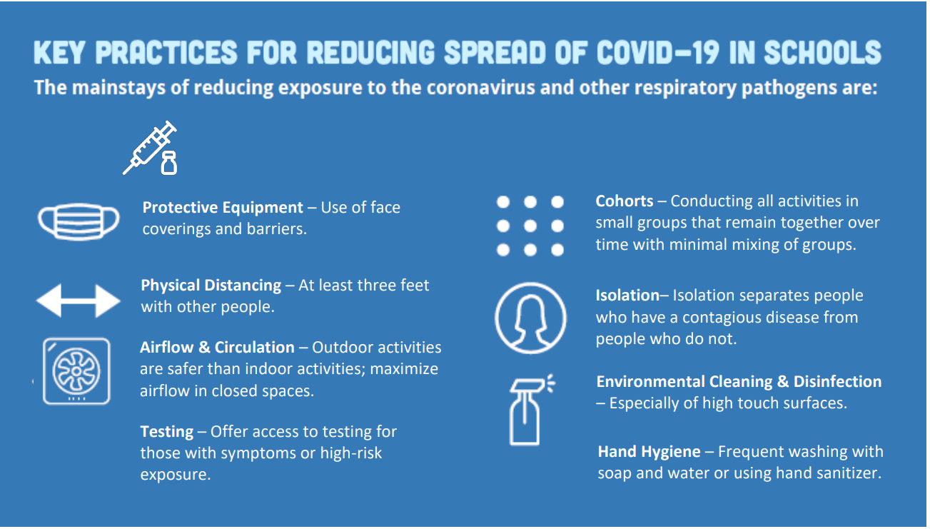

3. Examples
Below are examples of key practices, applied to athletics, based on actions that were implemented in Oregon schools during times of high viral transmission.

KEY PRACTICE | EXAMPLE ACTIONS
Maintain physical distance. | - Stay at least 6 feet apart when not in play/actively participating. Put chairs on Xs spaced apart, or tape Xs on bleachers.  - Locker rooms: eliminate or reduce time inside together. Come to practice already dressed down. Shower at home. Move through the locker room in under 5 minutes pre/post. Supervise entrances and/or inside spaces to reduce lingering.  - Water cooler/snacks: don’t crowd together. Bring individual water bottles or maintain a distanced line. (Drink from your OWN bottle!) Set up snacks in distanced piles or toss across a distanced circle.  - Swimming: use alternating lanes or swim alternate directions. Maintain distance while waiting; don’t hang on the wall within 6 feet of others.  - Soccer/Track/Football/Golf: any sport that includes running drills or warm-up runs, maintain 6 foot spacing.  - Dance/Cheer: seek choreography that maintains 6-foot distance between participants.
Maintain stable cohorts. | - Locker rooms: establish small groups that change together or are in one area of the room, rather than all athletes mingling.  - Wrestling: spar with the same partner / small group of partners, at least for the duration of each week. (A positive case identified during that week would only impact those partners).  - Swimming example: swim in designated order or designated lanes, with the same individuals near one another, at least for the duration of each week.  - Dance/cheer: seek choreography such as mirroring groups, rather than full-group intermingling. Minimize time spent stunting (high risk exposure). If stunting, conduct lifts/stunts with stable groups of 3-4, at least for the duration of each week.  - Soccer/football/basketball/baseball: establish small groups to practice close-contact passes, at least for the duration of each week. Keep consistent lineups and seating arrangements at games/on buses.
Encourage vaccination . | - Vaccination can prevent disease transmission, and can reduce the severity of disease if transmission does occur. For athletes this can mean the difference between returning to play in a week, versus experiencing long-term illness and symptoms that interfere with ability to participate.  - For school-restrictable diseases, fully-vaccinated students and staff are usually exempt from quarantine. High vaccination rates keep teams from being quarantined. (Quarantine is not required for COVID-19 at the time of writing, but remains required for unvaccinated exposure to other school-restrictable diseases.)
Maintain hand hygiene. | - Wash or sanitize hands before entering play, and after leaving the court/field, BEFORE grabbing water bottle or snacks.
Encourage face-covering. | - Face covering while waiting on the bench, on athletic buses, etc.  - Keep face coverings clean. For example: when masks are removed, fold them inside-to-inside and place them with straps around the individual’s water-bottle.  - Face covering should not be used when it poses a risk, such as a choking hazard during wrestling or swimming.
Maintain environmental cleaning. | - Clean / sanitize / disinfect common-use items and high-touch surfaces, such as bats, balls, chair backs, door handles, wrestling mats. Clean between use where applicable; and before and after each practice, or between use by different cohorts.
Maximize air flow and ventilation. | - If practice/games can occur outdoors, do so.  - If practice/games must occur indoors, maximize ventilation such as opening windows and doors, using fans to vent air out of the space, using high-quality filters such as HEPA filters, maintaining school ventilation systems, etc.
Anticipate the need to isolate. | - Plan ahead: establish where/how to isolate if a team member or adult develops symptoms of illness during a practice or game.  - Provide a separate space away from others until that person can be taken home or taken for care.  - Anticipate and plan ahead, not only for onsite activities but also for away games with group bus travel, and overnight trips.

References
CDC Schools, Childcare, and Colleges COVID-19 Mitigation
CDC Whole School, Whole Community, Whole Child coordinated school health model
OHA/ODE Communicable Disease Guidance for Schools
OHA/ODE 2021-2022 Ready Schools, Safe Learners

