COVID-19 Specific Prevention Measures & Procedures for 2021-2022 School Year

COVID-19 Mitigation measures in the school setting have evolved since the onset of the pandemic. Current mitigation measures can be categorized by best practice based on current public health publications and minimum practice as related to state specific published guidance. It should be noted that guidelines are subject to change based on updated guidelines and executive orders while the COVID-19 pandemic persists.
The District Communicable Disease Management Plan is the primary guiding document for Communicable Disease planning and prevention in the school setting. This is document will address specific measures and procedures outlined in the 2021-2022 Ready Schools Safe Learners Resiliency Framework for COVID-19 that districts must address. This includes:
- Risk Assessment
- Designated Personnel
- Important Contacts
- Prevention Oriented Measures
  - Masks
  - Cohort Tracking/Contact Tracing
  - Distancing
  - Environmental Health
  - Symptom Based Exclusion
  - Hand Hygiene and Respiratory Etiquette
  - Vaccination
  - Testing
- Response Oriented Measures
  - Surveillance
  - Exclusion
  - Isolation and Quarantine
  - Designated Personnel
- Communication Process
- Testing
- Vaccination

This document authored by Dr. Jan Olson, DNP, MSNEd, BSN, RN, NCSN-Clinical Consultant. Reviewed by Amanda Bickford, BSN, RN-District Nurse, Jennifer Ellis-HR Director, Michael Salitore-Director of Special Education, Tony Mann-Superintendent, Rick Gill-Business Manager, Kathleen French-Director of Curriculum, Missy Grindle-Executive Assistant to the Superintendent , Allison Holstein-Communications Manager
MOLALLA RIVER SCHOOL DISTRICT

Statutory & Administrative Regulations

Emergency Rules Related to COVID-19
The Oregon Health Authority (OHA), Public Health Division, is temporarily adopting OAR 333-017-0800 and OAR 333-018-900, which adds a definition of COVID-19 and adds COVID-19 to the list of diseases reportable to public health authorities within 24 hours.

In addition, OHA is also adopting OAR 333-19-1000 related to exclusion from schools, children's facilities, food service facilities, and health care facilities.

OAR 333-019-1015. Was adopted to require universal masking in school.

Existing Rules and Statutes
School Centered
OAR 581-022-2220 Standards for Public Elementary and Secondary Schools: Health Services
OAR 581-022-2225 Emergency Plan and Safety Programs
OAR 166-400-0010 Educational Service Districts, School Districts, And Individual School Records
ORS 433.255¹ Persons with or exposed to restrictable disease excluded from school or children’s facility.
ORS 336.201¹ Nursing services provided by district.
Occupational Centered
1910-1030 OSHA Bloodborne Pathogens
OAR 437-001-0744 Oregon Occupational Safety and Health Division
Public Health Centered
OAR 333-019-0015 Investigation and Control of Diseases: General Powers and Responsibilities
OAR 333-003-0050 Impending Public Health Crisis: Access to Individually Identifiable Health Information
ORS 431A.015¹ Authority of Public Health Director to take public health actions.

Risk Assessment

OAR 437-001- 0744(3)(g) requires a risk assessment to address COVID-19 in the workplace. The district risk assessment can be accessed here:
OSHA Required Risk Assessments - Instructional Staff
OSHA Required Reis Assessments - Custodial Staff

Designated Personnel
Per the 2021-2022 Ready Schools Safe Learners Resiliency Framework, designated must be identified in the Communicable Disease Management plan. Specific roles are important to ensure consistent and appropriate control measure implementation and processes. The following outlines where designated personnel or resources are required with role and responsibility.
Required Designation | Responsibility | Role
Designated Point Person Per Each Building | Implementation and oversight of safety and mitigation measures | Administrator
Designated Person to Respond to COVID-19 Related Inquiries | Point person for COVID-19 related inquiries within the school setting. | - Logistics: Administrator  - Clinical: Nurse  - Human Resources Related: HR Director
Designated COVID-19 Point of Contact for LPHS | Liaison to LPHA and point person for internal COVID-19 reports. | District Nurses
Data Entry/Logs | Health Room Logs, Communicable disease Surveillance logs, Cohort assignment in Synergy | Attendance Secretaries, Screeners,
Case and Contact Data and Follow Up | Case and contact calls, communication, and data. | District Nurses
Designated Staff for Screening & Exclusion | Screening for symptom exclusion | As designated by admin, attendance secretary, RN

Medical Contacts
Per the 2021-2022 Ready Schools Safe Learners Resiliency Framework a list of clinical contacts are a required element of the Communicable Disease Management Plan as it relates to COVID-19 mitigation.
Person | Title | Contact | Agency
Sara Present | Deputy Health Officer | spresent@clackamas.us | Clackamas County
Lane Thompson | COVID-19 Outbreak Team | lthompson@clackamas.us | Clackamas County
Carolee Asher | Infectious Disease RN | casher@clackmas.us | Clackamas County
Renee Jenkins | Infectious Disease RN | rjenkins@clackamas.us | Clackamas County
Kamryn Brown | COVID-19 School Liaison | COVIDschoolliaison@clackamas.us | Clackamas County
Corrina Brower | Oregon School Nurse Consultant | Corrina.E.Brower@dhsoha.state.or.us | Oregon Health Authority
Sasha Grenier | Oregon School Health Specialist | Sasha.Grenier@ode.state.or.us | Oregon Department of Education
Amanda Bickford | District Nurse
Barbara Campbell | District Nurse
Jan Olson | Clinical Consultant | Jan.Olson@molallariv.k12.or.us | Molalla River School District

Important Links:
Oregon Department of Education
Oregon Health Authority
Local Public Health Authority
Centers for Disease Control & Prevention

Prevention Oriented Measures
Prevention oriented measures, as outlined in the District Communicable Disease Management Plan, are those measures which seek to prevent transmission based on practices in the school setting. For the purposes of COVID-19 specific measures, this document address ODE’s Key Practices for Reducing Spread of COVID-19 in Schools. Due to the fluid nature of the pandemic and guidance, MRSD will outline best practices, current minimum practices, existing rules, and orders and highlight practices being adopted. Of note, practices are subject to change based on executive orders which are guided by current incidence and severity of transmission in the community. Current Executive orders can be accessed here.
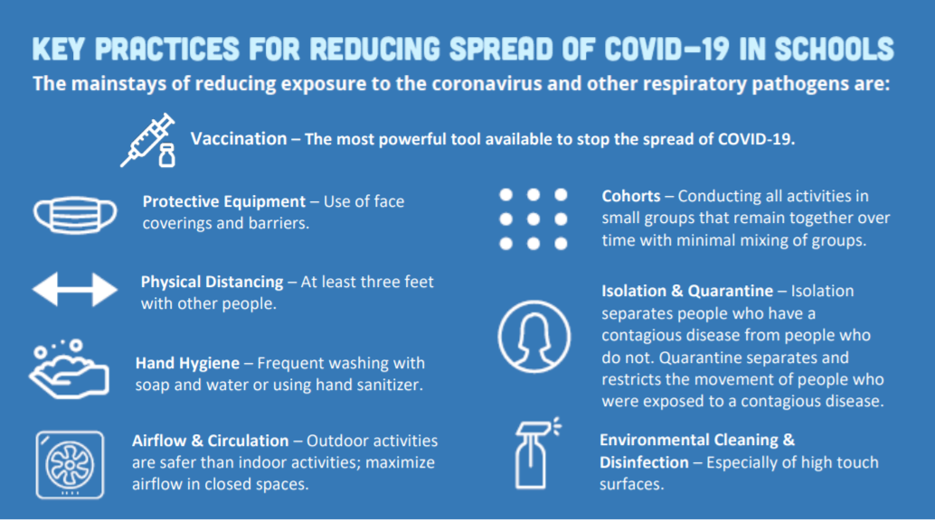
The district recognizes the volume of information that is available on the topic of COVID-19 in the school setting. In order to promote full transparency and isolate school decision making to the most reputable and reliable resources in addition to our governing documents; The following table summarizes the existing guidance on the topics identified in the 2021-2022 Ready Schools Safe Learners Resiliency Framework. This table uses publications by the:
- CDC
- Oregon Health Authority
- American Academy of Pediatrics
- National Association of School Nurses
Supporting evidence by Oregon Department of Education and Oregon School Nurses Association to highlight the existing best practice for COVID-19 mitigation in the school setting, the minimum practice permitted under the current rules and guidelines in Oregon, and important considerations. Each respective area will link a substantive resource to the content. The green box will highlight the current practice planned for school implementation. Measures will be outlined by level of prevention:
Primary Prevention
(Measures to Prevent Disease)
Secondary Prevention
Early identification & Mitigation to prevent complications

Tertiary Prevention
Preventing Complications associated with illness

Addressing Prevention Oriented Measures for COVID-19 at School
Primary Prevention
Measure | Best Practice | Minimum Practice | Potential Considerations | Resource
Consistent and Correct Mask Use  [Appendix A] | All individuals over the age of 2 should wear masks inside at all times. 1, 2  Masks should be worn outdoors when transmission is substantial or high or when outdoor settings are very crowded. 1 | Universal Masking is required in all schools per OAR-333-019-1015 as of 08/03/2021 | - Rise in cases of COVID-19 and variants may reintroduce universal masking.  - Practices will evolve under public health directives.  - The district will follow executive orders as it relates to masking.  - School age children are specifically susceptible to transmission given the lack of vaccine availability to children currently. | CDC Mask Recommendations  OAR 333-019-1015
MRSD MASK PRACTICE | MRSD will maintain practice that aligns with current executive orders and emergency rules, and state and federal guidelines pertaining to masks. Appropriate processes will be utilized to determine accommodations for masking of students with specific disabilities. Currently universal masking indoors is required at school.
Physical Distancing  [Appendix B] | Maintain 6 feet of distancing. 1  Maintain 3 feet of distancing with universal mask wearing. 1 | Maintain 3 feet of distancing. 3 | - When having all students return to school poses a barrier to maintaining physical distance, other mitigation measures should be exercised such as masking, increased sanitation and cohorting.1  - The current case contact definition of COVID-19 includes 15 minutes or more within 6 feet proximity to a diagnosed case of COVID-19. Distancing of 6 feet precludes quarantine entire cohorts in the event of a classroom exposure. Distancing of 3 feet indicates whole cohort and potentially multiple cohort quarantine in the event of an exposure. 4 | CDC Guidance for COVID-19 Prevention in Schools
MRSD DISTANCING PRACTICE | MRSD will prioritize the return of all students every day in the school setting. MRSD will practice 3 feet of distancing for positive infection control and when feasible will encourage 6-foot distancing. MRSD will follow distancing measures as designated by state and federal guidelines.
Cohorting  [Appendix C] | Maintain small groups and limit overlap between cohorts to the extent feasible for all students and staff. 1, 3  Cohorts should be assigned when 6-foot distancing is infeasible. 7  Cohorts should be assigned when masks are not worn regularly. 7 | Maintain identifiable cohorts and a means of tracking cohorts in the event of exposure. 3 | - Cohorts minimize the risk of exposure. 1  - Cohorting is best used in combination with other mitigation measures but should be used when distancing and masking is not universally practiced.  - Cohorts allow for rapid identification of exposed. 1,3  - Cohorting minimizes the number of individuals quarantined when an exposure occurs. 1 | CDC Operational Strategy for K-12 Schools through Phased Prevention
MRSD COHORTING PRACTICE | MRSD will work to minimize the interactions between grade-level groups at the elementary schools during the normal course of the instructional day to the greatest extent possible. MRSD middle and high schools will not practice cohorting in order to allow all students to access their anticipated schedule on all days.
Cohort Tracking/Contact Tracing  [Appendix D] | Ensure there is an identifiable means to track cohort members for school, bus, school sponsored activities and athletics. 1,3,6  Ensure there is an identifiable means to tracking staff activity, specifically itinerant staff. 1,3  Data to include arrival and departure time, attendance and parent and guardian information must be readily accessible. 1,3 | A system for maintaining daily logs for contact tracing. 3  Logs should include:  - Child name  - Drop off/pick up time  - Parent/guardian name and emergency contact information.  All staff that interact with child’s stable group of children (including floater staff). 3 | - Absence data can be used to support this process.  - Synergy cohort logs can be used to support this process but requires assigning cohorts.  - Itinerant staff tracking makes information more readily available to nurses facilitating contact tracing and should be prioritized over individual tracking in calendars. | Oregon School Nurses Association COVID-19 Toolkit
MRSD COHORT TRACKING PRACTICE | MRSD will maintain class lists in Synergy. Additional lists will be comprised of students in small groups, bus routes, school sponsored activities, and athletics. Visitors and Itinerant staff will track building activity using building tracking forms. Lists will be retrieved and appropriately compiled based on exposures in the school setting where close proximity (within 6 feet) interaction occurred for 15 minutes or longer with a confirmed case of COVID-19 or where distancing is unable to be confirmed in collaboration with LPHA.
Handwashing & Respiratory Etiquette | Follow MRSD CD Management Plan for hand hygiene, respiratory etiquette, and health promotion.  Teach, model, and reinforce appropriate hand hygiene and respiratory etiquette. 1  Remind everyone to wash hands frequently. 1  Provide hand sanitizer as a back up to handwashing. 1,3 | Wash hands when feasible and provide alcohol-based hand sanitizer when handwashing is not feasible. 3  Reinforce and role model respiratory etiquette. 3 | - Hand hygiene and respiratory etiquette are two universal practices that should be practiced, role modeled and enforced consistently for healthy schools. | CDC Handwashing in Community Settings.  Molalla River School District Communicable Disease Management Plan
MRSD HANDWASHING AND RESPIRATORY ETTIQUETTE PRACTICE | Staff will maintain direction, encouragement and role modeling of hygiene standards as outlined in the District CD Management Plan. In addition to routine hand hygiene measures. Students and staff will practice hand hygiene when entering the building or new spaces and after return from recess. Students and staff will endorse practice positive respiratory etiquette by covering coughs and sneezes and washing hands accordingly as outlined in the District CD Management Plan.
Healthy Environment | Ventilation and airflow procedures should be in place to ensure increased outside air is circulated and appropriate filtration is used and replaced as recommended  Routine Sanitation and disinfection should be practiced to reduce transmission of communicable diseases in the school setting. |  | - Defer to Facilities policies and procedures on ventilation, airflow, and HVAC.  - Defer to Facilities Procedures on routine disinfection  - Refer to District Exposure Control Plan for body fluid exposures at school | CDC Guidance on Ventilation in Schools
MRSD ENVIRONMENTAL PRACTICES | Facilities will maintain sanitation and ventilation practices consistent with state and federal guidance.
Vaccination | Vaccination is one of the best methods to prevent complications and mortality related to COVID-19. 1,2,3,4,5,6,7.8,9  The district has partnered with public health to offer vaccination on-site and will maintain partnerships if community venues are needed.  Vaccination information will be provided to endorse health promotion and prevention activities. |  | - Vaccines are currently available for individuals 12 and older.  - Vaccines are readily accessible at many locations at no charge. Find a COVID-19 Vaccine.  Vaccine records should be maintained by students and staff obtaining vaccines in the event of exposure in the school setting, as vaccinated individuals may not need to be quarantined. | CDC Key Things to Know About COVID-19 Vaccines.
MRSD VACCINATION PRACTICES | MRSD will follow vaccine guidance provide by local public health as it relates to health promotion, referral and access to vaccines and collection of vaccination records. MRSD will maintain itself as a community partner to Oregon Health Authority and Clackamas County for distribution of vaccination when requested.
Secondary Prevention
Staying Home and Going Home when ill  [Appendix E] | Students and staff must follow all exclusion guidelines and isolation and quarantine measures when ill with COVID-19 compatible symptoms, when diagnosed with COVID-19, when in contact with a diagnosed case of COVID-19. 3, 4, 6,7  Individuals with symptoms compatible with COVID-19 or who have been in contact with a diagnosed case of COVID-19 should be tested for COVID-19. 3 | Students and staff must follow all exclusion guidelines and isolation and quarantine measures when ill with COVID-19 compatible symptoms, when diagnosed with COVID-19, when in contact with a diagnosed case of COVID-19. 3, 4, 6,7 | - Families should screen for illness at home  - Health promotion, education and written recommendations should endorse these practices.  - Students and staff with excludable symptoms or diagnoses must be excluded per state guidance. | Oregon Health Authority and Oregon Department of Education Communicable Disease Guidance for Schools  Oregon Department of Education and Oregon Health Authority Planning for COVID-19 Scenarios in Schools  CDC What to do if you are sick.
MRSD STAYING HOME AND GOING HOME PRACTICE | Families and staff will be reminded of exclusion criteria and when to stay home from school. Individuals who develop illness that meets exclusion criteria will be dismissed to home during the school day or during school sponsored activities. Students determined to be close contacts of cases of COVID-19 will be appropriately excluded per Oregon Health Authority and Oregon Department of Education’s Planning for COVID-19 Scenarios in Schools.
Screening and Students at School  [Appendix F] | Universal screening is no longer recommended, but vigilant visual screening and awareness of symptom presentation and reports of symptoms should be maintained in order to identify communicable disease in the school setting. 1, 5, 6, 7, 8  Students and staff with indicators of illness should be screened to identify excludable symptoms or conditions. 7 | Students with indicators of illness should be screened for exclusion criteria. 7 | - School staff and students with onset of illness during the school day should be screened for COVID-19 symptoms and excluded per guidelines/Rules. (OAR 333-019-0010; OAR 333-019-0010)  - Individuals who have symptoms or conditions that are excludable should remain home as per guidelines. | Oregon Health Authority and Oregon Department of Education Communicable Disease Guidance for Schools  Oregon Department of Education and Oregon Health Authority Planning for COVID-19 Scenarios in Schools
MRSD SCREENING PRACTICE | As per current evidence universal screening will not be endorsed. Individuals will be passively screened during the course of the day. Individuals who experience any indicators of illness at school will be screened for excludable symptoms per exclusion guidelines and excluded accordingly.
Isolation | Schools shall have an isolation space that is equipped for students with injuries or illness where sick students can be isolated during the school day. 1 |  | - Oregon rule OAR 581-022-2220 requires an isolation space in each school. | ODE/OHA Ready Schools Safe Learners Resiliency Framework for the 2021-22 School Year
MRSD ISOLATION PRACTICE | Students who meet the criteria for illness exclusion in the school setting will be observed in the isolation space pending parent pick up. For the purposes of COVID-19 mitigation, students performing chronic care and being tended to with first aid will be served in the health room or nurses office.
Testing | Testing for COVID-19 in the school setting will occur as indicated by OHA under certain circumstances to include student or staff development of symptoms consistent with COVID-19 while at school or where a school cohort has been exposed to a case of COVID-19 and where written parent authorization is on file. 10 |  | - Testing will be provided when required under Oregon Health Authority  - Parent written permission must be provided prior to testing.  - Results should be provided by the RN when positive results are identified. | Oregon Health Authority: COVID-19 Testing in Oregon’s K-12 Schools
TESTING PRACTICE | MRSD will maintain rapid testing procedures when required by the state of Oregon.
Tertiary Prevention
Prevention of disease complications primarily rests on the clinical practice setting. In the school setting prevention of disease related complications is accomplished by controlling outbreaks in the school setting and referring families to medical care and, when necessary, obtaining emergency services or transportation. These processes are discussed in the District Communicable Disease Management Plan and the School Health Services Manual

Key Definitions Related to COVID-19 Measures
In order to fully understand the procedures associated with prevention measures, some key terms are defined below:

COVID-19 Cases
Cases of COVID-19 are categorized as suspect, presumptive or confirmed.
Suspect Case | Presumptive Case | Confirmed Case
An individual who has symptoms compatible with COVID-19 but does not meet the criteria of a presumptive or confirmed case | An individual acute illness with at least two of the following: Shortness of breath, loss of taste or smell, cough, fever, or radiographic evidence of viral pneumonia.  AND  No more likely alternative diagnosis.  AND  Within the 14 days before illness onset had close contact with a confirmed case or is identified as having been exposed in an outbreak. | Someone who has a positive lab result for COVID-19

Case Contacts
Contacts are defined as individuals who have been in 6 feet or closer contact with a confirmed or presumptive case of COVID-19 for 15 minutes or more.
Isolation & Quarantine
“Isolation” means to separate people who have a contagious disease from people who are not sick.
“Quarantine” means to separate and restrict the movement of people who were exposed to a contagious disease and could become infectious themselves to limit further spread of the disease
“Exclusion” means sending students or staff home based on specific symptoms (fever, vomiting, diarrhea, etc.) or specific risk of a communicable disease based on exposure and susceptibility.
“COSIE Space” is a trauma informed acronym for COVID-19 Observation Screening Isolation and Exclusion space. Which is the designated space for isolating ill individuals in the school setting,

Procedures for COVID-19 Prevention Measures
The below categories will address specific procedures and provide guiding information associated with prevention measures to provide specific action associated with practice.
Reference Documents:
- Oregon Communicable Disease Guidance for Schools
- Planning for COVID-19 Scenarios at School
- Oregon Health Authority Novel Coronavirus 2019 Investigative Guidelines

Staying Home and Going Home When Ill
Communicable Disease Guidelines for school setting far predated COVID-19, which means that there are many measures that are already in place related to when one can and cannot attend school. The Exclusion Measures outlined int the district Communicable Disease Management Plan should be referred to for an exhaustive list of excludable illnesses and symptoms. Below is a simplified version of when to stay home for parents:
  - Guidance for Parents
IF | THEN
Individual has major symptoms of COVID-19  - Fever  - Shortness of Breath  - Cough  - Loss of taste or smell | Remain home for 10-days beyond the date of onset.  Notify school.  Individual must have improving symptoms AND be fever free for 24 hours without the use of anti-fever medication to return.
Individual has been in contact with a diagnosed case of COVID-19 and is not vaccinated | Remain home for 14 days from last exposure.  Notify school of exposure.
Individual has been in contact with a diagnosed case of COVID-19 and is vaccinated | Symptom monitor for 14 days. If COVID-19 symptoms develop, stay home, and get tested.  Notify school of exposure.

The categories above are compatible with categorical areas of response for the school setting as well. Refer to the Planning for COVID-19 Scenarios in Schools for a comprehensive guidance document related to COVID-19 Exclusion. The following table provides a simplified process for guidance.

  - Covid-19 Case and Contact Exclusion
Individual has illness compatible with COVID-19 and no contact to a confirmed case of COVID-19 in the past 14 days. | Individual has major symptoms of COVID-19 AND has been in contact with a confirmed case of COVID-19  Presumptive Case | Individual is NOT symptomatic and has been in close contact with a confirmed case of COVID-19  Close Contact | Individual is diagnosed with positive COVID-19 lab result.  Confirmed Case | If individual is a household contact with someone who is in quarantine but has not had contact with the case of COVID-19.
Suspect Case  - If the individual is not tested, they must stay home for at least 10 days and until 24 hours fever free.  - See  “Confirmed case” for positive labs.  - If the individual is tested and is negative, they must remain home until 24 hours’ symptom free without the use of anti-fever medication.  - Household contacts do not have to quarantine | - Major symptoms of COVID-19 plus Exposure equals a Presumptive Case.  - Testing is recommended  - Individual must remain home for at least 10 days.  - Symptoms must be improving, and individual must be free of symptoms for 24 hours without the use of anti-fever medication to return to school. | If individual is vaccinated, they must monitor symptoms for 14 days but may attend school.  - Unvaccinated Individuals must remain home and self-monitor for 14 days after the last exposure  - This means that if the exposure is a household contact, the 14-day quarantine begins after the 10-day home isolation for the household contact, for a total of 24 days. | - Home isolation for 10 days from the date of onset of illness.  - Individual may not return to buildings until the 10 days has past AND their symptoms are improving AND they have been fever-free at least 24 hours without the use of fever reducing medication. | - No exclusion. Tertiary contact is not excludable, only close contact.

All cases and case contacts should be referred to nursing staff or designated personnel to ensure appropriate case and contact tracking.

Screening
While universal screening is not recommended, it is important to ensure passive screening occurs throughout the day in the school setting. This is a common process in any given year due to the commonality of communicable diseases in school age populations.
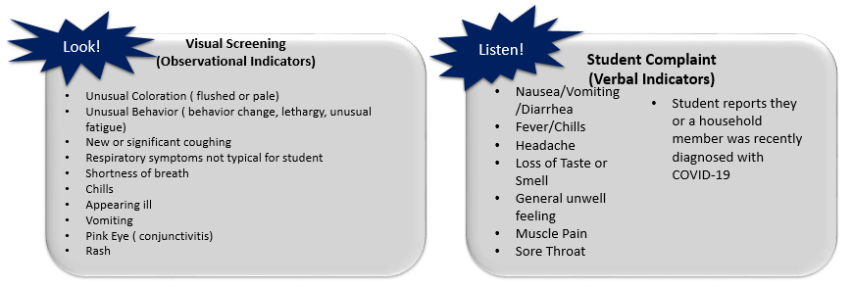
School staff can screen effectively both by visual and auditory means.

Guidance For Teachers
IF | THEN
Student has an observational indicator of illness | Send to designated space for full screening
Student provider verbal indicator of illness | Send to designated space for full screening
Student reports close contact with confirmed case of COVID-19 | Send to designated space pending follow up.

Guidance For COSIE STAFF
IF | THEN
Student screens positive for excludable symptoms [See Appendix E] | - Log into surveillance form  - Ensure isolation until parents arrive  - Exclude per exclusion guidelines
Student reports close contact with confirmed case of COVID-19 | - Identify source of contact  - Confirm contact with parent  - As needed, contact RN

Isolation
Students found positive for excludable symptoms upon full screening by COSIE staff will be observed in the isolation space until parents are able to pick up.
Surveillance and Tracking
Surveillance in the school setting includes monitoring students and staff who present with or report illness compatible with COVID-19, diagnosis with COVID-19 or close contact with a confirmed or presumptive case of COVID-19.
Surveillance is accomplished by tracking students and staff excluded for communicable disease compatible symptoms and by case and contact tracking.
2021-2022 Communicable Disease Surveillance Log
  - Guidance for Attendance Secretaries and COSIE Staff
IF | THEN
Student or staff calls into school with reports of major symptoms of COVID-19 | - Record in Communicable Disease Surveillance Log  - Identify date of onset  - Identify last date at school
Student or staff develops major symptoms of COVID-19 at School | - Record in Communicable Disease Surveillance Log  - Follow Exclusion Guidelines
Student reports diagnosis of COVID-19 | - Refer to RN  - Identify date of onset and date of lab  - Identify last date at school  - Record in Communicable Disease Surveillance Log  - Follow Exclusion/Isolation Guidelines
Student reports close contact with a case of COVID-19 | - Refer to RN  - Record in Communicable Disease Surveillance Log  - Identify last date of contact  - Identify any symptoms present  - Follow Quarantine Guidelines

Logs
Logs for illness surveillance and case and contact investigation, isolation, quarantine, and exclusion are important tools to aid nursing staff and administration in contact tracing, communication and surveying the incidence and change in illness trends in the school setting.
Health Room Log
As per OAR 166-400-0010 any student reporting to the health room will be logged into the student Health Room Log.

Audience: Secretarial Staff, Designated Staff
Health Room Log

COVID-19 Specific Surveillance Logs
COVID-19 Surveillance Logs will be maintained for students who:
- Are absent due to confirmed COVID-19.
- Have any symptoms of COVID-19 and have been in contact with a confirmed case.
- Have compatible illness or symptoms associated with COVID-19.
- Have been dismissed to home for symptoms associated with COVID-19.

Audience: COSIE Staff, Attendance Secretary, Designated Staff, Nursing Staff

HYPERLINK "https://docs.google.com/forms/d/14K_1w04yXFULLcAsXQThkvD-5MBTzILVRAKEe4JYFzs/edit" 2021-2022 COVID-19 Communicable Disease Surveillance Log

Case and Contact Logs
Case and Contact Logs s used by designated staff, primarily nurses and administrators for case and contact investigation.

Audience: Nursing Staff, Administrative Staff
2021-2022 MRSD Case and Contact Logs

Cohort tracking logs
Cohort Tracking Logs are those kept as a matter of standard practice to identify contact in the school setting. The primary reservoir of cohort tracking will be kept in Synergy for assigned classes and cohorts.

Note: Cohort tracking should be done in an electronic format in order to avoid laborious data entry during the process of an exposure. Group facilitators are responsible to track their group attendance. If groups are not assigned in Synergy, it is preferred that a routine tracking form is used for small group tracking that can easily export necessary data for contact tracing if needed.
Small Group Cohort Tracking

Cohort Tracking has multiple responsible parties in order to be done effectively. The following table outlines additional logs and responsible parties.
Tracking Area | Process | Responsible Parties
Visitors, Volunteers, Vendors and 3rd Parties, Itinerant staff. | All visitors, volunteers, 3rd parties and individuals not regularly assigned to a building must sign in upon entry. Visitors, Volunteers, and 3rd parties will be limited.  Sign in may be done using designated Chromebooks at the main office of each school.  Itinerant staff may also use QR codes (below) and posted at schools to access school specific sign in form. | Administration, Secretaries
Small Groups | Small Group Leaders/Educators must identify a means of tracking their small groups in an electronic format accessible to nurses and administration if their cohort is not assigned in Synergy and it includes students from 2 or more cohorts.  Small group cohort tracking must include staff and students. | Group Leaders/Administrators
Athletics/Clubs | Athletics and clubs must designate a means of tracking attendance in school sponsored activities in an electronic format that is transferrable to school nurses and administration upon contact that has students first and last name and one other identifier such as grade or date of birth. And include contact information.  School sponsored activity logs must also include names of adults present at activities with first and last name and contact information. | Athletic Director, Coaches, Club Leaders, Administrators.
Bus Routes | Identifiable bus routes are maintained by the Transportation and in Synergy and are electronically accessible via Synergy. Logs will be verified with Transportation. | Transportation

Individual School Staff Sign In Logs
Clarkes Elementary | Molalla Elementary | Molalla High School
Molalla River Middle School | Mulino Elementary | Rural Dell Elementary
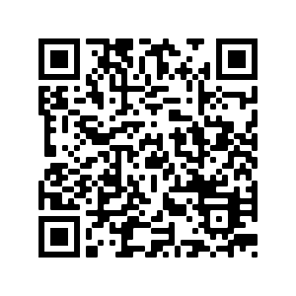 | 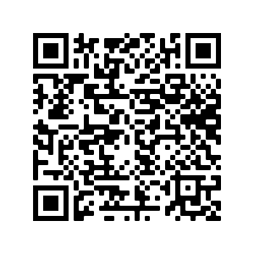
MRSD District Office | Molalla River Academy | Renaissance Public Academy

Close contacts identified via cohort tracking will be entered in Contact Tracing Logs for transmission to LPHA.

Audience: Nursing Staff
Contact Tracing Log

Outbreak Line List
A line list is an epidemiological tool that characterizes the population and specific clinical information during and outbreak. In the event of an outbreak or cluster Respiratory Outbreak Line Listings will be used for case investigations. This process will occur as outlined in the Communicable Disease Plan (pages. 4-14) and as prompted by the District RN.

Audience: Nursing Staff, Designated Staff

Respiratory Outbreak Line Listing

Positive Cases at School
When a positive case is identified in the school setting, there is a multi-step process with multiple parties involved.
The below chart indicates the communication process that should occur in the event of a COVID-19 case in the school setting, identifying each respective role:
Staff | School Health Services | Administration | Human Resources | District Administration
Refer case to health services or administration upon initial report.  Do not disseminate any information to other staff or students.  Report self-illness or contact to Human Resources | Coordinate and verify information with LPHA  Contact parent to ensure understanding of home isolation for individual and quarantine for household contacts | Coordinate communication and contact tracing with RN.  Coordinate with teachers for continuity of education related to isolation or quarantine. | Provide exclusion orders to staff when required based on exposure.  Coordinate any leave related to COVID-19. | Coordinate Communication when exposure impacts multiple settings.  Work with school level teams when whole cohorts must be quarantined.  Maintain communication to school board related to cases, outbreaks, or clusters of illness or.
Identify applicable cohorts including transportation and school sponsored.

Identify close contacts at school
Communicate to close contacts for quarantine orders in coordination with LPHA.

Communicate to any applicable leadership related to transportation or school sponsored activities where and exposure may have occurred.

Nursing Guidance
Upon receipt of report of positive COVID-19 Case
- Contact parent, ensure understanding of isolation measures and duration.
- Identify any siblings or parents that attend or teach school.
- Provide quarantine exclusion recommendations to household contacts.
- Determine days at school or school sponsored activities during infection time frame (48 hours before symptoms onset or 48 hours before lab if not symptomatic).
- Log Case into 2021-2022 MRSD COVID-19 Case and Contact Log.
Contact Tracing
- In collaboration with admin and designated staff, identify applicable cohorts during infectious time frame.
- Identify close contacts (within 6 feet for 15 minutes or longer) within cohorts in the school setting.
- If 6-foot distancing is not being maintained, entire cohort will have to be quarantined.
- Export applicable cohort rosters from Synergy (Appendix D), Transportation, Small Groups, Staff logs, etc.
- Compile close contact information in Contact Tracing Log.
*Note to use log, select “Make a Copy”, and save to the School Health Services Drive.
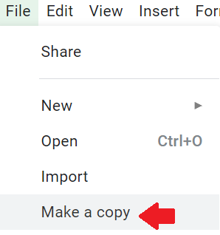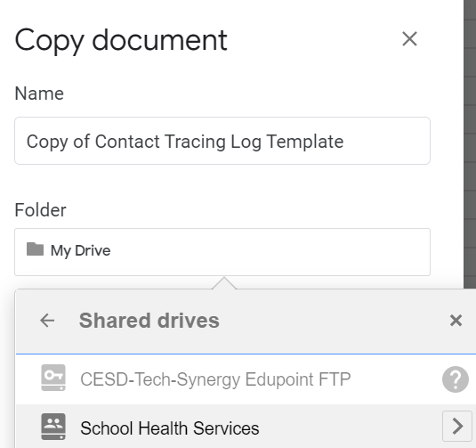

- Save all contact data under designated school file in the Shared Drive:
School Health Services>Population Health> Communicable Disease> COVID-19>Contact Tracing.
- To avoid duplication of data entry effort the spreadsheet can be uploaded to the 2021-2022 MRSD COVID-19 Case and Contact Log:
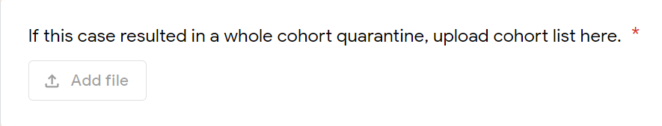
Communication
- Provide report to LPHA and verify positive lab with [Name/DOB/ Date of lab].
- Provide Contact Tracing Logs to LPHA.
- Coordinate with administrative teams to identify appropriate letter to forward to cohorts and individuals affected.
- Coordinate with other key stakeholders as applicable (Transportation, Nutrition, SPED Director, Superintendent).

Communication

Family Communications
- Families will receive reminders of exclusion guidelines and when to keep children home.
- Families will receive regular updates from the district office.
- Families will be notified when their children are impacted by an individual or cohort quarantine order in collaboration with LPHA.

Staff Communication
- Staff will receive reminders of exclusion guidelines and when to keep children home.
- Staff will receive regular communications and updates from building administration, human resources, and district when changes in guidelines or measures occur.
- Staff will be notified when impacted by a COVID-19 isolation or quarantine.
- Staff will be notified when education accommodations need to be made for students with extended at home periods.

LPHA Communication
- As per case and contact processes previously outlined, LPHA will be contacted when the district is informed of a positive case of COVID-19.
- The district will provide case contact logs as required for the purposes of contact tracing related to school exposures.
- The district will maintain contact with LPHA for case investigations and outbreak measures to coordinate response and communication.

Testing
Testing for COVID-19 will be done in the school setting relative to current rapid testing guidelines and requirements. Testing will occur only under the specified circumstances identified in the state testing manual when appropriate parent authorization is provided. Staff will have access to appropriate PPE and students, or staff being tested, will be provided appropriate patient privacy.
- MRSD is registered as a testing site.
- COVID-19 Testing in Oregon’s K-12 Schools outlines the requirements for training and testing.
- Nurses will oversee process, return of positive results and report to LPHA.
- Nurses and COSIE staff will participate in BinaNow™ COVID-19 AG Card and Navica ™Training,

Vaccination
Vaccination is one of the best methods of stopping the pandemic and returning society to a typical pattern of Function (Oregon Health Authority, 2021).
Vaccines are not typically offered in the school setting and will not be administered by school staff. Molalla River School District has hosted multiple vaccination clinics in order to provide access to the community, specifically in the early phases of vaccine distribution, and will continue to partner with Clackamas County when needed.
As vaccination status does impact quarantine, proof of vaccination may be required in the event of an exposure in the school setting to remove quarantine restrictions.
Appendix A: Masks

Use of Face Coverings in the general population will be driven by current guidelines and orders based on current epidemiological trends in the community.
When face coverings are used:
- Cloth face coverings must be laundered regularly.
- Face coverings cannot be shared.
- New disposable face covering must be used daily.
- Single use PPE will not be re-used.
- Face shields that are reusable will be designated to individual staff.
- Plastic face shields will be wiped down regularly.

Students requiring breaks from masks must have a designated space to remove masks and take breaks that respects distancing and ventilation requirements. Breaks will also respect student dignity and developmental level.
- Designated spaces may be provided for students who require sensory breaks from masks, which will not exceed 5 minutes.
- Full class mask breaks are prohibited when masks are required.
Children who experience a condition or disability that precludes them from safely wearing a face covering will be addressed on an individual basis in collaboration with family, IEP team, physician, district RN and administration
When masks are optional, no discrimination should be directed toward students or staff for their decision to wear or not wear a mask.
Personal Protective Equipment (PPE) is specialized clothing or equipment used by staff in an occupational setting to reduce the risk of infection transmission or risk of chemical exposure. The district Exposure Control Plan will be consulted for necessary and appropriate use of PPE. For the purposes of COVID-19 response, where cloth facial coverings are used in unprecedented frequency, it will be clarified that face coverings are not synonymous with masks. Face coverings may include masks, cloth covers, or shields.
Video Resources
Donning PPE (CDC)
Doffing PPE (CDC)
Handwashing (CDC)

Appendix B: Distancing
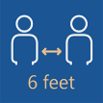
Physical or spatial distancing is the intentional physical distance placed between individuals to limit the likelihood of respiratory droplets reaching other individuals. While staying at home and avoiding groups of people are important measures in achieving this, as schools reopen, spatial measures must be taken to ensure physical distance between individuals. Generally speaking, this is 6 feet between individuals, since respiratory droplets often spread between 3 and 6 feet (CDC, 2020). Evidence suggests that spacing as close as 3 feet may approach the benefits of 6 feet of space, particularly if students are “wearing face coverings and are asymptomatic” (AAP, 2020a) [Image: OHA]

Although 3 feet is becoming increasing acceptable as a safe distance in low-risk activities, 6 feet remains best practice under the following circumstances:
- Between members of staff and other staff and between staff and students.
- Whenever PPE is not being worn (mask breaks, eating).
- Activities with exhalation such as singing, shouting, band, sports, or physical activity.
- Between members of different cohorts.
- Among all individuals when there has been a known exposure.

Other considerations related to distancing include:
- Room capacity
- Room layout
- Physical barriers
- Scheduling
- Activities
- Location (indoor vs. outdoor)

Appendix C: Cohorting
Cohorts help manage risks in the potential spread of COVID-19. In particular, the size of the cohort matters for risk management. Student cohorting:
- limits the number of exposed people when a COVID-19 case is identified in the school.
- quickly identifies exposed individuals when a COVID-19 case is identified.
- minimizes school-wide disruptions in student learning.
Student cohorting not only helps to quickly identify exposed people, but it also minimizes disruptions to learning, because only the cohort members would be affected by the exposure. Maintaining small, stable cohorts can decrease the risk of closure to in-person instruction. A smaller cohort size of 24-36 is recommended for public health and safety (OHA, 2020).
Cohorts will be established with minimum numbers where feasible, understanding that the fewer encounters and smaller number per cohort lend to reduced transmission of infectious disease. It is important to note that Cohorting may be more important in elementary settings where physical distancing is less likely to be maintained (AAP, 2020a). Cohorting will not be established in the context of ability or disability. Cohorts will be established by grade levels in elementary settings and where feasible in upper grade levels.

Appendix D: Cohort Tracking & Contact Tracing
The purpose of contact tracing is to be able to identify those with the potential exposure risk of a communicable disease. This occurs on a small scale readily throughout the year with specific communicable disease exposures. In regard to COVID-19 schools are required to report data on close contacts to the local health department. The school’s role in contact tracing is cohort tracking. Cohort tracking is described in greater detail on the Oregon School Nurses Association COVID-19 Toolkit webpage.
OAR 333-003-0050 authorizes school districts to release individually identifiable information relative to an Impending Public Health Crisis which includes a declared public health emergency, anyone exposed to a communicable disease, a reportable disease, or a condition of public health importance. COVID-19 response meets all of these categories.
A close contact is regarded as: Someone who was within 6 feet of an infected person for at least 15 minutes starting from 2 days before illness onset (or, for asymptomatic patients, 2 days prior to specimen collection) until the time the patient is isolated (CDC, 2020).

To be able to provide necessary information for the LPHA, each school must plan in advance by:
- Having easily accessible rosters of each stable cohort. This can be accomplished through accurate student rosters of each classroom.
  - If the roster is not prepopulated in Synergy, a roster must be created.
- Having accurate attendance collected to determine who was present during potential exposures.
  - Reinforcing accurate attendance is crucial in provision of accurate information to the LPHA in regard to exposures.
  - This includes logging late arrivals and early departures.
- Having a mechanism for sign-in at the front office and in record of itinerant staff that entered each classroom is necessary to track staff interaction with cohorts. Itinerant tracking forms will be used in each school setting. Itinerant tracking forms will preferably be in a Google Form for confidentiality and electronic feasibility with designated personnel and the RN as an owner.
In relationship to LPHA request and in order to align with ODE/OHA guidance, each individual school must be able to produce:
- A list of students and staff that would have encountered a confirmed case if a member of the education community is diagnosed, this includes:
  - Classroom cohorts
  - Intervention and student support cohorts (SLP groups)
  - Lunchtime and recess cohorts (if these students overlap)
  - Transportation roster
- A list of all staff that encountered confirmed case.
Required information for LPHA includes:
- Student name
- Arrival and departure time
- Parent contact and emergency contact information
- A list of staff who have interacted with the infected student/staff.

Items 1-4 are accessible in Synergy and can be exported to an Excel® spreadsheet for transmission to the LPHA for the purposes of contact tracing. A report in Synergy titled Contact Tracing has been developed for this purpose.
In Synergy enter “Contact Tracing” under “Quick Launch “

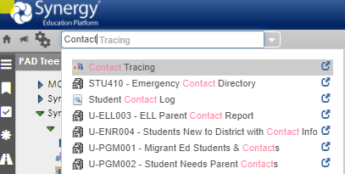
After entering “Contact Tracing” into the report finder (Quick Launch) a contact tracing screen will populate (below), designating a search for student or staff.
Enter the student/staff name in the area and the potential exposure dates to assess the contacts. Select the “Trace” button and all cohorts and teachers will populate.
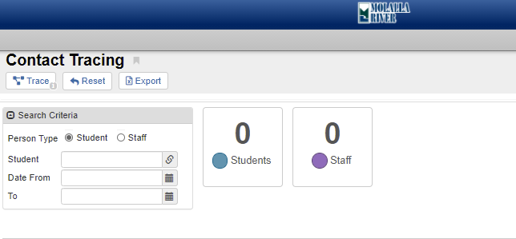

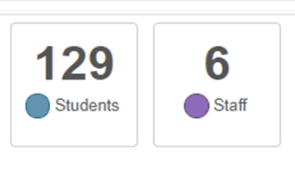

Once the students and staff are populated, they will be itemized in a list below.
Please note these lists are not all inclusive, contact tracing will be deferred to trained staff and performed in conjunction with the District RN to capture all potential cohort lists.

There are additionally some Synergy reports that can produce the required information for the LPHA such as demographics and parent contact. These reports include:
  - STU-001 Student List with Contact
  - U-STU 002 Emergency Contacts
To determine any students who may have not been present in the cohort during a potential exposure, student attendance records can be reviewed to determine which students may be eliminated from the above student lists.

Student Attendance
  - ATD-406 Daily Student List by Attendance
If an ill student visited the health room prior to isolation or exclusion health room logs will be reviewed to potential contacts.
A designated staff member will coordinate and ensure rosters and sign-ins are regularly used and maintained.
The building administrator must reinforce the need for accurate attendance to reflect accurate arrival and departure times in student logs.

Appendix E: Screening
- Families are advised to screen at home. Students positive for excludable symptoms should not report to school.
- Students will be passively screened in the school setting.
- Students positive for one visual or verbal indicator (below) will be referred to the COSIE space for a Full Screening.
- Building specific procedures should be followed to get student from screening point to COSIE space.
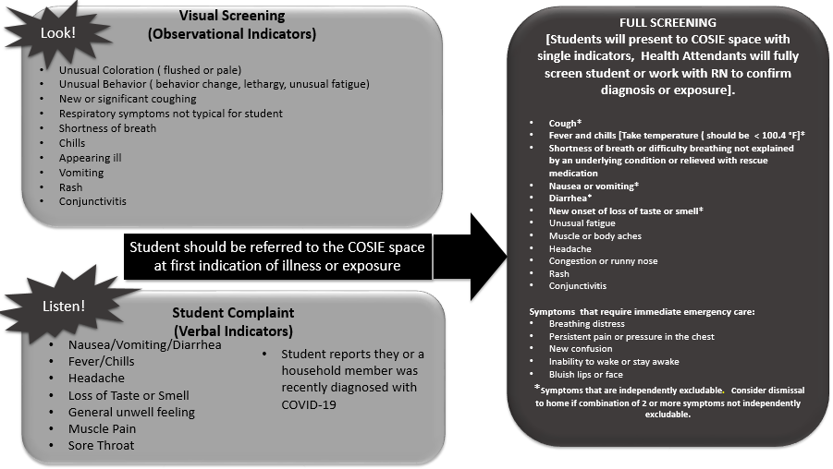
- Students identified as having any excludable symptom must be excluded for the timeline indicated by the Oregon Health Authority.
- Students will be appropriately logged in to COVID-19 Surveillance Logs.
- Isolation and dismissal process must be observed for students positive for excludable illness or close contact.

Appendix F: COSIE Procedures & Isolation Measures

COSIE Room procedures are categorized into two broad categories:
- Case/Case Contact
- Symptomatic Cases
Case/Case Contact
IF A STUDENT REPORTS THEY ARE A CLOSE CONTACT OF SOMEONE WHO HAS TESTED POSITIVE FOR COVID-19:
- Education staff will use building specific process to refer student to COSIE space.
- COSIE staff will inquire with student to identify the possible case.
- Depending on the student age and context of report, COSIE Staff will contact parents to inquire on report.
- COSIE Staff will report the name and additional information of the case to the RN to confirm report with the local public health authority.
  - The RN will contact the LPHA Communicable Disease Department to confirm lab *Note there is a delay in report confirmation when the volume is high.
  - The LPHA may not be able to confirm report if two identifiers (i.e., Name and Date of Birth) are not available for the reported case.
- If the family confirms the student is a case contact, student should be dismissed to home. Advise that close contacts must remain home for 14 days from last exposure to ill contact.
- If the LPHA confirms the student is a case contact, student should be dismissed to home. Advise that close contacts must remain home for 14 days from last exposure to ill contact.
- Prior to dismissal, screen student for all symptoms of COVID-19 to determine potential exposures of a presumptive case in the school setting.
- If neither the LPHA nor the family can confirm contact to a confirmed case, and no further investigation is advised from the RN, then the student should be returned to class if they are asymptomatic.
- If the student is symptomatic, exclude per exclusion guidelines.
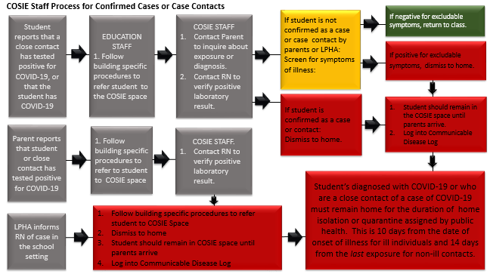
- Provide education as applicable.
IF A STUDENT REPORTS THEY HAVE TESTED POSITIVE FOR COVID-19
  - Education staff will follow building specific procedures to refer student to COSIE space.
  - COSIE staff will contact the family to inquire on report of diagnosis.
  - COSIE staff should make report to RN/ Clinical Consultant to confirm case with LPHA.
  - If the family/LPHA confirms the student is identified as a confirmed case of COVID-19: Determine date of test and onset of symptoms.
IF… | THEN…
Date of test was more than 10 days ago, AND student is not symptomatic | Contact Clinical Consultant, student may remain at school, as they are beyond their isolation timeframe.
Date of test was less than 10 days ago | Student must be dismissed to home until 10 days has passed from the date of onset of symptoms.

  - Refer onset date and date of test to Clinical Consultant for follow up and Communication.
  - If LPHA and parent deny diagnosis of COVID-19, screen student for symptoms.
  - If student is positive for excludable symptoms, dismiss to home and isolate while awaiting parent pick up.
  - If student is negative for (diagnosis and) symptoms, return to class.
IF THE LPHA INFORMS RN OF CONFIRMED CASE
- RN informs building staff to isolate student and contact parent.
- Student is dismissed to home.
- Clinical Consultant will coordinate follow up and communication with administration as needed.
Students diagnosed with COVID-19 or who are a close contact of a case of COVID-19 must remain home for the duration of home isolation or quarantine assigned by public health. This is 10 days from the date of onset of illness for ill individuals and 14 days from the last exposure for non-ill contacts.

Symptomatic Students
If a student is positive for visual or verbal screening indicator on bus, at entry point or during the day:
- Education staff will use building specific process to refer student to COSIE space.
- COSIE space staff performs full screening of ill student.
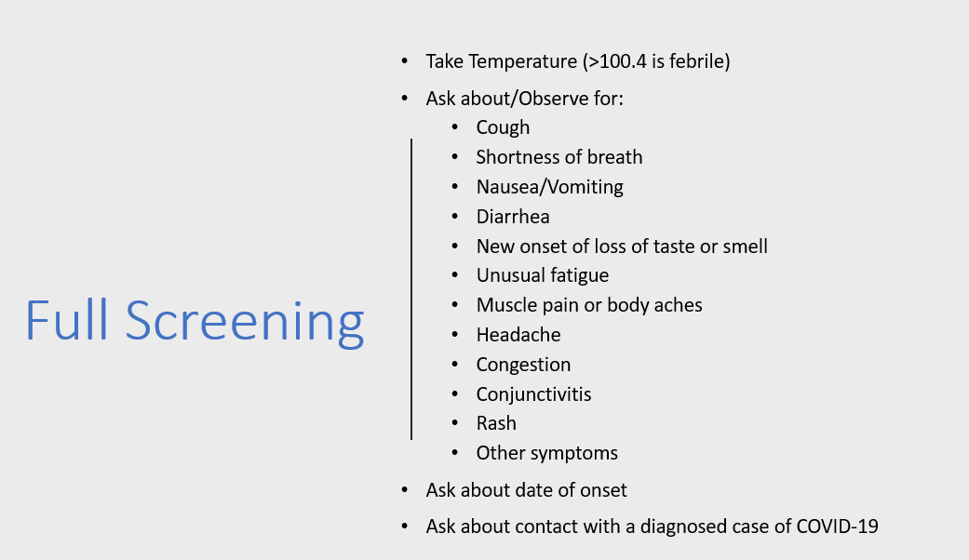

- Identify if student has underlying health condition that may explain symptoms (i.e., asthma and shortness of breath/cough).
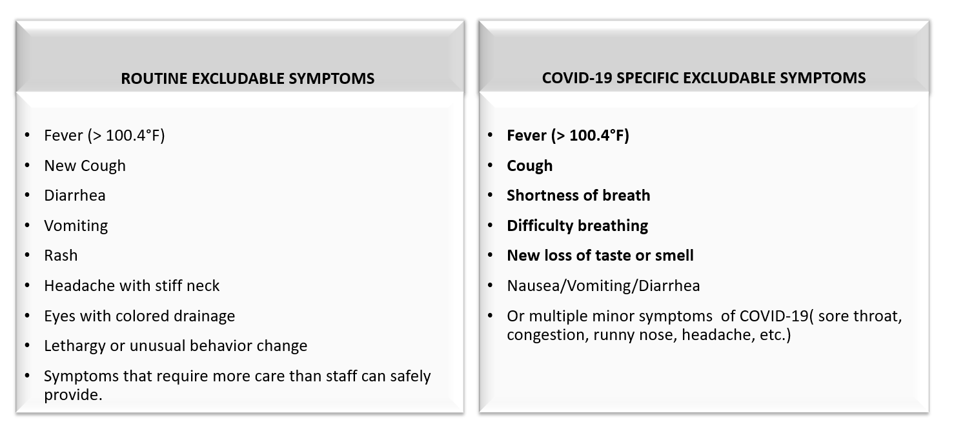
  - Follow student’s Individual Health Plan/Asthma Action Plan to determine if symptoms resolve.
- If student has excludable symptoms:
  - Call parents to dismiss student to home.
  - Ensure student remains in COSIE space while awaiting parent pick up.
  - Advise parents that:
    - Students/staff who do not have major symptoms of COVID-19 (bold); are negative for COVID-19; and are not a close contact of a confirmed case may return when free of vomiting and diarrhea for 48 hours and free of fever for 24 hours without the use of fever reducing medications.
    - Students/staff who are positive for COVID-19 or who were not tested and have major symptoms of COVID (bold) or who are close contacts with confirmed cases must remain home 10 days AND be free of vomiting and diarrhea for 48 hours and free of fever for 24 hours without the use of fever reducing medications to return.
  - Log student information into communicable disease log
  - Provide parent post-screening document to parents.

- If student is negative for excludable symptoms of illness, they may return to class.

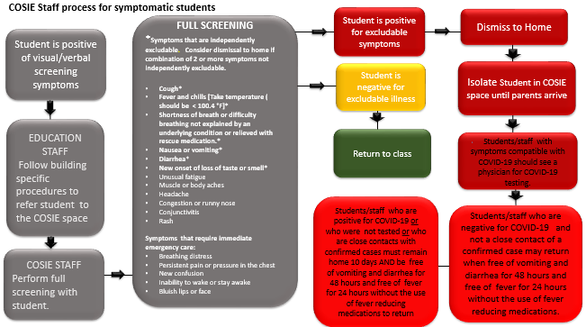
Students Exhibiting Signs and Symptoms of Complications of COVID-19
Students exhibiting signs and symptoms of COVID-19 complications such as systemic inflammation should be dismissed to home and advised to seek medical attention.
Students who present to the COSIE space in distress should be deferred to EMS (9-1-1)
Symptoms of MIS-C:
- Fever
- Abdominal pain
- Vomiting
- Diarrhea
- Neck pain
- Rash
- Bloodshot eyes
- Feeling extra tired
Be aware that not all children will have all the same symptoms.
Seek emergency care right away if the child is showing any of these emergency warning signs of MIS-C or other concerning signs:
- Trouble breathing
- Pain or pressure in the chest that does not go away
- New confusion
- Inability to wake or stay awake
- Bluish lips or face
- Severe abdominal pain (CDC, 2020)

References
- Centers for Disease Control and Prevention. (2021). Centers for Disease Control and Prevention: Guidance for COVID-19 Prevention in K-12 Schools. https://www.cdc.gov/coronavirus/2019-ncov/community/schools-childcare/k-12-guidance.html
- American Academy of Pediatrics. (2021). Recommendations for Opening School in Fall 2021. https://services.aap.org/en/news-room/news-releases/aap/2021/american-academy-of-pediatrics-updates-recommendations-for-opening-schools-in-fall-2021/
- Oregon Department of Education. (2021). Ready School, Safe Learners Resiliency Framework for the 2021-2022 School Year. https://www.oregon.gov/ode/students-and-family/healthsafety/Documents/Ready%20Schools%20Safe%20Learners%20Resiliency%20Framework%20for%20the%202021-22%20School%20Year.pdf
- Oregon Health Authority. (2021). Oregon Health Authority: Novel Coronavirus 2019 (COVID-19) Investigative Guidelines. https://www.oregon.gov/oha/PH/DISEASESCONDITIONS/COMMUNICABLEDISEASE/REPORTINGCOMMUNICABLEDISEASE/REPORTINGGUIDELINES/Documents/Novel-Coronavirus-2019.pdf
- National Association of School Nurses. (2021). 2020-2021 School Year Suggested School Nursing Practice Activities. https://cdn.fs.pathlms.com/TKKYjwl5SlmLFbcno4jJ?cache=true&_ga=2.38361569.359562262.1627492886-511249223.1627492886
- Oregon School Nurses Association. (2021). COVID-19 Toolkit. https://www.oregonschoolnurses.org/resources/covid-19-toolkit
- Oregon Department of Education and Oregon Health Authority (2020). Communicable Disease Guidance for Schools. https://www.oregon.gov/ode/students-and-family/healthsafety/Documents/commdisease.pdf
- Oregon Department of Education. (2021). Planning for COVID-19 Scenarios in Schools. https://www.oregon.gov/ode/students-and-family/healthsafety/Documents/Planning%20and%20Responding%20to%20COVID-19%20Scenarios%20in%20Schools.pdf
- Centers for Disease Control and Prevention. (2021). Operational Strategy for K-12 Schools through Phased Prevention. https://www.cdc.gov/coronavirus/2019-ncov/community/schools-childcare/operation-strategy.html
- Oregon Health Authority (2021). COVID-19 Testing in Oregon’s K-12 Schools. https://sharedsystems.dhsoha.state.or.us/DHSForms/Served/le3560.pdf

