COMMUNICABLE DISEASE MANAGEMENT PLAN

Introduction
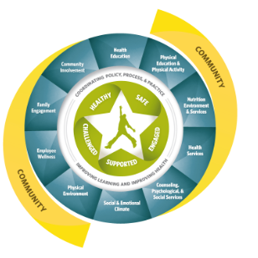
Students and staff health and safety is a priority of the Molalla River School District. One area of health and wellness in the school setting includes controlling communicable diseases. Providing a safe, comfortable, and healthy environment facilitates the educational process, encourages social development, and allows children to acquire healthy attitudes toward school (NRC, 2020).
Illness and injury are not uncommon in the school setting, and thus, policies, procedures, and guidance in regard to infection control are of the utmost importance. When children are injured or feel unwell, it can create difficulties in the school setting in regard to both risk to others and the ability of a child to participate in class or educational activities fully. Like the Whole School, Whole Community, Whole Child model, staff collaborate for the best outcomes of the student population and individuals. In this regard, staff must be prepared to have accessible resources and materials to identify appropriate measures and interventions for child health issue including communicable diseases (ACSD, 2020)
Associated plans include:
- Exposure Control Plan
- Pandemic Plan
- COVID-19 Specific Mitigation Measures & Procedures

COMMUNICABLE DISEASE MANAGEMENT PLAN

Communicable disease control and prevention is of significant importance in creating a safe and healthy environment for students and staff. A communicable disease is an infectious disease transmissible by contact with infected individuals or their bodily discharges or fluids, by contact with contaminated surfaces or objects, by ingestion of contaminated food or water, or by direct or indirect contact with disease vectors. Although the terms infectious disease, communicable disease and contagious disease are often used interchangeably, it is important to note that not all infectious diseases that are spread by contact with disease vectors are considered to be "contagious" diseases since they cannot be spread from direct contact with another person (ACPHD, 2013).
In the school setting, there is a prevention-oriented approach for communicable disease, which is grounded in education, role modeling, and standard precautions and hygiene. However, the nature of a population-based setting lends to the need to establish practices for measures and interventions associated with exposures or potential exposure. This management plan focuses on a population-based set of prevention practices for communicable disease in the school setting.

Molalla River School District Board Policies
- Communicable Diseases JHC
- Communicable Diseases JHCC/GBEB-AR
- Student Health Services JHC
- Animals in District Facilities ING
- Emergency Procedures and Disaster Plan EBC/EBCA
- Food Preparation EFD

Oregon Legislation
- OAR 581-022-2220 Standards for Public Elementary and Secondary Schools: Health Services
- OAR 581-022-2225 Emergency Plan and Safety Programs
- OAR 166-400-0010 Educational Service Districts, School Districts, And Individual School Records
- ORS 433.255¹ Persons with or exposed to restrictable disease excluded from school or children’s facility.
- ORS 336.201¹ Nursing services provided by district.
- OAR 437-001-0744 Oregon Occupational Safety and Health Division
- OAR 333-019-0015 Investigation and Control of Diseases: General Powers and Responsibilities
- OAR 333-003-0050 Impending Public Health Crisis: Access to Individually Identifiable Health
Oregon Health Authority & Oregon Department of Education
Oregon Communicable Disease Guidelines for School

Communicable Disease Prevention
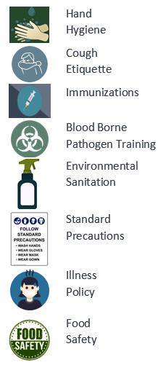
There are a variety of Common Childhood Infectious Diseases that are regularly encountered in the school setting. Routine childhood respiratory illnesses such as the common cold (adenoviruses, coronaviruses, rhinoviruses) or conditions such as bronchitis, sinusitis, and tonsillitis caused by a variety of bacteria and viruses occur throughout the year. Other conditions such as gastroenteritis (norovirus, most frequently) and croup (most commonly parainfluenza) and influenza (A & B) most often occur seasonally. Other common communicable conditions include strep throat, hand-foot, and mouth disease, fifths disease, and staph skin infections. More severe infectious diseases occur with less predictable trends (COVID-19) and profoundly severe conditions (meningococcal) are rare occurrences (BCDC, 2009).
There are a multitude of methods that can be applied to control communicable diseases at each level of prevention.

- Primary Prevention: Measures to prevent disease
- Secondary Prevention: Early Identification and measures to prevent spread.
- Tertiary Prevention: Measures to prevent complications.
Fully endorsing the control and prevention of communicable diseases requires a level of understanding of how communicable diseases can be spread.
How these communicable diseases are spread depends on the specific infectious agent. Common ways in which communicable diseases spread include:
- Physical contact with an infected person, such as through touch (staphylococcus), sexual intercourse (gonorrhea, HIV), fecal/oral transmission (hepatitis A), or droplets (influenza, TB)
- Contact with a contaminated surface or object (Norovirus), food (salmonella, E. coli), blood (HIV, hepatitis B, hepatitis C), or water (cholera, listeria).
- Bites from insects or animals capable of transmitting the disease (mosquito: malaria and yellow fever; flea: plague); and
- Travel through the air (measles).

In the school setting, the most frequent risks are associated with direct contact with ill individuals, contamination of surfaces or through airborne transmission. Primary sources of prevention-oriented measures include hand and surface hygiene, isolation, exclusion, and standard precautions.
The district Exposure Control Plan discusses Standard Precautions in detail as well as Transmission Based Precautions, which include contact, droplet, and airborne precautions. The District Pandemic Plan provides a framework for Novel Virus Response Planning. The COVID-19 Specific Mitigation Measures and Procedures.

Prevention Oriented Measures
Prevention oriented measures are those which seek to prevent transmission of communicable diseases based on routine practices associated with sanitation and hygiene. Prevention also incudes important steps such as vaccination and health promotion.
Primary Prevention | Secondary Prevention | Tertiary Prevention
- Clean & Healthy Environments  - Vaccination  - Hand Hygiene  - Respiratory Etiquette | - Staying home when ill  - Isolation  - Exclusion | - Preventing complications  - Outbreak Response  - Pandemic Response

PRIMARY PREVENTION

Clean & Healthy Environments
Clean schools contribute to healthy environments and minimize the risk of communicable disease transmission. Some of the important concepts associated with a reduction in illness include scheduling routine cleaning of each classroom and common areas, ensuring appropriate stock of appropriate sanitizers and disinfectants, ensuring garbage is emptied regularly, ensuring working ventilation and clean filtration, and ensuring any classrooms with pets have a cleaning plan in place to minimize odors or contamination. While environmental cleaning is primarily governed by facilities management and custodial services, there are specific classroom measures that can be practiced improving cleanliness and reduce the risk of illness transmission during peak illness such as increasing access to sanitizing wipes, tissue and hand sanitizer, disposal of tissues in appropriate receptacles and immediate notification of body fluid spills ( such as vomit).

Vaccination
In the school setting, vaccines are an important piece of communicable disease control. Vaccines are a requirement for attending school in Oregon. However, it is important to remark that certain populations may not be vaccinated because of medical contraindications or because of religious or philosophical decisions. Each school has a record of which students are and are not vaccinated with routine childhood immunizations as a primary control measure for outbreaks of vaccine-preventable diseases. Vaccine process is covered in detail in the Molalla River School District School Health Services Manual. Vaccine Preventable Diseases are covered under Notifiable Diseases in this plan.

Respiratory Etiquette
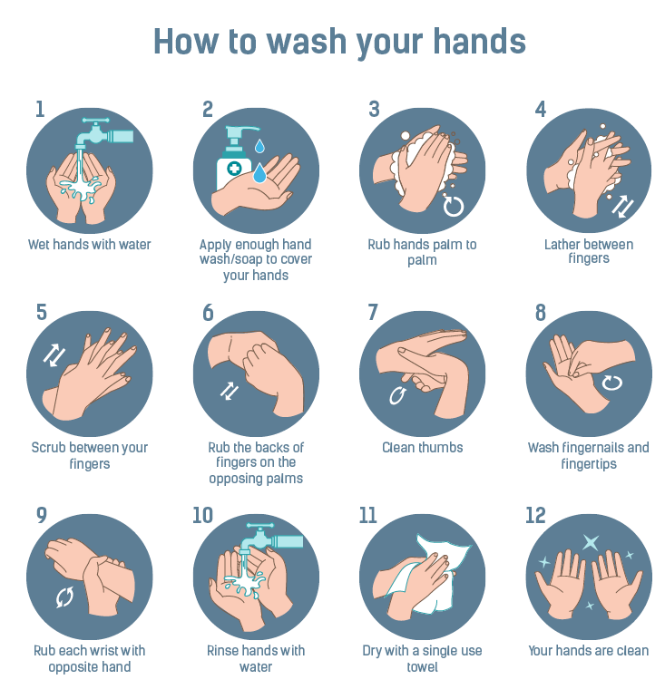
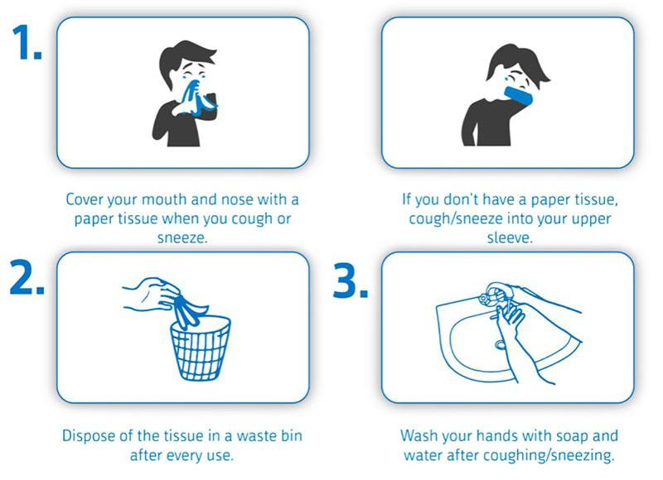
Respiratory hygiene and cough etiquette are terms used to describe infection prevention measures to decrease the transmission of respiratory illness (e.g., influenza and cold viruses). A respiratory infection is spread when a person who is infected with a virus coughs or sneezes. The droplets released from an ill person’s cough or sneeze can travel for several feet, reaching the nose or mouth of others and causing illness. Viruses can spread easily from person to person through direct contact via touching or shaking hands. Droplets can also live for a short time on a variety of objects such as high touch areas like doorknobs or desks. Because some individuals cough without having respiratory infections (e.g., persons with chronic obstructive lung disease), we do not always know who is infectious and who is not. Therefore, respiratory hygiene and cough etiquette are essential components to protecting yourself from illness and preventing others from becoming ill. Like hand hygiene, respiratory hygiene is part of the standard precautions that will be taught, practiced, and role-modeled to prevent the spread of disease. Practices and interventions are described under Respiratory Hygiene and Cough Etiquette and Transmission Based Measure in Exposure Controls Plan

Hand Hygiene
Hygiene and sanitation are some of the most important methods of disease prevention. Handwashing is one of the single most important methods of keeping germs at bay, specifically in the school setting. Appropriate handwashing practices will be taught, role-modeled, and practiced.
Hand sanitizer, while not effective against a large number of pathogens, will be made available for times that handwashing is not immediately accessible. Hand sanitizer will be easily accessible throughout the building, specifically in high contact areas and at entrances and exits as feasible. Hand sanitizers will be accessible in each classroom.
Students and staff will wash their hands when:
- Before, during, and after preparing food.
- Before eating food
- Before and after caring for someone at home who is sick with vomiting or diarrhea
- Before and after treating a cut or wound
- After using the toilet
- After changing diapers or cleaning up a child who has used the toilet
- After blowing your nose, coughing, or sneezing
- After touching an animal, animal feed, or animal waste
- After handling pet food or pet treats
- After touching garbage
(CDC, 2020)

Health Promotion
Prevention oriented measures are grounded in education of how diseases are transmitted, as well as practice application and role modeling related to appropriate measures and precautions.
- Age-appropriate hand hygiene curriculum can be found from a variety of resources and will be provided annually in the fall and as needed during peak illness season or specific increases of disease in the school setting.
- Cleanliness, germ transmission, and cough etiquette will be taught as age appropriate and signage will be endorsed during peak illness seasons.
- Reminders will be provided to families about keeping children home when ill and reinforcing health and safety measures as a matter of practice.
- Vaccination reminders will be provided each year to students and families and partnerships with public health will be endorsed to host vaccines clinics within the district. Vaccines will be promoted on behalf of the school district.
- Endorsing and following illness policies
- Provision of food safety and hygiene measures with mealtimes
- Provision of hygiene and safety information around recess and physical education
- Coordination with counseling services to minimize fear when illness is present in the school setting
- Communication to families of medically fragile children when illness is present in the school setting
- Health promotion for staff including education, reinforcement of guidelines and recognition of illness
- Community involvement in health and safety

SECONDARY PREVENTION
Secondary prevention measures are those used to detect and minimize effects of illness related to early identification. These include:
- Staying home when ill
- Symptom based Isolation and Exclusion
- Specific Disease Exclusion
Communicable diseases are transmitted from person to person by various routes. While some conditions are restrictable based on diagnosis, more often early identification of signs and symptoms of communicable disease is of paramount importance to increase the health of the school population and decrease school absenteeism. In the school environment, many communicable diseases are easily transmitted from one individual to another.

Staying Home When Ill
An important element of prevention is the policy and practice of staying home when ill with symptom or conditions that are excludable. Annual reminders to students and staff regarding when to stay home is an important element of prevention. As well, additional communication can be endorsed during peak illness seasons.

Symptom Based Exclusion
Oregon public health law mandates that persons who work in or attend school who are diagnosed with certain diseases or conditions be excluded from school until no longer contagious. However, diagnosis often presumes a physician visit and specific testing, and schools must often make decisions regarding exclusion based on non-diagnostic but readily identifiable signs or symptoms. The Oregon Department of Education Communicable Disease Guidance Document details both symptom based and disease specific exclusion guidelines. The following exclusion criteria and actions are extracted from the ODE Guidance Document to abbreviate symptom-based exclusion:
EXCLUSION CRITERIA | EXCLUSION ACTION
Primary Symptoms of COVID-19  - Cough  - Temperature of 100.4oF or higher  - Chills  - Shortness of breath  - Difficulty breathing  - New loss of taste or smell | Exclude student for 10-day isolation. Refer to testing.  Defer to COVID-19 Scenarios in Schools.
Fever: a measured oral temperature of 100.4°F, with or without the symptoms below | Stay home until fever is below 100.4°F for 24 hours WITHOUT the use of fever-reducing medication such as ibuprofen (Advil), acetaminophen (Tylenol), aspirin and per COVID-19 guidance.
Skin rash or sores: ANY new rash if not previously diagnosed by a health care provider OR if the rash is increasing in size OR if new sores or wounds are developing day-to-day OR if rash, sores or wounds are draining and cannot be completely covered with a bandage | Stay home until the rash is resolved OR until sores and wounds are dry or can be completed covered with a bandage OR until diagnosis and clearance are provided by a licensed healthcare provider
Difficulty breathing or shortness of breath not explained by a situation such as exercise: feeling unable to catch their breath, gasping for air, breathing too fast or too shallowly, breathing with extra effort such as using muscles of the stomach, chest, or neck. | Seek medical attention; return to school when advised by a licensed healthcare provider, may return after 24 hours and per COVID-19 guidance.
Concerning cough: persistent cough that is not yet diagnosed and cleared by a licensed healthcare provider OR any acute (non-chronic) cough illness OR cough that is frequent or severe enough to interfere with active participation in usual school activities. | Stay home until 24 hours after cough resolves. b) If pertussis (“whooping cough”) is diagnosed by a licensed healthcare provider, student must be excluded from school until completion of a 5-day course of prescribed antibiotics or until cleared for return by the local public health authority. If COVID-19 is diagnosed, exclude until cleared for return by the local public health authority.
Diarrhea: three or more watery or loose stools in 24 hours OR sudden onset of loose stools OR student unable to control bowel function when previously able to do so | Stay home until 48 hours after diarrhea resolves
Vomiting: at least 1 episode that is unexplained | Stay home until 48 hours after last episode
Headache with a stiff neck and fever | Referral to physician and/or 24 hours after fever has resolved.
Jaundice: yellowing of the eyes or skin (new or uncharacteristic) | Must be seen by a licensed prescriber and cleared before return to school
Concerning eye symptoms: colored drainage from the eyes OR unexplained redness of one or both eyes OR eye irritation accompanied by vision changes OR symptoms such as eye irritation, pain, redness, swelling or excessive tear production that prevent active participation in usual school activities | Students with eye symptoms who have been seen and cleared by a licensed prescriber may remain in school after indicated therapy has been started
Behavior changes unexplained uncharacteristic irritability, lethargy, decreased alertness, or increased confusion OR any unexplained behavior change accompanied by recent head injury not yet assessed and cleared by a licensed healthcare provider. | Refer to healthcare provider.  Student will not be at school until health and safety are addressed
Major health event: may include an illness lasting more than two weeks; a surgical procedure with the potential to affect vital signs or active participation in school activities; or a new or changed health condition for which school staff is not adequately informed, trained, or licensed to provide care | Student will not be at school until health and safety are addressed.  School staff will follow the appropriate process to address reasonable accommodations and school health service provision in accordance with applicable federal and state laws
Student requiring more care than school staff can safely provide | School staff will follow appropriate process to address reasonable accommodations and school health service provision in accordance with applicable federal and state laws.

Restrictable Diseases
Restrictable diseases are specific infectious disease diagnoses that require students or staff to remain at home for a specified amount of time to limit transmission. Restriction is typically associated with the communicability or severity of a disease. Restrictable diseases are reportable to the local health department (LHD). The local health department typically notifies school health services of a diagnosis in students or staff. Although there are occasions when the parent will notify the school first and in such cases the RN should notify the LHD.
Students with diagnoses of disease restrictable by the local public health authority (LPHA) under Oregon Administrative Rule (OAR) 333-019-0010 will return to school when documentation is obtained from the local health department (LHD) indicating they are no longer communicable including:
- Diphtheria,
- Measles,
- Salmonella
- Typhi infection,
- Shigellosis,
- Shiga-toxigenic Escherichia coli (STEC) infection,
- Hepatitis A,
- Tuberculosis,
- Pertussis,
- Rubella
- Acute Hepatitis B
- COVID-19
- If a report is made to the school office, administration, or other school staff in regard to any communicable disease diagnosis in students or staff, this will immediately be referred to the district RN immediately.
- This is be regarded as an urgent referral to the RN if the disease is s a restrictable condition.
- The District RN and Administrators will identify the need for communication, surveillance or control measures. The interventions and communication are driven by multiple factors, including the diagnosis, student health status, risk of exposure number of individuals infected, and risk to cohort or specific students.
- School staff receiving reports will not inform any other students, staff, or parents of the report. This is a privacy violation.
Clackamas County Disease Reporting Line: (503) 655-8411

Isolation Spaces
As per OAR 581-022-2220, The school district is required to maintain a prevention-oriented program which included a health care space that is appropriately supervised and adequately equipped for first aid and isolation of ill or injured child from the student body.
When students are identified with restrictable diseases or excludable symptoms, students will be isolated in an appropriate space until they can be dismissed to home. This space should be in close proximity to adult supervision and should be cleaned regularly.

Tertiary Prevention
Tertiary prevention measures are those implemented when a disease has already occurred, in the context of the school setting this may be relative to identification of outbreaks or clusters and specific mitigation measures used to prevent additional morbidity.

Outbreaks & Clusters
Outbreaks are most often defined as compatible diagnoses or syndromes in individuals from 2 or more households in the same time period. Because of the nature of the ongoing congregate setting of school, this definition is insufficient for the purposes of seasonal illness, rather an increase in morbidity or severity will be indicators to report to the district RN for consideration of outbreak reports or control measure implementation. The attention to outbreaks, interventions, and resources are highly dependent on the severity or communicability of the syndrome or pathogen identified. Outbreak response including surveillance, infection control measures, and potentially exclusion are also diagnosing specific and may be indicated when:
- A single significant infectious diagnosis is confirmed in the school setting.
- Clusters of compatible syndromes or diagnoses associated with an infectious condition are identified within the school setting.
- Significant absenteeism is identified to be associated with compatible syndromes.
- Community transmission of an infectious disease is significant in the community and the Local Public Health Authority (LPHA) or the RN has deemed increased surveillance or response to outbreak a necessary measure.
Outbreak investigations will be facilitated through the district RN in collaboration with administration and the local health department with the use of Oregon Health Authority Outbreak Toolkits for Schools.

Gastroenteritis
An outbreak of gastroenteritis is defined as more cases than expected for a given population and time period. For example, two children in a 25- person classroom with vomiting or diarrhea within one week could potentially indicate an outbreak. Because the nature of norovirus (viral gastroenteritis) is common, seasonal, and highly infectious, it is unlikely to result in an outbreak investigation unless the number infected, frequency, or duration is unusual. Because symptoms of bacterial gastroenteritis may start with a similar presentation, it is important to evaluate the severity for the duration of illness. Indicators to report to the district RN include:
- Multiple children with compatible symptoms in 48 hours within the same cohort, but separate
households.
- More than 2 cases of diarrhea with bloody stool in the school setting.
- Sudden onset of vomiting in multiple persons in the same cohort.
- Any unusual combination of gastrointestinal symptoms, severity, duration, or incidence.
Norovirus Outbreak Detection and Management
Indicators of gastroenteritis clusters or outbreaks should be deferred to the RN. This may prompt increased surveillance or information finding, increased health promotion or coordination with the LPHA depending on the presentation, severity, conditions and population impacted.

Any single case of a notifiable gastrointestinal infection should be immediately deferred to the RN

Gastrointestinal illness that are also notifiable or restrictable have individual measures that require collaboration with local public health and may include investigation and implementation of specific measures, restrictions, and prophylaxis. These most common parasitic and bacterial diarrheal illnesses include:
- Campylobacter
- Cryptosporidiosis
- Giardiasis
- Enterotoxigenic Escherichia coli (ETEC)
- Shigatoxigenic Escherichia coli (STEC)
- Salmonellosis
- Shigellosis

Respiratory Outbreaks
Respiratory illness or disease refer to the pathological conditions affecting the organs and tissues that make gas exchange possible, and includes conditions of the upper respiratory tract, trachea, bronchi, bronchioles, alveoli, pleura and pleural cavity, and the nerves and muscles of breathing. Respiratory diseases range from mild and self-limiting, such as the common cold, to life-threatening entities like bacterial pneumonia. Respiratory illnesses are often observed on the school setting. The following indicators will be reported to the district RN in regard to respiratory illness:
- Any respiratory illness resulting in hospitalization or death of a student or staff member.
- Diagnosed pneumonia in 3 or more individuals in the same cohort.
- Unusually high (10 or more individuals or 20% or more, whichever is greater) population of
individuals affected with compatible respiratory symptoms.
- Prolonged illness, lasting longer than three days on average, among ten or more persons of the same.
cohort.
- Any uncommon incidence of illness in more than two students.

Indicators of unusual respiratory illness due to frequency, severity or incidence should be referred to the RN Immediately.
Influenza Outbreak Toolkit
In the event of respiratory illnesses related to novel viruses, the Pandemic Plan or State issued disease specific protocols or guidelines will be deferred to.
Most respiratory illnesses that have major interventions or mitigation measures associated fall under the Vaccine Preventable Disease (VPD) category.

Vaccine-Preventable Disease
A vaccine-preventable disease (VPD) is an infectious disease for which an effective preventive vaccine exists. Current VPD routinely immunized for in the United States includes:
1. Diphtheria*
2. Tetanus*
3. Measles*
4. Mumps*
5. Rubella*
6. Haemophilus influenzae type b infections (Hib)*
7. Pneumococcal infections*
8. Meningococcal disease*
9. Pertussis (whooping cough) *
10. Poliomyelitis (polio)*
11. Hepatitis A*
12. Hepatitis B*
13. Varicella
14. Influenza
15. COVID-19*

Most VPD’s are also notifiable diseases*, meaning they are reportable to the local health department and are under consistent surveillance.
Other VPD that are not routinely vaccinated for the United States may arise for a particular person or group of people in specific situations such cholera, plague, rabies, bat lyssavirus, yellow fever, Japanese encephalitis, Q fever, tuberculosis, and typhoid. While these conditions are uncommon locally, a diagnosed case should be deferred to the RN immediately.
Indicators for VPD reports include:
- A single case of a vaccine-preventable disease that is also a notifiable disease* or uncommon locally.
- More than 2 cases of chickenpox (varicella) from separate households in the same classroom or more than 5 cases in a school.
- More than 3 cases of diagnosed influenza from separate households in the same school setting.
When a VPD is identified in the school setting, under coordination and direction from administration or nursing staff:
- Immunization reports should be ran to identify susceptible students in the school community
- When prescribed by public health vaccine information will be collected for staff members
- Individuals not who are unvaccinated or who have insufficient vaccination may be excluded for a maximum incubation period for the disease to which they were exposed for certain conditions.
  - COVID-19: 14 days
  - Varicella: 21 Days
  - Measles: 21 days
- Other conditions may require coordination of antibiotic or immunization prophylaxis with the LPHA:
- Meningococcal
- Pertussis

COVID-19 Specific Communicable Disease Measures

Other Circumstances
Less commonly outbreaks of skin infections, novel diseases, or unusual infectious disease circumstances arise. In efforts to ensure appropriate disease control, interventions, and coordination with appropriate stakeholders, these other situations will be referred to the school nurse immediately. These circumstances will be handled on a case-by-case basis. Examples of these circumstances may include:
- More than two students from separate households with reported compatible skin infections in the same school setting or athletic team.
- Any student or staff member coming into contact with blood, saliva, or feces from a non-domestic animal in the school setting.
- Any student or staff coming into contact with blood that is not their own.
- Any combination of illness, symptoms, severity, duration, or frequency that seems unusual as compared to routine seasonal illness.
- The school nurse may decide that additional control measures or data collection is necessary and will consult with administration and LHD as needed, in regard to determined outbreaks or novel diagnoses.
- The school RN will always be consulted regarding any written communication that may be developed to notify parents about illness, disease outbreaks, and risks to students, families, and staff and/or control measures specific to the outbreak in collaboration with the administrator.
- Any reports of these circumstances or similar will not be communicated by school staff to students and families.
- Any presentation of illness or combination of illnesses as described above will be reported to the district RN and administrator.

Animals in School
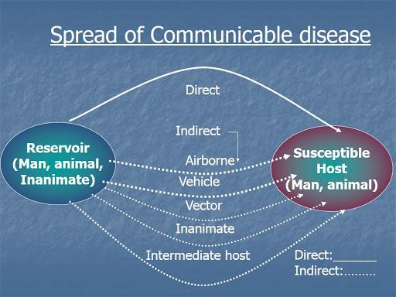
Animals in schools can have a positive effect in the school environment, but also may cause infectious disease issues for staff and students. Molalla River School District only allows for schools on district property with specific approval under specific circumstances. School board policies and district applications will be visited for this. Other considerations will be made in regard to controlling spread on infectious disease from animals:
- Wild mammals, alive or recently dead, will not be allowed in school. Bats and skunks have a significant risk of being rabid, and other wild animals may be more prone to causing injury through bites and scratches.
- Dogs, cats, and ferrets allowed in school will have a current rabies vaccine under circumstances that are consistent with board policies and building guidelines.
- Any animal bites on school premise will be reported to the local health department for follow up.
- Animals who are ill will not be allowed into the school setting.
- Class pets will be removed if they become ill.
- Handwashing must occur before and after handling of animals to prevent diseases such as transmission. [Image: Science Direct]
- Animals will not be present or handled in areas where food and drink are consumed or prepared.
- Children will not kiss high-risk animals such as chicks, ducks, turtles, and other reptiles.
- Children will always be monitored with animal interactions.
- Consider the medical needs of students who may be immunosuppressed or who may have allergies as they may become severely ill when exposed to certain pathogens.
- Service animals fall under specific guidelines which include protection of the animal to the extent that signage and education may be provided to prevent interaction with a service animal while it is working.
In the event of an animal bite in the school setting, please ensure standard first aid is followed, and the student/staff is deferred to medical care. Unprovoked bites sustained from canines are reportable to the local health department.
(503) 655-8411

In the event that a student in a classroom is diagnosed with a disease known to be carried by animals (campylobacteriosis or salmonellosis, for example), the animal will be removed from the classroom setting until the risk is determined to be resolved.

Food Safety
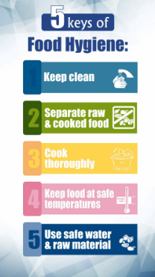
Food safety for kitchen staff is supervised by nutrition services. For the purpose of population-based health and food preparation and consumption within the classroom, general food safety standards and disease prevention principles will be endorsed.
For elementary school classrooms
- Hand hygiene is practiced prior to eating,
- General principles of food safety can be taught that are age appropriate.
- Food sharing will be avoided.
- For classroom and school-sponsored events, only commercially prepared products are permitted. No homemade goods from non-licensed kitchens are permitted.
For middle school or high school culinary classrooms
- Hand hygiene will always be encouraged.
- Age-appropriate food safety principles are taught.
- Appropriate food handling processes must be taught, role-modeled, and endorsed. This includes overview of:
  - Hand hygiene and appropriate use of gloves.
  - Clean surfaces and appropriate use of sanitizers. [ Image: Slideserve]

  - Separating raw and ready to eat foods/ avoidance of cross-contamination.
  - Cooking food to appropriate temperatures.
  - Appropriate storage and refrigeration.
  - Measures to prevent allergic reactions.
  - Abstaining from food preparation when specific symptoms or specific illnesses have been identified.

GLOSSARY OF TERMS
Airborne precautions: Precautions that are required to protect against airborne transmission of infectious agents. Diseases requiring airborne precautions include, but are not limited to: Measles, Severe Acute Respiratory Syndrome (SARS), Varicella (chickenpox), and Mycobacterium tuberculosis
Antibody: A protein produced as an immune response against a specific antigen.
Antigen: A substance that produces an immune response.
Bacteria: Microscopic living organisms. Some bacteria are beneficial, and some are harmless, but some can pathogenic (cause disease).
Bloodborne pathogens: Microorganisms which are spread through contact with infected blood, that can cause diseases such as human immunodeficiency virus (HIV) and hepatitis B (HBV).
Communicable Disease: Illness that spreads from one person to another through contact with the infected person or their bodily fluids, or through contaminated food/water or disease vectors, such as mosquitos or mice.
Contact Tracing: Working with an infected person to determine who they have had contact with and potentially exposed, to an illness.
Disinfection: High level cleaning intended to kill germs on surfaces
Droplet precautions: Safety measures used for diseases or germs that are spread in tiny droplets caused by coughing and sneezing (examples: pneumonia, influenza, whooping cough, bacterial meningitis).
Epidemic: A disease affecting a large number of people in a community or region.
Exclusion: Preventing someone from entering a place or participating in an activity
Immunocompromised: Having a weakened immune system that cannot respond normally to an infectious agent. This limits the body’s ability to fight disease.
Isolation: Being kept separate from others. A method of controlling the spread of a disease.
Novel: New—in medical terms, previously unidentified, as in, novel coronavirus
Pandemic: An epidemic that spreads over countries or continents.
Pathogen: A microorganism that can cause disease.
Personal Protective Equipment (PPE): Physical barriers used when exposure to hazards cannot be engineered completely out of normal operations and when safe work practices and administrative controls cannot provide sufficient protection from exposure to infectious or hazardous conditions. PPE includes such items as gloves, gowns, and masks.
Restrictable Diseases: Diseases that require exclusion from work, school, childcare facilities, for the protection of public health. According to the Oregon Health Authority, restrictable disease include diphtheria, measles, Salmonella enterica serotype Typhi infection, shigellosis, Shiga-toxigenic Escherichia coli (STEC) infection, hepatitis A, tuberculosis, open or draining skin lesions infected with Staphylococcus aureus or Streptococcus pyogenes, chickenpox, mumps, pertussis, rubella, scabies, and any illness accompanied by diarrhea or vomiting.
Sanitize: Reduce contaminants (viruses, bacteria) on an object or surface.
Seasonal Illness: Illnesses whose occurrence appears to be associated with environmental factors (temperature and humidity changes). For example, colds, and other upper respiratory illness are more common during the winter months when people are more often indoors.
Standard Precautions: A set of infection control practices used to prevent transmission of diseases that can be acquired by contact with blood, body fluids, non-intact skin (including rashes), and mucous membranes. These measures are to be used when providing care to all individuals, whether or not they appear infectious or symptomatic.
Surveillance: Collecting and analyzing data related to a disease in order to implement and evaluate control measures
Transmission: How a disease spread. There are four modes of transmission:
    - Direct—physical contact with infected host or vector
    - Indirect—contact with infected fluids or tissues.
    - Droplet—contact with respiratory particles sprayed into the air (sneezed or coughed)
    - Droplet Nuclei—dried droplets that can remain suspended in the air for long periods of time (e.g., tuberculosis)
The mode of transmission of a disease will determine what PPE is required.
Universal Precautions: Preventing exposure to blood borne pathogens by assuming all blood and bodily fluids to be potentially infectious and taking appropriate protective measures.
Vaccine: A preparation containing a weakened or killed germ. Vaccines stimulate the immune system to produce antibodies to prevent a person from contracting the illness.
Variant: A difference in the DNA sequence, a mutation. Viruses can change and mutate, and these variant forms can be intractable to established treatments.
Vector: A carrier of a pathogen (germ) that can transmit the pathogen to a living host. Mosquitoes, fleas, ticks, and rodents are examples of vectors.

References
Alameda County Public Health Department (2013) Communicable Disease. Retrieved from http://www.acphd.org/communicable-disease.aspx
ASCD (Association for Supervisors and Curriculum Development) (2020). WSCC. Retrieved from http://www.ascd.org/programs/learning-and-health/wscc-model.aspx
BC Center for Disease Control (BCDC) (2009) A quick Guide to Common Childhood Diseases. Retrieved from http://www.bccdc.ca/resourcegallery/Documents/Guidelines%20and%20Forms/Guidelines%20an %20Manuals/Epid/Other/Epid_GF_childhood_quickguide_may_09.pdf
Centers for Disease Control and Prevention. (2020). Influenza. Retrieved from https://www.cdc.gov/flu/about/index.html
CDC (2020) When and how to wash your hands. Retrieved https://www.cdc.gov/handwashing/whenhow handwashing.html
CDC (2016a) Bloodborne Pathogens. Retrieved https://www.cdc.gov/niosh/topics/bbp/emergnedl.html
CDC (2016b) Variant Influenza Viruses: Background and CDC Risk Assessment and Reporting. Retrieved from https://www.cdc.gov/flu/swineflu/variant.htm
CDC (2017) Getting your school ready for pandemic flu. Retrieved from https://www.cdc.gov/nonpharmaceutical-interventions/pdf/gr-pan-flu-ed-set.pdf
Minnesota Department of Health (2020). Teaching Hand Hygiene. Retrieved from https://www.health.state.mn.us/people/handhygiene/curricula/index.html
Montana Department of Public Health and Human Services (MDPHHS) (2018) Communicable Disease: A guide for Schools in Montana. Retrieved from https://dphhs.mt.gov/Portals/85/publichealth/documents/CDEpi/CDGuideforSchools2018_Final.pdf
National Resource Center for Health and Safety in Child Care and Early Education (NRC). (2020). Environmental Health in Early Care and Education. Retrieved from https://nrckids.org/CFOC/Environmental_Health
Oregon Department of Education (2020) Communicable Disease Guidance for Schools. Retrieved from Oregon Department of Education Communicable Disease Guidance Document.
South Dakota Department of Health (2019) Seasonal Respiratory Viruses. Retrieved from https://doh.sd.gov/diseases/infectious/diseasefacts/viral-respiratory.aspx
Victoria State Government. (2020). Managing spills of blood and body fluids and substances. Retrieved from https://www2.health.vic.gov.au/public-health/infectious-diseases/infection-controlguidelines/manage-blood body-fluidspills#:~:text=Spots%20or%20drops%20of%20blood, as%20wet%20areas%20attract%20contaminan s.
Virginia Department of Health (2011) FAQ Respiratory Hygiene and Cough Etiquette. Retrieved from https://www.vdh.virginia.gov/content/uploads/sites/3/2016/01/RespiratoryHygieneCoughEtiquett _FAQ.pdf
Weatherspoon, D. (2019) Acute Viral Respiratory Infections. Retrieved from https://www.healthline.com/health/acute-respiratory-disease
Images:
- CDC.gov  - Manitoba Department of Health  - Multicare.org | - Open University  - Prepare.gov  - Safety Signs | - Slideserve  - Science Direct

