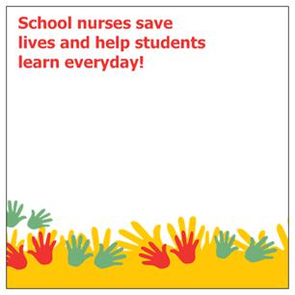
Northwest Ohio Association of School Nurses
Dear Nurses,
Welcome to NWOASN. I am so happy you have decided to join your regional professional organization. We welcome membership from nurses working in public, charter, private and parochial schools. As a member you will have an opportunity to network with school nurses and other health professionals who have an interest in school health services. Membership provides you with an opportunity to attend our educational conferences at a discount rate. By providing us with your e-mail we will keep you informed through e-mail blasts to keep alerted of upcoming events, legislative changes and current news concerning school nurses.
NWOASN promises to promote and advance the quality of school health services, health education and a healthy school environment for the children of Northwest Ohio
Membership dues are $20.00 per year and $10.00 for retired school nurses’ valid from August through August. Please detach and return bottom with your payment.
------------------------------NWOASN Dues 2018-2019———————————————
Name________________________________________Phone_______________________
Address-__________________________________________________Zip______________
Preferred E-mail________________________________________ (required)
Active-RN with ODE school nurse license ____
Associate-Professional working in school____ Retired______________
Name of School(s) ______________________________________
Address______________________________________________Phone________________
City___________________________________________________County_____________

May we share your contact information with other members yes_______ No_______
Remit to: Membership c/o Denise Kaufman 30041 Bates Rd.Perrysburg, Ohio 43551

