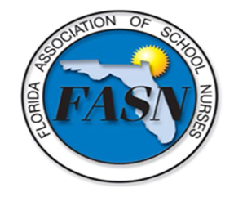
Florida Association of School Nurses
Conference Agenda (Tentative*)
Celebrating School Nurses in Supporting Student Success
October 14-15, 2022
Hyatt Place Tampa Wesley Chapel
26000 Sierra Center Boulevard, Lutz, Florida 33559

Friday October 14, 2022
4:30 - 6:30 Check in/Registration/Vendors
6:00 - 6:30 Welcome/networking
6:30 - 8:00 Dinner and Learn: Keynote speaker NASN President-elect Kate King: Celebrating the Changing Role of the School Nurse (1 CE) - Dinner provided
8:00 –9:00 After Dinner Mingle & Dessert

Saturday October 15, 2022
7:00 - 8:00 Check in/Registration/Vendors - Breakfast provided
8:00 - 8:15 Welcome
8:15 - 10:15 Session 1: FDOE State School Nurse Consultant, Karla Bass: Florida School Health Legislative Update (2 CE)

10:15 - 10:45 Break/Vendors - Refreshments (drinks) available all day
10:45 -11:45 Session 2: Tobacco Program Manager, Kayla Jones-Willis: Vaping: Hidden in Plain Sight (1 CE)
11:45 - 12:00 Blessing of the Hands
11:45 - 1:00 Lunch break/Vendors - Lunch provided
1:00 - 3:00 Session 3: USF Certified Diabetes Care and Education Specialist, Janet Rodriguez: Caring for Students with Diabetes: Technology Updates (2 CE)
3:00 - 3:15 Break/Vendors - Afternoon snacks available

3:15 - 5:15 Session 4: The Lifeboat Project Founder and CEO Jill Cohen: School Nurses and Human Trafficking (2 CE)

Direct Registration Process or FASN Conference questions to Lisa Kern @ rnlisaann59@aol.com

