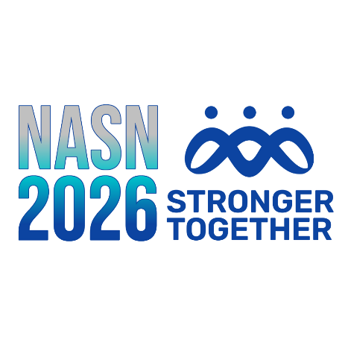
Blogging Instructions for NASN2026
Before You Post Your Blog Entry
- Write a rough draft of your message. Here are some tips:

  - The title of your blog should be the title of your session.
  - Write your blog post to be between 200 and 400 words.
  - Include the event name, session date and session time in your blog post.
  - Use easy-to-read text and language; reading online should be somewhat effortless.
  - Organize your message into short paragraphs.
  - Write in first-person so the message is yours.
  - Include links to additional resources, definitions, and/or citations instead of inserting footnotes.

- Update your NASN website profile: https://www.nasn.org/profile

  - Add or update your profile photo.
  - Add or update your bio.
  - Make your photo and bio visible to the public by editing your privacy settings (go here https://www.nasn.org/profile, find My Profile Settings, and choose Privacy-Visibility Settings).

- Reach out to Devin Dinkel, NASN Education and Conference Manager, at ddinkel@nasn.org for blogging permissions.

- Your NASN account must include the blogger role before the instructions below can be completed.

How to Post Your Blog

- Go to https://www.nasn.org/schoolnursenet/participate/createnewblog
- Log In using your NASN website login: If you need assistance, email info@nasn.org
- Create your blog post:

  - Enter your NASN session name as the title.
  - Enter your blog; use images and hyperlinks if you have these.
  - In the settings below the blog entry, where it says, “Associate this post with a community,” choose the NASN2026 conference. If you do not see the conference listed, leave as “Nothing Selected.”
  - In the setting where it says, “Who can read your blog entry,” make sure it says “Public.”
  - Select the PUBLISH button.

- Email the NASN Conference Team to let them know your blog has been posted (conference@nasn.org) --- NASN will link your blog to the conference website if you were unable to choose the conference community in step “c.”

