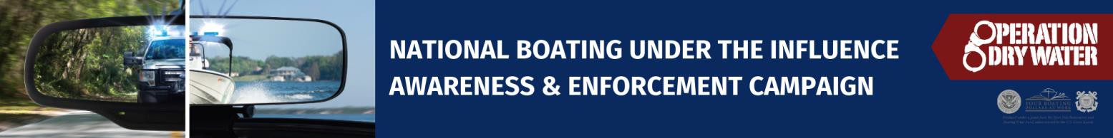
FOR IMMEDIATE RELEASE: [Date]
CONTACT: [Name, Phone Number, Email Address]

[Organization] Promotes Safe, Sober Boating Through Nationwide
Operation Dry Water Awareness Campaign

[City, STATE] – As boating activity increases nationwide over the Fourth of July holiday, [Organization] is participating in Operation Dry Water, a national awareness campaign focused on educating boaters about the dangers of alcohol- and drug-impaired boating and promoting sober behavior for everyone on board. The campaign will take place July 3–5.

Alcohol remains the leading known contributing factor in recreational boating fatalities, impairing judgment, balance, vision, and reaction time — skills essential for safe boating.¹ Through Operation Dry Water, [Organization] is raising awareness about how alcohol and drugs increase risk on the water, even in situations that may seem routine or familiar.

“Boating safety depends on everyone making responsible choices,” said [Spokesperson Name]. “Operation Dry Water helps boaters understand that alcohol affects more than just the person at the helm. Impairment anywhere on a boat can lead to dangerous situations, and staying sober helps protect everyone on the water.”

Throughout the Operation Dry Water weekend, [Organization] will support education and outreach efforts that encourage sober boating, life jacket use, and heightened awareness of changing conditions on the water. These prevention-focused messages are intended to reduce risky behaviors that contribute to preventable incidents and fatalities.

Alcohol use by passengers — not just operators — can also create hazardous situations on the water.² Impaired balance, slowed reactions, and distraction increase the risk of falls, ejections, and other serious injuries. Operation Dry Water emphasizes shared responsibility, reinforcing that boating safety is a collective effort.

Ahead of the July 4 holiday, [Organization] urges boaters to recognize that alcohol and drugs have no place on the water and that sober behavior by everyone on board is essential to preventing injuries and fatalities. Educational resources about boating under the influence and Operation Dry Water are available at [Organization website] and operationdrywater.org.

Operation Dry Water is coordinated nationally by the National Association of State Boating Law Administrators (NASBLA) in partnership with the U.S. Coast Guard.

###

1 2024 U.S. Coast Guard Recreational Boating Statistics
2 2019 Boating Under the Influence (BUI) Research Report

