Summer Boating Safety Tips Social Media Posts
#SafeBoatingTips
*2019 U.S. Coast Guard Recreational Boating Accident Statistics
- Don’t let a BUI sink a good time. #OperationDryWater #staysober #SafeBoatingTips
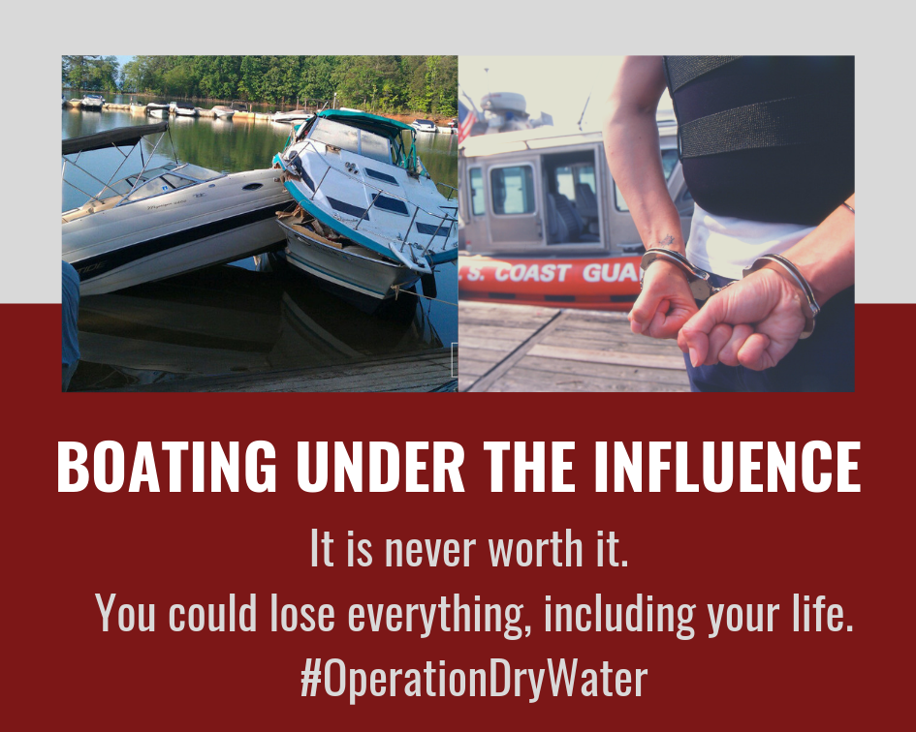

- Taking a boating safety course can remind you of the serious hazards associated with boating. #SafeBoatingTips
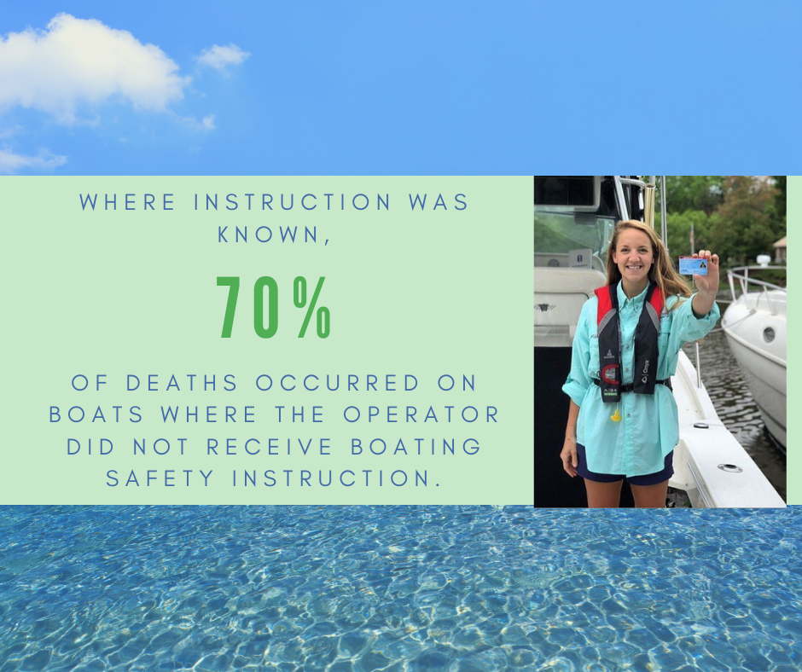

- Don’t become another statistic. Safe boating is smart boating. #SafeBoatingTips

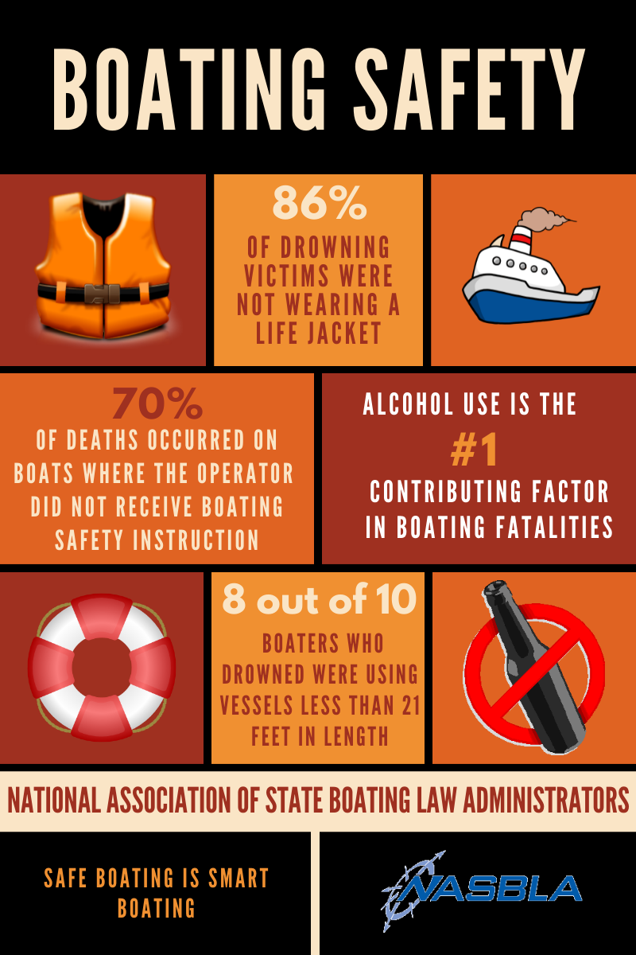

- Always be aware of your surroundings while on the water. #SafeBoatingTips

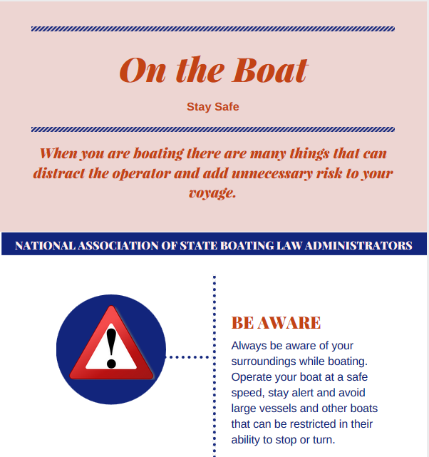

- Before you hit the water, make sure you have successfully completed these tasks. #SafeBoatingTips
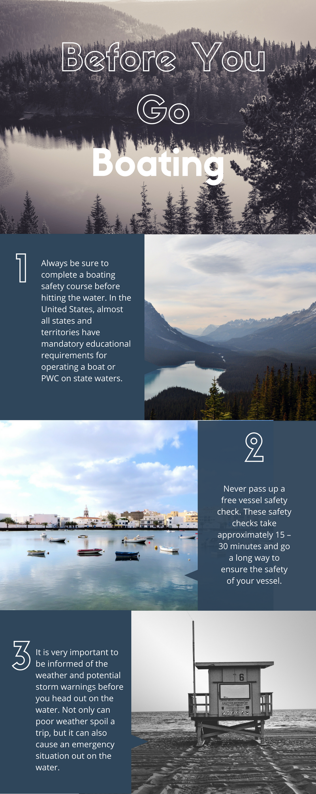

- Emergency Boating Kits should be on board every vessel. Do not forget to get yours from your local outdoor retailer. #SafeBoatingTips

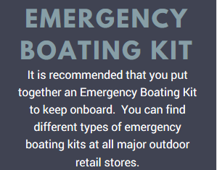

- An unmanned, out of control boat may circle ejected occupants, often running them over. Wear an engine cut-off device! #SafeBoatingTips

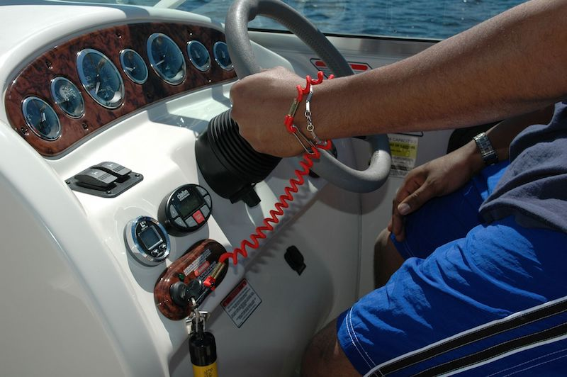

- Throwable devices include buoyant cushions, ring buoys, and horseshoe buoys. These throwable devices should be USCG approved. #SafeBoatingTips

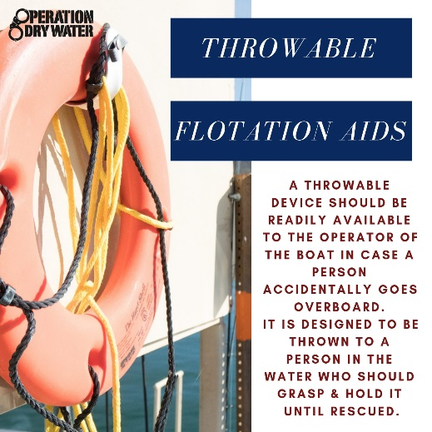

- Remember to follow all buoys and navigation aids on the water. #SafeBoatingTips
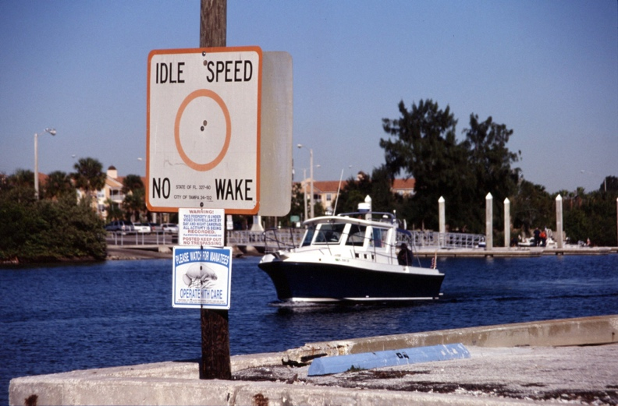

- Bring water for everyone onboard the boat. Boating takes place during the warmer months of the year & it is vital to stay hydrated. #SafeBoatingTips

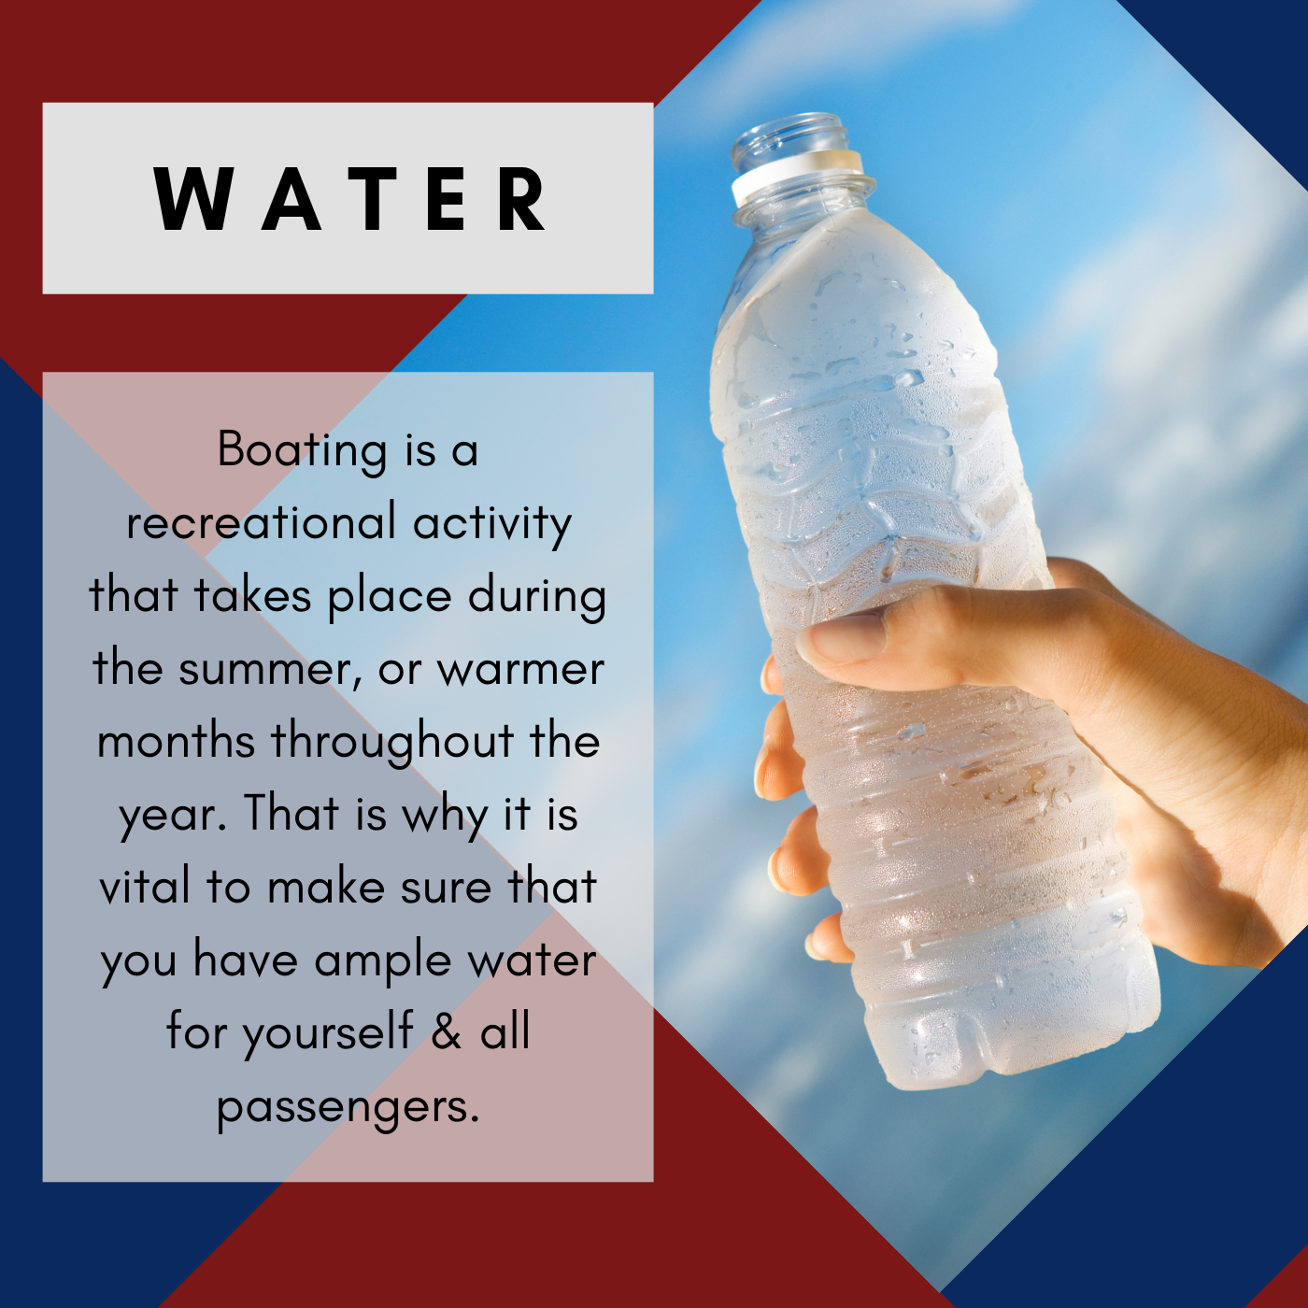

- Vessel Safety checks are free of charge, and you will have the chance to receive helpful recommendations and boating safety tips. #SafeBoatingTips

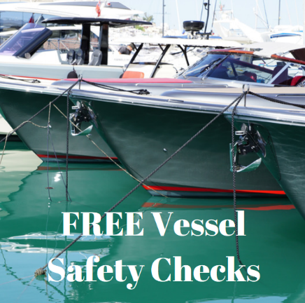

- Always make sure your instrument lights are working so that you don’t miss important maintenance checks. #SafeBoatingTips

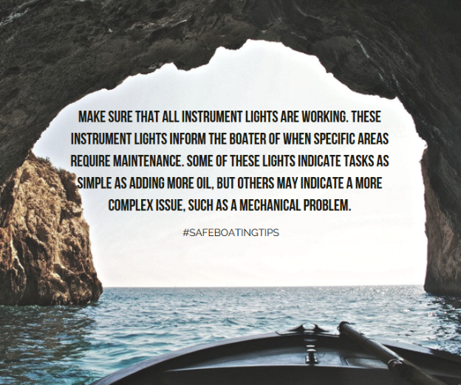

- Don’t let a hot day ruin your engine. Always check the engine oil and coolant levels to prevent damage to the engine. #SafeBoatingTips

- Always check the weather prior to leaving shore. It is better to postpone a boating trip than to become a victim of the weather. #SafeBoatingTips

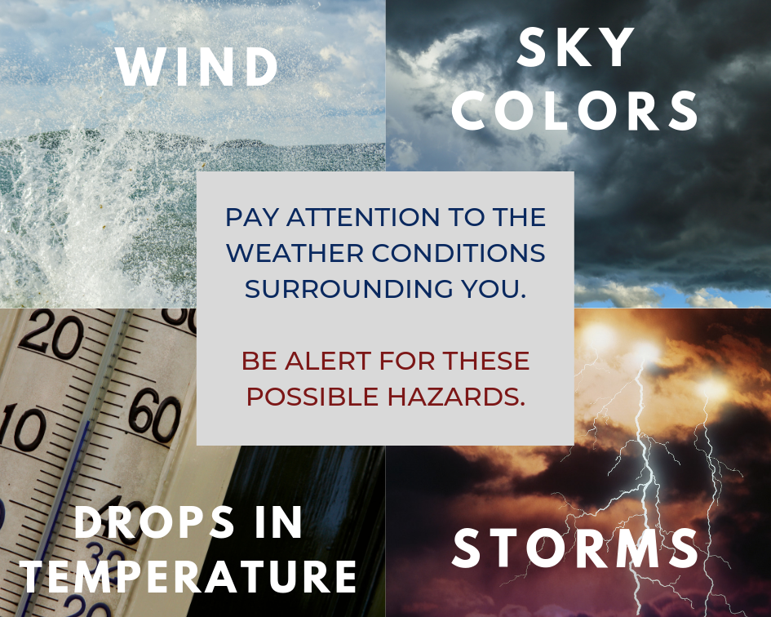

- Be sure to designate an assistant Skipper! Always have more than one person onboard capable of navigating the vessel. #SafeBoatingTips

- Always have everyone on board wear a life jacket at all times. #SafeBoatingTips

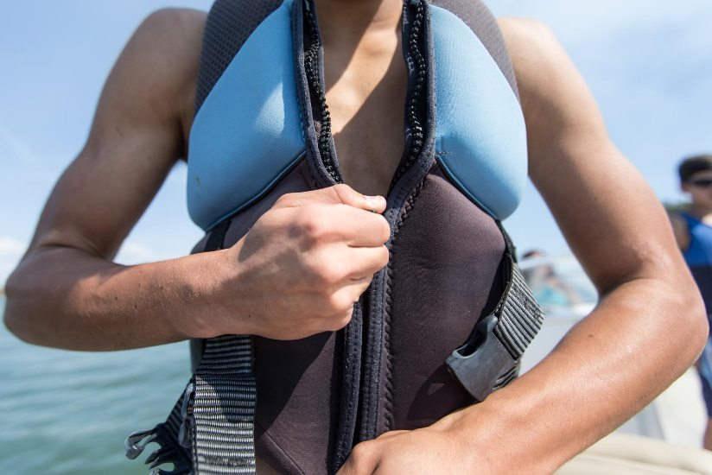

- Before you go boating: take a safe boating course, receive a free vessel safety check and go over your boat safety checklist. #SafeBoatingTips

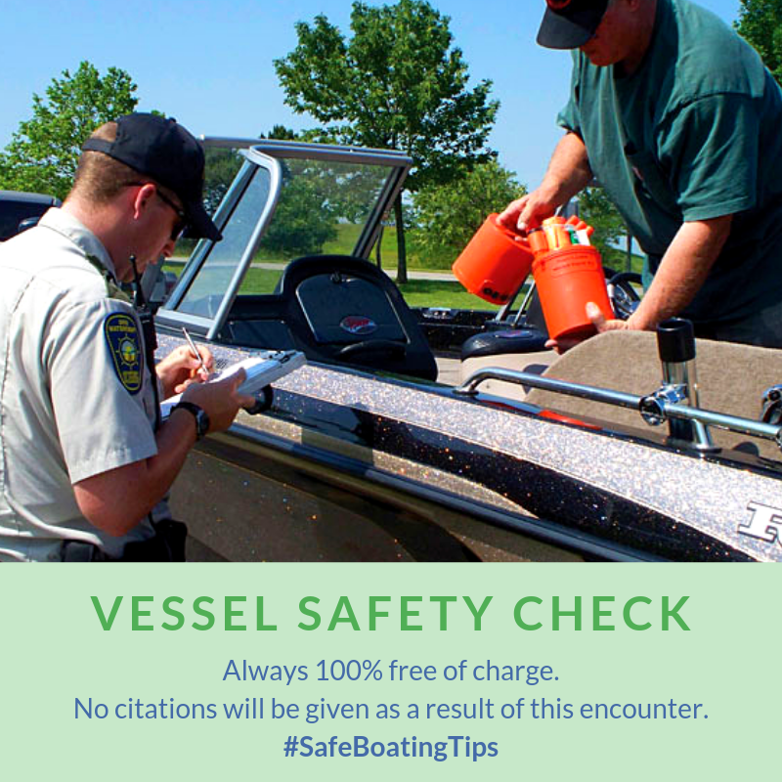

- Make sure your vessel is fully equipped with visual distress signals. #SafeBoatingTips

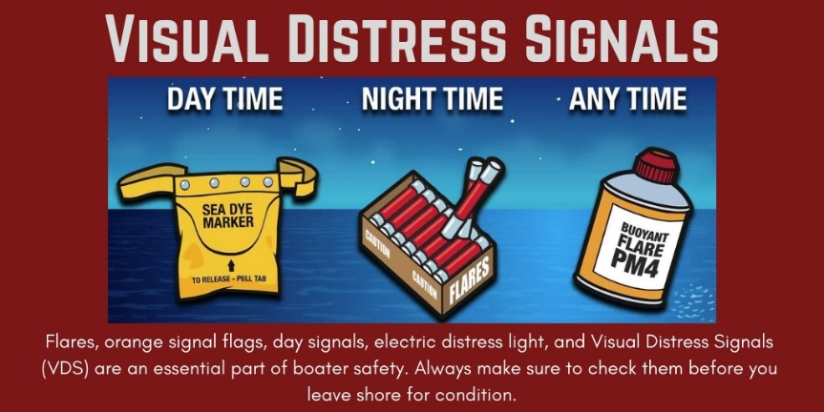

- Make sure your sound producing device can be audible from one-half mile. #SafeBoatingTips

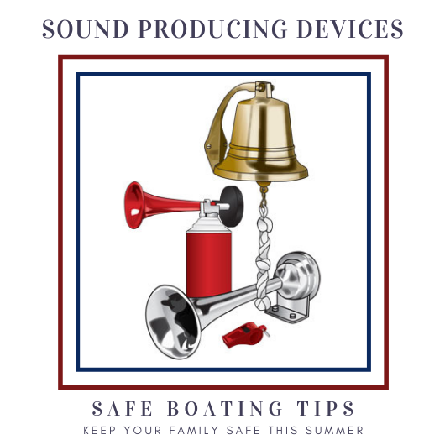
- Never get lost. Make sure you have an Emergency Position Indicating Radio Beacon (EPIRB) or a Personal Locator Beacon (PLB). #SafeBoatingTips

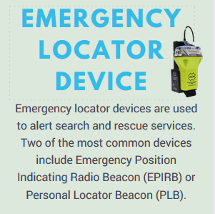

- Alcohol has many effects that directly threaten safety and well-being on the water. Physical performance is impaired - evidenced by balance problems, lack of coordination, and increased reaction time. #SafeBoatingTips

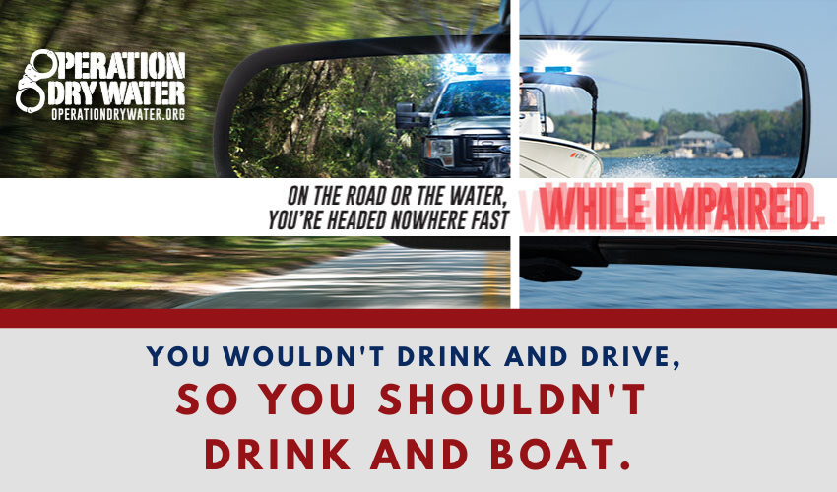

- Paddlecrafts are available in different types often designed for a specific activity, waterway, and performance. It is recommended that in addition to a basic boating safety course that the operator takes paddlecraft specific instruction. #SafeBoatingTips

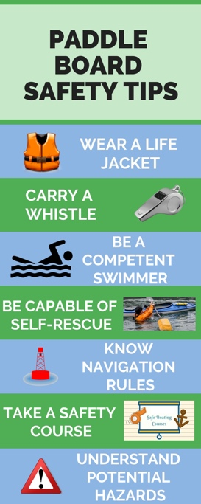

Don’t forget to use #SafeBoatingTips when sharing these messages.
Connect with us!
Facebook.com/NASBLA Twitter.com/NASBLA
Facebook.com/OperationDryWater Twitter.com/OpDryWater

