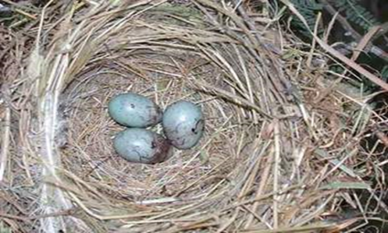
Historical Society Presents:
Long Island National Association Of PedIATRIC NURSE ASSOCIATES & pRACTITIONERS
BEGINNINGS
The Long Island National Association of Pediatric Nurse Practitioners (LINAPNAP) chapter began in 1998 with 10 members led by the 1st President Janet. She along with our pioneer colleagues formed a promise mission to respect the dedication of the members of this professional organization and their vision of sharing knowledge and protecting the advanced practice nurse through education and excellence in the care of pediatric patients.
We embrace our professional organization which had taken flight more than two decades ago and has become the dynamic program that we value today. Through charitable acts of kindness we have extended our knowledge to benefit the communities we serve. Together we share experiences and learn to implement research based knowledge to provide excellence in primary care, intensive, critical and specialized pediatric inpatient and outpatient care in hospitals, clinics, schools, and tertiary nursing facilities. Our advanced care practitioners are leaders on the frontlines of health care, supervisors in administration, and coordinators in home and education programs. Our borders of health care services have not been limited to our local communities but through voluntary missions as we have extended our services to national and international outreach programs. Our presidential TORCH award is a representative symbol of our organization’s mission to uphold high healthcare standards and is presented annually to an esteemed colleague chosen on character, professionalism and dedicated service to LINAPNAP.
Today we are thankful to our frontline heroes. It is the genuine dedication to a moral obligation and oath of service to heal and comfort that brings hope in these unprecedented times. As we confront current health care crisis, we denounce racial disparity and promote health equity and acceptance as we are challenged by contemporary health issues involving the transgender patient, human trafficking, childhood obesity, teen suicide, opioid addition, and an unforeseen global viral pandemic.
We can learn from history live in the present and dream of the future.
Thank you to our loyal membership for your dedicated service
1998 | 1999
President | President
2000 | 2001
President | President
2002 | 2003
President | President
2004 | 2005
President | President
2006 | 2007
President | President
2008 | 2009
President | President
2010 | 2011
President | President
2012 | 2013
President | President
2014 | 2015
President | President
2016 | 2017
President | President
2018 | 2019
President | President
2020 | 2021
President | President

